**Question 1**

**--**List the following details of each employee: employee number, last name, first name, sex, and salary.

select e.emp_no, e.last_name,e.first_name, e.sex,

s.salary

from employees e

join salaries s on s.emp_no=e.emp_no

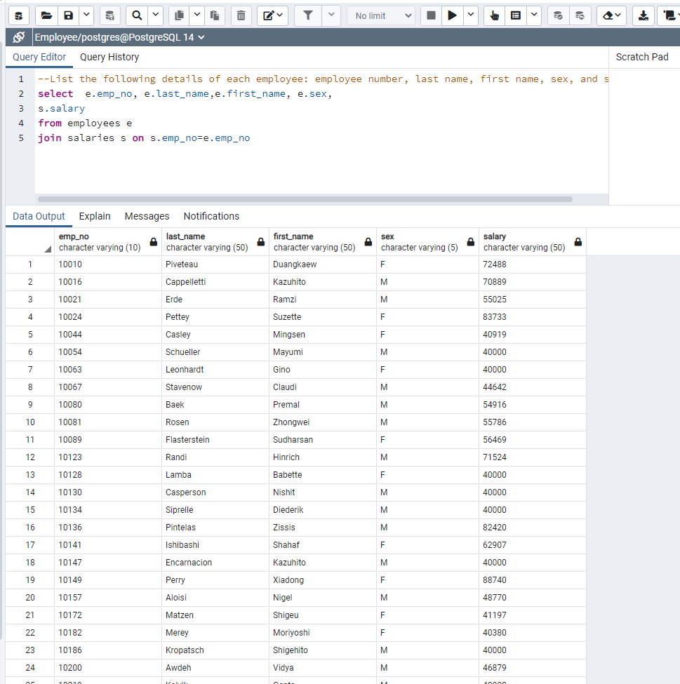

**Question 2**

--List first name, last name, and hire date for employees who were hired in 1986.

select e.first_name, e.last_name,e.hire_date

from employees e

where hire_date between '1986-01-01' and '1986-12-31'

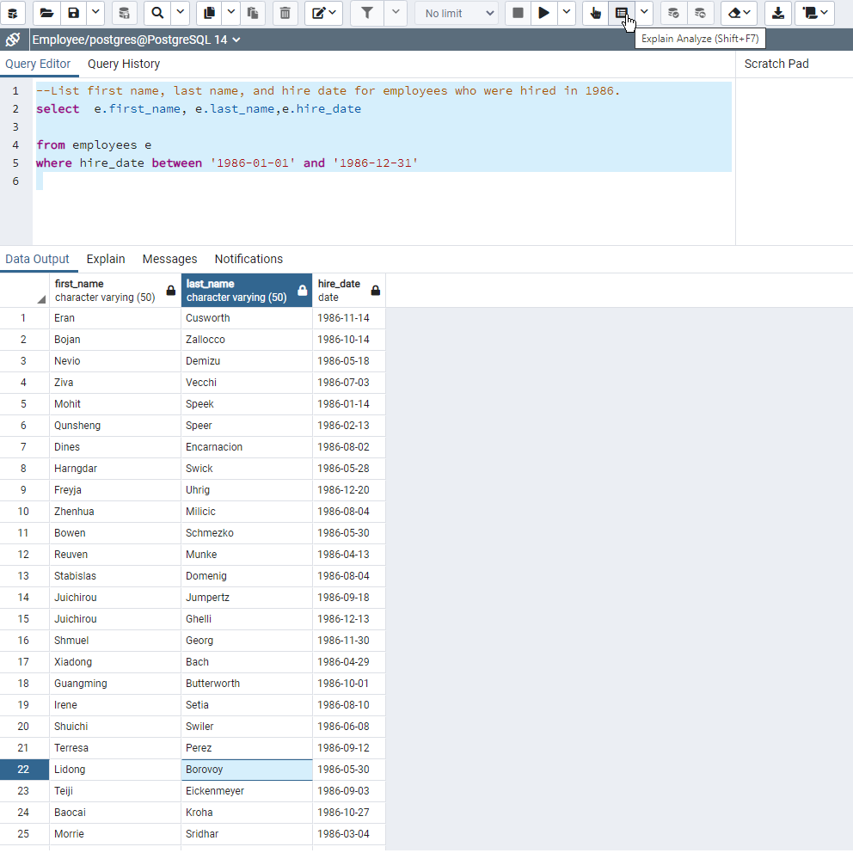

**Question 3**

--List the manager of each department with the following information: department number,

--department name, the manager's employee number, last name, first name.

select

d.dept_no,d.dept_name,dm.emp_no,e.last_name,e.first_name

from

departments d

join dept_manager dm on dm.dept_no=d.dept_no

join employees e on e.emp_no=dm.emp_no

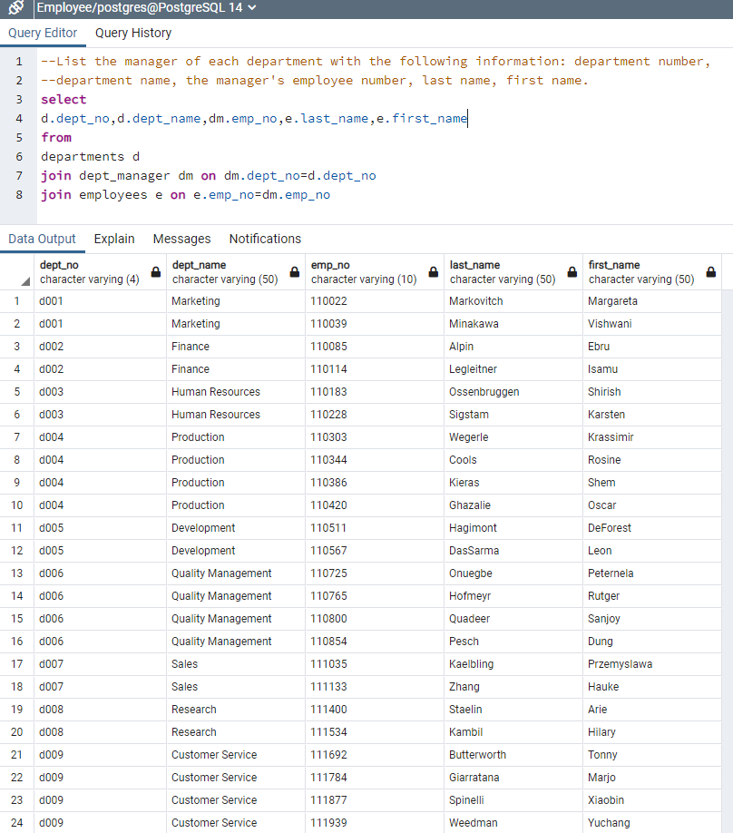

**Question 4**

--List the department of each employee with the following information: employee number,

--last name, first name, and department name.

select

d.dept_no,d.dept_name,de.emp_no,e.last_name,e.first_name

from

departments d

join dept_emp de on de.dept_no=d.dept_no

join employees e on e.emp_no=de.emp_no

order by 1,2,4,5

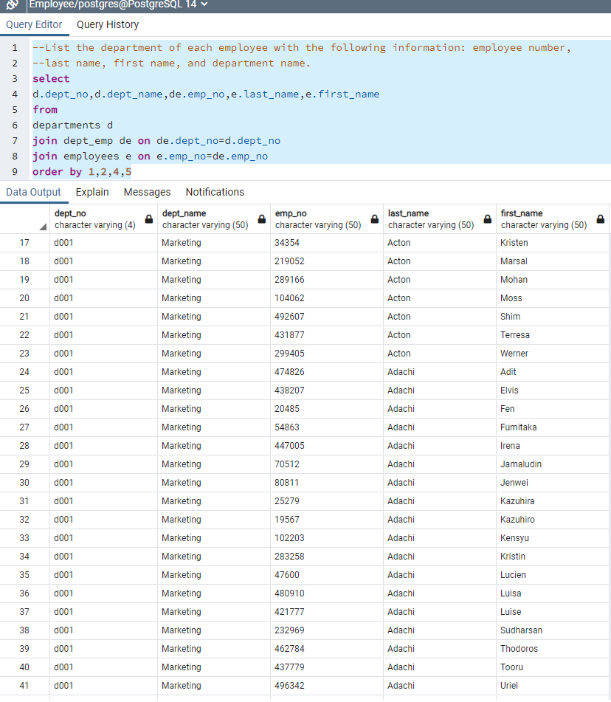

**Question 5**

--List first name, last name, and sex for employees whose

--first name is "Hercules" and last names begin with "B."

select

first_name,last_name,sex from employees

where first_name='Hercules' and last_name like 'B%'

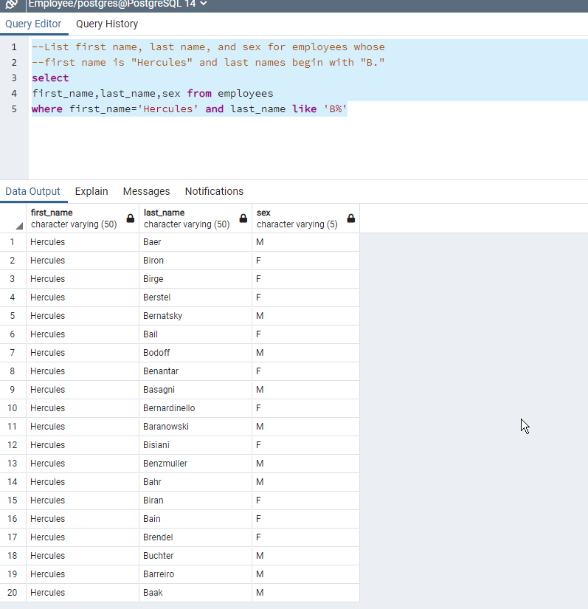

**Question 6**

--List all employees in the Sales department,

--including their employee number, last name, first name, and department name.

select e.emp_no,e.last_name,e.first_name,d.dept_name from employees e

join dept_emp de on de.emp_no=e.emp_no

join departments d on d.dept_no=de.dept_no

where d.dept_name='Sales'

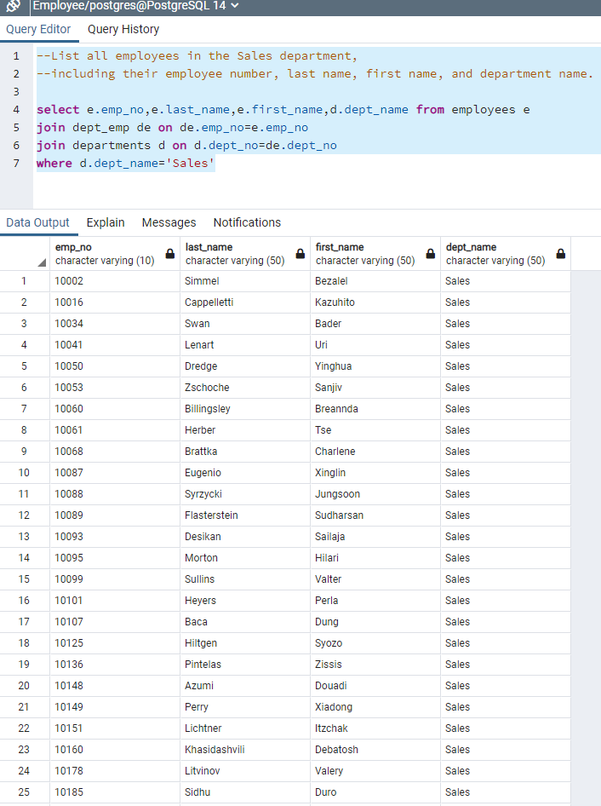

**Question 7**

--List all employees in the Sales and Development departments, including their employee number,

--last name, first name, and department name.

select e.emp_no,e.last_name,e.first_name,d.dept_name from employees e

join dept_emp de on de.emp_no=e.emp_no

join departments d on d.dept_no=de.dept_no

where d.dept_name='Sales' or d.dept_name ='Development'

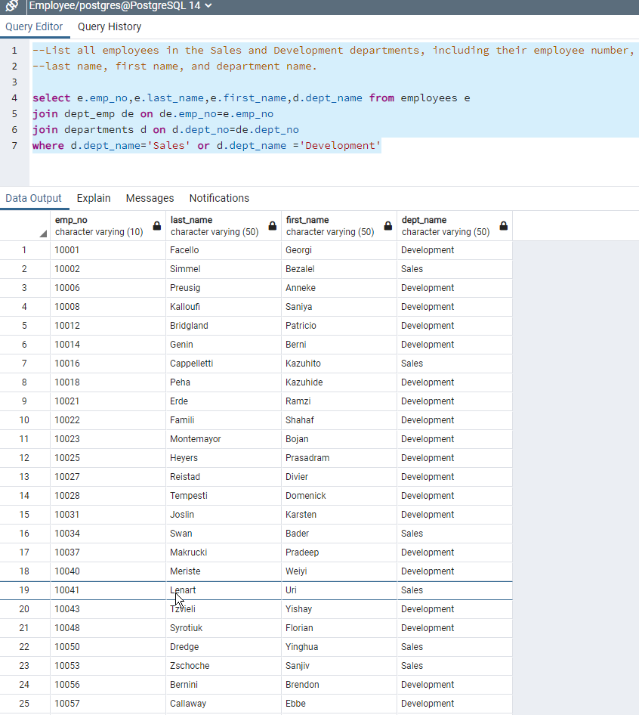

**Question 8**

--In descending order, list the frequency count of employee last names,

--i.e., how many employees share each last name.

select last_name,count(*) frequency from employees

group by last_name

order by 2 desc

