<https://en.wikipedia.org/wiki/List_of_data_structures>

https://coggle.it/diagram/W5E5tqYlrXvFJPsq/t/master-the-interview-click-here-for-course-link/c25f98c73a03f5b1107cd0e2f4bce29c9d78e31655e55cb0b785d56f0036c9d1

# **Computer Memory**

https://www.youtube.com/watch?v=fpnE6UAfbtU

<https://statmath.wu.ac.at/courses/data-analysis/itdtHTML/node55.html>

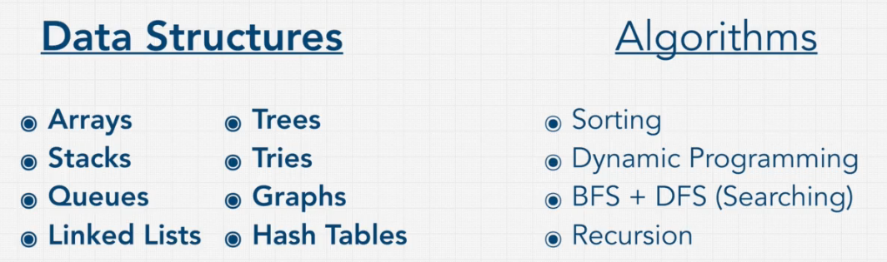

Hash tables

hash function generates a key with md5 or smth else(SHA). then we understand which is which

grapes → 3426dqsfsdg14 (md5 hash) holds in the memory