Arrays are fixed size.

**DISADVANTAGES**

1-This is disadvantage and inconvenience there is a reason actually because When you create an array you need to pick before even starting the problem or using the array how big is array gonna be. If you don’ know answer this is a problem.

2-If you create an array for example 10 size.You can not add 11th element to this array.

For example If you create an array sized 10,000 sized.then that takes memory in your computer and this is known as memory leak by creating massive array that not actually u gonna use.I mean u create an big array but u just store some elements.don’t forget big sized arrays takes memories from your computer.

**ADVANTAGES**

7 8 5 3 2

1-we can index items. [0]

2-Look an item is CONSTANT TIME . O(1)

3-Comparing to lists looking to an item in array is faster.

4-**ADD an item**

Let’s think that we want to insert 4 between 7 and 8 .We need to shift all of array and we might *to remove last element of the list. Each Element in the list change their places. So When we add 4 between 7 and 8 All of elements needs to swap next index so that last item 2 is disappear.

What happens is

7 4 8 5 3 2

7 4 8 5 3

Last item 2 is not in New array.

That process takes O(n) times means u busted dude….

5-**Remove an item**.

7 4 8 5 3

7 4 8 3 NULL

If you want to remove 5 for ex; We remove 5 then 3 comes to index of 5 then index of 5 is gonna be Null after 3.

If you make your erray big and you store them a few items that is gonna take your memory a lot do not forget that.

Insert remove add takes O(n) times so u should think that when u use.

For randomly access items we can use arrays. Because accessing something in array is constant time that’s why its is good actually.

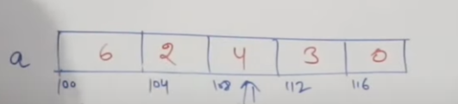

Each array element is takes 4 bytes.

Ornegin yukarida olan array icin toplamda 5 KB diyoruz cunku her 1 eleman 1 kb ve 4 bytes aliyor.Fixed size bir array varsa burada bosluklara null oluyor ama kalmaya devam ediyor yani hafizada olmaya devam ediyor.

Array Operations - Traversal, Insertion

Traversal means visiting every array once.

Each intergers takes 4 bytes. I goes to right to each array element

IF you have 50 element sized array that means 200 bytes because each element takes 4 bytes.