**PART 1**

I=imread('mickey.jpg');

I = im2double(I);

red = I(:,:,1); % Red channel

green = I(:,:,2); % Green channel

blue = I(:,:,3); % Blue channel

k=5;

for i = 1:3

[U,S,V] = svd(I(:,:,i));

N(:,:,i) = U(:,1:k)*S(1:k,1:k)*V(:,1:k)';

end

imshow(N)

axis off

imwrite(N,'mickeynew.jpg')

For k=5

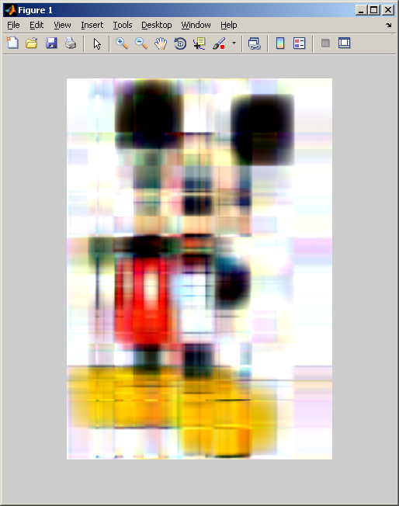

For k=25

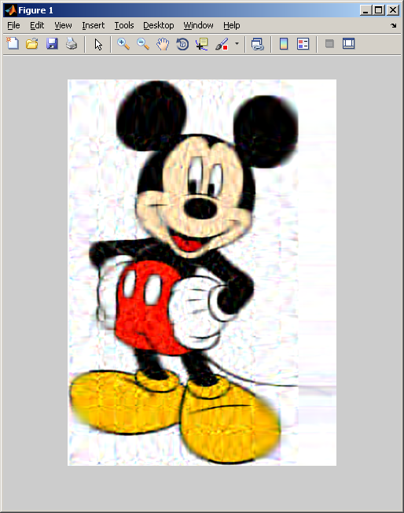

For k=55

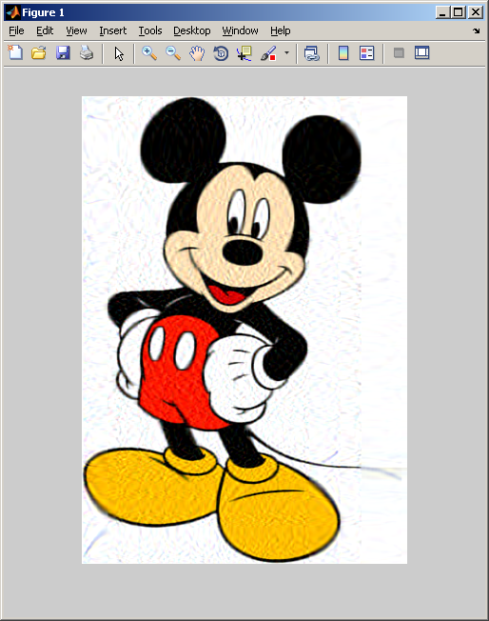

For k=300

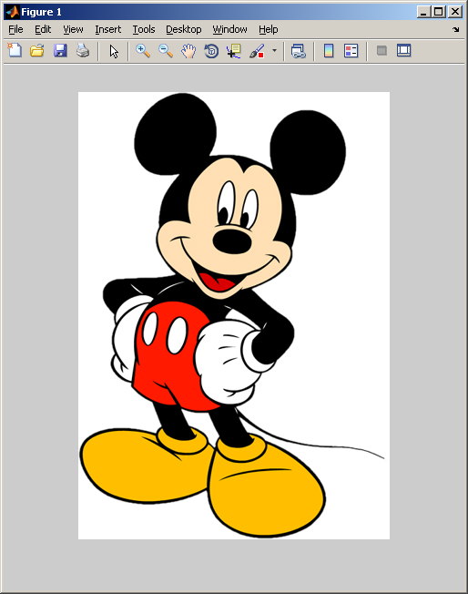

**PART 2**

A=[8 -7 9;5 3 4;5 -6 7];

B=[3;-8;4];

if det(A)==0

disp('no solution with cramer rule...');

else

disp('the solution can be found below:');

end

[row,col]=size(A);

Y=A;

for j=1:col

for i=1:row

Y(i,j)=B(i,1);

end

Y

solution=det(Y)/det(A);

X(j)=solution;

Y=A;

end