1) Find the solution using matlab.

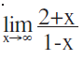

Answer:

syms x

limit((2+x)/(1-x),x,inf)

ans =

-1

2) Find the solution using matlab.

a)  b) 

Answer:

b)

syms x syms x

limit((x/abs(x)),x,0,'left') limit((x/abs(x)),x,0,'right')

ans =

-1 ans =

1

3)

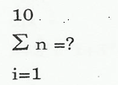

Answer:

syms n

symsum(n,1,10)

ans =

55

4)Plot functions and find the Maximum and Minimum values.

a) f(x) = 1/2x3 – 3x2 +2 [-1 , 2]

Answer:

a)

fplot('1/2\*x^3-3\*x^2+2',[-1,2])

syms x

fx=1/2\*x^3-3\*x^2+2

fxd= diff(fx,x); % take derivative of function

ext= solve(fxd) % find root of derivative

fxdd= diff(fxd,x); % find second derivative of function

maxmin1=subs(fxdd,x,ext(1))

maxmin2=subs(fxdd,x,ext(2))

fx =

1/2\*x^3-3\*x^2+2

ext =

0

4

maxmin1 =

-6

maxmin2 =

6

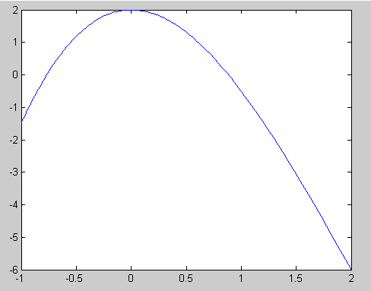

5) Find the equation of the tangent to the function f(x) = x3 - 6x + 1 / 2, at the point (1 ,2.3).

Answer:

Syms f x

f = x^3-6\*x+1/2;

fd = diff(f,x);

ftegim=subs(fd,x,1)

sabit=2.3-ftegim\*1

ftegim =

-3

sabit =

5.3000

6) Calculate derivative using matlab.

f(x,y,z) = yz2 + e-xyz + x2z

Answer:

syms x y z

fxyz=y\*z^2+exp(-x\*y\*z)+x^2\*z

fxyzdx=diff(fxyz,x)

fxyzdx =

-y\*z\*exp(-x\*y\*z)+2\*x\*z

7) f(x,y,z) = xy2 + e-xyz + z2y





Answer:

a)

syms x y z

fxyz= x\*y^2+exp(-x\*y\*z)+x^2\*y

diff(fxyz,x)

ans =

y^2-y\*z\*exp(-x\*y\*z)+2\*x\*y

b)

syms x y z

fxyz= x\*y^2+exp(-x\*y\*z)+x^2\*y

fxyz=diff(diff(fxyz,y),x)

fxyz =

2\*y-z\*exp(-x\*y\*z)+x\*z^2\*y\*exp(-x\*y\*z)+2\*x

8) Calculate integral using matlab.



syms x

fx = 3\*x^3+2\*x^2+x

i=int(fx)

i =

3/4\*x^4+2/3\*x^3+1/2\*x^2

9)C:\Documents and Settings\2k931038\Desktop\MSP126041e1276bi5ehh25i700004891i38i175692gc.gif find integral using pretty.Function is f(x,y)=x\*2y^2-x\*ln(x\*y)

Answer:

syms x y

f=x\*y^2-x\*log(x\*y)

I=int(int(f,x,0,pi/2),y,0,pi)

pretty(I)

I =

1/24\*pi^5+1/8\*pi^3\*log(2)-1/4\*pi^3\*log(pi)+3/16\*pi^3

5 3 3 3

1/24 pi + 1/8 pi log(2) - 1/4 pi log(pi) + 3/16 pi