Question1:
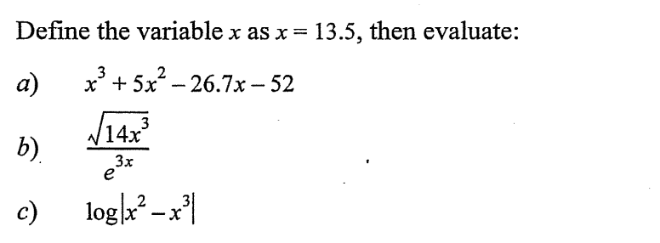

Answer1:
a)

b)

c)

Question2:
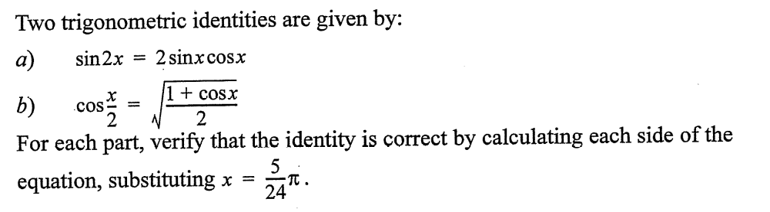

Answer2:
a)

b)

Question3:
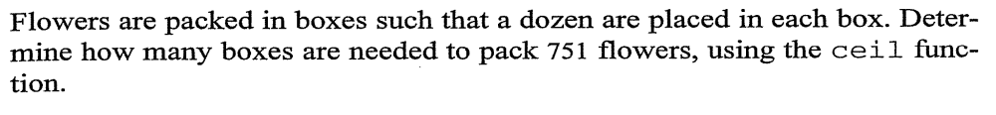
Answer3:

Question4:
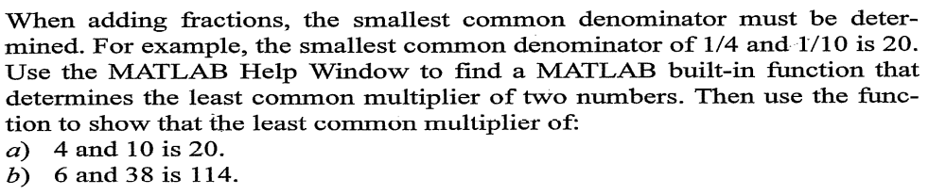
Answer4:
a)

b)

Question5:
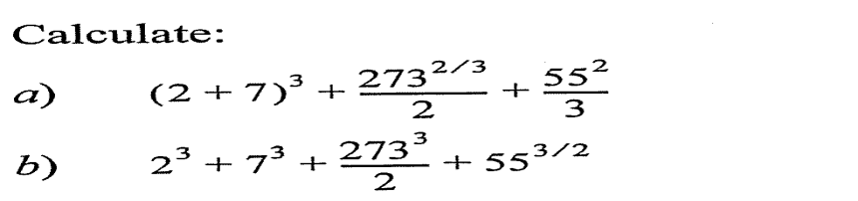

a)

b)

