EXERCISE 1: Load NYC contagious disease data set
EXERCISE 2: Create variables for various rows and columns
- Define a variable called mumps1942 that contains the case counts of mumps for the year 1942.
- Define a variable called measlesApril that contains case counts of measles for the month of April.
- Define a variable called chickenPoxSummer that contains the case counts of chicken pox for the summer months (June, July, and August).
EXERCISE 3: Plot mumps cases for 1942 in a new figure. Label your axes and gave a proper table title.
EXERCISE 4: Plot mumps cases for 1942, rescaling y.
EXERCISE 5: Plot April measles cases, giving x values explicitly.
EXERCISE 6: Plot mumps1942 and mumps1943 cases on same graph.
EXERCISE 7:
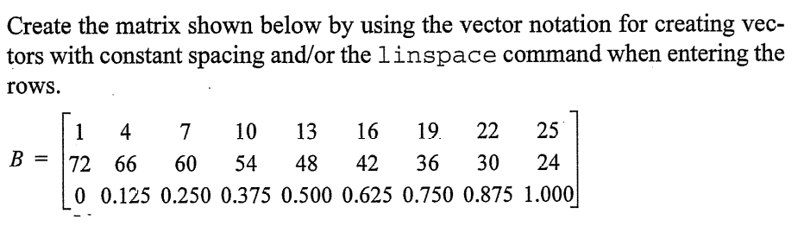
EXERCISE 8:
