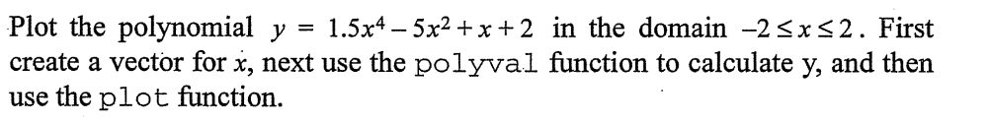
>> x=-3.2:0.3:7.9;
>> p=[1.5 0 -5 1 2];
>> y=polyval(p,x);
>> plot(y)

>> p1=[15 35 -37 -19 41 -15];
>> p2=[5 0 -4 3];
>> [q,r]=deconv(p1,p2)

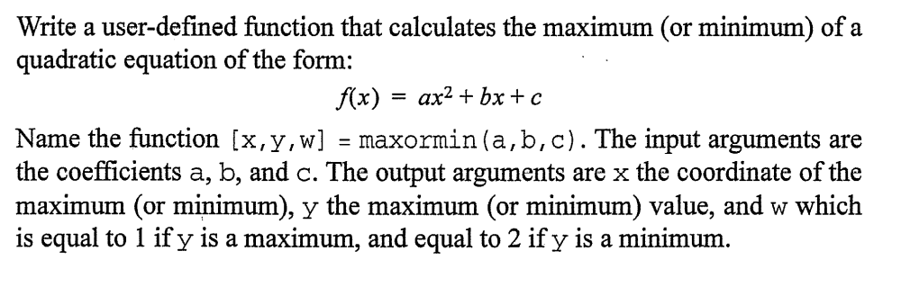
Ayrıca maxormin fonksiyonu m file olarak ödev klasörüne eklenmiştir
******
function [x,y,w]=maxormin(a,b,c)
maxorminVal=-b/(2*a);
if a>0
p=[a b c];
w=2;
x=maxorminVal; %the value of x in the coordinate system when it has min point
y=polyval(p,x); %obtained y with using x, in the coordinate system when it has min point
coordOfPoint=[x,y]; %coordinates of the minimum point
end
if a<0
p=[a b c];
w=1;
x=maxorminVal; %the value of x in the coordinate system when it has max point
y=polyval(p,x); %obtained y with using x, in the coordinate system when it has max point
coordOfPoint=[x,y]; %coordinates of the maximum point
end
if a==0
disp('a is the neccessary coeffient!!')
end

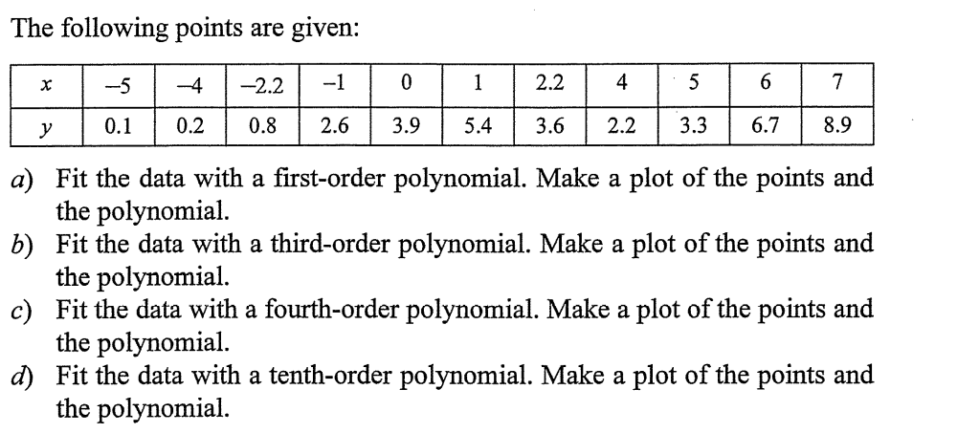
>> x=[-5 -4 -2.2 -1 0 1 2.2 4 5 6 7];
>> y=[0.1 0.2 0.8 2.6 3.9 5.4 3.6 2.2 3.3 6.7 8.9];
>> p=polyfit(x,y,1)
>> p=polyfit(x,y,3)
>> p=polyfit(x,y,4)
>> p=polyfit(x,y,10)

