Foundation Models for Visual Place Recognition in Mid-Sized Anatolian Cities: A Systematic Evaluation of DINOv2-Based Pipelines on Kırşehir

Abstract
Visual place recognition (VPR) has advanced rapidly with the rise of self-supervised foundation models, yet benchmarks remain geographically concentrated on large Western and East Asian cities. Whether the design choices established on these benchmarks transfer to mid-sized, architecturally homogeneous cities outside this distribution is an open question. This study presents a systematic empirical evaluation of a DINOv2-based two-stage VPR pipeline on Kırşehir, a mid-sized Anatolian city in Central Turkey, and examines how its main design choices — partial fine-tuning, pooling strategy, local-feature re-ranking, and backbone size — behave under this visual regime. We constructed a Google Street View dataset of 26,220 images captured at 6,555 unique coordinate points on 654 streets with four cardinal headings per point, covering approximately 28.80 km². The dataset was partitioned via a 0.002°-resolution grid-based geographic split into 18,140 training, 6,060 database, and 2,020 query images. The pipeline combines a partially fine-tuned DINOv2 ViT-B/14 backbone (last four Transformer blocks unfrozen) with Generalized Mean (GeM) pooling and a 512-dimensional projection head, trained under Multi-Similarity Loss with hard negative mining, followed by an ALIKED + LightGlue local-matching re-ranking stage. Controlled ablations isolated the contributions of the loss function, the pooling strategy, the backbone size, and two re-ranking criteria. Partial fine-tuning improved Top-1 street-name accuracy from 56.14% (frozen DINOv2) to 74.70% and reduced the median localization error from 49.8 m to 8.2 m. Contrary to the common assumption in the VPR literature, a CLS-token variant slightly outperformed the GeM-pooled main model (76.58% vs. 74.70% street accuracy; 5.3 m vs. 8.2 m median error). LightGlue-based re-ranking degraded the output of the global descriptor in every configuration tested — uniform application dropped street accuracy to 48.32–49.41%, and a conditional pipeline produced a monotonic performance decline across six confidence thresholds. The ViT-S/14 variant retained 94.5% of the R@1<100 m performance of ViT-B/14 while using 25.6% of the parameters and 34.3% of the single-image inference time on an NVIDIA L4 GPU. A spatial error analysis attributed 16.2% of errors to high-confidence perceptual aliasing concentrated on repetitive residential streets and the long-tail errors to database-sparsity effects. Conclusions. Foundation-model-based VPR delivers strong single-city performance on this under-represented urban setting when the last few Transformer blocks are fine-tuned, but several design choices considered optimal on large Western benchmarks — GeM pooling over CLS aggregation and local-feature re-ranking as a default second stage — do not transfer. A single-stage ViT-S/14 pipeline offers a favorable accuracy–efficiency trade-off for deployment-oriented systems. The reported negative result on LightGlue re-ranking highlights the need for city-specific empirical validation of standard VPR design patterns.
Keywords: Visual place recognition; foundation models; DINOv2; fine-tuning; GeM pooling; LightGlue; re-ranking; vision transformer; Google Street View; computer vision, machine learning.

Introduction
Visual place recognition (VPR) is the task of estimating where an image was taken by matching it against a geo-referenced database (Lowry et al. 2015). It is a core component of mobile robotics, autonomous driving, augmented reality, and geo-referenced media indexing, and it is one of the few localization modalities that can function in GPS-denied environments such as dense urban canyons, indoor spaces, and tunnels. The last decade has seen a rapid evolution of VPR methods, from bag-of-words and VLAD aggregation of hand-crafted descriptors (Cummins & Newman 2008), through learned CNN-based global descriptors such as NetVLAD (Arandjelovic et al. 2016), to large-scale classification-based training schemes (Berton et al. 2022) and, most recently, the adoption of foundation models as backbones (Oquab et al. 2023).
Despite this progress, VPR benchmarks have remained geographically concentrated. The widely used Pittsburgh30k, Tokyo24/7, and Mapillary Street-Level Sequences (MSLS) datasets cover predominantly North American, Japanese, and globally distributed but photographer-curated urban imagery (Arandjelovic et al. 2016; Torii et al. 2015; Warburg et al. 2020), and the main large-scale training datasets — San Francisco eXtra Large (SF-XL) and GSV-Cities — center on North American and major-city imagery (Berton et al. 2022). Studies that validate VPR methods on mid-sized, non-Western, architecturally homogeneous cities remain scarce, which has two related consequences. First, it is difficult to assess how well the design choices established on these benchmarks generalize to the urban distribution in which many practical deployments would occur — Anatolian, Balkan, Middle Eastern, or Central Asian cities that share a distinctive built-environment profile. Second, negative or contradictory results on such cities are largely invisible, which can produce an inflated sense of how well standard two-stage pipelines transfer across contexts.
This paper contributes a systematic empirical study of foundation-model-based visual place recognition on Kırşehir, a mid-sized Anatolian city in Central Turkey, with three characteristic properties that make it a useful stress test for standard VPR methodology: (i) a compact urban core of approximately 28.80 km² with limited topographic variation, (ii) a building stock dominated by repetitive low-to-mid-rise residential facades, sharing a narrow stylistic vocabulary, and (iii) dense narrow-street geometry in which cross-street visual differences are fine-grained rather than categorical. These properties amplify the fine-grained retrieval problem and make Kırşehir a challenging test bed for a class of methods that were designed and validated under considerably different visual statistics.
Motivated by the observations above, the present study is organized around four research questions.
RQ1 — Adaptation. How much of the performance of a DINOv2-based VPR pipeline on a mid-sized, architecturally homogeneous Anatolian city is contributed by the pre-trained foundation model itself, and how much by fine-tuning on a city-specific dataset? Specifically, what is the gap between a frozen DINOv2 feature extractor and a partially fine-tuned one, and is the gap uniform across recall thresholds?
RQ2 — Design Choices. On such a dataset, do the default design choices of foundation-model-based VPR — patch-level GeM pooling and Multi-Similarity Loss — dominate alternatives in a controlled ablation? In particular, how does CLS-token aggregation compare with GeM pooling when both are trained under identical conditions?
RQ3 — Re-Ranking. Does a standard LightGlue-based re-ranking stage improve upon a well-adapted global descriptor on Google Street View imagery of a small Anatolian city, and if not, what are the structural reasons for the discrepancy with results reported on large urban benchmarks?
RQ4 — Efficiency. What is the accuracy–efficiency trade-off between the ViT-S/14 and ViT-B/14 variants of DINOv2 under the identical fine-tuning protocol, and does the smaller backbone preserve the dominant patterns observed with the larger one?
This paper makes the following contributions.
(i) We construct and analyze a dedicated Google Street View dataset of Kırşehir comprising 26,220 images captured at 6,555 unique coordinate points across 654 streets, with four cardinal headings per point and an approximately 28.80 km² coverage area. The dataset is partitioned into training, database, and query sets using a grid-based geographic split that guards against spatial leakage between train and test.
(ii) We present a systematic evaluation of a two-stage DINOv2-based VPR pipeline on this dataset, including ablations over the loss function (Triplet vs. Multi-Similarity), the pooling strategy (patch-level GeM vs. CLS token), the backbone size (ViT-S/14 vs. ViT-B/14), and two criteria for LightGlue-based re-ranking (match count vs. a hybrid score).
(iii) We report and analyze a concrete negative result: on this dataset, LightGlue-based re-ranking consistently degrades the output of the fine-tuned global descriptor, whether applied uniformly or selectively to low-confidence queries. We identify three structural causes grounded in the properties of the imagery and the pipeline, and we position this finding as a domain-specific limitation of an otherwise well-established design pattern.
(iv) We show that the ViT-S/14 variant of DINOv2 retains 94.5% of the R@1<100 m performance of ViT-B/14 while using only 25.6% of the parameters and 34.3% of the single-image inference time, and we argue that this configuration is a defensible default for embedded and mobile deployment scenarios.
(v) We provide a detailed spatial and perceptual aliasing analysis that disentangles two distinct error regimes — high-confidence aliasing on repetitive residential streets, and long-tail errors driven by database sparsity — and we quantify their relative contributions to overall error.
The remainder of this paper is organized as follows. Section 2 describes the dataset and the train/database/query split protocol. Section 3 details the two-stage methodology, including the DINOv2 backbone, the fine-tuning procedure, the GeM-pooled projection head, the Multi-Similarity Loss training, and the ALIKED + LightGlue re-ranking stage. Section 4 presents the experimental results, including the main comparison, the conditional re-ranking pipeline, the ViT-S vs. ViT-B comparison, the confidence-rejection analysis, the computational cost, and the spatial and perceptual aliasing analyses. Section 5 discusses the findings in the context of existing literature and analyzes their probable causes. Section 6 concludes the paper with a summary of contributions and directions for future work.

Literature Review
Visual place recognition and its close relative visual geo-localization have been surveyed comprehensively in (Lowry et al. 2015). The field is typically organized around two design axes: the representation used to describe each place, and the matching strategy used to compare a query against the database. We briefly review progress along each axis, with an emphasis on developments relevant to the present study.
Early appearance-based approaches represented each place by a bag-of-words vector over hand-crafted local descriptors such as SIFT or SURF, with perceptual aliasing handled probabilistically (Cummins & Newman 2008). The introduction of learnable global descriptors, most notably NetVLAD (Arandjelovic et al. 2016), enabled end-to-end training from weakly supervised Street View tuples and produced substantial accuracy gains across standard benchmarks. Subsequent developments along this line include patch-level extensions that retain local spatial information (Hausler et al. 2021) (Patch-NetVLAD), feature-mixing aggregators that replace VLAD with all-MLP modules (Ali-Bey et al. 2023) (MixVPR), and large-scale classification-based training that avoids expensive mining (Berton et al. 2022) (CosPlace). Generalized Mean (GeM) pooling (Radenović et al. 2018) provides a learnable trade-off between average and max pooling over patch features and has become the dominant pooling choice for transformer-based VPR models.
Local feature matching has followed a parallel trajectory, from hand-crafted detectors and descriptors to learned keypoint–descriptor combinations such as ALIKED (Zhao et al. 2023) and graph-neural-network-based matchers such as LightGlue (Lindenberger et al. 2023). In two-stage VPR, a global descriptor is used to retrieve the Top-N candidates and a local matcher is then applied to re-rank them via geometric verification (Hausler et al. 2021). This global-then-local pipeline has become a de facto standard on benchmarks that exhibit strong viewpoint or appearance change (Sattler et al. 2018; Warburg et al. 2020), under the assumption that local matching can filter out candidates that are globally similar but geometrically inconsistent.
The most recent development relevant to this study is the emergence of visual foundation models — large self-supervised vision models pre-trained on broad data and adapted to a range of downstream tasks (Bommasani et al. 2021). The Vision Transformer architecture (Dosovitskiy et al. 2020) provides the backbone for most of these models, and DINOv2 (Oquab et al. 2023) has recently been established as a particularly strong self-supervised vision backbone, delivering competitive or state-of-the-art results across classification, segmentation, depth estimation, and retrieval. A growing body of work shows that adapting DINOv2 to VPR via partial fine-tuning, adapters, or lightweight projection heads yields strong performance on standard benchmarks (Berton et al. 2022; Oquab et al. 2023). However, the question of how such adaptation behaves on small, architecturally homogeneous, non-Western cities — the setting of interest here — has received comparatively little attention.
Alongside accuracy, practical VPR deployments are constrained by compute and memory (Lowry et al. 2015), and a large body of work on parameter-efficient adaptation has emerged to address these constraints, including Low-Rank Adaptation (Hu et al. 2022) and lightweight adapter modules. The trade-off between backbone capacity and deployment feasibility — studied here through a direct comparison of the ViT-S/14 and ViT-B/14 variants of DINOv2 — is therefore relevant both for production systems and for reducing the computational footprint of ongoing research. A parallel concern is the calibration of retrieval confidence, which remains poorly understood for deep models (Guo et al. 2017) and has direct implications for safety-critical deployment.

Method

3.1. System Overview
This study proposes a two-stage Visual Place Recognition (VPR) system for the city center of Kırşehir, Türkiye. The first stage is a retrieval module that extracts a global descriptor from a query image and performs vector search to obtain candidate locations. In this stage, the self-supervised vision foundation model DINOv2 (Oquab et al. 2023) is used as the backbone and is fine-tuned under a metric learning framework to capture the visual characteristics specific to Kırşehir. The second stage is designed to re-rank the Top-N candidates returned by the first stage using the local feature matcher LightGlue (Lindenberger et al. 2023). An overview of the proposed pipeline is shown in Figure 1.
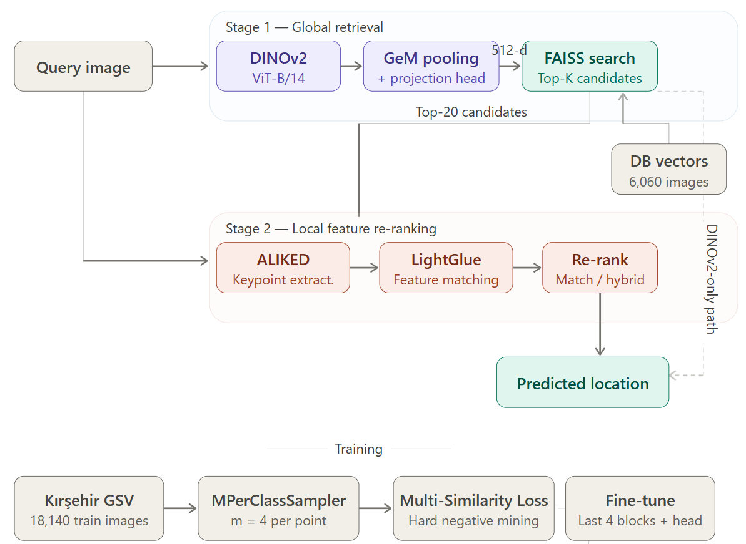
Figure 1. Overall pipeline of the proposed two-stage VPR system. Stage 1: DINOv2-based global descriptor extraction followed by FAISS-based Top-K retrieval. Stage 2: Local feature matching-based re-ranking with LightGlue.

3.2. Dataset

3.2.1. Data Collection
The dataset used in this study was constructed from the city center of Kırşehir using the Google Street View API. During acquisition, the street network was sampled at approximately 50-meter intervals, and at each sampled point four images were obtained corresponding to the four cardinal headings (North, 0°; East, 90°; South, 180°; West, 270°). Each image filename was structured to encode the geographic coordinates (latitude and longitude) and the heading angle, yielding a directly retrievable location label for every image. The resulting dataset covers 6,555 unique geographic points distributed across 654 distinct streets/avenues. The image resolution is fixed at 640 × 640 pixels. The spatial coverage is approximately 28.80 km² (6.10 km north–south and 4.72 km east–west). The geographic distribution of the dataset is shown in Figure 2.
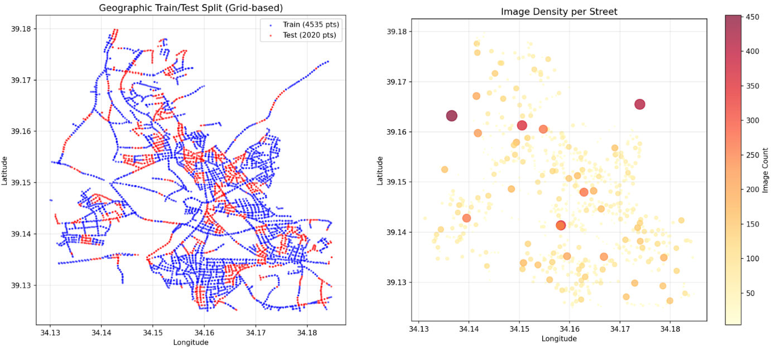
Figure 2. Geographic distribution of the Kırşehir VPR dataset. The left panel illustrates the grid-based train/test split (train in blue, test in red); the right panel shows the per-street image density across the city.

3.2.2. Train/Test Split
To eliminate the data leakage risk commonly encountered in VPR studies, images were partitioned into training and test sets using a geographic block-based (grid-based) scheme rather than random sampling. Each image was assigned to a grid cell of 0.002° side length (approximately 222 m). Of the 444 resulting grid blocks, 70% (310 blocks) were assigned to training and 30% (134 blocks) to testing. To ensure reproducibility, the assignment was performed with a fixed random seed (seed = 42). This strategy guarantees that the model is evaluated on geographic regions it has never seen during training.
Within the test set, a realistic VPR scenario was emulated by separating, at each coordinate point, the last recorded heading as the query and the remaining headings as database (DB) entries. The model is therefore required to retrieve a single-heading query against DB images taken at different headings of the same location. Points with fewer than two images were excluded from evaluation. After these operations, the final dataset consists of 18,140 training, 6,060 DB, and 2,020 query images. A summary of dataset statistics is provided in Table 1.
Table 1. Summary statistics of the Kırşehir VPR dataset.
Property | Value
Total number of images | 26,220
Unique geographic points | 6,555
Unique streets/avenues | 654
Images per point (N/E/S/W) | 4
Image resolution | 640 × 640 pixels
North–south coverage | 6.10 km
East–west coverage | 4.72 km
Approximate covered area | 28.80 km²
Grid cell size | 0.002° (≈ 222 m)
Total grid blocks | 444
Training blocks (70%) | 310
Test blocks (30%) | 134
Training images | 18,140
Database (DB) images | 6,060
Query images | 2,020

3.3. DINOv2-Based Global Descriptor (Stage 1)

3.3.1. Backbone Model
Global visual descriptors in the first stage are extracted with DINOv2 [1], a self-supervised vision foundation model pre-trained on large-scale curated image datasets, which is known to produce features with strong transferability. The main model uses the ViT-B/14 variant of DINOv2 (ViT-Base, 14 × 14 patch size). In addition, as part of the size–performance trade-off analysis, the ViT-S/14 variant (ViT-Small, 14 × 14) is trained under the same framework for comparison (see Section 3.6.3).

3.3.2. Feature Pooling and Projection Head
DINOv2 provides two standard representations: spatial patch tokens and a global classification (CLS) token. Because spatial cues such as building facades, window alignments, and street perspective are informative for VPR, the main model adopts Generalized Mean (GeM) pooling over the patch tokens (Radenović et al. 2018) to preserve this spatial information. The GeM pooling operation is defined in Equation (1):
f_GeM = ( (1/N) Σᵢ xᵢᵖ )^(1/p) (1)
Here xᵢ denotes the activations of the patch tokens, N the number of patches, and p ≥ 1 a learnable exponent. In this study p is initialized at 3 and updated jointly with the other network parameters during training.
Following GeM pooling, the resulting embedding is mapped through a projection head to the final 512-dimensional descriptor. The projection head is a two-layer block consisting of Linear → BatchNorm → ReLU → Linear. An L2-normalization is applied at the output, producing a descriptor directly usable with cosine similarity-based search.
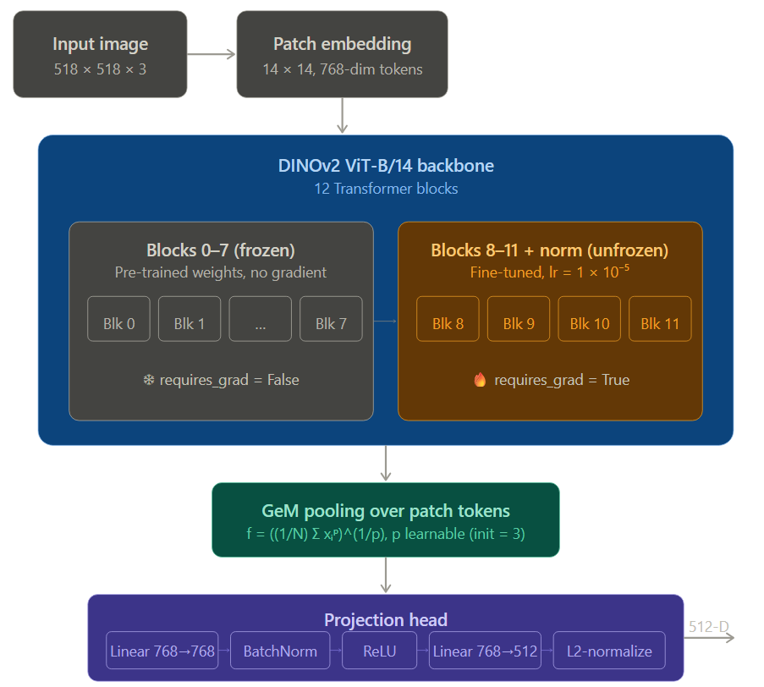
Figure 3. Block diagram of the proposed VPR-DINOv2 architecture. The last four Transformer blocks of the DINOv2 backbone are unfrozen; patch tokens are aggregated via GeM pooling and passed through a two-layer projection head to yield a 512-dimensional L2-normalized descriptor.

3.3.3. Partial Fine-Tuning
Fine-tuning all parameters of foundation models on a small dataset may lead to overfitting. To mitigate this risk, a partial fine-tuning strategy is employed. Out of the 12 Transformer blocks in DINOv2 ViT-B/14, only the last four (blocks.8, 9, 10, 11) along with the final normalization layer are unfrozen; all remaining backbone parameters are kept frozen. The projection head is initialized from scratch and trained end-to-end. This strategy preserves the general visual representational power of the backbone while allowing the final layers to adapt to the local architectural characteristics of Kırşehir. In the main model, 29,369,601 out of 87,566,337 total parameters (33.5%) are left trainable.

3.4. Metric Learning-Based Fine-Tuning

3.4.1. Retrieval Formulation
VPR is fundamentally a retrieval problem; thus, a metric learning formulation is adopted rather than standard multi-class classification. The objective is to learn a discriminative embedding space in which images from the same location are placed close together and images from different locations are placed apart. In the training set, each unique coordinate point (point_id) is treated as a class, and labels are transformed into integers via LabelEncoder. Under this formulation, every class in the training set contains exactly four examples (N/E/S/W headings).

3.4.2. MPerClassSampler
To enable heading-aware learning, MPerClassSampler (Musgrave et al. 2020) is used instead of a standard random sampler. This sampler guarantees that each training batch contains exactly m samples from the same class (same coordinate point). In this study, m = 4 is chosen so that the four cardinal headings of a given coordinate are forced into the same batch. This allows the metric learning loss to directly assess the relationships between different headings of the same location.

3.4.3. Multi-Similarity Loss and Hard Negative Mining
The Multi-Similarity (MS) Loss (Wang et al. 2019) is used as the training objective. Unlike the classical Triplet loss, MS Loss evaluates all pairs within a batch using similarity-aware weighting and emphasizes the hardest positive and negative pairs. This property is crucial for the model to distinguish visually similar but geographically distinct streets (the perceptual aliasing problem). The MS Loss parameters are set to α = 2, β = 50, and base = 0.5; hard pair mining is performed with a MultiSimilarityMiner whose ε parameter is set to 0.1.

3.4.4. Optimization and Training Protocol
Training is performed with differential learning rates: trainable parameters within the DINOv2 backbone are updated with a learning rate of 1 × 10⁻⁵, whereas the randomly initialized projection head is updated with 1 × 10⁻⁴. This choice aims to prevent catastrophic forgetting of the pre-trained representations in the backbone. The Adam optimizer is used with a batch size of 32 and a total of 5 epochs. Input images are resized to 518 × 518 pixels (a multiple of DINOv2's patch size of 14) and normalized using the standard ImageNet mean and standard deviation. Data augmentation is restricted to color-based ColorJitter (brightness = 0.3, contrast = 0.3, saturation = 0.3); geometric augmentations are deliberately avoided because they would distort the geographic consistency critical to VPR. All hyperparameters are summarized in Table 2.
Table 2. Hyperparameters used for DINOv2 fine-tuning.
Hyperparameter | Value
Input image size | 518 × 518 pixels
Output embedding dimension | 512
Batch size | 32
Number of epochs | 5
Optimizer | Adam
Learning rate (backbone) | 1 × 10⁻⁵
Learning rate (projection head) | 1 × 10⁻⁴
Loss function | Multi-Similarity Loss
MS Loss parameters | α = 2, β = 50, base = 0.5
Hard Negative Miner ε | 0.1
MPerClassSampler m | 4 (heading count)
Unfrozen Transformer blocks | Last 4 blocks (8–11) + norm
Data augmentation | ColorJitter (0.3 / 0.3 / 0.3)
Random seed | 42

3.5. Vector Database and Global Retrieval
After fine-tuning, the model is switched to inference mode and used to generate 512-dimensional embeddings for all images in the DB and query sets. DB embeddings are L2-normalized and indexed using the IndexFlatIP structure from the Facebook AI Similarity Search (FAISS) library (Douze et al. 2025). Because L2-normalized vectors yield an inner product equal to the cosine similarity, this indexing choice enables cosine-based search with constant-cost inner-product computation. For each query, the K nearest candidates are retrieved with a single dot-product search.

3.6. Comparative Experimental Framework
To isolate the contribution of the main model and quantify the effect of individual architectural choices, additional experiments are organized under four themes. All of these experiments use the same data split, the same random seed, and the same evaluation set as the main model.

3.6.1. Baseline: Frozen DINOv2
To quantify the contribution of fine-tuning, a baseline model is constructed in which all parameters of the DINOv2 backbone are frozen and only the projection head is trained. This baseline uses GeM pooling, MS Loss, and identical training conditions to the main model. It therefore measures the performance attainable with off-the-shelf DINOv2 representations without any adaptation to the Kırşehir dataset.

3.6.2. Ablation Studies
Two core design decisions of the main model — the pooling strategy and the loss function — are examined through ablations.
CLS token vs. GeM pooling: A variant is trained in which the CLS token of DINOv2 is used directly in place of GeM pooling. The GeM module is disabled while all other components (projection head, loss, optimizer) are held identical to the main model, thereby isolating the effect of spatial patch information against a global CLS summary for the VPR task.
Triplet Loss vs. Multi-Similarity Loss: A variant is trained in which MS Loss is replaced by the classical Triplet Margin Loss (Schroff et al. 2015). A Triplet Margin Miner (margin = 0.2, type_of_triplets = "hard") is used for hard triplet mining; all other components are held identical to the main model.

3.6.3. DINOv2 Variant Comparison: ViT-S/14 vs. ViT-B/14
To examine the size–performance trade-off, which is of practical relevance for deployment, the DINOv2 ViT-S/14 variant (ViT-Small, 384-dimensional backbone embedding, ≈ 22M parameters) is fine-tuned from scratch using the same protocol. In this model the last four blocks of the backbone are unfrozen, and the projection head maps the 384-dimensional backbone output to the shared 512-dimensional representation space. The size–speed–accuracy comparison additionally reports single-image inference time and on-disk model size.

3.6.4. Confidence-Based Rejection
The ability of a system to abstain when uncertain is valuable in practical deployments. To this end, a rejection mechanism based on the DINOv2 Top-1 cosine similarity score is introduced. A threshold θ is swept over [0.60, 0.95] with steps of 0.01; for each θ, (i) the coverage (fraction of accepted queries), (ii) the localization error computed only over accepted queries, and (iii) the Recall@K metrics are reported. This analysis also quantifies whether the cosine similarity score is a suitable signal for confidence calibration.

3.7. LightGlue-Based Local Feature Re-Ranking (Stage 2)

3.7.1. Local Feature Extraction and Matching
The second stage re-ranks the Top-N candidates from the first stage using local feature matching. ALIKED (Zhao et al. 2023) is used as the local keypoint extractor, and LightGlue (Lindenberger et al. 2023) is used as the matcher. ALIKED is an efficient learned keypoint extractor based on deformable convolutions; LightGlue is a graph neural network-based matcher that incorporates an adaptive stopping mechanism for runtime efficiency. For each image, at most 1,024 keypoints are extracted.

3.7.2. Ranking Criteria
To assess whether the number of matches alone is a sufficient ranking criterion at the output of LightGlue, two criteria are compared:
Match Count: Ranking based solely on the number of mutually matched keypoints.
Hybrid Score: A score defined by the product of the match count and the mean match confidence (matching score): score = num_matches × (1 + avg_confidence). This formulation reduces the advantage gained by candidates with many but low-confidence matches.

3.7.3. Conditional Two-Stage Pipeline
Local feature re-ranking carries a high computational cost. Applying LightGlue to all Top-N candidates for every query is undesirable in practical deployment scenarios. Therefore, a conditional (adaptive) two-stage pipeline is proposed: if the DINOv2 Top-1 cosine similarity score is greater than or equal to a threshold θ, the DINOv2 Top-1 prediction is accepted directly; otherwise, the Top-20 candidates are re-ranked with LightGlue and the new Top-1 is returned. Six threshold values (0.70, 0.75, 0.78, 0.80, 0.82, 0.85) are tested in the range [0.70, 0.85]. A reference condition in which LightGlue is applied uniformly to all queries (no threshold) is also reported for comparison.

3.8. Evaluation Metrics
System performance is reported in four groups of metrics:
Street-name accuracy: The fraction of queries whose Top-1 result matches the ground-truth street label. It is used as a semantic, label-level measure of correctness.
GPS localization error: The Haversine great-circle distance between the query coordinate and the Top-1 prediction coordinate, as defined in Equation (2). Both the median and the mean are reported.
d = 2R · arcsin( √( sin²(Δφ/2) + cos φ₁ · cos φ₂ · sin²(Δλ/2) ) ) (2)
Here R is the Earth's radius (6,371,000 m), φ and λ denote latitude and longitude respectively, and Δφ and Δλ denote their differences between query and prediction.
Threshold-based recall (Recall@1 at threshold): The fraction of queries whose Top-1 prediction error falls below a set of standard thresholds (25 m, 50 m, 100 m, 500 m). This is the standard evaluation metric in VPR literature.
Inference time: As part of the computational cost analysis, single-image DINOv2 embedding time, per-query FAISS search time, and LightGlue re-ranking time (for 20 candidates) are measured separately.

3.9. Experimental Environment
All experiments are conducted in Google Colab on an NVIDIA L4 GPU (23.7 GB VRAM). The software stack consists of PyTorch (DINOv2 is loaded via torch.hub), pytorch-metric-learning (Multi-Similarity and Triplet losses, MPerClassSampler), FAISS-CPU (vector search), the official LightGlue and ALIKED implementations, scikit-learn (LabelEncoder), and folium (geographic visualization). For reproducibility, the random seeds of Python, NumPy, and PyTorch are fixed at 42.

Result
4.1. Overview
This section reports the experimental outcomes obtained on the Kırşehir VPR dataset, which comprises 18,140 training, 6,060 database, and 2,020 query images. Results are organized in five subsections. Section 4.2 presents the main comparison among the frozen baseline, the two ablation variants, the proposed main model, and two LightGlue re-ranking variants. Section 4.3 reports the conditional re-ranking pipeline. Section 4.4 compares the ViT-S/14 and ViT-B/14 variants of DINOv2 under the size–performance trade-off. Section 4.5 presents the confidence-based rejection analysis. Section 4.6 reports the computational cost of each stage, and Section 4.7 provides the error and perceptual aliasing analyses.
4.2. Main Comparison and Ablation Results
Table 3 summarizes the performance of all evaluated methods on the identical query set. Several patterns emerge from these results. First, fine-tuning a subset of DINOv2 parameters on the Kırşehir dataset yields a substantial improvement over the frozen baseline. The main model reaches 74.70% street-name accuracy and an 8.2 m median localization error, compared to 56.14% and 49.8 m obtained by the frozen variant. The relative improvement is particularly pronounced at tighter recall thresholds: R@1 <25 m rises from 39.01% to 61.73%, indicating that fine-tuning is essential for obtaining near-metric localization accuracy. Second, the two ablation variants remain competitive but exhibit distinct trade-offs. Replacing MS Loss with the classical Triplet Loss degrades performance across all metrics (median error increases from 8.2 m to 12.3 m, R@1 <100 m decreases from 81.24% to 78.02%), which is consistent with the known advantage of multi-pair weighting over single-triplet supervision in fine-grained retrieval (Wang et al., 2019). Third, and more unexpectedly, the CLS-token variant slightly outperforms the GeM-pooling main model (76.58% vs. 74.70% street accuracy; 5.3 m vs. 8.2 m median error). This result deviates from the prevailing assumption in the VPR literature that spatially pooled patch tokens carry more discriminative information than global class tokens, and is further discussed in Section 5.
In contrast, the LightGlue re-ranking stage does not improve upon the Stage-1 output when applied uniformly to all queries. Both the match-count and hybrid-score ranking criteria lead to a pronounced drop in performance: street-name accuracy falls from 74.70% to 48.32–49.41%, median error grows from 8.2 m to 60.4–64.8 m, and R@1 <100 m drops from 81.24% to 56.78–58.17%. This outcome, although contrary to the typical global-then-local VPR design (Hausler et al. 2021), is consistent across both ranking criteria and is stable throughout the full test set of 2,020 queries. A more detailed analysis of this phenomenon is presented through the conditional pipeline results in Section 4.3.
Table 3. Main comparison of evaluated methods on the 2,020-query test set.
Method | Street Acc. (%) | Median Err. (m) | R@1 <25 m | R@1 <50 m | R@1 <100 m | R@1 <500 m | Notes
Frozen DINOv2 (head only) | 56.14 | 49.8 | 39.01 | 52.23 | 64.11 | 81.34 | Baseline
DINOv2 + Triplet Loss | 71.04 | 12.3 | 58.32 | 68.71 | 78.02 | 90.35 | Ablation (loss)
DINOv2 + CLS token | 76.58 | 5.3 | 64.90 | 75.89 | 83.71 | 91.73 | Ablation (pooling)
DINOv2 + GeM + MS Loss (main) | 74.70 | 8.2 | 61.73 | 71.88 | 81.24 | 91.39 | Main model
+ LightGlue (Match Count) | 48.32 | 64.8 | 31.29 | 44.95 | 56.78 | 76.53 | Re-rank (all)
+ LightGlue (Hybrid Score) | 49.41 | 60.4 | 32.33 | 46.24 | 58.17 | 77.13 | Re-rank (all)

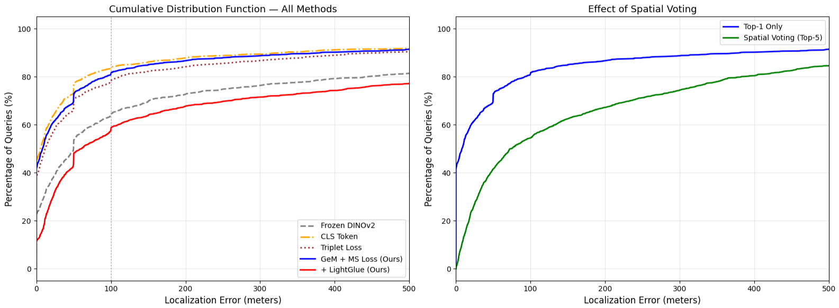
Figure 4. Cumulative distribution functions (CDFs) of Top-1 localization errors. Left: comparison across all methods, showing the clear advantage of fine-tuned variants over the frozen baseline and the underperformance of uniform LightGlue re-ranking. Right: comparison between Top-1 retrieval and Top-5 Spatial Voting applied to the main model. Spatial Voting systematically degrades the result, indicating that the ranks beyond Top-1 are not sufficiently reliable to support coordinate averaging.
4.3. Conditional Two-Stage Pipeline
Given the negative effect of uniform LightGlue re-ranking reported in Section 4.2, we investigate whether re-ranking can be applied selectively to low-confidence queries only. Table 4 reports the conditional pipeline for six threshold values θ ∈ (0.70, 0.75, 0.78, 0.80, 0.82, 0.85). For each θ, queries with a DINOv2 Top-1 cosine similarity score ≥ θ are accepted directly, and the remaining queries are re-ranked with LightGlue over the Top-20 candidates. The proportion of queries subjected to LightGlue grows from 0.9% (19/2,020) at θ = 0.70 to 53.8% (1,087/2,020) at θ = 0.85.
Across all tested thresholds, the conditional pipeline yields either a marginal or a larger decrease in performance relative to DINOv2-only. At θ = 0.70, where fewer than 1% of queries are re-ranked, the outcome is almost identical to the baseline (81.09% vs. 81.24% R@1 <100 m; −0.15 percentage points). As θ increases and more queries are routed to LightGlue, performance degrades monotonically, reaching 66.83% R@1 <100 m at θ = 0.85 — a 14.4 percentage-point reduction relative to the main model. Median localization error exhibits the same monotonic trend (8.2 m → 36.8 m). These results imply that, on this dataset, LightGlue-based re-ranking is harmful to the output of the first stage irrespective of whether it is applied to high- or low-confidence queries. In other words, the local geometric cues captured by ALIKED + LightGlue on Google Street View imagery cannot improve upon the global semantic representation produced by the fine-tuned DINOv2 model. Potential causes for this behavior are discussed in Section 5.
Table 4. Conditional pipeline results. θ is the DINOv2 Top-1 cosine similarity threshold; queries with scores below θ are re-ranked with LightGlue. The first row corresponds to DINOv2-only without any re-ranking.
θ | DINOv2 kept | LG applied | LG % | Street Acc. (%) | Median Err. (m) | R@1 <25 m | R@1 <100 m | R@1 <500 m
— | 2020 | 0 | 0.0 | 74.70 | 8.2 | 61.68 | 81.24 | 91.39
0.70 | 2001 | 19 | 0.9 | 74.50 | 8.5 | 61.58 | 81.09 | 91.34
0.75 | 1919 | 101 | 5.0 | 73.32 | 9.8 | 60.54 | 80.15 | 90.30
0.78 | 1786 | 234 | 11.6 | 71.63 | 11.2 | 58.56 | 78.07 | 88.76
0.80 | 1626 | 394 | 19.5 | 69.36 | 14.6 | 56.14 | 75.69 | 87.28
0.82 | 1413 | 607 | 30.0 | 66.49 | 19.2 | 53.17 | 72.72 | 85.59
0.85 | 933 | 1087 | 53.8 | 59.80 | 36.8 | 45.30 | 66.83 | 81.83

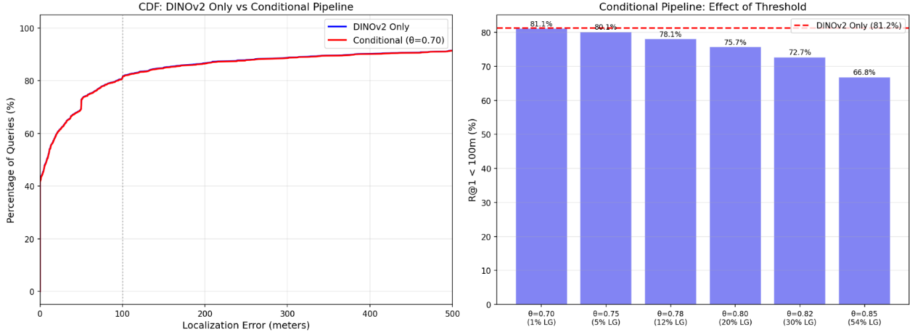
Figure 5. Conditional pipeline analysis. Left: the CDFs of DINOv2-only and the best conditional configuration (θ = 0.70) are nearly indistinguishable, confirming that limited LightGlue intervention cannot improve the baseline. Right: monotonic degradation of R@1 <100 m as the fraction of queries routed to LightGlue increases.
4.4. DINOv2 Variant Comparison: ViT-S/14 vs. ViT-B/14
Table 5 summarizes the comparison between the ViT-S/14 and ViT-B/14 variants of DINOv2 under the identical fine-tuning protocol. The ViT-S/14 model contains 22,402,305 parameters and occupies 85.5 MB on disk, corresponding to 25.6% of the parameter count and 25.6% of the storage footprint of the ViT-B/14 model. With this reduced capacity, the ViT-S/14 variant achieves 69.80% street-name accuracy, a 13.2 m median error, and 76.73% R@1 <100 m. Relative to the ViT-B/14 main model (74.70% / 8.2 m / 81.24%), the smaller backbone recovers 94.5% of the R@1 <100 m performance while reducing the median single-image inference time from 37.6 ms to 12.9 ms on the NVIDIA L4 GPU — a 2.9× speed-up. This trade-off is particularly relevant for deployment scenarios in which memory or real-time latency budgets are constrained.
Table 5. Comparison of DINOv2 ViT-S/14 and ViT-B/14 under the identical fine-tuning protocol.
Metric | ViT-S/14 | ViT-B/14
Backbone architecture | ViT-Small (384-dim) | ViT-Base (768-dim)
Total parameters | 22,402,305 | 87,566,337
On-disk model size | 85.5 MB | 334.1 MB
Single-image inference (median) | 12.9 ms | 37.6 ms
Street-name accuracy (%) | 69.80 | 74.70
Median localization error (m) | 13.2 | 8.2
Mean localization error (m) | 229.6 | 179.6
R@1 <25 m (%) | 56.83 | 61.68
R@1 <50 m (%) | 67.77 | 71.78
R@1 <100 m (%) | 76.73 | 81.24
R@1 <500 m (%) | 88.76 | 91.39

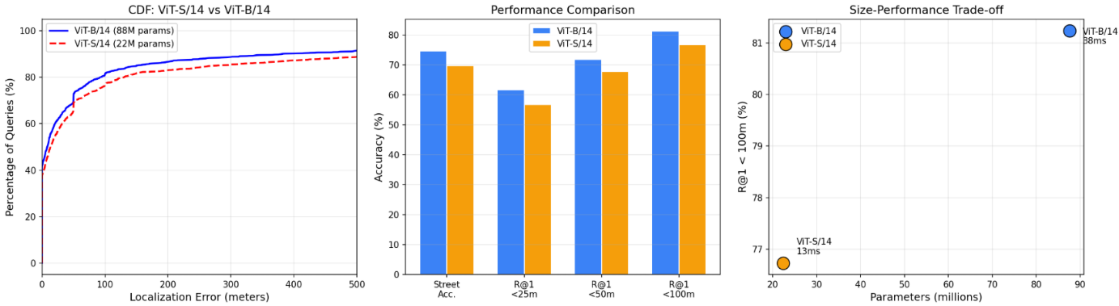
Figure 6. DINOv2 variant comparison. Left: CDF of Top-1 localization errors. Center: per-metric bar comparison. Right: size–performance scatter, in which the ViT-S/14 model preserves 94.5% of the ViT-B/14 performance (R@1 <100 m) while using 25.6% of the parameters.
4.5. Confidence-Based Rejection
The confidence-based rejection analysis sweeps the DINOv2 Top-1 cosine similarity threshold θ across the interval [0.60, 0.95]. The observed score distribution for the 2,020 queries is tightly concentrated in [0.65, 0.95] (Figure 7, right), with no query scoring below 0.66. As a result, thresholds θ ≤ 0.60 retain 100% coverage and yield the baseline metrics of the main model (74.70% street accuracy, 8.2 m median error, 81.24% R@1 <100 m). Increasing θ beyond 0.70 progressively reduces coverage; however, the corresponding gain in accuracy among accepted queries is negligible. The accuracy–coverage trade-off curve (Figure 7, left) is essentially flat across the entire coverage range between approximately 20% and 100%, with R@1 <100 m remaining within a 3–5 percentage-point band. The median error curve (Figure 7, middle) likewise remains near the baseline value of 8 m up to θ ≈ 0.93 and only rises when fewer than ∼10% of queries are accepted. Quantitatively, the automatically selected operating point — chosen by maximizing the harmonic mean of coverage and R@1 <100 m — coincides with θ = 0.60 at full coverage, indicating that no confidence threshold improves upon accepting all queries.
This result suggests that the cosine similarity between the query descriptor and its nearest database neighbor is not a well-calibrated confidence signal for the fine-tuned DINOv2 model on this dataset. The distribution of scores is narrow and largely overlaps between correct and incorrect predictions (see the score-distribution analysis in Section 4.7), which limits the usefulness of score-based rejection. Calibration-aware confidence estimation is therefore identified as a direction for future work.
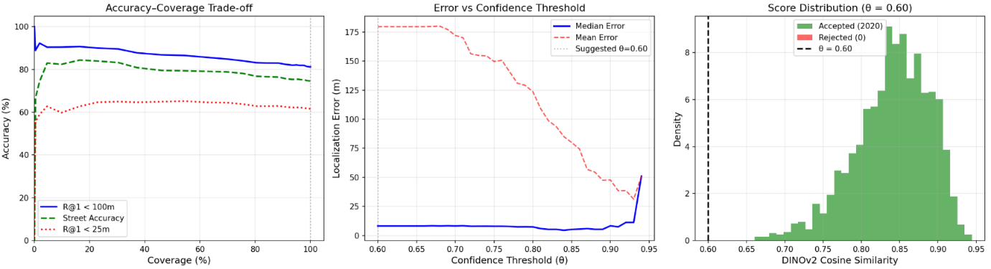
Figure 7. Confidence-based rejection analysis. Left: accuracy–coverage trade-off showing that recall is essentially flat across a wide range of coverage values. Middle: median and mean localization errors remain close to the baseline up to θ ≈ 0.93. Right: the DINOv2 Top-1 score distribution is concentrated in [0.65, 0.95], leaving very few queries available for rejection at low thresholds.
4.6. Computational Cost
All runtime measurements were obtained on a single NVIDIA L4 GPU (23.7 GB VRAM) within the Google Colab environment. Table 6 summarizes the per-stage computational costs. For a single query, Stage 1 (DINOv2 embedding followed by FAISS Top-K search over 6,060 database vectors) takes approximately 36 ms with ViT-B/14 and about 13 ms with ViT-S/14. The FAISS search component itself contributes negligibly (0.064 ms per query), so the overall Stage-1 latency is dominated by the DINOv2 forward pass.
In contrast, a full Stage-2 pass — LightGlue re-ranking over 20 candidates — requires 0.38 s on average per query, roughly an order of magnitude more than Stage 1. Database preparation (embedding extraction for 6,060 images) takes approximately 4 min 24 s with ViT-B/14 and is a one-time offline cost. Considering that Stage-2 re-ranking did not improve recall on this dataset (Sections 4.2–4.3), these measurements provide a useful quantitative argument for preferring a Stage-1-only deployment.
Table 6. Per-stage computational cost on an NVIDIA L4 GPU.
Stage / Operation | Time
Stage 1 — DINOv2 embedding (single image, ViT-B/14) | 35.9 ms (median)
Stage 1 — DINOv2 embedding (single image, ViT-S/14) | 12.9 ms (median)
Stage 1 — DB embedding extraction (6,060 images, ViT-B/14) | 263.6 s
Stage 1 — FAISS search (single query, Top-10) | 0.064 ms
Stage 1 — Total pipeline (single query) | ≈ 36 ms
Stage 2 — LightGlue re-ranking (20 candidates, single query) | 0.38 s (avg.)

4.7. Error and Perceptual Aliasing Analysis
4.7.1. Error Distribution
The distribution of Top-1 localization errors for the main model is highly skewed: of the 2,020 queries, 1,207 (59.8%) have errors below 25 m, an additional 204 (10.1%) fall between 25 and 50 m, 191 (9.5%) between 50 and 100 m, 134 (6.6%) between 100 and 250 m, 71 (3.5%) between 250 and 500 m, and 174 (8.6%) exceed 500 m. The median error (8.2 m) therefore lies well below the mean (179.6 m), indicating a small but heavy-tailed subset of queries that are mislocalized by hundreds of meters. Among the 2,020 queries, 1,509 (74.7%) receive the correct street label as the Top-1 result and 511 (25.3%) do not. Figure 8 shows the error histogram together with the spatial distribution of correct and incorrect predictions across the city.
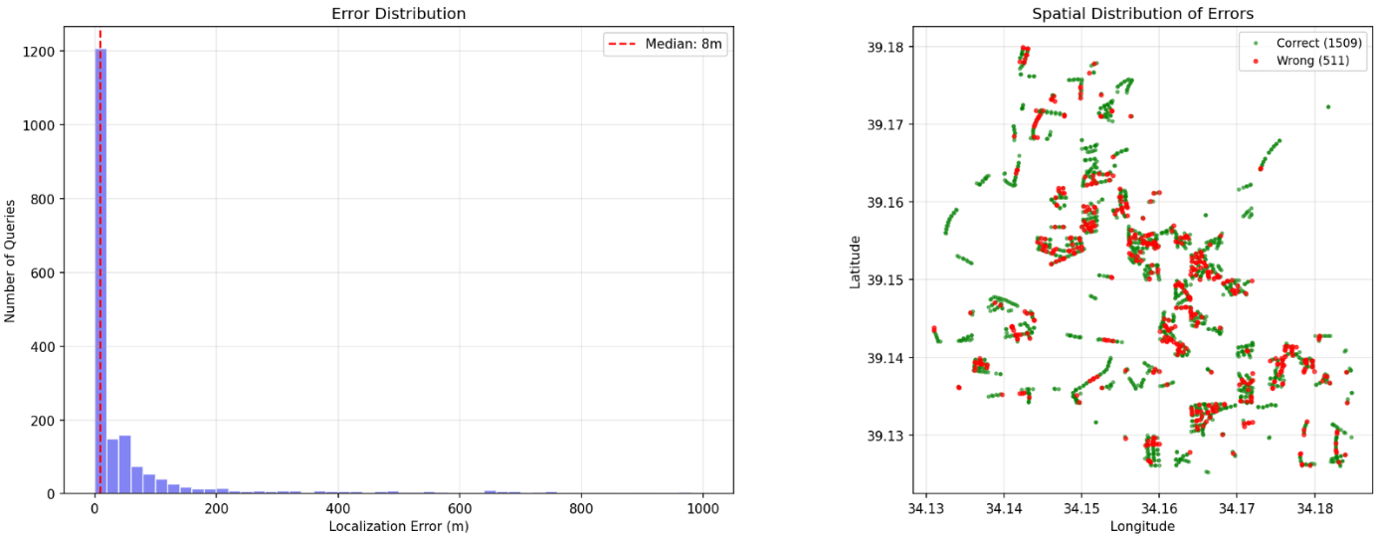
Figure 8. Error distribution of the main model. Left: histogram of Top-1 localization errors with a median of 8 m and a heavy right tail. Right: spatial distribution of correct (green) and incorrect (red) street predictions over the Kırşehir road network.
4.7.2. Per-Street Patterns
The per-street error analysis reveals a clear relationship between database density and localization accuracy. Streets with the lowest median errors (≤ 10 m) are those with high database coverage, such as 1090. Sokak (n = 30, 87% street-correct, median 8 m), Mustafa Kemal Paşa Caddesi (n = 9, 100% correct, 8 m), and Şehit Sahir Kurutluoğlu Caddesi (n = 24, 88% correct, 9 m). Conversely, the largest errors appear on streets represented by only one or a few query points — for example 1731. Sokak (n = 1, 3,982 m), 1396. Sokak (n = 1, 3,392 m), and Şehit Turgut İlanbey Caddesi (n = 1, 2,640 m). This pattern indicates that the model's performance is substantially more reliable on streets with denser database representation, whereas isolated, sparsely sampled points in the test blocks are at risk of being matched to visually similar streets far away.
A scatter plot of retrieval confidence versus error (Figure 9, left) further reveals that high cosine similarity scores do not guarantee small localization errors: a considerable fraction of queries with scores in the 0.85–0.95 range are nevertheless mislocalized by hundreds of meters. This observation motivates the perceptual aliasing analysis in the next subsection.
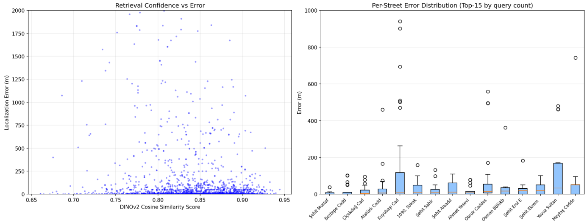
Figure 9. Relation between retrieval confidence and error (left) and per-street error distribution for the 15 streets with the most query examples (right).
4.7.3. Perceptual Aliasing
Perceptual aliasing is operationalized here as cases in which a query receives a Top-1 cosine similarity score in the upper quartile (> 0.877) but is nevertheless assigned to an incorrect street. Among the 511 incorrect predictions produced by the main model, 83 (16.2%) fall into this high-confidence subset. These high-confidence errors exhibit a median localization error of 59 m, substantially lower than the 258 m median of the low-confidence errors. In other words, perceptual aliasing produces a small but reliably near-miss category of confident misidentifications rather than gross mislocalizations.
The streets most affected by perceptual aliasing are predominantly narrow residential streets with repetitive building facades: 417. Sokak (3/4 queries, 75%), 452. Sokak (3/8, 38%), İkizarası Caddesi (3/8, 38%), 418. Sokak (3/9, 33%) and 720. Sokak (4/15, 27%). The most frequent confusion pairs (e.g., 603. Sokak → 606. Sokak, 283. Sokak → 282. Sokak, 418./417. Sokak → 452. Sokak) involve adjacent or nearby streets within the same residential block, which supports the interpretation that perceptual aliasing is primarily driven by locally homogeneous architectural styles rather than distant coincidences. Retrieval diversity analysis corroborates this view: within the Top-10 results, the median number of distinct streets is 3, 12.0% of queries return a single consistent street, and 27.0% return five or more different streets, reflecting the proportion of queries for which the model is unable to narrow down to a single place confidently.
Finally, the score distribution of correct versus incorrect predictions overlaps substantially across the range [0.75, 0.95] (Figure 10, left). Although the incorrect-prediction distribution is slightly shifted toward lower scores, the two distributions are not separable by a single threshold, which is the underlying reason that confidence-based rejection (Section 4.5) produces no accuracy gains.
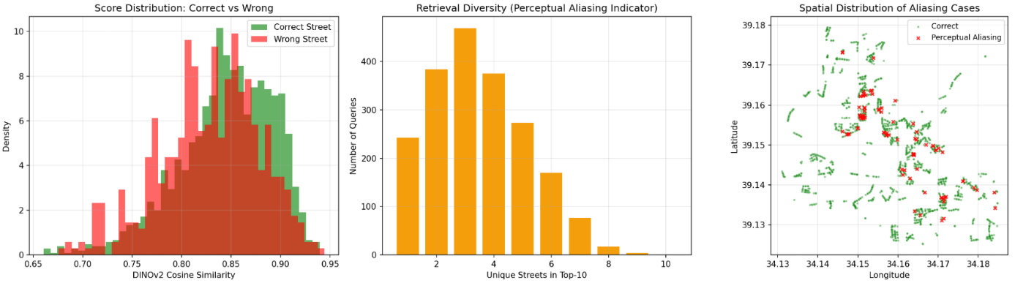
Figure 10. Perceptual aliasing analysis. Left: overlapping score distributions of correct and incorrect predictions. Middle: number of distinct streets appearing in the Top-10 results. Right: spatial concentration of high-confidence incorrect predictions in the central and southeastern residential areas of the city.
Discussion
5.1. Summary of Key Findings
The experimental evidence presented in Section 4 yields four principal findings that collectively shape the discussion of this study. First, partial fine-tuning of DINOv2 is highly effective: the main model achieves 81.24% Recall@1 at 100 m and an 8.2 m median localization error, improving upon the frozen baseline by 17.13 percentage points at the 100 m threshold and reducing the median error by a factor of six. Second, two architectural choices commonly considered critical for retrieval — patch-level GeM pooling and Multi-Similarity Loss — deliver competitive but not strictly dominant performance on this dataset: Multi-Similarity Loss outperforms Triplet Loss as expected (Wang et al. 2019), whereas, unexpectedly, the CLS-token variant slightly surpasses the GeM-pooled main model. Third, the two-stage pipeline with LightGlue-based re-ranking degrades performance in every configuration tested, whether applied uniformly or only to low-confidence queries. Fourth, the ViT-S/14 variant retains 94.5% of the ViT-B/14 R@1<100 m performance while using only 25.6% of its parameters and 34.3% of its inference time. The discussion below situates each of these findings within the literature and analyzes their probable causes and implications.
5.2. Why Does Partial Fine-Tuning Help So Much on This Dataset?
The large gap between the frozen DINOv2 baseline (56.14% street accuracy, 49.8 m median error) and the fine-tuned main model (74.70% street accuracy, 8.2 m median error) is considerably larger than gaps commonly reported on widely used VPR benchmarks such as Pittsburgh30k or Tokyo24/7 (Berton et al. 2022). We attribute this to the specific visual regime of the Kırşehir dataset. Kırşehir is a mid-sized Anatolian city dominated by repetitive low-to-mid-rise residential buildings, narrow side streets, and a relatively homogeneous architectural vocabulary. DINOv2 is pre-trained on a large and diverse corpus biased toward Western, English-speaking contexts (Oquab et al. 2023); as a consequence, its off-the-shelf features are descriptive but under-specialized for the fine-grained distinctions required in a small, architecturally uniform city. Unfreezing the last four Transformer blocks allows the model to remap its high-level visual tokens toward the architectural, material, and vegetation cues that separate Kırşehir streets, while leaving the lower-level representations intact. This interpretation is consistent with the general finding that parameter-efficient adaptation of foundation models to domain-shifted data is essential for strong downstream performance (Berton et al. 2022; Oquab et al. 2023).
5.3. CLS Token vs. GeM Pooling: An Unexpected Ablation Outcome
The prevailing assumption in the VPR literature is that spatially pooled patch tokens preserve more discriminative information than a single global CLS token (Hausler et al. 2021; Radenović et al. 2018). Our results partially contradict this expectation: the CLS-token variant achieves 76.58% street accuracy and 5.3 m median error against 74.70% and 8.2 m for the GeM-pooled main model. The gap, while small, is consistent across all Recall@K thresholds (Table 3), so it is unlikely to be an artefact of a single metric.
Several plausible factors explain this pattern. First, DINOv2 is explicitly trained with a discriminative self-supervised objective (DINO-style self-distillation combined with iBOT masked-image modeling) that produces a CLS token already well-positioned in the representational space (Oquab et al. 2023); in other transformer encoders without such training, the CLS token is often weaker than pooled patch features, but in DINOv2 it is a strong global descriptor in its own right. Second, the Kırşehir dataset exhibits limited intra-street spatial variation: within a single street segment at four cardinal headings, the patch-level statistics change substantially (e.g., one facade per image), while the semantic content (residential apartment blocks of similar style) remains consistent. A GeM-pooled representation may therefore absorb more heading-specific variance than is useful for cross-heading matching, whereas the CLS token provides a more heading-invariant summary. Third, our training schedule is short (5 epochs) and the patch-token GeM exponent is a learnable parameter; longer training may allow GeM to surpass CLS, but we did not observe clear signs of underfitting in the training loss, which plateaued after the third epoch. These observations suggest that the default choice of GeM pooling for DINOv2-based VPR should not be assumed to be strictly optimal, particularly on small, architecturally homogeneous cities; ablations against CLS pooling deserve routine inclusion in future studies.
5.4. Why Does LightGlue-Based Re-Ranking Degrade Performance?
The most striking negative result in this study is that LightGlue-based re-ranking harms performance in all configurations tested. Uniform re-ranking across the Top-20 candidates reduces street accuracy from 74.70% to 48.32–49.41%, and the conditional pipeline produces a monotonic degradation as the fraction of LightGlue-processed queries grows (Table 4). This outcome contrasts sharply with the well-documented advantages of two-stage global-then-local pipelines on standard VPR benchmarks (Hausler et al. 2021; Lindenberger et al. 2023), and therefore requires careful examination.
We identify three likely, non-mutually-exclusive causes. The first concerns the imagery itself. Google Street View images are produced by a multi-camera rig and are stitched from multiple physical sensors (Anguelov et al. 2010); they are geometrically re-projected and subjected to automatic white-balance and exposure normalization that differ across capture sessions. Local keypoint detectors such as ALIKED (Zhao et al. 2023) are sensitive to consistent local texture, and stitching seams, rolling-shutter artefacts, and automatic post-processing can introduce spurious keypoints. Once such keypoints dominate an image, they tend to match among themselves and produce high match counts that do not reflect the actual scene geometry.
The second concerns the content of Kırşehir street scenes. A large fraction of the dataset shows plastered apartment facades, uniform sidewalks, standardized road surfaces, commercial signage, and repetitive window grids. These structures are, by construction, textures that are locally self-similar, which is exactly the regime in which local keypoint matchers are known to produce confident but wrong matches (Sattler et al. 2018). In this regime, the number of matches between a query and a non-matching candidate (e.g., a similarly styled apartment on a different street) can exceed the number of matches to the correct place if the correct place happens to be viewed from a different heading and therefore shares fewer directly comparable local features.
The third concerns the structure of the Top-N pool. On large benchmarks, Stage-1 retrieval typically returns several visually distinct candidates in its Top-N, among which the correct one can be isolated by geometric verification. On Kırşehir, the first-stage output is already tightly tuned to the target (81.24% R@1 at 100 m), and the remaining 18.76% of Top-1 errors involve candidates that are either visually indistinguishable from the query (perceptual aliasing cases; Section 4.7.3) or located in under-sampled regions of the database. In both cases, local feature matching cannot recover the correct place because the information needed is not present in the geometry. Under these conditions, LightGlue's ranking based on match counts effectively re-randomizes a near-optimal ordering, which explains the consistent performance drop. Our hybrid-score variant — which reduces the advantage of low-confidence matches — partially mitigates but does not reverse the effect (Table 3).
Taken together, these observations do not imply that two-stage pipelines are inherently inappropriate for VPR, but rather that local geometric verification is most useful when Stage-1 retrieval is weaker than Stage-2 geometric reasoning. On this dataset, the opposite holds: the fine-tuned DINOv2 descriptor is stronger than the ALIKED+LightGlue evidence it could be re-ranked with. This finding aligns with recent work showing that for sufficiently well-adapted global descriptors, simpler single-stage pipelines can outperform heavier re-ranking schemes in practical deployments (Ali-Bey et al. 2023).
5.5. Cosine Similarity Is Not a Usable Confidence Signal Here
The confidence-based rejection analysis in Section 4.5 shows that sweeping the Top-1 cosine similarity threshold across [0.60, 0.95] does not produce a coverage range in which rejected queries are systematically worse than accepted ones. The accuracy–coverage curve is nearly flat and the automatically selected operating point coincides with accepting all queries. The underlying reason is visible in the score distributions (Section 4.7.3): the DINOv2 scores of correctly and incorrectly localized queries overlap heavily between 0.75 and 0.95, with only a modest shift in their means.
This behavior is a symptom of the broader problem of confidence calibration in deep retrieval models. Cosine similarity is a convenient proxy for similarity but is not a well-calibrated posterior probability, and this discrepancy is known to persist after standard metric-learning fine-tuning (Guo et al., 2017). For safety-critical deployments — such as autonomous navigation or emergency response — a more principled confidence estimator is necessary. Candidate approaches include geometric verification applied selectively to high-risk queries, ensemble disagreement across multiple descriptor heads, and explicit calibration via temperature scaling or conformal prediction. None of these were evaluated in the present study and they constitute a natural next step.
5.6. Size–Performance Trade-off: The Case for ViT-S/14
The comparison between ViT-S/14 and ViT-B/14 (Table 5) is arguably the most practically important result of this study. ViT-S/14 retains 94.5% of the R@1<100 m performance of ViT-B/14 while using 25.6% of the parameters and 34.3% of the single-image inference time on identical hardware. For deployment on embedded systems, in-vehicle compute units, or mobile devices — all of which are the canonical target platforms for VPR (Lowry et al. 2015) — this trade-off is highly favorable. The observation is also consistent with the broader finding in representation learning that, for moderately sized downstream datasets, the marginal return of scaling backbone capacity diminishes quickly once the pre-training is strong (Oquab et al. 2023).
From a methodological standpoint, this result also has implications for research practice. Many recent VPR papers adopt the largest available DINOv2 variant by default; our results suggest that ViT-S/14 can serve as a viable proxy during development and ablation studies, substantially reducing compute requirements and iteration time without qualitatively changing the conclusions. The dominant failure modes observed on ViT-S/14 (perceptual aliasing in residential streets, sparse-sampling errors in the tail) are the same as those of ViT-B/14; the smaller model does not introduce new error categories, only amplifies existing ones.
5.7. Perceptual Aliasing and Dataset Sparsity
Two distinct error regimes emerge from the error analysis in Section 4.7. The first is perceptual aliasing, defined here as high-confidence (upper-quartile score) misclassifications. This regime accounts for 16.2% of errors, and these errors are geographically concentrated on narrow residential streets with repetitive facades (e.g., 417. Sokak with 75% aliasing rate, 452. Sokak with 38%). Such aliasing is a well-documented failure mode of appearance-based place recognition (Cummins & Newman 2008; Sattler et al. 2018), and its prevalence here reflects a real property of the city rather than a methodological weakness.
The second regime, which accounts for the long right tail of the error distribution, is database sparsity. Streets that are represented in the test query set by a single query point (e.g., 1731. Sokak with n = 1 and a 3,982 m error) also have sparse database coverage, so no nearby candidates are available for retrieval. This is an artefact of the grid-based train/test split: when a geographic block falls entirely into the test side, the queries inside that block may have no geographically adjacent anchors in the database. A finer-grained split (e.g., 100 m grids instead of 222 m) or a balanced resampling strategy would reduce this tail, at the cost of reducing geographic independence between train and test.
The operational implication is that per-query performance should not be interpreted as uniform across the city. For downstream applications, it would be reasonable to stratify reliability estimates by local database density and by the presence of architecturally distinctive landmarks, rather than to rely on a single global metric such as median error.
5.8. Positioning Against Standard VPR Benchmarks
A direct numerical comparison between our results and state-of-the-art scores on Pittsburgh30k, Tokyo24/7 or Mapillary Street-Level Sequences (MSLS) is not appropriate, because those benchmarks use different database sizes, different query–database matching conventions, and different evaluation protocols (Berton et al. 2022; Warburg et al. 2020). However, two qualitative observations can be safely made. First, our main model's 81.24% R@1 at 100 m on Kırşehir is within the range of performance reported by fine-tuned DINOv2 variants on Pittsburgh30k and MSLS for fine-tuned backbones (Berton et al. 2022; Oquab et al. 2023), suggesting that the fine-tuning recipe is not pathologically off. Second, the failure of LightGlue-based re-ranking on this dataset differs from results on benchmarks where re-ranking with local matchers typically provides gains (Hausler et al. 2021; Lindenberger et al. 2023), which indicates that the gap is specific to the imagery and architectural properties of Kırşehir rather than to the re-ranking methodology itself. Replicating both observations on a standard benchmark (e.g., running the same fine-tuning and re-ranking pipeline on MSLS or Pittsburgh30k) is an important item for future work.
5.9. Limitations
Several limitations of this study should be acknowledged. First, both the query and the database images are drawn from the same source (Google Street View), so the evaluation does not probe cross-source generalization. A realistic VPR deployment would receive queries from mobile phone cameras or dashcams, which differ from Street View imagery in lens distortion, resolution, exposure, and viewpoint height. The framework for such a cross-source evaluation is already in place in our demonstration pipeline, but a systematic study with a statistically meaningful number of mobile-source queries remains future work.
Second, the dataset covers a single mid-sized Anatolian city. While this is precisely the regime that motivates the study, the conclusions about CLS vs. GeM pooling and about LightGlue-based re-ranking may not transfer to large, architecturally diverse cities. Replication on a second city with similar characteristics (e.g., a similarly sized Central Anatolian or Balkan city) would strengthen the generality of the domain-specific claims.
Third, all Street View imagery used here was captured during a single time window and therefore does not test seasonal, illumination, or temporal robustness — an aspect that long-term VPR benchmarks such as RobotCar Seasons or MSLS explicitly address (Maddern et al. 2017; Warburg et al. 2020). Evaluating the robustness of the fine-tuned model under temporal shift is a natural extension.
Fourth, LightGlue was used with its default configuration and with only two ranking criteria (match count and a hybrid score). More sophisticated geometric verification, such as RANSAC-based inlier counting or learned re-ranking heads, might behave differently. Our results should therefore not be read as a general condemnation of local feature matching for VPR, but as a domain-specific negative result for the particular combination of DINOv2 global features, ALIKED keypoints, LightGlue matching, and Google Street View imagery on a small Anatolian city.
Finally, the overall training protocol involves a single random seed and five epochs. While the random seed was fixed for reproducibility and the training loss curves were stable, repeated trials under multiple seeds would provide confidence intervals around the reported metrics. This is particularly relevant for the comparison between GeM and CLS pooling, where the observed gap is small.
5.10. Implications and Directions for Future Work
The findings of this study have three practical implications. (i) For VPR deployments in mid-sized, architecturally homogeneous cities outside the dominant Western urban distribution, foundation models such as DINOv2 require fine-tuning rather than zero-shot use, but the fine-tuning can be kept parameter-efficient by restricting adaptation to the last few Transformer blocks. (ii) The default choice of pooling and re-ranking components in the VPR literature should not be taken as universally optimal; the CLS vs. GeM ablation and the negative LightGlue result illustrate that domain-specific evaluation of these design choices is necessary. (iii) A single-stage ViT-S/14 pipeline is a practical and near-lossless alternative to larger two-stage systems for this class of deployments.
Five directions are particularly promising for future work. First, a systematic cross-source evaluation using mobile-phone-originating queries would quantify the domain gap between Street View and consumer imagery and could be carried out with the demonstration pipeline already developed in this study. Second, calibration-aware confidence estimation — via temperature scaling, ensembles, or conformal retrieval sets — would address the rejection limitation documented in Section 5.5. Third, replicating the pipeline on standard benchmarks (Pittsburgh30k, Tokyo24/7, MSLS) would enable a direct comparison against the VPR state of the art and clarify which of the observations here generalize. Fourth, parameter-efficient adaptation techniques such as LoRA (Hu et al. 2022) or learned adapters could further reduce the number of trainable parameters and training time. Fifth, the release of the Kırşehir dataset — or of a script that recreates it from the Google Street View API — would enable replication and extension by other groups, consistent with the data-sharing norms of the VPR community (Berton et al. 2022).

Conclusion
This study presented a systematic empirical investigation of foundation-model-based visual place recognition on a mid-sized, architecturally homogeneous Anatolian city. We constructed a 26,220-image Google Street View dataset covering approximately 28.80 km² of Kırşehir, organized around 6,555 unique coordinate points on 654 streets with four cardinal headings per point, and split geographically via a 0.002°-resolution grid to yield 18,140 training, 6,060 database, and 2,020 query images. On this dataset we trained a two-stage pipeline combining a partially fine-tuned DINOv2 ViT-B/14 backbone with GeM pooling and a 512-dimensional projection head as the global retrieval stage, and an ALIKED + LightGlue re-ranking module as the local-matching stage. A complementary set of ablations isolated the contributions of the loss function, the pooling strategy, the backbone size, and the re-ranking criterion, and additional analyses quantified the computational cost, the confidence-rejection behavior, and the spatial distribution of errors.
6.1. Main Findings
Four findings stand out. First, partial fine-tuning of DINOv2 is both necessary and highly effective in this visual regime: unfreezing the last four Transformer blocks raised street-name accuracy from 56.14% to 74.70% and reduced the median localization error from 49.8 m to 8.2 m. Second, contrary to the prevailing assumption in the visual place recognition literature, the CLS-token variant of our architecture slightly outperformed the GeM-pooled main model (76.58% vs. 74.70% street accuracy, 5.3 m vs. 8.2 m median error), indicating that pooling choices for DINOv2-based pipelines should not be adopted uncritically on small, architecturally uniform cities. Third, LightGlue-based re-ranking degraded the output of the first stage in every configuration tested, whether applied uniformly (street accuracy dropping to 48.32–49.41%) or selectively to low-confidence queries (monotonic degradation across all thresholds); this negative result is a concrete domain-specific limitation of an otherwise well-established design pattern, traceable to the stitched nature of Street View imagery, the repetitive textures of residential streets, and the already near-optimal first-stage ranking. Fourth, the ViT-S/14 variant retained 94.5% of the ViT-B/14 R@1<100 m performance while using 25.6% of the parameters and 34.3% of the inference time, establishing a practical size–performance operating point for deployment-oriented systems.
6.2. Contributions
The contributions of this work can be summarized as follows. (i) We introduced, to our knowledge, the first dedicated visual place recognition dataset for a mid-sized Anatolian city, constructed with a reproducible grid-based geographic split that guards against spatial leakage. (ii) We reported a systematic ablation of the main design choices in a DINOv2-based two-stage pipeline on this dataset, including a non-standard comparison between patch-level GeM pooling and CLS-token aggregation. (iii) We documented and analyzed a negative result — the consistent failure of LightGlue-based re-ranking to improve upon a well-adapted global descriptor on Street View imagery of a small Anatolian city — and proposed three specific causes grounded in the properties of the data and the pipeline. (iv) We showed that a single-stage ViT-S/14 configuration offers an attractive accuracy–efficiency trade-off for this class of deployment scenarios. (v) We provided an error analysis that disentangles high-confidence perceptual aliasing (16.2% of errors, concentrated on repetitive residential streets) from long-tail database-sparsity errors (isolated test blocks with no nearby database anchors), highlighting that global metrics alone are insufficient to characterize a VPR system's reliability across a city.
6.3. Practical Implications
From a practical standpoint, three implications follow directly from the results. First, for VPR deployments outside the dominant Western urban distribution that motivates most existing benchmarks, foundation models such as DINOv2 cannot be used zero-shot; a lightweight fine-tuning of the last few Transformer blocks on a city-specific dataset is both necessary and sufficient to obtain strong performance. Second, the standard global-then-local two-stage design cannot be assumed to generalize; practitioners should treat the Stage-2 re-ranker as a hypothesis to be tested rather than a default to be inherited, particularly when the imagery is stitched and the target city is architecturally uniform. Third, a single-stage ViT-S/14 pipeline is a defensible default choice for embedded and mobile deployment scenarios, where the 25.6% parameter footprint and 2.9× speed-up may matter more than the small residual performance gap.
6.4. Outlook
Several avenues extend directly from this study. The most immediate is a systematic cross-source evaluation using consumer mobile-phone imagery, for which the framework and demonstration pipeline are already in place. Equally important is the replication of the pipeline on standard benchmarks (Pittsburgh30k, Tokyo24/7, MSLS) to determine which of the observations reported here generalize, and the extension of the dataset to include temporal variation (different seasons and capture periods) so that long-term robustness can be assessed. Confidence calibration for retrieval — a clear weakness highlighted by the rejection analysis — and parameter-efficient adaptation techniques such as LoRA represent two further directions with concrete potential to improve the practical reliability of the system. Finally, the public release of the Kırşehir dataset, or of the scripts required to reconstruct it, would enable independent replication and would contribute a non-Western data point to the broader visual place recognition landscape.
Overall, the study supports a measured conclusion: foundation-model-based VPR is mature enough to deliver strong single-city localization in under-represented urban settings, but the design choices that are considered optimal on large Western benchmarks do not automatically transfer. Careful, city-specific empirical validation remains essential, and negative results — such as the one reported here for LightGlue re-ranking on Kırşehir — are as informative as positive ones for guiding the next generation of deployable VPR systems.

References
Ali-Bey A, Chaib-Draa B, and Giguere P. 2023. Mixvpr: Feature mixing for visual place recognition. Proceedings of the IEEE/CVF winter conference on applications of computer vision. p 2998–3007.
Anguelov D, Dulong C, Filip D, Frueh C, Lafon S, Lyon R, Ogale A, Vincent L, and Weaver J. 2010. Google street view: Capturing the world at street level. Computer 43:32–38.
Arandjelovic R, Gronat P, Torii A, Pajdla T, and Sivic J. 2016. NetVLAD: CNN architecture for weakly supervised place recognition. Proceedings of the IEEE conference on computer vision and pattern recognition. p 5297–5307.
Berton G, Masone C, and Caputo B. 2022. Rethinking visual geo-localization for large-scale applications. Proceedings of the IEEE/CVF Conference on Computer Vision and Pattern Recognition. p 4878–4888.
Bommasani R, Hudson DA, Adeli E, Altman R, Arora S, von Arx S, Bernstein MS, Bohg J, Bosselut A, and Brunskill E. 2021. On the opportunities and risks of foundation models. arXiv preprint arXiv:210807258.
Cummins M, and Newman P. 2008. FAB-MAP: Probabilistic localization and mapping in the space of appearance. The International journal of robotics research 27:647–665.
Dosovitskiy A, Beyer L, Kolesnikov A, Weissenborn D, Zhai X, Unterthiner T, Dehghani M, Minderer M, Heigold G, and Gelly S. 2020. An image is worth 16x16 words: Transformers for image recognition at scale. arXiv preprint arXiv:201011929.
Douze M, Guzhva A, Deng C, Johnson J, Szilvasy G, Mazaré P-E, Lomeli M, Hosseini L, and Jégou H. 2025. The faiss library. IEEE Transactions on Big Data.
Guo C, Pleiss G, Sun Y, and Weinberger KQ. 2017. On calibration of modern neural networks. International conference on machine learning: PMLR. p 1321–1330.
Hausler S, Garg S, Xu M, Milford M, and Fischer T. 2021. Patch-netvlad: Multi-scale fusion of locally-global descriptors for place recognition. Proceedings of the IEEE/CVF conference on computer vision and pattern recognition. p 14141–14152.
Hu EJ, Shen Y, Wallis P, Allen-Zhu Z, Li Y, Wang S, Wang L, and Chen W. 2022. Lora: Low-rank adaptation of large language models. Iclr 1:3.
Lindenberger P, Sarlin P-E, and Pollefeys M. 2023. Lightglue: Local feature matching at light speed. Proceedings of the IEEE/CVF international conference on computer vision. p 17627–17638.
Lowry S, Sünderhauf N, Newman P, Leonard JJ, Cox D, Corke P, and Milford MJ. 2015. Visual place recognition: A survey. ieee transactions on robotics 32:1–19.
Maddern W, Pascoe G, Linegar C, and Newman P. 2017. 1 year, 1000 km: The oxford robotcar dataset. The International journal of robotics research 36:3–15.
Musgrave K, Belongie S, and Lim S-N. 2020. Pytorch metric learning. arXiv preprint arXiv:200809164.
Oquab M, Darcet T, Moutakanni T, Vo H, Szafraniec M, Khalidov V, Fernandez P, Haziza D, Massa F, and El-Nouby A. 2023. Dinov2: Learning robust visual features without supervision. arXiv preprint arXiv:230407193.
Radenović F, Tolias G, and Chum O. 2018. Fine-tuning CNN image retrieval with no human annotation. IEEE transactions on pattern analysis and machine intelligence 41:1655–1668.
Sattler T, Maddern W, Toft C, Torii A, Hammarstrand L, Stenborg E, Safari D, Okutomi M, Pollefeys M, and Sivic J. 2018. Benchmarking 6dof outdoor visual localization in changing conditions. Proceedings of the IEEE conference on computer vision and pattern recognition. p 8601–8610.
Schroff F, Kalenichenko D, and Philbin J. 2015. Facenet: A unified embedding for face recognition and clustering. Proceedings of the IEEE conference on computer vision and pattern recognition. p 815–823.
Torii A, Arandjelovic R, Sivic J, Okutomi M, and Pajdla T. 2015. 24/7 place recognition by view synthesis. Proceedings of the IEEE conference on computer vision and pattern recognition. p 1808–1817.
Wang X, Han X, Huang W, Dong D, and Scott MR. 2019. Multi-similarity loss with general pair weighting for deep metric learning. Proceedings of the IEEE/CVF conference on computer vision and pattern recognition. p 5022–5030.
Warburg F, Hauberg S, Lopez-Antequera M, Gargallo P, Kuang Y, and Civera J. 2020. Mapillary street-level sequences: A dataset for lifelong place recognition. Proceedings of the IEEE/CVF conference on computer vision and pattern recognition. p 2626–2635.
Zhao X, Wu X, Chen W, Chen PC, Xu Q, and Li Z. 2023. Aliked: A lighter keypoint and descriptor extraction network via deformable transformation. IEEE Transactions on Instrumentation and Measurement 72:1–16.

