**VARİABLES FOR PİCTURES**

**1-) Mean Sea Level Pressure (CFSR)**

**2-) 1000hPa Temperature(CFSR)**

**3-) Entire Atmosphere Precipitable Water(CFSR)**

**Correlations of those 3 variables with Arctic Sea Ice Area has been computed for both Spring and Winter Period.For DECADES OF:**

**|1980-1989|**

**|1990-1999|**

**|2000-2010|**

**|2011-2019|**

* **FIGURE 1 illustrates the correlations of WINTER VALUES of those 3 variables with AUTUMN Arctic Sea Ice Area Average. Each row indicates a new variable. Columns represent the decade for which the correlations has been computed.**
* **FIGURE 2 illustrates the correlations of SPRING VALUES of those 3 variables with AUTUMN Arctic Sea Ice Area Average. Each row indicates a new variable. Columns represent the decade for which the correlations has been computed**

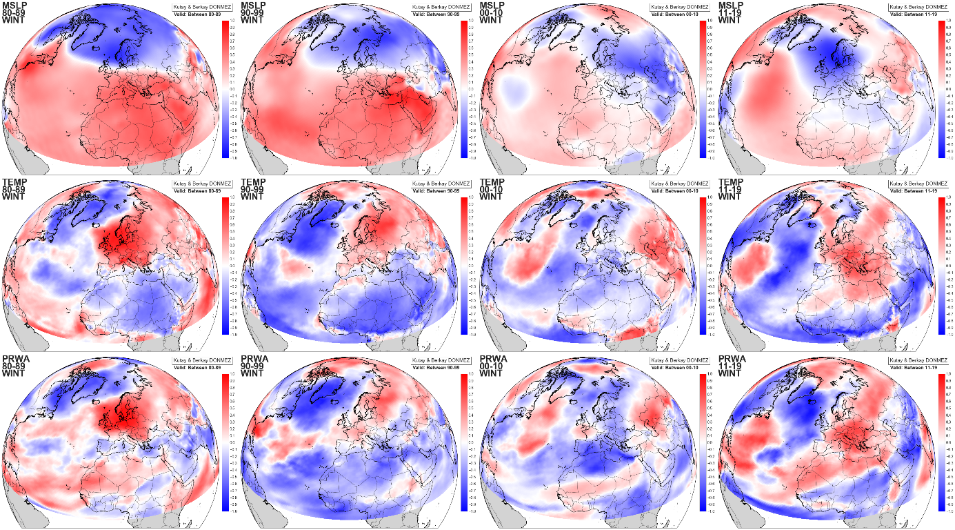

Figure

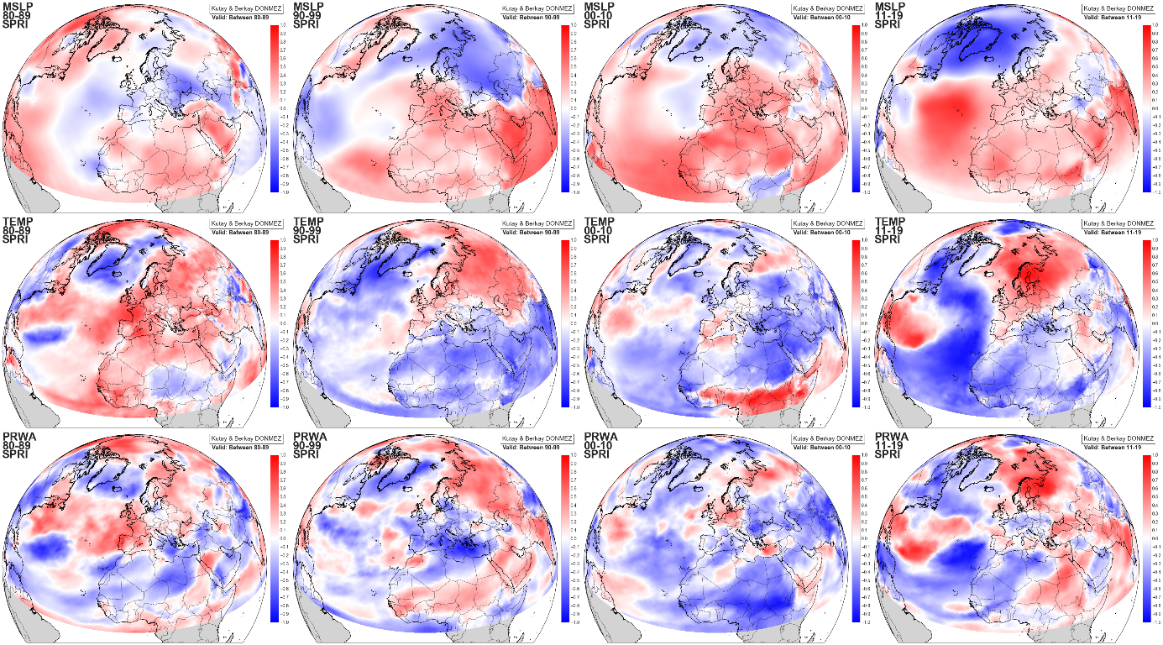

Figure

FİGURES ORIGINALY CAN BE FOUND AT **ORIGINAL_FIGURES_Arctic** DIRECTORY