**Scenario 1**

|  |
| --- |
| **Scenario name:** Login |
| **Participant actor instances: Ahmet:** Register User |
| **Flow of events:**   1. Firstly, Ahmet open the online voting application after the download it. 2. He sees login pages and he enters username info username text field also enter a password into password text field on this pages. If he leaves one or more field empty, the system displays a warning message, like “please do not leave free space”. If he leaves or wrong username text field, system display a warning message, like “please enter a valid username”. If he leaves or the wrong password, the system displays a message, like “please enter a valid password”. 3. He clicks the “login” button after he writes username and password. System checked and if login is a success, the system assigns to the main page. |

**Scenario 2**

|  |
| --- |
| **Scenario name:** View Login |
| **Participant actor instances: Ahmet:** User |
| **Flow of events:**   1. Firstly, Ahmet opens the online voting application after the download it. 2. He sees the main page and he clicks the login-register button then he sees the login page. After sees these pages, he clicks the back button and he sees the main page again. |

**Scenario 3**

|  |
| --- |
| **Scenario name:** View Election Results |
| **Participant actor instances: John:** Register User |
| **Flow of events:**   1. John opens the online voting application after downloads the online voting application. 2. He sees the main page and he clicks the election results segment then he sees all categories. 3. He selects music categories and he sees all complete music elections results. |

**Scenario 4**

|  |
| --- |
| **Scenario name:** View Election Results |
| **Participant actor instances: John:**  User |
| **Flow of events:**   1. John opens the online voting application his phone after downloading the application. 2. Then he clicks the view elections result from the segment. He sees all categories. 3. He selects sport categories and he sees all complete sport elections results. |

**Scenario 5**

|  |
| --- |
| **Scenario name:** View Popular Elections |
| **Participant actor instances: Cenk:** User |
| **Flow of events:**   1. Cenk opens the online voting application and sees the main page of the app. Then he clicks the popular election segment. He sees the listview of popular elections. 2. He clicks the third survey and system display message, like “please register to join this”. |

**Scenario 6**

|  |
| --- |
| **Scenario name:** View Popular Elections |
| **Participant actor instances: John:** Register User |
| **Flow of events:**   1. John opens the online voting application after he downloads it. 2. The system displays his main page and he clicks popular election segment. Then he sees open the all popular elections in a list. 3. He click second election and starts voting the second election when he reading open elections. He clicks the send button and his results send the system. 4. Finally, the system displays a message like “your request success.” |

**Scenario 7**

|  |
| --- |
| **Scenario name:** Complain |
| **Participant actor instances: Ali:** Register User |
| **Flow of events:**   1. Ali downloads the online voting application and opens it. 2. He sees the main page and he clicks popular elections. After he sees the elections, he decides to complain its. 3. He clicked the settings button and he sees the options. He selects complain button. 4. Firstly, he writes the subject in the first text view and writes info for the complaint before he clicks the send complaint button. After he clicks the send complaint button, the system displays the message like “your complaint sent”. |

**Scenario 8**

|  |
| --- |
| **Scenario name:** View Complain |
| **Participant actor instances: Ali:** Register User |
| **Flow of events:**   1. Ali downloads the online voting application and opens it. 2. He sees the main page and he clicks the settings button and he sees the options. He selects complain button. 3. After he sees the complaint page, he clicks the back button. Finally, He sees the main page. |

**Use Case 1**

|  |
| --- |
| **Use Case Name:** Login |
| **Participant actor instances:** Register User |
| **Flow of events:**   1. The user opens the application. 2. The user sees the main page and he clicks the login-register button. He sees the login screen. 3. The user enters email and password to the login fields. 4. If the email and password match with the email and password which is stored in the database, he authenticates. 5. Voting system fetches the main page. |
| **Entry Condition:** User opens the app and clicks the login-register button. |
| **Exit Condition:** User clicks “Login” button and entered information should be correct. |
| **Quality Requirement:**  3*. If the user leaves one or more field empty, system display a warning message, like “please do not leave free space”.  4*. If the information’s checked from the database are not true, the system displays a warning message, like "Wrong username or password, please retry.” |
| **Exceptional Case:**   1. If the user email does not include “@” character, system display warning message, like “please enter a valid email”. |

**Use Case 2**

|  |
| --- |
| **Use Case Name:** View Election Results |
| **Participant actor instances:** Register User |
| **Flow of events:**   1. The user opens the application. 2. The user sees the main page and he clicks view results segment. |
| **Entry Condition:** User opens the app and clicks the view results segment. |

**Use Case 3**

|  |
| --- |
| **Use Case Name:** View Election Results |
| **Participant actor instances:** User |
| **Flow of events:**   1. The user opens the application. 2. The user sees the main page and he clicks view results segment. |
| **Entry Condition:** User opens the app and clicks the view results segment. |

**Use Case 4**

|  |
| --- |
| **Use Case Name:** View Popular Elections |
| **Participant actor instances:** Register User |
| **Flow of events:**   1. The user opens the application. 2. The user sees main page and clicks popular elections segment. 3. The system gets all popular elections in database. 4. The user votes second popular election and send button. 5. The system display message, like “your request is successed”. |
| **Entry Condition:** User opens the app and clicks popular elections segment. |
| **Exit Condition:** User clicks “Send” button and entered information should be not empty. |
| **Quality Requirement:**  4*. If the user leaves options, system display a warning message, like “please select option for your answer”. |

**Use Case 5**

|  |
| --- |
| **Use Case Name:** View Popular Elections |
| **Participant actor instances:** User |
| **Flow of events:**   1. The user opens the application. 2. The user sees main page and clicks popular elections segment. 3. The system gets all popular elections in database. 4. The user does not vote popular election. 5. The system display message, like “please register”. |
| **Entry Condition:** User opens the app and clicks popular elections segment. |
| **Exit Condition:** User clicks “Send” button and system display alert. |
| **Quality Requirement:**  4*. If the user is not register user, system display warning message like “please register”. |

**Use Case 6**

|  |
| --- |
| **Use Case Name:** Complain |
| **Participant actor instances:** Register User |
| **Flow of events:**   1. The user opens the application. 2. The user sees the main page and clicks popular elections segment. 3. The system gets all popular elections in the database. 4. The user sees all popular elections. 5. The user clicks back button then the user sees the main page. 6. The user clicks settings button then the user sees options. 7. The user selects complain row then he entered a subject and description in text fields for complaint. 8. The user clicks the send button. 9. The system writes complain info in the database. 10. The system display message like “your complaint sent”. |
| **Entry Condition:** User opens the app, clicks settings button and select complain button. |
| **Exit Condition:** User clicks “Send” button and system display alert. |
| **Quality Requirement:**  7*. If user leaves subject text field or description text field empty, system display warning message like “please do not leave free space” |
| **Exceptional Case:**   1. If database error occurs, system display error message like “An error has occurred please try again”. |

**Use Case 7**

|  |
| --- |
| **Use Case Name:** View Complain |
| **Participant actor instances:** Register User |
| **Flow of events:**   1. The user opens the application. 2. The user sees the main page and clicks popular elections segment. 3. The system gets all popular elections in the database. 4. The user sees all popular elections. 5. The user clicks settings button then the user sees options. 6. The user clicks back button twice. 7. Finally, the user sees the main page. |
| **Entry Condition:** User opens the app, clicks settings button and select complain button. |
| **Exit Condition:** When user sees the main page. |
| **Exceptional Case:**   1. If database error occurs, system display error message like “An error has occurred please try again”. |

Login Sequence Diagram 1:

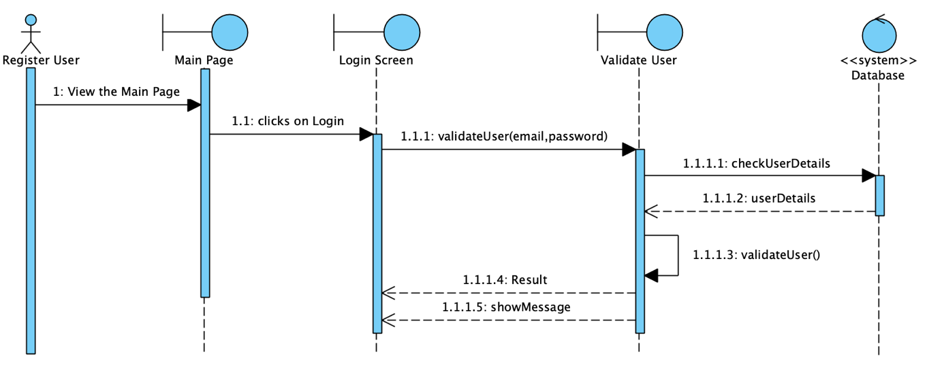

Login Sequence Diagram 2:

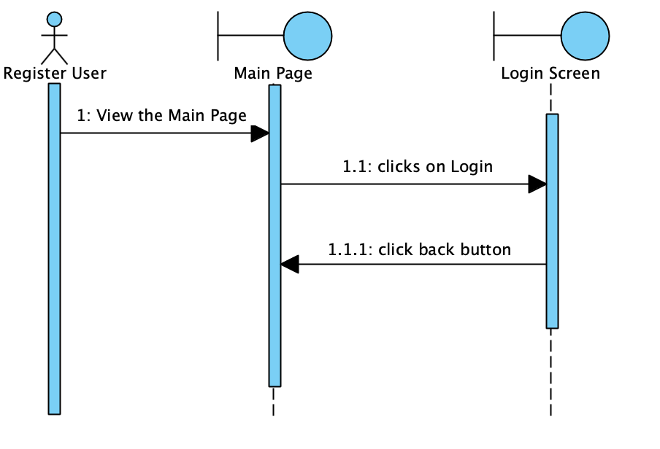

Popular Election Sequence Diagram 1:

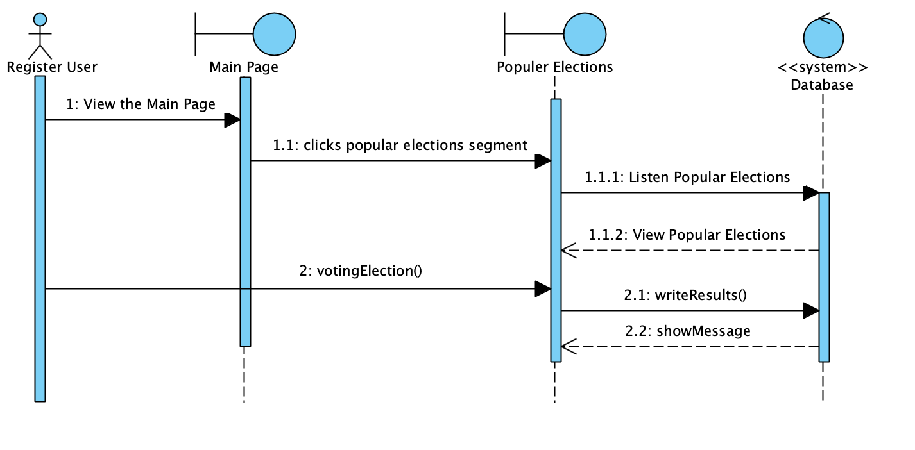

Popular Election Sequence Diagram 2:

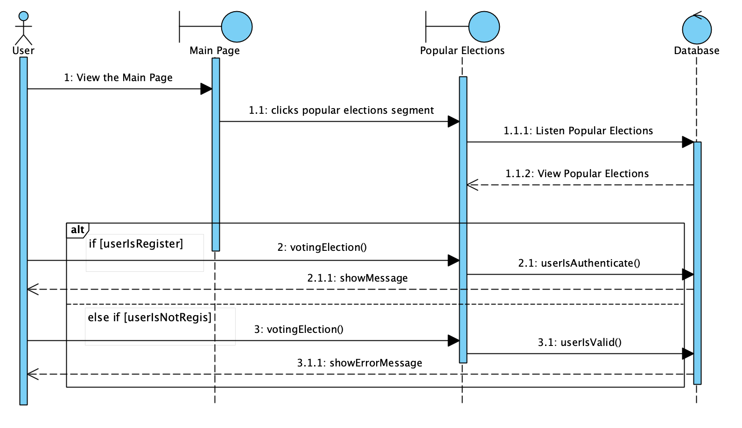

View Results Sequence Diagram 1:

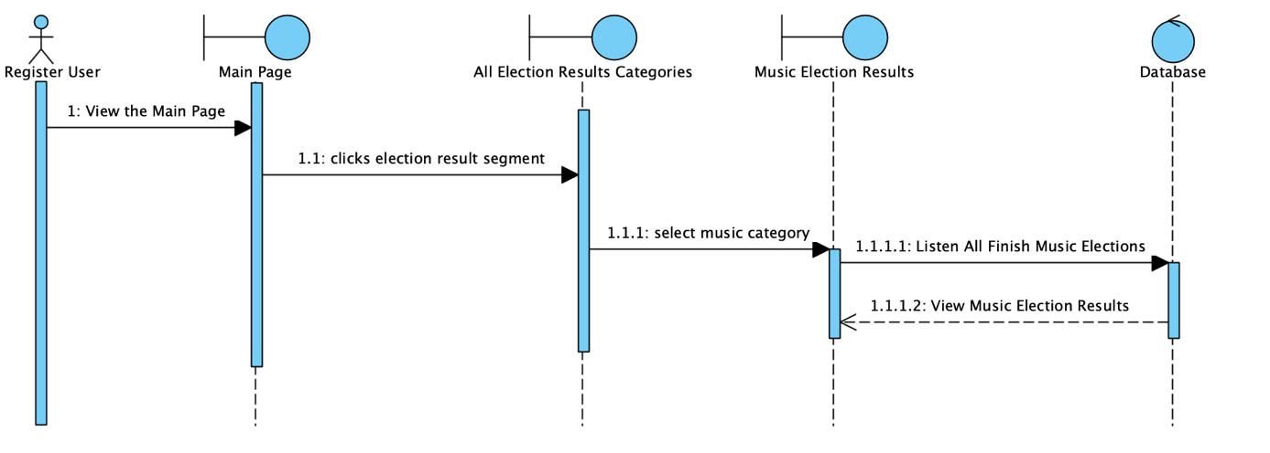

View Results Sequence Diagram 2:

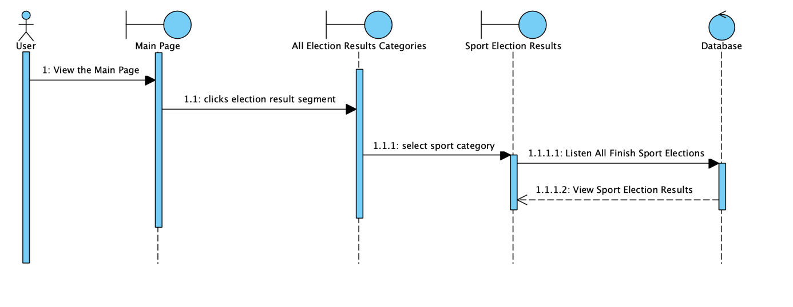

Complain Sequence Diagram 1:

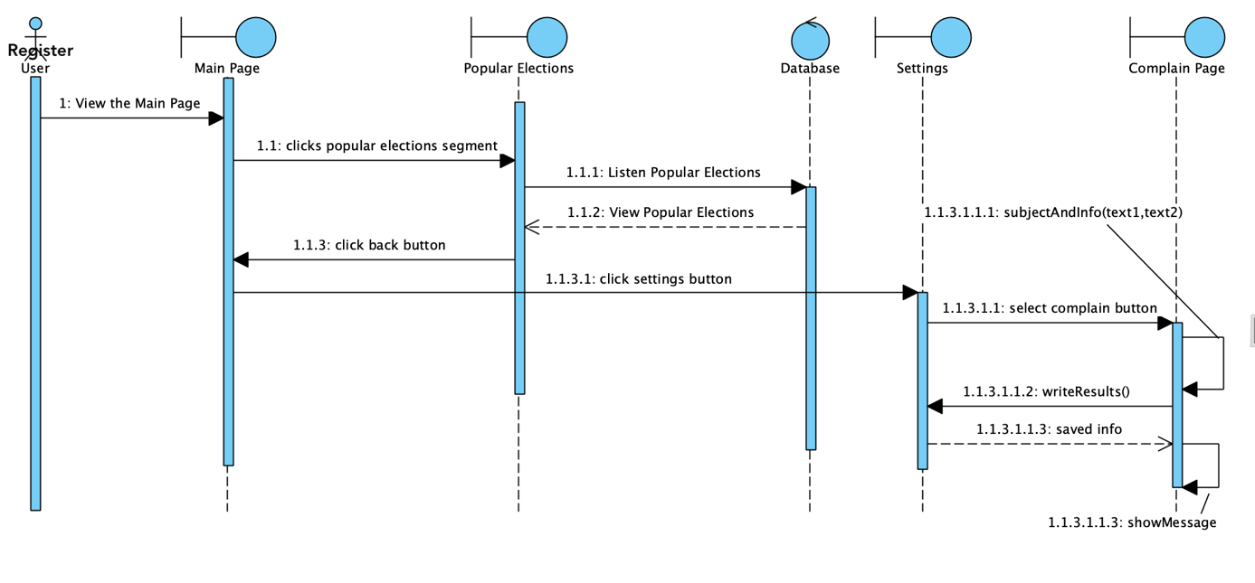

Complain Sequence Diagram 2:

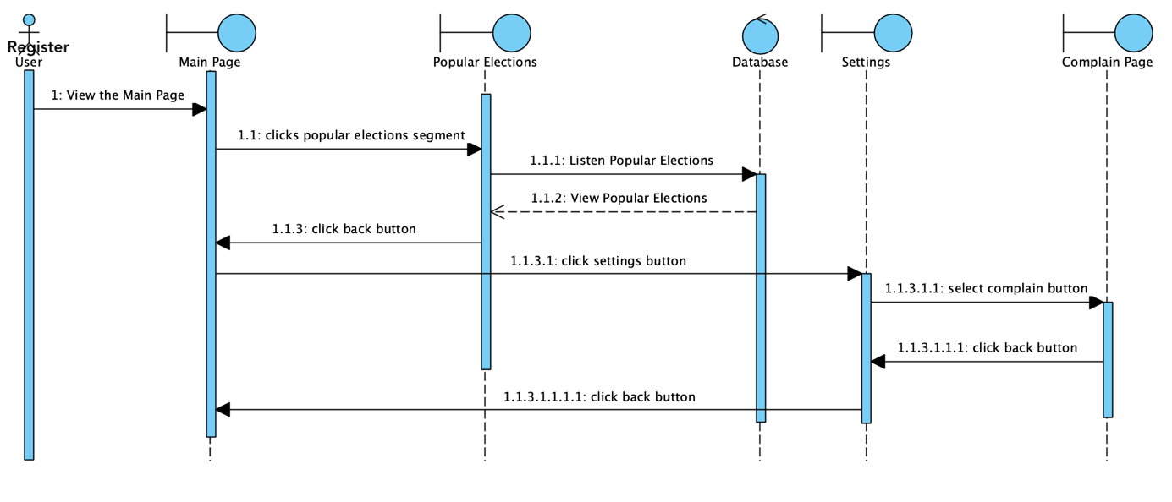

***Proposed System :***

**Our online selection app allows people to see the selections sent by the admin or by users as an anonymous or registered user, the results of the voting, and the most voted selections.**

**The admin in the system can add its own selections and publish or reject the selections that users send.**

**Finally, the system allows users to update their profile information, freeze their accounts, and log in and out of their accounts.**

**The online selection application prevents the waste of unnecessary paper and the time lost in the virtual environment of the information since the choices are not made on paper.**

***Proje 1.3 bölümü :***

## Objectives and Success Criteria of the Project

1- Paper saving

2- Prevent loss of time

3- To allow users to vote in a simple and comfortable way

4- Ensuring that everyone can vote

5- To be able to communicate all the details of the elections to all users