

MACHINE LEARNING
PROJECT
NAME: BERKAY

SURNAME: KÜÇÜK

STUDENT ID: 23040102022

DEPARTMENT:
COMPUTER ENGINEERING

SIGNATURE:

1.Loading the Datasets
In this part I have imported my datasets using scikit-learn library’s functions.
load_breast_cancer and load_wine
I seperated the dataset to two parts. I used X variable for features and y variable for target. I kept the original class numbers 0 is malignant 1 is benign for breast cancer dataset. For the wine dataset the classes are 0,1 and 2. Then I printed the first five rows.

2. Dataset Quality Checks
I checked the two datasets for seeing are there any empty or duplicated rows. In these two datasets there are no empty or duplicated rows.
Also I check the data types. All features are numerical.
Then I checked for potential outliers using IQR. I saw some outliers but I didnt do anything.
3. Exploratory Data Analysis (EDA)
I analysed two datasets using necessary tools. First I calculated all mean , median sd and Q1, Q3 etc. Then I plotted two datasets class distrubitation and correlation heatmap. I printed 3 most correlated pairs. Lastly, I drew boxplots for the features. I have seen outliers on some features.
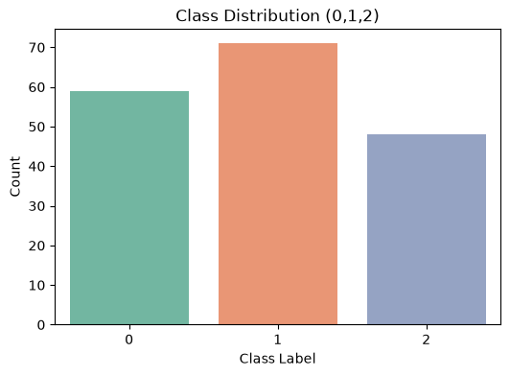
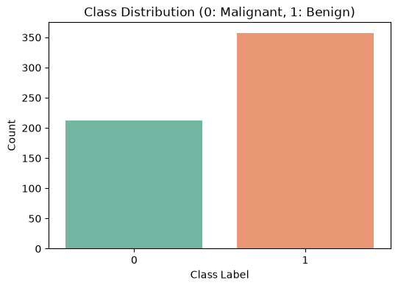

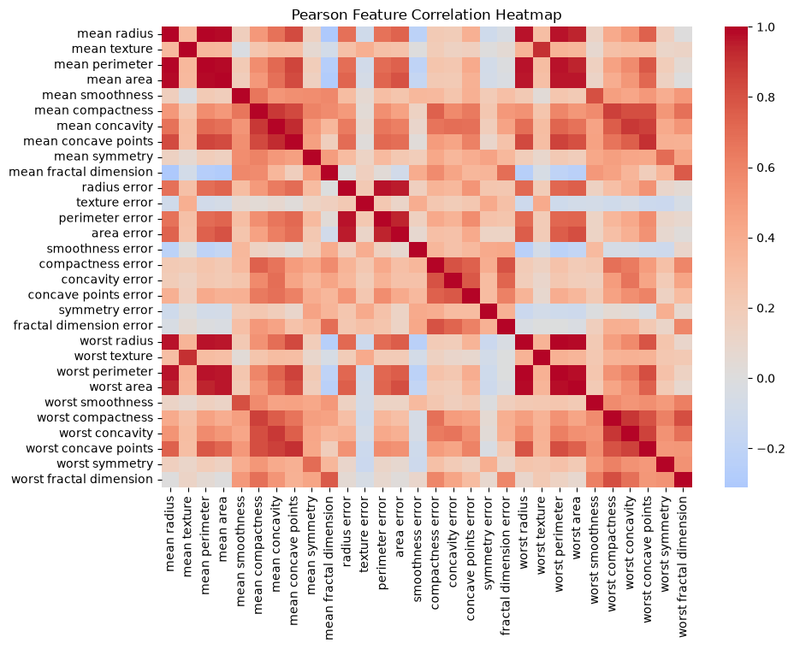
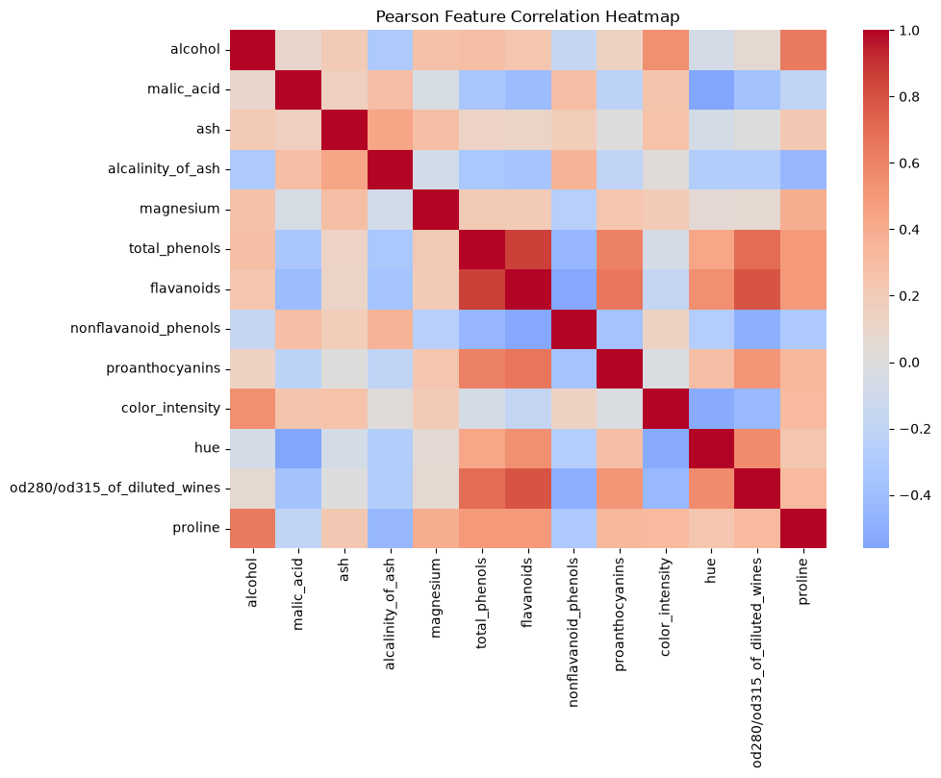
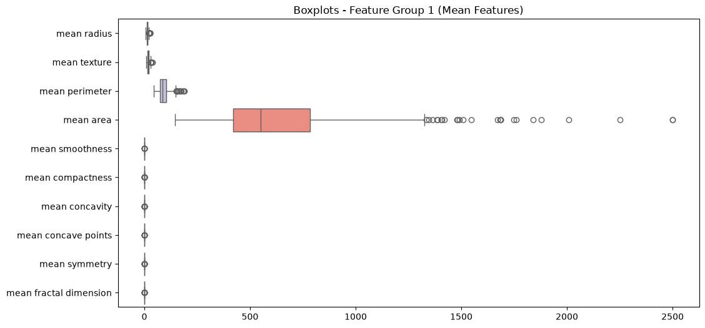
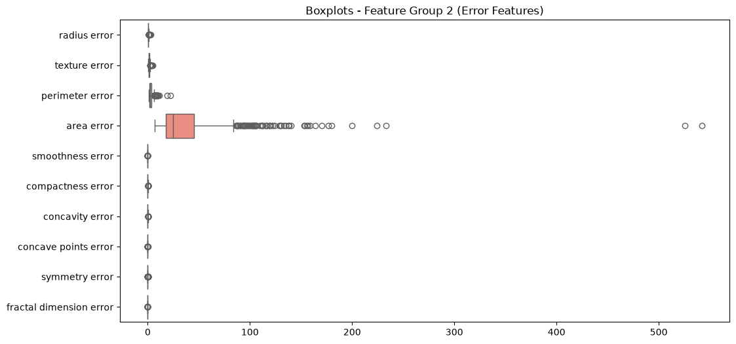
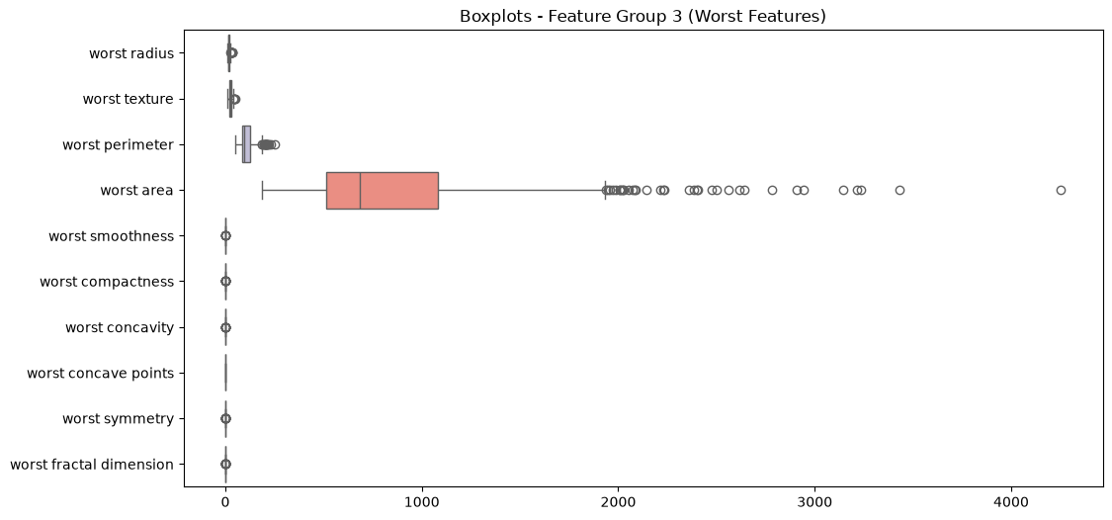
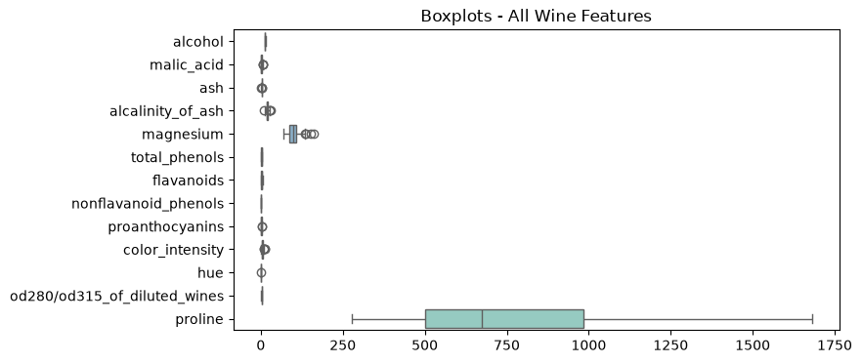
4. Spliting the Datasets
In this part I splitted the datasets into training, validation and test sets. I seperated %20 part of the data for test set. I used random=state=42 for this. Then I locked it as it wanted.
Then I used the remaining %80 of the data and split into training (%70) and validation (%10).
I did this for 3 times seed 42,52 and 62. I used stratify = y to keep the class ratios balanced in all splits. Finally I printed summary tables to check it.
5. Data Preprocessing and Scaling
For this part I didn’t use any imputer because we have seen that in 2. Part we don’t have any missing columns in our datasets. I chose the StandartScaler to scale features. I created new scaler for each dataset and seed. I used it only training part because I didnt want to get any data leakage. After I used this scaler to transform the training and validation sets. After, I printed first five rows before and after scaling. I saw that large values started to become a value arounded 0.
6. Preparing the Two Data Representations
I created two versions of the data. Unscaled and scaled versions. Unscaled is the original data we didnt do anything. Scaled is the data after using StandartScaler. I used these two for all my models to see how scaling affects.

7. Training the Classification Models
I trained three different classification algorithms: Decision Tree, KNN and Gaussian Naive Bayes. I tested different parameter settings, tree depth: 2,3,5,10,None for Decision tree.
For KNN 1,3,5,7,11. I trained every model on both unscaled and scaled data for all three seeds. 5 (Decision Tree) + 5(KNN) + 1(Naive) = 11 settings and 2 different data (Scaled Unscaled) and three seed(42,52,62) these all becomes 11x2x3=66 classifier runs. I saved the metrics in a table and kept the seed 42 models for the final test.
8. Measuring Validation Performance
In this section I tested all models on the validation sets. I calculated accuracy, precision,recall, F1 and ROC-AUC. I grouped the results by algorithm, represantation and parameter. Then I calculated the mean and standart deviation to make a 22 row summary table for each dataset. I chose the best model for looking highest mean validation macro f1 score.
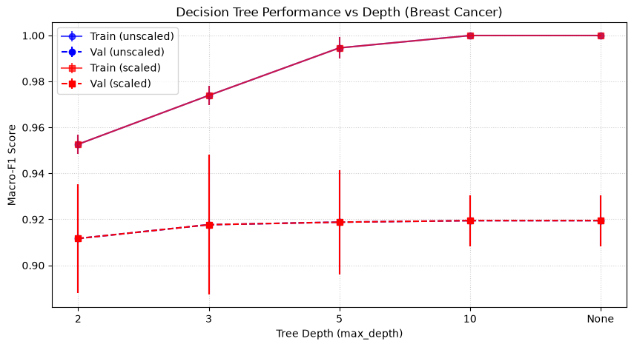
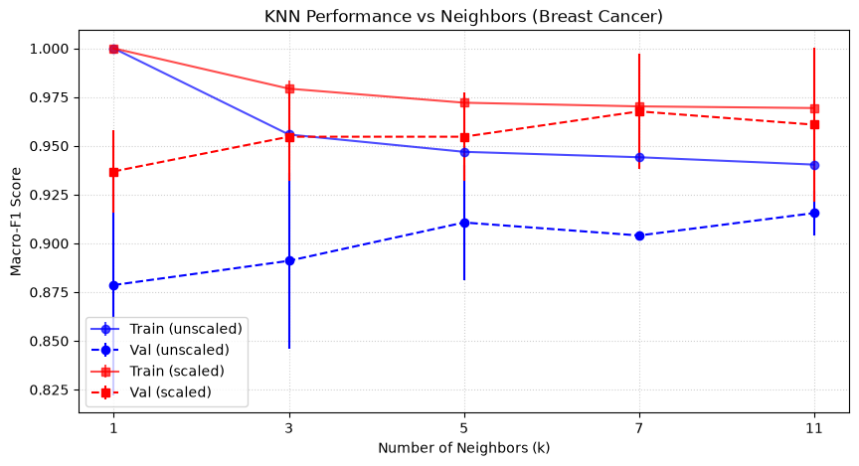

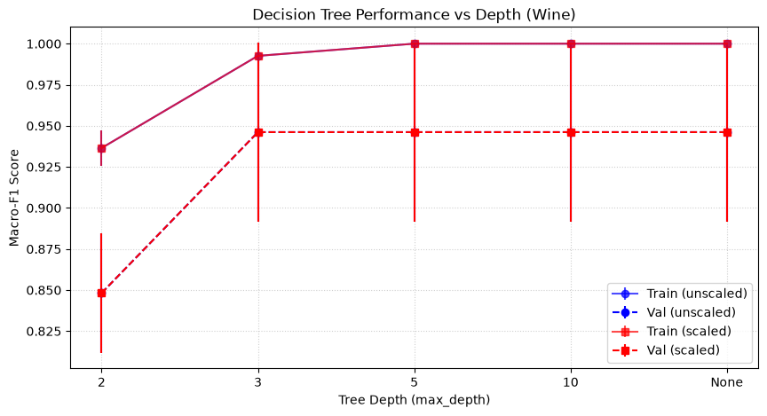
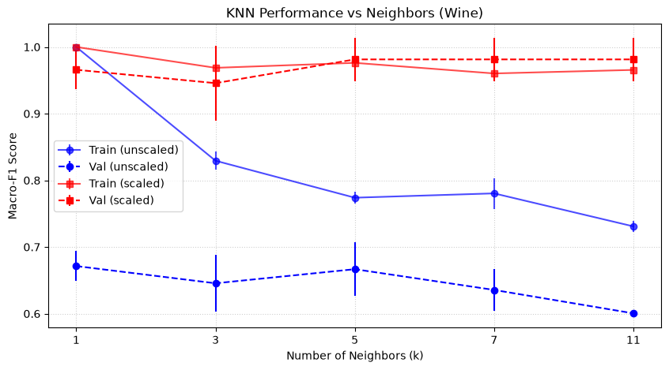
For decision trees scaling didnt change the results. Scaled and unscaled are very close to each other. When tree goes to deep the training score goes up to 1 validation score goes down. This means model memorized the training data which is overfitting.
For KNN models scaling changed a lot. The scaled lines are much higher than unscaled ones. The middle numbers worked best like 3 and 5. The error bars on the lines show that results change slightly when I use different seeds.

9.Evaluating the Selected Models on the Test Sets
In this section, I tested my best models on the final 20% test set. I only used the models trained with seed 42. I did not train the models again on the test data. I followed four main steps for this evaluation:
1. Final Metrics: First, I calculated five performance metrics: Accuracy, Macro-Precision, Macro-Recall, Macro-F1, and ROC-AUC. I put these results in a final test table.
2. Visualizations: Second, I plotted a confusion matrix to see the correct and incorrect predictions. I also plotted an ROC curve for both datasets. For the wine dataset, I used the One-vs-Rest (OVR) method for the ROC curve because it has three classes.
3. Manual Calculation: Third, I calculated the metrics manually to check the computer. I took the True Positive (TP), False Positive (FP), and False Negative (FN) numbers from the confusion matrix. I used math formulas to find precision and recall. My manual math perfectly matched the scikit-learn classification report.
4. Error Analysis: Finally, I looked at the mistakes. My best KNN model for wine made zero mistakes on the test set. My model for breast cancer made a few mistakes
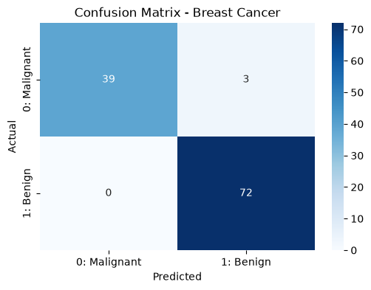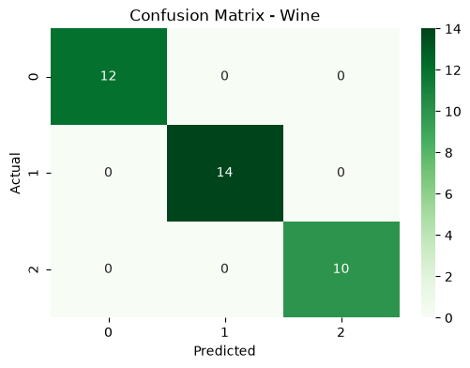
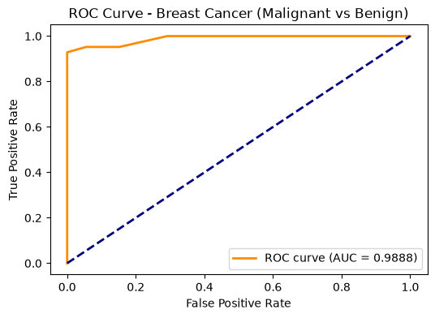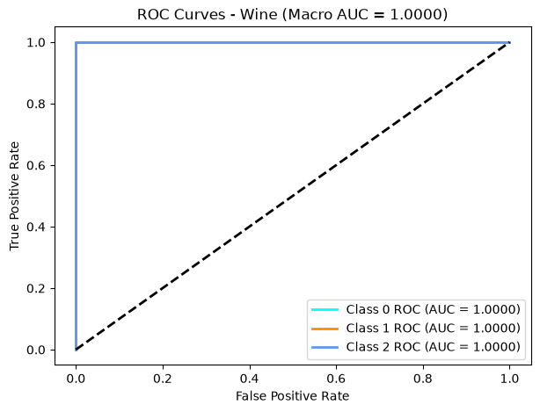
10. K-Means Clustering
In this section, I used the KNN. This is unsupervised learning, so I did not give the true class labels (y) to the model. I set the number of clusters (k) to 2 for Breast Cancer and 3 for Wine. I tested KNN on both unscaled and scaled data. I calculated the Adjusted Rand Index (ARI) and Silhouette scores to measure the performance. I also created contingency tables to compare the clusters with the true classes.
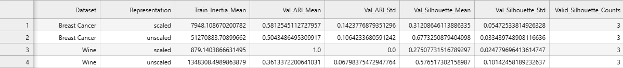
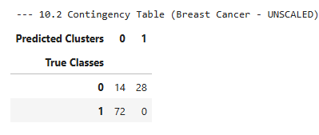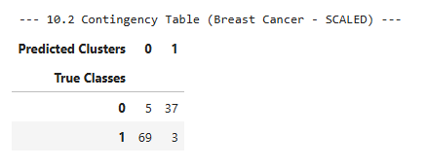

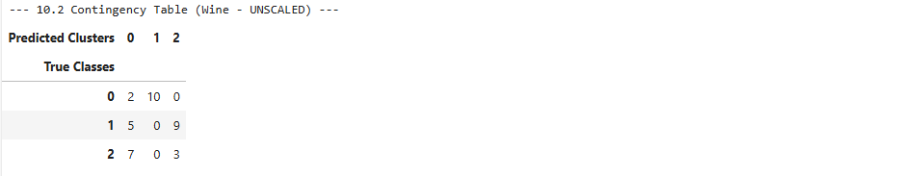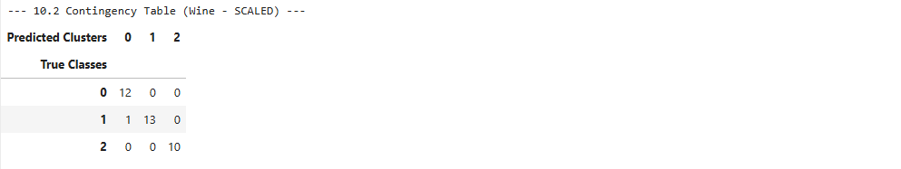

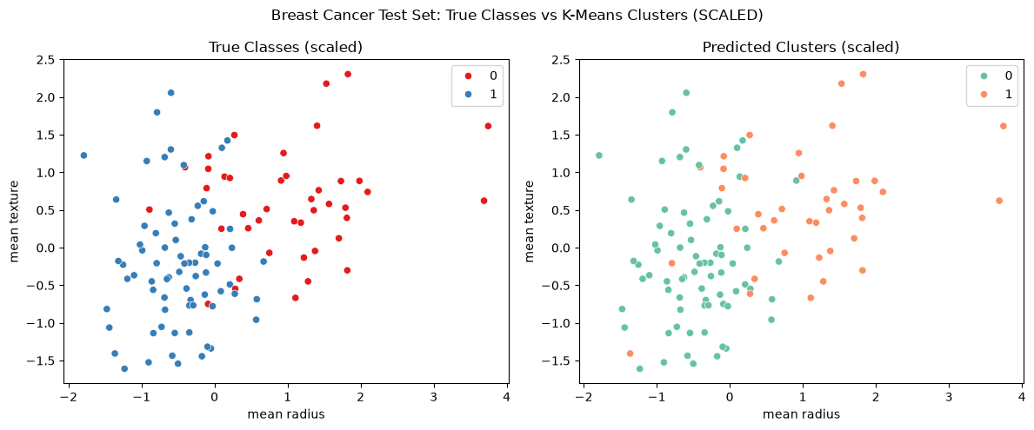
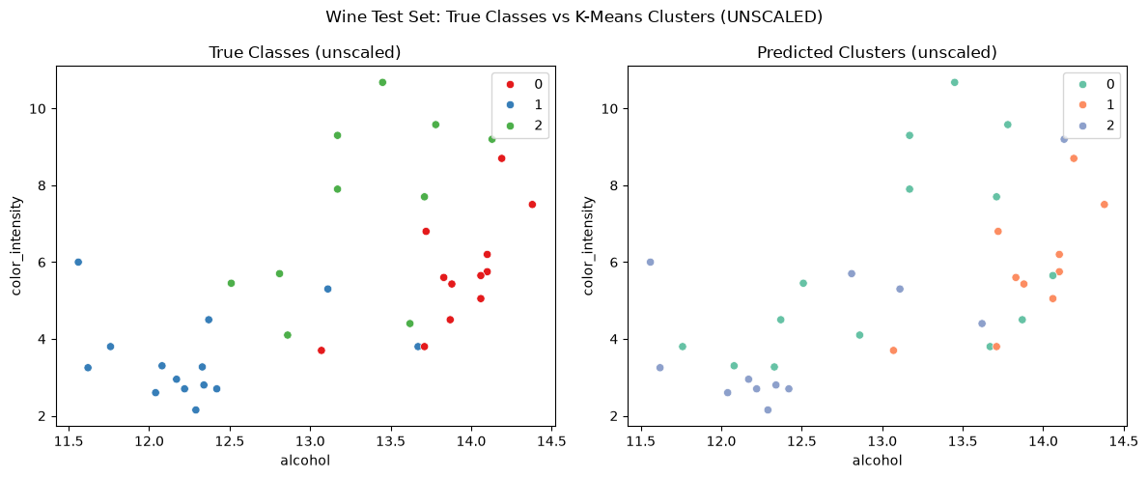
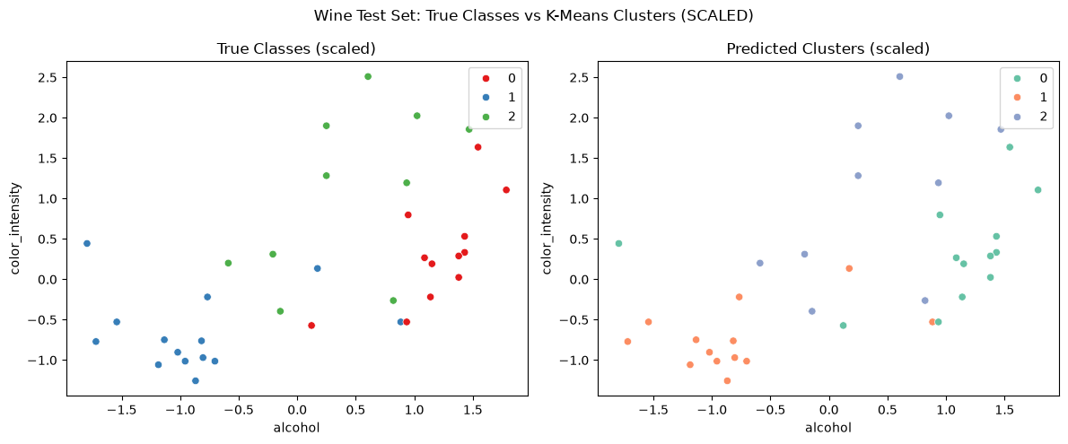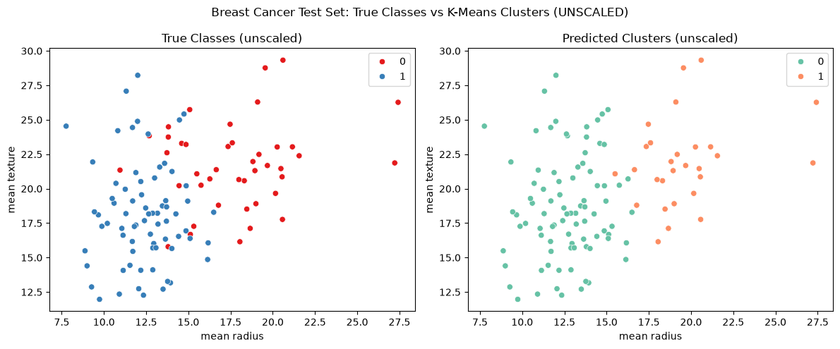
I looked at the KNNscatter plots and the contingency tables. Scaling the data is very important for the KNN algorithm because KNN uses distance to make groups.
When I used the unscaled data, the clusters were very bad. The points were mixed, and the ARI score was very low. The big numbers in the dataset confused the model. When I used the scaled data (StandardScaler), the clusters became much better. The groups separated clearly. The ARI score increased a lot, especially for the wine dataset. This shows that scaling is necessary for knn to find the correct groups.

11. Questions
1. Did the same classifier and representation perform best on both datasets? Yes, the same algorithm and representation performed best. However, the parameters were different. In the validation results, scaled KNN had the highest mean Macro-F1 score on both datasets. For Breast Cancer, the best parameter was k=7 (score: 0.968). For Wine, the best parameter was k=11 (score: 0.981). On the test sets, the Breast Cancer model got a 0.971 Macro-F1 score, and the Wine model got a perfect 1.000 score. I only evaluated the selected models on the test set. These results show that the selected models perform very well. But I cannot know if they are the best on the test set.
2. Which algorithm was most affected by scaling?
The KNN algorithm was the most affected by scaling, especially for the Wine dataset. For example, in the validation table, the unscaled KNN model had very low scores (around 0.65 Macro-F1). But the scaled KNN model had almost perfect scores (0.98 Macro-F1). Decision Tree results did not change much after scaling.
3. Did deeper trees or larger neighbour counts always improve mean validation performance? How much did results vary across seeds?
No, they did not always improve performance. When the tree depth became very large (like 10 or None), the validation score dropped because of overfitting. For KNN, large neighbour counts (like 11) also decreased the validation score. The results varied a little bit across the three seeds. The standard deviation was usually between 0.01 and 0.03, which shows the models were mostly stable.
4. How did the main classification errors differ between the two datasets?
The Wine test set had zero errors; the confusion matrix was perfect. The Breast Cancer test set had a few errors. The model predicted "benign" (healthy) but the true class was "malignant" (cancer). This was a False Negative error.
5. How did K-Means agreement with the true classes differ between datasets? K-Means found the true classes better for the Wine dataset when the data was scaled. The ARI score for scaled Wine was around 0.85. The ARI score for scaled Breast Cancer was lower, around 0.65. This shows K-Means agreement was stronger for Wine.
6. What one change would you investigate next, and why?
I would investigate different feature selection methods. Some features might not be important. If I remove the unimportant features, the models might work even faster and better.

