**CrossOver Demo Application**

**Used Technologies :**

* 1. PHP 5.6.3 with OPcache
  2. MySQL 5.6.19
  3. Nginx 1.10.3 & Php5.6-FPM
  4. Symfony 2.8
     1. Twig
     2. Doctrine
     3. GregwarImageBundle
     4. EkoFeedBundle
     5. KnpSnappyBundle
  5. Bootstrap 4.0
  6. Jquery
  7. Popper.JS

**Design Patterns** (inside of symfony) **:**

* 1. Factory
  2. Strategy
  3. Facade
  4. Composite
  5. Builder
  6. Flyweight
  7. Dependency Injection

**Activity Diagrams :**

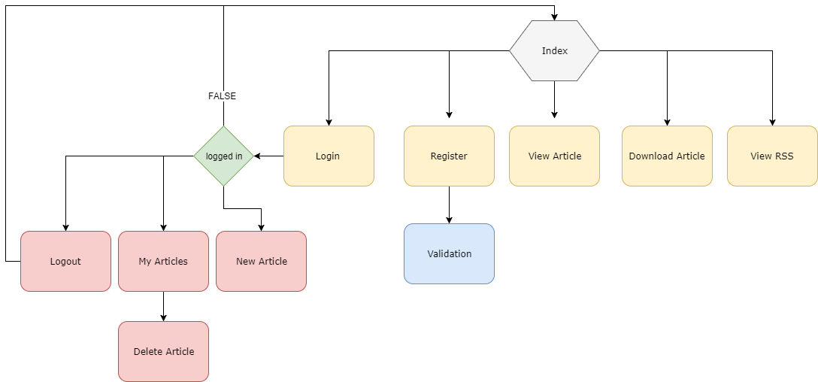

**Component Interaction Diagrams :**

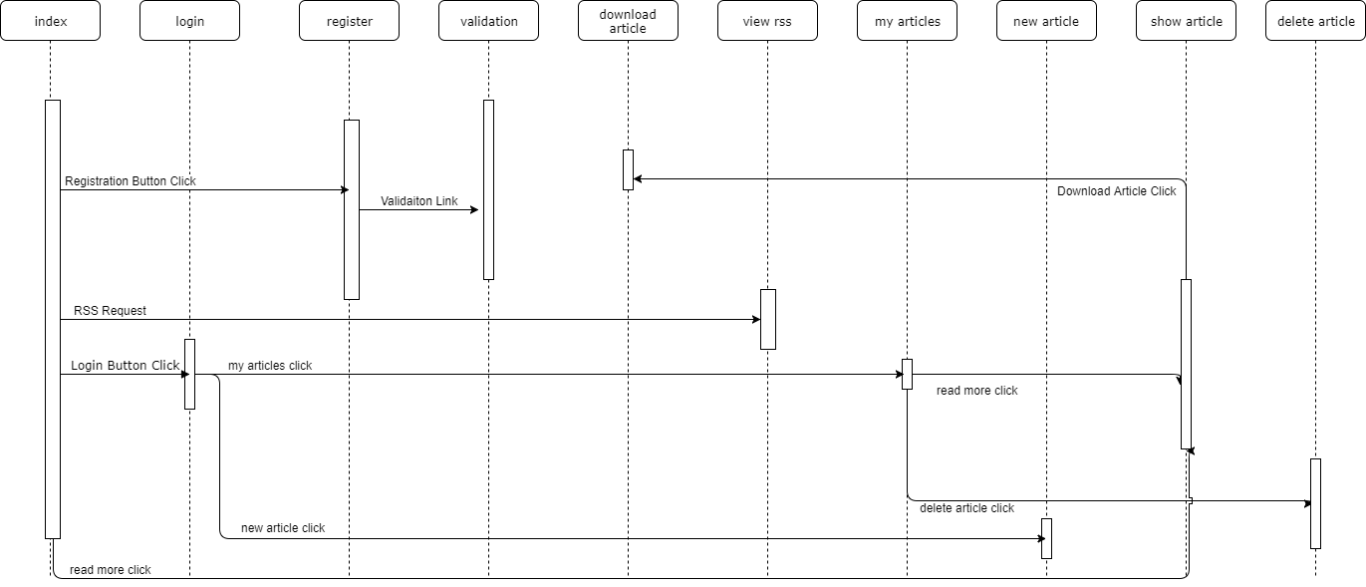

**Source Diagrams :**

