**Bayesian Inference**

P ~ Type I Extreme Value(mean=2000, cov=0.2)

E ~ Lognormal(mean=30000, cov=0.1)

I ~ Normal(mean=10, cov=0.05)

Create a surrogate model for Y = (L^3)P/3EI => y = c.x1/(x2.x3) using Gaussian Process

The actual system response is



The errors are assumed to be normally distributed with zero mean and standard deviation **.**



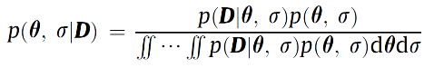The posterior distribution of the uncertain parameters can be inferred using Bayesian approach

**Case I**

* $y_{model}=\frac{cx_{1}}{x_{2}x_{3}}$**, where x1, x2, x3 are deterministic**

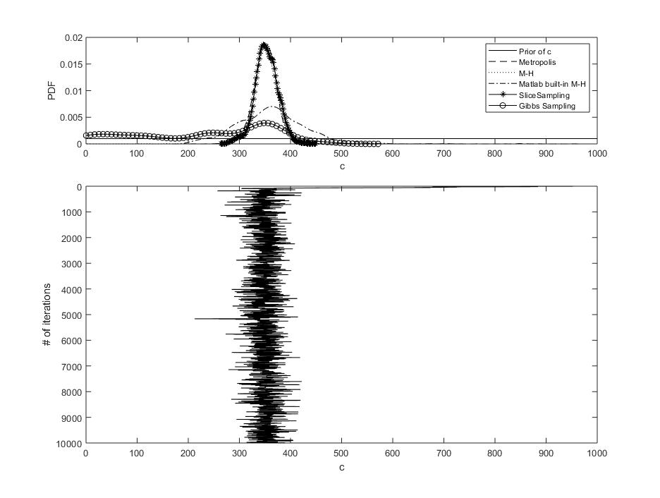

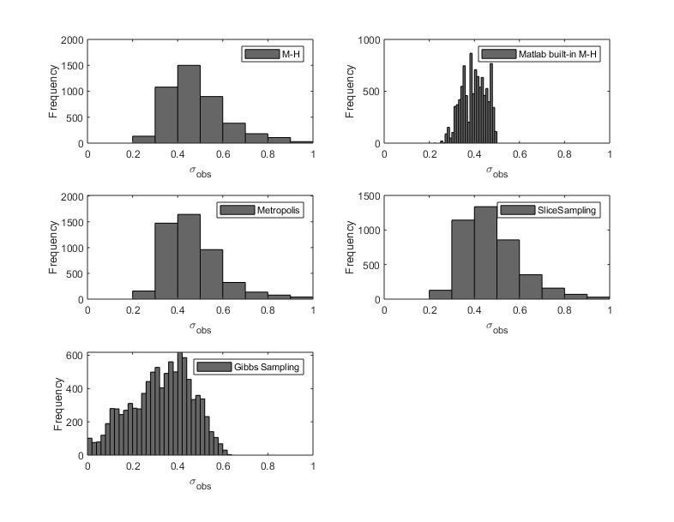

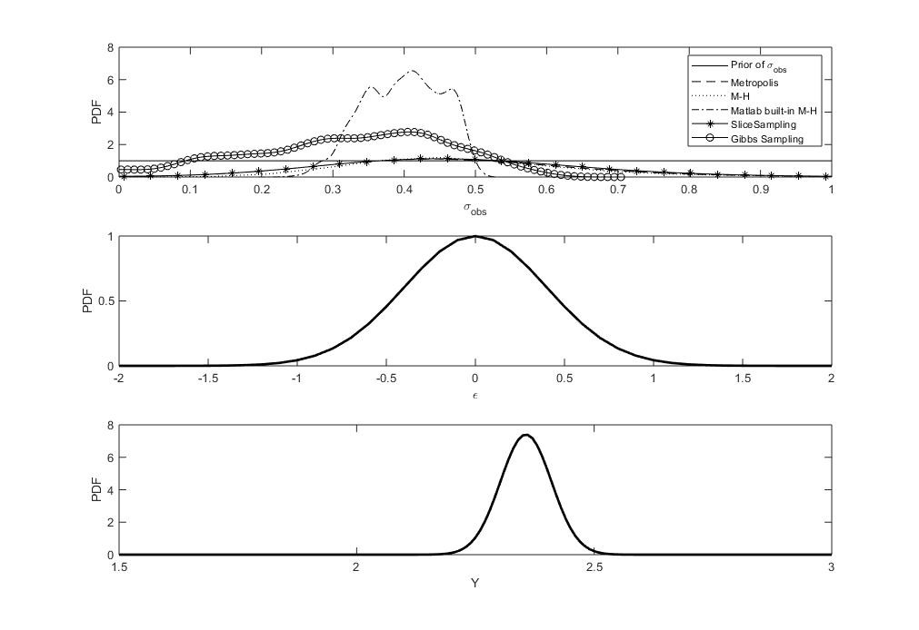

**Case II**

* $y_{model}=\frac{cx_{1}}{x_{2}x_{3}}$**, where x1, x2, x3 are stochastic**

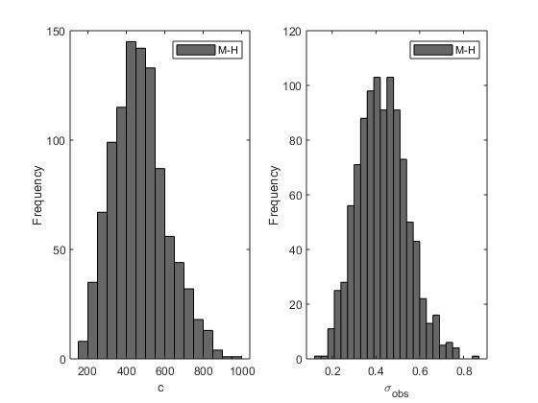

% clc;

% clear;

close all

%% Assume uncorrelated inputs

% Grid Samples

% P~Type I

mu_x1 = 2000;

cov_x1 = 0.2;

sigma_x1 = mu_x1*cov_x1;

% E~Lognormal

mu_x2 = 30000;

cov_x2 = 0.1;

sigma_x2 = mu_x2*cov_x2;

zeta_x2 = sqrt(log(1+cov_x2^2));

lambda_x2 = log(mu_x2) - 0.5*zeta_x2^2;

% I~Normal

muN_x3 = 10;

cov_x3 = 0.05;

sigmaN_x3 = muN_x3*cov_x3;

dev = 3;

N_train=5;

P = linspace( mu_x1 - dev*sigma_x1, mu_x1 + dev*sigma_x1, N_train);

E = linspace( mu_x2 - dev*sigma_x2, mu_x2 + dev*sigma_x2, N_train);

I = linspace( muN_x3 - dev*sigmaN_x3, muN_x3 + dev*sigmaN_x3, N_train);

[PP, EE, II] = ndgrid(P,E,I);

% Input

inp = [PP(:) EE(:) II(:)];

% Output

% Y = inp(:,1)./(inp(:,2).*inp(:,3));

%

%% MCS

%--------------------------------------------------------------------------

nsamples = 10;

% Uniform numbers

muN_x2 = log(mu_x2 / sqrt(1 + sigma_x2^2/mu_x2^2));

sigmaN_x2 = log(1 + sigma_x2^2/mu_x2^2);

r = rand(nsamples,3);

x1 = icdf('Extreme Value', r(:,1), mu_x1, sigma_x1)';

x2 = icdf('Lognormal', r(:,2), muN_x2, sigmaN_x2)';

x3 = icdf('Normal', r(:,3), muN_x3, sigmaN_x3)';

Y =@(c) c.*mu_x1./(mu_x2.*muN_x3);

%-----------------------------------------------------------

P = mu_x1; E = mu_x2; I = muN_x3;

L = 10;

% beam deflection Euler-Bernoulli

mu_y = P*L^3/(3*E*I);

sigma_y = 0.33;

% Generate 10 samples of Y~N(mu_y,sigma_y)

N = 10;

yobs = normrnd(mu_y,sigma_y,1,N);

%% Case I

% x1, x2, x3 are deterministic at their mean values

%% Initialize the Metropolis sampler

T = 10000; % Set the maximum number of iterations

sigma_c = 35; % Set standard deviation of normal proposal density

sigma_eps = 0.3; % Set standard deviation of normal proposal density

cmin = 0; cmax = L^3; % define a range for starting values

c = zeros( 1 , T ); % Init storage space for our samples

sigma_e = zeros( 1 , T ); % Init storage space for our samples

seed=1; rand( 'state' , seed ); randn('state',seed ); % set the random seed

% Prior distribution for c = L^3/3

% Assume uniform (non-informative prior)

c(1) = unifrnd( cmin , cmax ); % Generate start value

pri_c = 1/(cmax-cmin);

smin = 0; smax = 1; % define a range for starting values

sigma_e(1) = unifrnd( smin , smax ); % Generate start value

% err =@(s) normrnd(0,s,1,N);

pri_s = 1/(smax-smin);

% likelihood dist.

L =@(c,s) 1/sqrt(2*pi*s^2)^N * exp(-0.5*((yobs-Y(c))*(yobs-Y(c))')/s^2 );

% posterior dist.

post =@(c,s) L(c,s)*pri_c*pri_s;

%% Start sampling Metropolis

t = 1;

while t < T % Iterate until we have T samples

t = t + 1;

% Propose a new value for theta using a normal proposal density

c_star = normrnd( c(t-1) , sigma_c );

sigma_star = normrnd( sigma_e(t-1) , sigma_eps );

% Calculate the acceptance ratio

alpha = min( [ 1 post( c_star, sigma_star ) / post( c(t-1),sigma_e(t-1) ) ] );

% Draw a uniform deviate from [ 0 1 ]

u = rand;

% Do we accept this proposal?

if u < alpha

c(t) = c_star; % If so, proposal becomes new state

sigma_e(t) = sigma_star; % If so, proposal becomes new state

else

c(t) = c(t-1); % If not, copy old state

sigma_e(t) = sigma_e(t-1); % If so, proposal becomes new state

end

end

%% Start sampling M-H

init=[0 0.2];

% posterior dist.

logpost =@(c,s) log(L(c,s))+log(pri_c)+log(pri_s);

D = numel(init);

samples = zeros(D, T);

state = init;

Lp_state = logpost(state(1),state(2));

for ss = 1:T

% Propose

prop = state + [sigma_c sigma_eps].*randn(size(state));

Lp_prop = logpost(prop(1),prop(2));

if log(rand) < (Lp_prop - Lp_state)

% Accept

state = prop;

Lp_state = Lp_prop;

end

samples(:, ss) = state(:);

end

%% uniform prior for c

X_c = linspace( cmin , cmax , 100 );

y_c = unifpdf(X_c,cmin,cmax);

% uniform prior for sigma

X_s = linspace( smin , smax , 100 );

y_s = unifpdf(X_s,smin,smax);

%% DO SLICE SAMPLING

% likelihood dist.

L =@(th) 1/sqrt(2*pi*th(2)^2)^N * exp(-0.5*((yobs-Y(th(1)))*(yobs-Y(th(1)))')/th(2)^2 );

fun=@(th,i) 1/sqrt(2*pi*th(2)^2) * exp(-0.5*((yobs(i)-Y(th(1)))^2)/th(2)^2 );

f = @(i,fun) @(th) fun(th, i); %anonymous function whose output is an anonymous function

Likelihood= 1;

for i=1:10

l1=Likelihood;

Likelihood =f(i, fun);

LL = @(th) l1(th).*Likelihood(th);

end

post =@(th) LL(th)*pri_c*pri_s;

logpost =@(th) log(L(th))+log(pri_c)+log(pri_s);

initial_samples = [300,0.5];

nSamples = 1e4;

trace = slicesample(initial_samples, 8000,'logpdf',logpost,'thin',5,...

'burnin', 2000);

mean(trace(:,2))

%% DO M-H

% pri_c =@(c,s) 1./(xPrior(:,2)-xPrior(:,1))';

% L =@(c,s) 1/sqrt(2*pi*s)^N * exp(-0.5*((yobs-Y(c))*(yobs-Y(c))')/s^2 );

% posterior dist.

proprnd = @(th) [200+(1000 - 200)*rand, 0+(0.6-0.1)*rand]; % proposal random sampler

% logpost =@(th) log(L(th))+log(pri_c)+log(pri_s);

fun=@(th,i) 1/sqrt(2*pi*th(2)^2) * exp(-0.5*((yobs(i)-Y(th(1)))^2)/th(2)^2 );

f = @(i,fun) @(th) fun(th, i); %anonymous function whose output is an anonymous function

Likelihood= 1;

for i=1:10

l1=Likelihood;

Likelihood =f(i, fun);

LL = @(th) l1(th).*Likelihood(th);

end

post =@(th) L(th)*pri_c*pri_s;

% logpost =@(th) log(LL(th))+log(pri_c)+log(pri_s);

% posterior dist.

logpost =@(th) log(L(th))+log(pri_c)+log(pri_s);

unsymPropPdf=@(x,y) mvnpdf([x(1), x(2)],[y(1),y(2)],[0.01*y(1)^2 0;

0 0.16*y(2)^2]);

tic

trace_mh = mhsample([300 0.1], 1e4,'logpdf',logpost,'proprnd',proprnd, ...

'proppdf',unsymPropPdf);

toc

post =@(th) LL(th)*pri_c*pri_s;

%% Gibbs Sampling

scale = [10 .01];

v_th=Gibbs(post,[30 0.4],T,scale);

%

%% Display ksdensity of c

figure( 1 ); clf;

subplot( 3,1,1 );

[f1,c1]=ksdensity(c);

[f2,c2]=ksdensity(samples(1,:));

[f3,c3]=ksdensity(trace_mh(:,1));

[f4,c4]=ksdensity(trace(:,1));

[f5,c5]=ksdensity(v_th(:,1));

% set(groot,'DefaultAxesColorOrder',[0 0 0],...

% 'DefaultAxesLineStyleOrder','-|--|:|-.|-*|o')

set(groot,'DefaultAxesColorOrder',[0 0 0],...

'DefaultAxesLineStyleOrder','-|--|:|-.|-*|-o|-.*')

plot(X_c,y_c);hold on;

plot(c1,f1);hold on;

plot(c2,f2);hold on;

plot(c3,f3);hold on;

plot(c4,f4);hold on;

plot(c5,f5);

xlim( [ cmin cmax ] );

xlabel( 'c' ); ylabel( 'PDF' );

legend('Prior of c','Metropolis','M-H', 'Matlab built-in M-H',...

'SliceSampling','Gibbs Sampling')

%% Display history of our samples

subplot( 3,1,2:3 );

stairs( c , 1:T , 'k-' );

ylabel( '# of iterations' ); xlabel( 'c' );

set( gca , 'YDir' , 'reverse' );

xlim( [ cmin cmax ] );

%% Display ksdensity of sigma

figure( 2 ); clf;

subplot( 3,1,1 );

plot(X_s,y_s);hold on;

ksdensity(sigma_e);hold on;

ksdensity(samples(2,:));hold on;

ksdensity(trace_mh(:,2));hold on;

ksdensity(trace(:,2));hold on;

ksdensity(v_th(:,2));

xlim( [ smin 1 ] );

xlabel( '\sigma_{obs}' ); ylabel( 'PDF' );

legend('Prior of \sigma_{obs}','Metropolis','M-H','Matlab built-in M-H',...

'SliceSampling','Gibbs Sampling')

subplot( 3,1,2 );

mu = 0;

sigma = mean(trace_mh(:,2));

pd = makedist('Normal','mu',mu,'sigma',sigma);

x =-2:0.1:2;

y = pdf(pd,x);

plot(x,y,'LineWidth',2);

xlabel( '\epsilon' ); ylabel( 'PDF' );

subplot( 3,1,3 );

mu = mean(trace_mh(:,1))*P/E/I;

sigma = std(trace_mh(:,2));

pd = makedist('Normal','mu',mu,'sigma',sigma);

x =1.5:0.01:3;

y = pdf(pd,x);

plot(x,y,'LineWidth',2);

xlabel( 'Y' ); ylabel( 'PDF' );

figure()

subplot(3,2,3)

histogram(sigma_e)

xlim( [ smin 1 ] );

xlabel( '\sigma_{obs}' ); ylabel( 'Frequency' );

legend('Metropolis')

subplot(3,2,1)

histogram(samples(2,:));

xlim( [ smin 1 ] );

xlabel( '\sigma_{obs}' ); ylabel( 'Frequency' );

legend('M-H')

subplot(3,2,2)

histogram(trace_mh(:,2));

xlim( [ smin 1 ] );

xlabel( '\sigma_{obs}' ); ylabel( 'Frequency' );

legend('Matlab built-in M-H')

subplot(3,2,4)

histogram(trace(:,2));

xlim( [ smin 1 ] );

xlabel( '\sigma_{obs}' ); ylabel( 'Frequency' );

legend('SliceSampling')

subplot(3,2,5)

histogram(v_th(:,2));

xlim( [ smin 1 ] );

xlabel( '\sigma_{obs}' ); ylabel( 'Frequency' );

legend('Gibbs Sampling')

% %% Display history of our samples

% subplot( 3,1,2:3 );

% stairs( sigma_e , 1:T , 'k-' );

% ylabel( '# of iterations' ); xlabel( '\sigma_{obs}' );

% set( gca , 'YDir' , 'reverse' );

% % xlim( [ smin 1 ] );

%% Case II

% x1, x2, x3 have given distributions

% To calculate likelihood assume error_obs~N(0,sigma_obs)

% We have 2 calibration quantity: c and error_obs

% Generate 10 samples of Y~N(mu_y,sigma_y)

N = 10;

yobs = normrnd(2.2,0.33,1,N);

% log posterior

logpost =@(X) ProposedPosterior(X,yobs,0,1000,0,1);

% proposed random number generator

proprnd = @(X) mvnrnd([500,0.4],[150^2 0;0 0.12^2],1);

% proposed unsymmetric pdf

unsymmPropPdf=@(X,Y) mvnpdf([X(1), X(2)],[Y(1),Y(2)],[0.09*Y(1)^2 0;

0 0.09*Y(2)^2]);

% tic

% trace_mm = mhsample([500 0.4], 1000,'logpdf',logpost,'proprnd',proprnd, ...

% 'symmetric',true,'thin',5,'burnin', 1000);

% toc

%

% tic

% trace_mh = mhsample([500 0.4], 1e3,'logpdf',logpost,'proprnd',proprnd, ...

% 'proppdf',unsymmPropPdf,'thin',5,'burnin', 1000);

% toc

%

% figure()

% subplot(1,2,1)

% histogram(trace_mm(:,1))

% xlabel( 'c' ); ylabel( 'Frequency' );

% legend('Metropolis')

% subplot(1,2,2)

% histogram(trace_mm(:,2))

% xlabel( '\sigma_{obs}' ); ylabel( 'Frequency' );

% legend('Metropolis')

%

% figure()

% subplot(1,2,1)

% histogram(trace_mh(:,1))

% xlabel( 'c' ); ylabel( 'Frequency' );

% legend('M-H')

% subplot(1,2,2)

% histogram(trace_mh(:,2))

% xlabel( '\sigma_{obs}' ); ylabel( 'Frequency' );

% legend('M-H')

tic

trace = slicesample([500 0.4], 100,'logpdf',logpost,'thin',5,...

'burnin', 2000,'width',[100 10]);

mean(trace(:,2))

toc

figure()

subplot(1,2,1)

histogram(trace(:,1))

xlabel( 'c' ); ylabel( 'Frequency' );

legend('SliceSampling')

subplot(1,2,2)

histogram(trace(:,2))

xlabel( '\sigma_{obs}' ); ylabel( 'Frequency' );

legend('SliceSampling')

function Y = ProposedPosterior(X, y_obs, cmin, cmax, sigma_min, sigma_max)

% c = X(1), sigma_obs = X(2)

N = 500; % # of MCS for X

% Uniform numbers (LHS)

r = [lhsdesign(N,3) rand(N,1)];

u = 0.5772;

sigmaBar = sqrt(6)*(2000*0.2)/pi;

muBar=2000-u*sigmaBar;

muN_x2 = log(30000 / sqrt(1 + 3000^2/30000^2));

sigmaN_x2 = log(1 + 3000^2/30000^2);

%% MCS

%--------------------------------------------------------------------------

x1 = icdf('GeneralizedExtreme Value', r(:,1), sigmaBar, muBar);

x2 = icdf('Lognormal', r(:,2), muN_x2, sigmaN_x2);

x3 = icdf('Normal', r(:,3), 10, 0.5);

% Y_obs = Y_m - eps_obs

eps_obs = icdf('Normal', r(:,4), 0, abs( X(2) ));

Y_m = X(1)*x1./(x2.*x3);

Y_obs = Y_m - eps_obs;

% find pdf values of corresponding y_obs

[fobs, yobs] = ksdensity(Y_obs);

len = length(y_obs);

L=0;

for i=1:len

[~,idx] = min(abs(yobs-y_obs(i)));

pdf_value = fobs(idx);

L = L + log(pdf_value);

end

Y = L + log(pdf('Uniform',X(1),cmin,cmax))+log(pdf('Uniform',X(2),sigma_min,sigma_max));

end