The power BI file is composed of 2 sheets that have as a purpose to facilitate the understanding of the results obtained during the project by the graphical representation of them. The first page was built using the data obtained from the customers’ behaviour analysis while the second one uses the data from the churn analysis. Both of them count with a Filtering section where the results and data can be filtered and the results section where the results are plotted.

**Customers’ behaviour analysis:**  
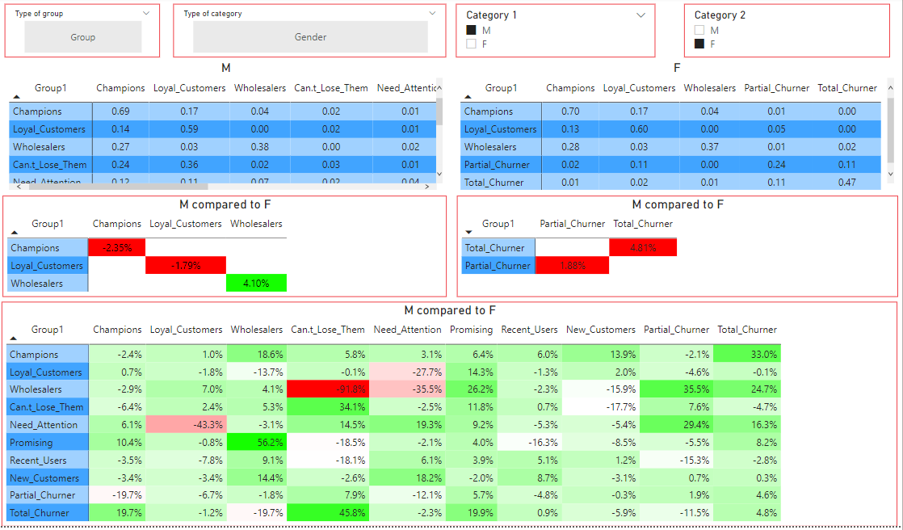

5

4

3

2

1

The previous page has 4 different filters to help the user choose the data to compare. Make sure that all filters are cleared out when starting an analysis. To clear a filter you just need to go to the “eraser” of the filter and clear the filer like in the following picture:   
  
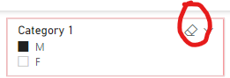

In this case “M” (which stands for Males) are compared to “F” (females).   
  
The first table (Table 1), is showing the probability of men going from one group to another one. On the right, the table 2 is presenting the same information but for women. Under these two tables, it is shown the percentage of change comparing “M” to “F” in two different tables. The table 3 shows the results of “good” groups while the table on the right, table 4 shows the results of undesired groups. Finally, on table 5 we find the overall percentage change between all the groups when comparing the probability of men and women to move from group to another one.

**Churn analysis:**

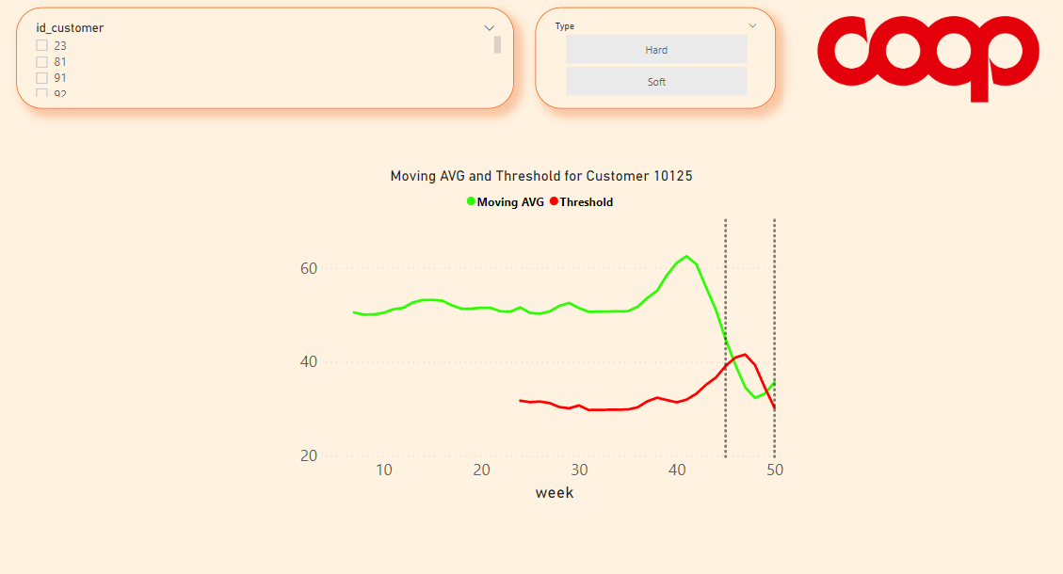

In this section it is visualised the behaviour of specific customers to understand the definition of soft and hard churners. For this reason, there are two filters. The first one is the specific id of the customers and the second one is the type of churner. Finally, the graph represents the trend of these customers to take effective marketing strategies actions. As in the last page, it is important to make sure that the filters are cleared out before beginning a new analysis.