**HARDWARE**

**OPERATING SYSTEM**

**PROGRAM**

**PROGRAM**

**PROGRAM**

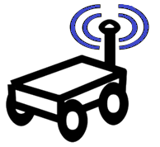

OS

HWW

HWW

OS

OS

HWW

OS

HWW

**roscore**