

The Exam Security System

Muzaffer DEMİRHAN
Berkecan Hamdi AKYÜZ
Muhammet Mirza BEKİROĞLU
230706004
230706003
220706022

Project: The Exam Security System
Date: 2026-01-09
Supervisor: Professor Emre OLCA

Table of Contents
1. Introduction 4
1.1 Purpose 4
1.2 Scope 4
1.3 Overview 4
2. System Overview 4
2.1 System Context 4
2.2 Design Constraints 5
3. Stakeholder Analysis 5
3.1 Identification 5
3.2 Responsibilities 5
4. Business Rules 6
BR1: Authentication & Authorization Rules 6
BR2: Exam & Roster Management Rules 6
BR3: Student Check-in Rules 7
BR4: Machine Learning Verification Rules 7
BR5: Violation Logging Rules 8
BR6: Reporting Rules 8
BR7: Data Integrity & Audit Rules 8
BR8: Operational Constraints 9
5. Functional Requirements (FR) 9
FR1: Authentication and Access Control 9
FR2: Exam and Roster Management (Admin) 9
FR3: Student Check-in Workflow (Proctor) 10
FR4: Violation Logging (Proctor) 10
FR5: Reporting (Admin) 10
6. Non-Functional Requirements (NFR) 10
NFR1: Performance 10
NFR2: Reliability 11
NFR3: Security 11
NFR4: Usability 11
NFR5: Scalability 11
7. Data Design 11
User Table 11
Student Table 12
StudentPhoto Table 12
Room Table 12
Seat Table 12
Exam Table 13
ExamRoster Table 13
CheckInLog Table 13
Violation Table 14
ERD Diagram 14
8. UI (User Interface) 14
Login 14
Admin 15
Proctor 20
9. References 22
10. Appendices 22
A. Use Case Diagrams 22
B. Sequence Diagrams 24
C. Activity Diagram 26
D. Data Dictionary 27
Data Definition Commands 27
Data Manipulation Commands (Sample Data) 29
E. Links 34

1. Introduction

1.1 Purpose
This document provides a detailed Software Requirements Specification for the Exam Security System. Its purpose is to provide a complete overview of the system's intended functionality, limitations and goals. This SRS will serve as the main reference document for the development team and the official agreement between all stakeholders, ensuring a shared vision for the final product.

1.2 Scope
The Exam Security System is an advanced, web-based application designed to support the integrity and security of in-person examinations. The system's scope is focused on exam-day operations, providing tools for proctors and administrators to manage student verification efficiently, seating arrangements, and incident reporting.
The core functionalities within this scope are:
- Identity Verification: Utilizing a machine learning component to match a student's live photo against their registered ID photo.
- Seating Plan Compliance: Ensuring students occupy their designated seats.
- Incident and Violation Recording: Creating a digital log of any irregularities or academic misconduct that occurs.
- Administrative Management: Allowing exam coordinators to set up exams, manage student rosters, and produce post-exam reports.

1.3 Overview
This document is designed to lead the reader from a high-level conceptual overview to detailed, specific requirements. It begins with the context and limitations of the system, outlines key stakeholders and their roles, and then carefully specifies the functional and non-functional requirements. The following sections elaborate on the data model, system architecture, and user interface principles. This structure ensures clarity and provides a complete picture of the project's requirements.

2. System Overview

2.1 System Context
The Exam Security System is designed to operate within an academic institution's examination framework. It is a self-contained, web-based application that will be accessed via standard web browsers on devices like laptops or tablets. The system is intended to interface with a pre-existing student information system to retrieve student rosters and photos, which are necessary for the verification process. Its primary operational environment is the exam hall on the day of the examination.

2.2 Design Constraints
The development and implementation of the system are subject to the following constraints:
- Database Management System: The system must use MS SQL as its relational database for all data persistence.
- Platform: The application must be web-based, ensuring accessibility across different operating systems without requiring native client installation.
- Machine Learning Implementation: The face verification component must be implemented using a pre-existing, library-based approach. Training a complex deep learning model from scratch is explicitly outside the project's scope. The focus is on the successful integration and application of the ML model within the workflow.
- Development Language: The backend will be developed using Python, and the frontend will utilize a modern JavaScript framework.

3. Stakeholder Analysis

3.1 Identification
The system has three key user roles, each with definite permissions and goals:
- Exam Coordinator (Admin): The administrative user responsible for pre-exam setup and post-exam analysis.
- Proctor (Invigilator): The on-the-ground staff member responsible for executing exam-day security procedures.
- Student: The end-user subject to the verification and compliance checks, but not a direct system operator.

3.2 Responsibilities

Stakeholder | Responsibilities
Exam Coordinator (Admin) | - Manage user accounts for Proctors. - Create and configure exam sessions (exam name, room, date/time). - Import student rosters for each exam. - Create and assign seating plans. - Generate and review reports on check-ins, identity mismatches, and violations.
Proctor (Staff) | - Log into the system to access assigned exam sessions. - Execute the student check-in workflow for each student. - Capture or upload a live photo of the student. - Review the ML-based identity verification result. - Confirm the student is in the correct seat as per the system's seating plan. - Log any observed violations with detailed notes and optional photographic evidence.
Student | - Provide their student ID for lookup. - Consent to having their photo taken for verification. - Proceed to their assigned seat.

4. Business Rules
This section defines the business rules that limit and manage the behavior of the Exam Security System. Business rules serve as organizational policies, operational constraints, and decision logic that must be charged by the system in addition to functional requirements.

BR1: Authentication & Authorization Rules
BR1.1
Only authenticated users with valid personal details shall be allowed to access the system.
BR1.2
Users shall only be permitted to perform actions that correspond to their assigned role:
- Admin users may access all system functionalities.
- Proctor users may only access exam-day operational features (check-in and violation logging).
BR1.3
Proctors shall not be permitted to create, edit, or delete exams, rooms, or seating plans.
BR1.4
Inactive user sessions shall be automatically cancelled after a predefined timeout period to prevent unauthorized access.

BR2: Exam & Roster Management Rules
BR2.1
An exam session must be created before any student roster or seating plan can be assigned.
BR2.2
Each student may appear only once per exam roster.
BR2.3
A student cannot be assigned to an exam without a related room configuration.
BR2.4
Each seat code within a room shall be assigned to at most one student per exam.
BR2.5
Automatic seat assignment shall respect room capacity and layout constraints.
BR2.6
An exam roster cannot be modified once the exam has started.

BR3: Student Check-in Rules
BR3.1
A student must exist in the exam roster before a check-in attempt is allowed.
BR3.2
A student may not complete more than one successful check-in for the same exam.
BR3.3
Check-in attempts shall only be permitted during the scheduled exam time window.
BR3.4
Each check-in attempt must include:
- A live captured or uploaded photo
- An ML verification result
- A seat compliance confirmation
BR3.5
If the ML verification result is “No Match” or “Low Confidence”, the check-in shall be marked accordingly and flagged for administrative review.
BR3.6
If the student is seated in a location different from their assigned seat, the system shall record a Seating Violation.
BR3.7
All check-in attempts shall be logged and saved for audit purposes, including unsuccessful attempts.

BR4: Machine Learning Verification Rules
BR4.1
The ML component shall not make final decisions independently; it shall return a confidence score and verification result to the system.
BR4.2
Verification outcomes shall be classified into one of the following states:
- Match
- No Match
- Low Confidence
BR4.3
Low-confidence results shall require manual review by an Admin.
BR4.4
The ML model itself shall not store student identity data; all data persistence shall be managed by the system database.

BR5: Violation Logging Rules
BR5.1
Only Proctors assigned to an active exam session may log violations for that exam.
BR5.2
A violation record must be associated with:
- A specific student
- A specific exam
- A reporting Proctor
BR5.3
Each violation must include a violation reason and timestamp.
BR5.4
Violation records cannot be edited or deleted after submission.

BR6: Reporting Rules
BR6.1
Reports shall only be accessible to Admin users.
BR6.2
Reports shall show the final, immutable state of check-ins and violations once an exam is completed.
BR6.3
Mismatch and violation reports shall include sufficient detail to support audit and disciplinary processes.

BR7: Data Integrity & Audit Rules
BR7.1
All critical system actions (check-ins, violations, ML decisions) shall be timestamped.
BR7.2
Historical check-in logs shall not be overwritten or deleted.
BR7.3
Sensitive data access (photos, embeddings) shall be restricted to authorized system processes only.

BR8: Operational Constraints
BR8.1
The system shall prevent check-in operations if the backend services or database are unavailable.
BR8.2
In the event of system failure, no partial check-in records shall be committed.

5. Functional Requirements (FR)
This section details the specific functionalities the system must provide, categorized by feature area.

FR1: Authentication and Access Control
- FR1.1: The system shall provide a secure login page for users.
- FR1.2: The system shall enforce role-based access control. Users logged in as "Exam Coordinator" shall have access to all administrative functions, while users logged in as "Proctor" shall only have access to exam-day operational functions (check-in, violation logging).
- FR1.3: The system shall include a secure session management mechanism, including session timeout for inactivity.
- FR1.4: The system shall enforce differentiated access permissions for Proctors, allowing read-only access to exam rosters and write access only to check-in and violation logging functionalities.

FR2: Exam and Roster Management (Admin)
- FR2.1: The system shall allow an Exam Coordinator to create a new exam session by specifying an exam name, room location, and the scheduled date and time.
- FR2.2: The system shall provide a mechanism for the Exam Coordinator to import a student roster for an exam from a CSV file. The file must contain at a minimum: Student ID, Student Name, and a path/URL to their official ID photo.
- FR2.3: The system shall allow an Exam Coordinator to create a seating plan for an exam. This can be done by defining the room layout (rows/columns) and assigning students to specific seat codes.
- FR2.4: The system shall allow an Exam Coordinator to manually enter or edit student roster information when CSV import is not used.
- FR2.5: The system shall support automatic seat assignment for students based on the defined room layout, with the option for manual adjustments by the Exam Coordinator.

FR3: Student Check-in Workflow (Proctor)
- FR3.1: The Proctor shall be able to select an active exam session and look up a student by entering their Student ID.
- FR3.2: Upon finding a student, the system shall display their registered information, including their name and official ID photo.
- FR3.3: The system shall provide an interface for the Proctor to capture a new, live photo of the student using the device's camera or upload a photo file.
- FR3.4: The system shall automatically send the live photo and the stored ID photo to the ML verification component. It shall display the result to the Proctor as a clear "Match" or "No Match" decision, potentially with a similarity score.
- FR3.5: The system shall display the student's assigned seat code. The Proctor must be able to visually confirm the student's seating and mark compliance in the system.
- FR3.6: The system shall record the outcome of the entire check-in along with a timestamp.
- FR3.7: The system shall support an additional ML verification outcome state indicating "Low Confidence" when the similarity score does not meet the acceptance threshold.

FR4: Violation Logging (Proctor)
- FR4.1: During an exam, a Proctor shall be able to select a student and log a new violation.
- FR4.2: The violation logging form must include a dropdown menu of common violation reasons, a text field for detailed notes, and an optional field to upload a photographic evidence image.
- FR4.3: Each logged violation shall be automatically timestamped and associated with the specific student and exam session.

FR5: Reporting (Admin)
- FR5.1: The Exam Coordinator shall be able to generate a "Check-in Report" for any completed exam session. This report must list all students on the roster and their final check-in status with timestamps.
- FR5.2: The system shall provide a "Mismatch Report" that filters and displays only the students whose identity verification resulted in a "No Match."
- FR5.3: The system shall provide a "Violations Report" that details all incidents logged during an exam, including the student's name, the violation reason, proctor's notes, and any evidence images.
- FR5.4: The system shall provide a real-time dashboard displaying high-level exam statistics, including the number of students checked in, pending check-ins, and logged violations.

6. Non-Functional Requirements (NFR)

NFR1: Performance
  - Student lookup and retrieval of details shall be completed in under 2 seconds.
  - The ML-based face verification process (image upload, comparison, and result display) shall take no longer than 8 seconds.
  - Report generation for an exam with up to 500 students shall be completed within 15 seconds.
NFR2: Reliability
- The system must guarantee an uptime of 99.5% during scheduled examination periods. It should include robust error handling to prevent crashes during critical operations like student check-in.

NFR3: Security
  - All user passwords must be securely hashed and salted using a modern algorithm.
  - All network communication between the client and server must be encrypted using TLS/SSL (HTTPS).
  - Sensitive student data, particularly photographs, must be encrypted at rest. Access to raw image files on the server should be restricted.

NFR4: Usability
The interface for Proctors must be highly intuitive, optimized for speed, and usable on touch-based tablet devices. Workflows should require minimal clicks and navigation.

NFR5: Scalability
The system architecture must be capable of supporting at least 50 Proctors using the check-in functionality concurrently for a single large-scale exam.

7. Data Design
The data model is designed to support secure exam management, student identity verification, seating compliance, and violation tracking. The database schema is implemented using MS SQL and enforces data integrity through primary keys, foreign keys, and constraints.

User Table
Stores system users including Exam Coordinators (Admins) and Proctors.
Columns:
- UserID (PK): Unique identifier for each system user.
- Username: Unique login name.
- PasswordHash: Securely hashed user password.
- Role: User role (Admin, Proctor).
- FullName: Full name of the user.

Student Table
Stores student identity information and primary reference data for identity verification.
Columns:
- StudentID (PK): Unique identifier for each student.
- UniversityID: Institution-issued unique student identifier.
- FullName: Student’s full name.
- Email: Student contact email.
- ReferencePhotoUrl: Path or URL to the primary stored identity photo.
- FaceEmbedding: Stored facial feature representation (JSON or encoded string).

StudentPhoto Table
Stores multiple reference photos for each student to improve identity verification reliability.
Columns:
- PhotoID (PK): Unique identifier for each photo.
- StudentID (FK): Reference to the associated student.
- PhotoUrl: Path or URL to the stored photo.
- CreatedAt: Timestamp indicating when the photo was added.

Room Table
Stores examination room information and high-level seating layout configurations.
Columns:
- RoomID (PK): Unique identifier for each room.
- RoomName: Human-readable room name or code.
- Capacity: Maximum number of students allowed in the room.
- LayoutConfig: JSON-based layout definition used as a legacy or cached representation.

Seat Table
Defines the normalized seating structure for each exam room.
Columns:
- SeatID (PK): Unique identifier for each seat.
- RoomID (FK): Reference to the room containing the seat.
- RowLabel: Row identifier (e.g., “A”, “1”).
- ColLabel: Column identifier (e.g., “1”, “2”).
- IsAccessible: Indicates whether the seat is usable.
- Status: Operational state of the seat (Active, Maintenance).

Exam Table
Stores exam session details including scheduling, room assignment, and ownership.
Columns:
- ExamID (PK): Unique identifier for each exam.
- CourseCode: Academic course identifier.
- ExamName: Name of the exam.
- StartTime: Scheduled start date and time.
- DurationMinutes: Length of the exam in minutes.
- RoomID (FK): Assigned exam room.
- CreatedBy (FK): Admin user who created the exam.

ExamRoster Table
Maps students to exams and manages seating assignments and attendance status.
Columns:
- RosterID (PK): Unique identifier for each exam-student assignment.
- ExamID (FK): Associated exam.
- StudentID (FK): Associated student.
- AssignedSeat: Seat code assigned to the student (e.g., “B12”).
- Status: Attendance status (Scheduled, Present, Absent).
- CheckInTime: Timestamp of successful check-in.
Constraints:
- Each student may appear only once per exam.

CheckInLog Table
Records all student check-in attempts for auditing and validation purposes.
Columns:
- LogID (PK): Unique identifier for each check-in log entry.
- RosterID (FK): Reference to the exam roster entry.
- Timestamp: Date and time of the check-in attempt.
- MLConfidenceScore: Similarity score returned by the ML verification service.
- IsMatch: Indicates whether identity verification succeeded.
- IsSeatCorrect: Indicates whether the student was seated correctly.
- CapturedImagePath: Path or URL to the captured live photo.

Violation Table
Stores logged exam violations along with evidence and reporting details.
Columns:
- ViolationID (PK): Unique identifier for each violation.
- ExamID (FK): Associated exam.
- StudentID (FK): Associated student.
- Reason: Violation category.
- Notes: Detailed description provided by the Proctor.
- EvidenceImagePath: Optional path or URL to photographic evidence.
- ReportedAt: Timestamp of the violation report.
- ReportedBy (FK): Proctor who reported the violation.

ERD Diagram

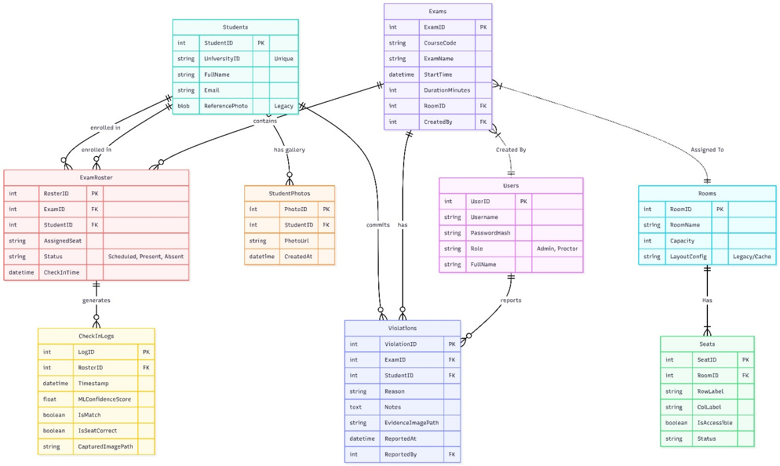

8. UI (User Interface)

Login
- This section is for loginning in to the system. It includes headline text, username input, password input and sign-in button.
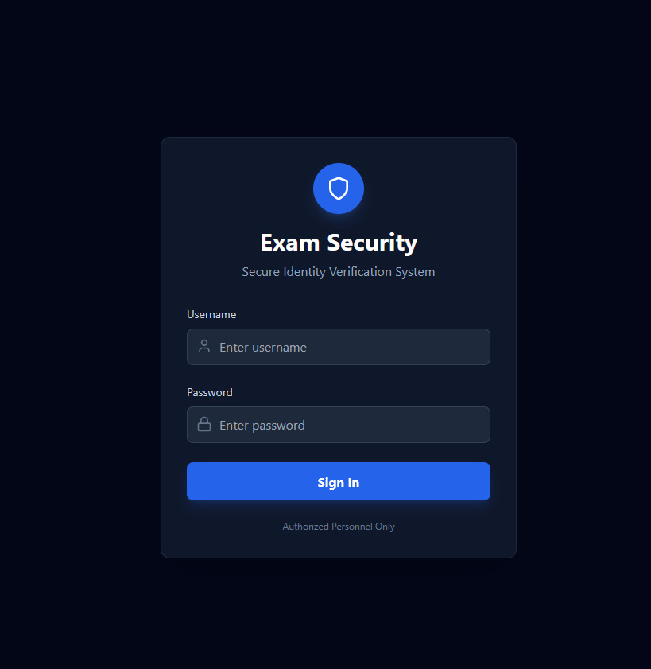

Admin
- This section is Admin’s main dashboard. It includes headline text, log-out button, manage exams button, student rosters button and room layouts button.
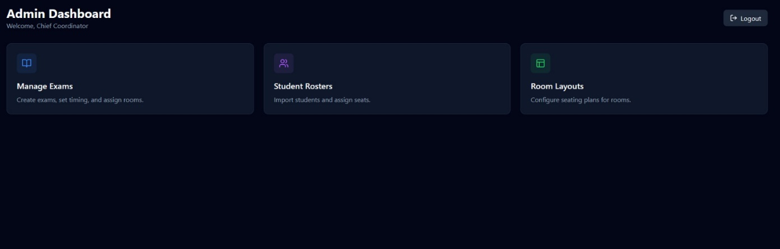

- This section is to manage exams and create new ones. It includes headline text, create exam button, Exam managemenet section
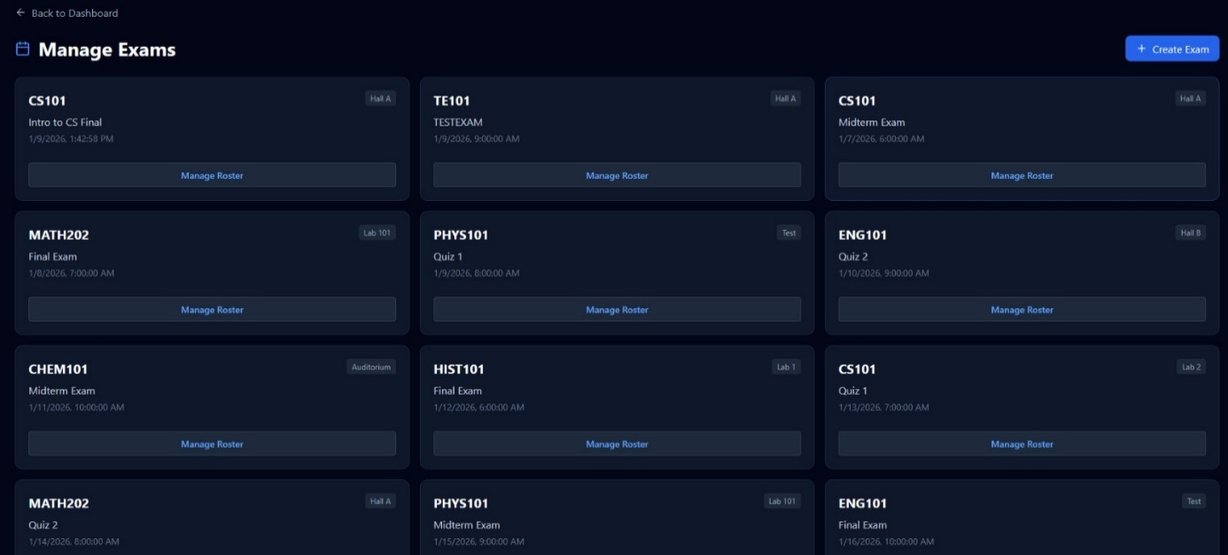

- This section is to create new exams. It includes headline text, course code input, exam name input, exam date input, exam time input, exam room input and save exam button.
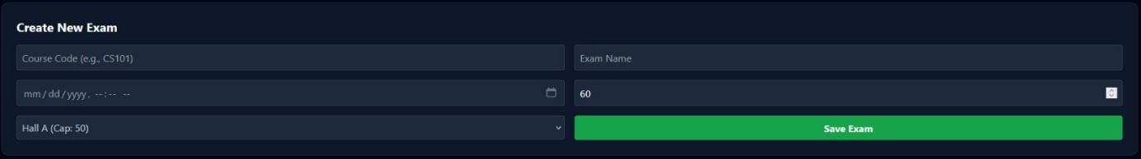

- This section is to manage student, seats and new students of the exam. It includes headline text, close button, student list section, seat map section, add student section, seats section and student input section.

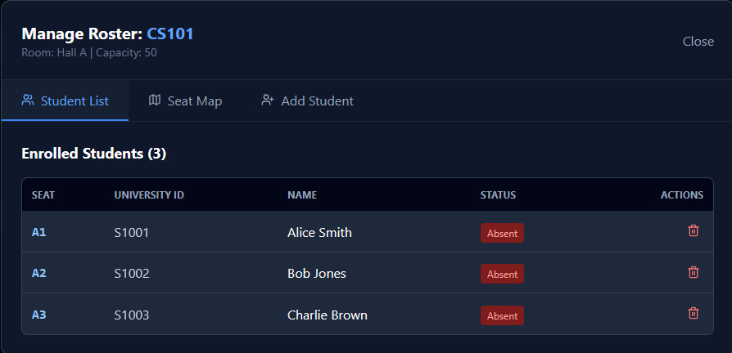

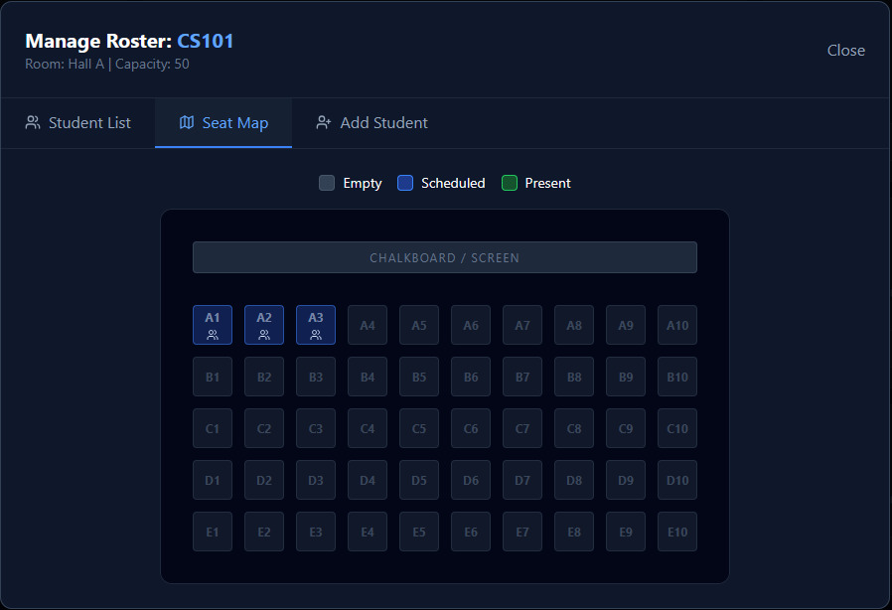

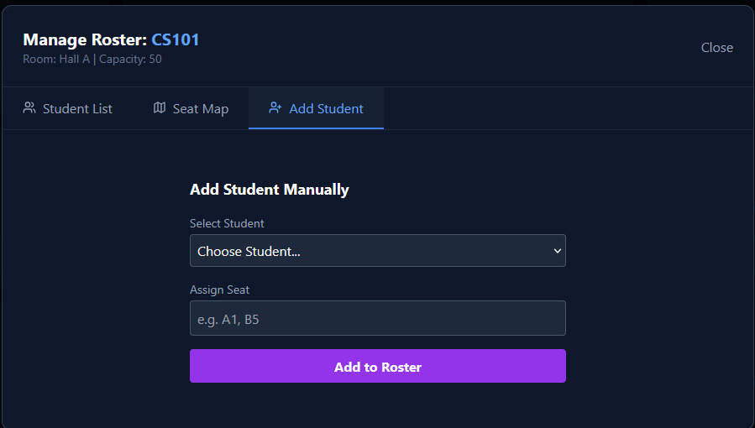

- This section is to manage students and add new students. It includes headline text, add student button and students section.
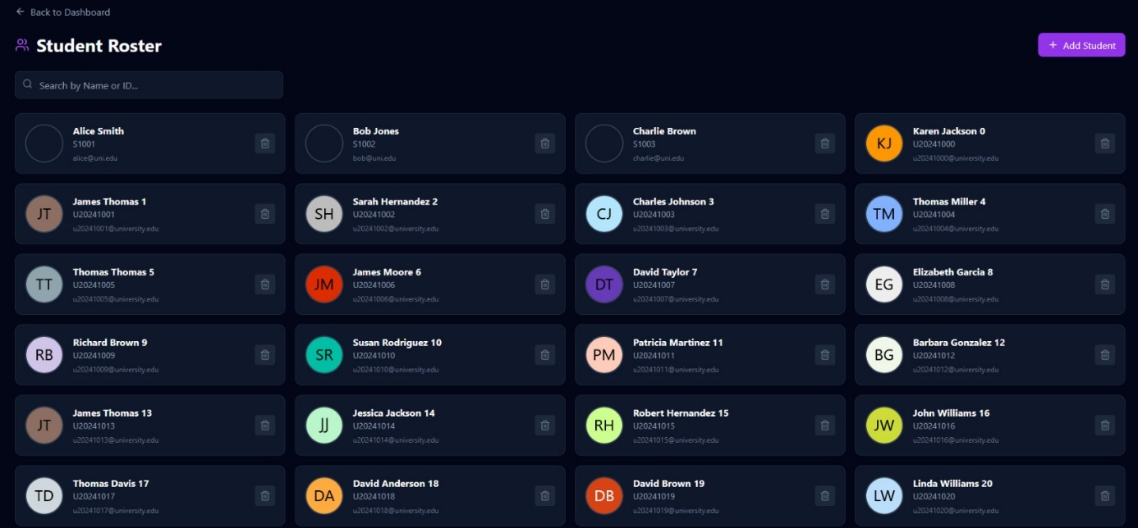

- This section is add new student. It includes headline text, student name input, student id input, student e-mail input, student reference photo input and save student button.
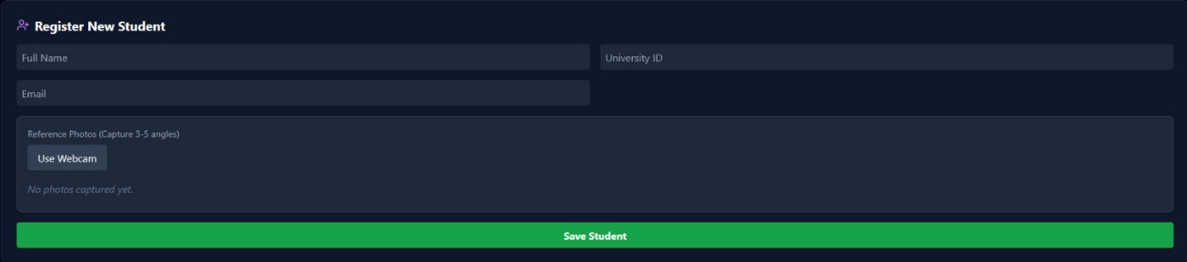

This section is to manage room layouts and add new ones. It includes headline text, add room button, rooms section.
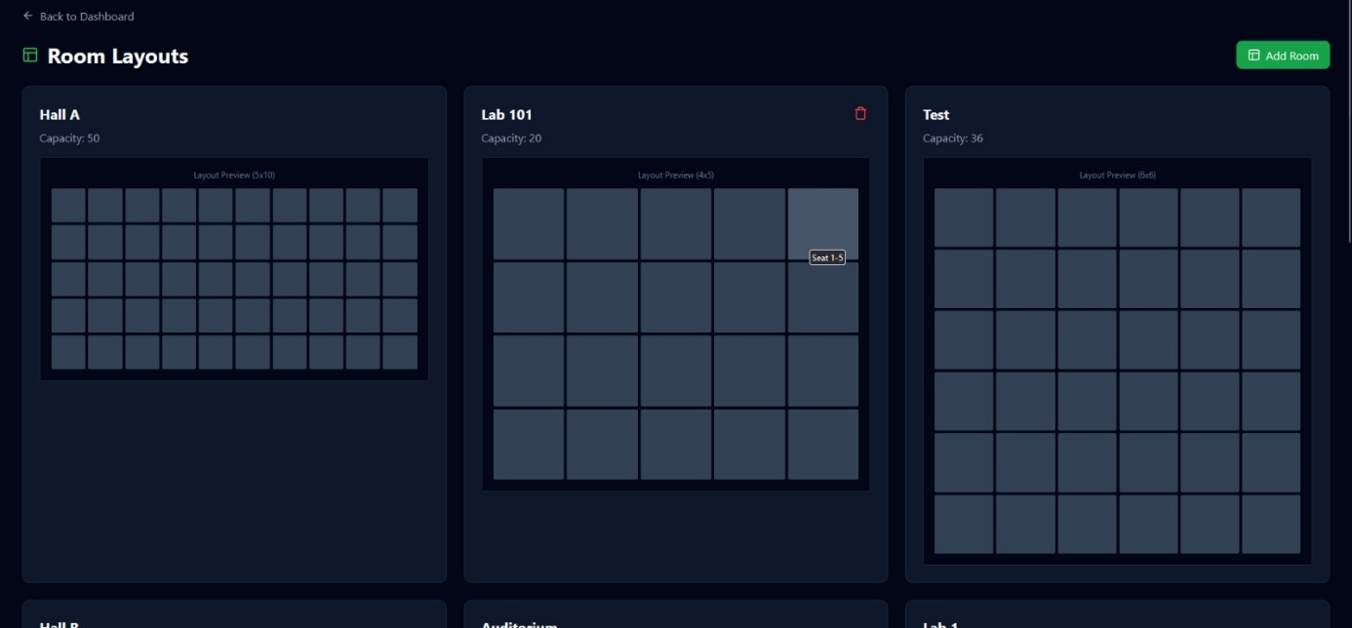

- This section is add room section. It includes headline text, room name input, room rows input, rom columns input, total capacity section and save room button.
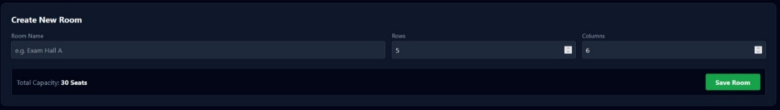

Proctor
- This section is Proctor’s main dashboard. It includes headline text, log-out button, start check-in button and view activity log button.
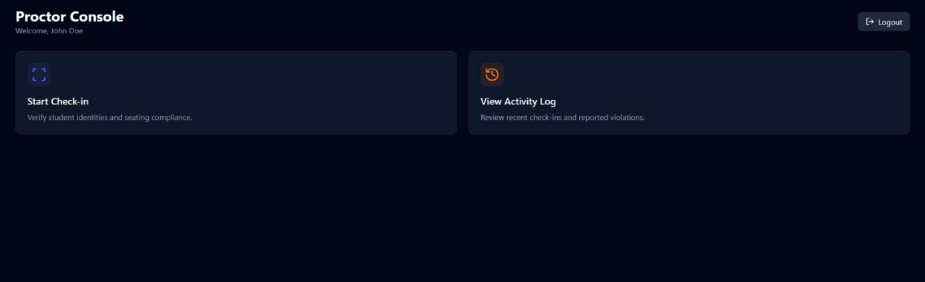

This section is activity log section. You can see which student is match or mismatch. You can report an incident too. It includes headline text, report incident button and activity log section.
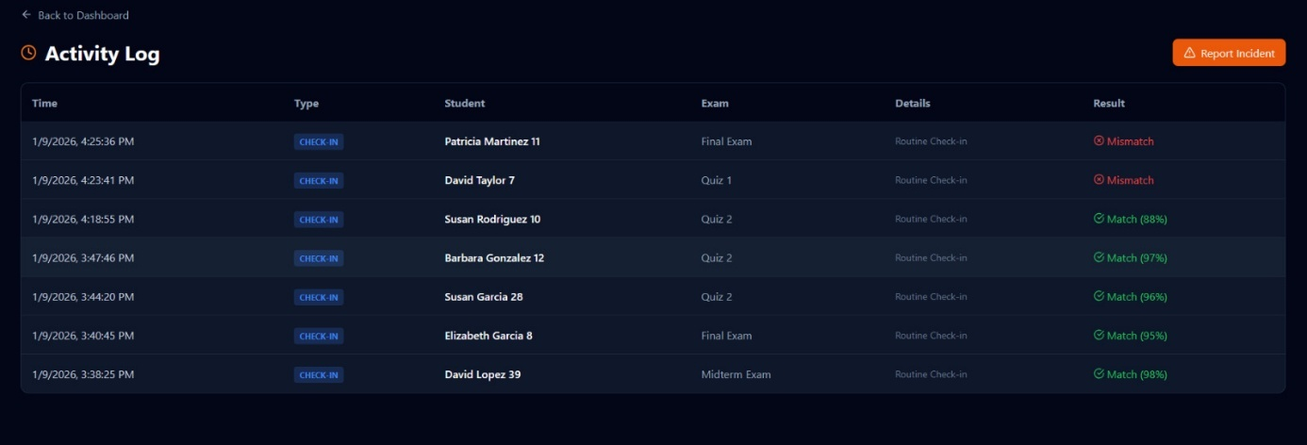

This section is report violation section. It includes headline text, exam input, student input, violation type input, description input, cancel button and submit report button.
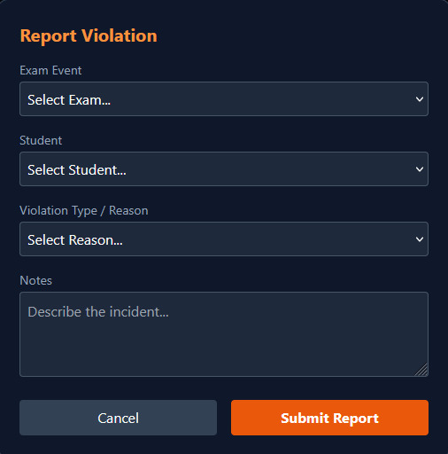

This section is start check-in section. It checks if the student is matched and at the correct seat. It includes headline text, student search filter, students section, seat section, camera section and verify button which concludes if it is match or not.

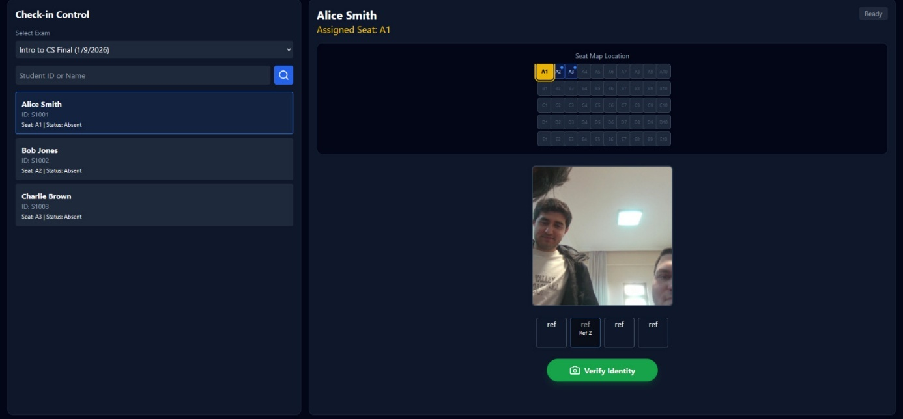

9. References
PlantUML for diagrams. https://www.plantuml.com/plantuml/uml/SyfFKj2rKt3CoKnELR1Io4ZDoSa700003

Mermaid Chart for ERD diagram. https://www.mermaidchart.com/

10. Appendices

A. Use Case Diagrams

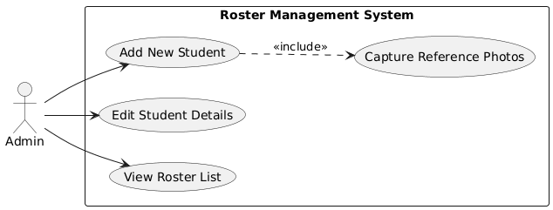

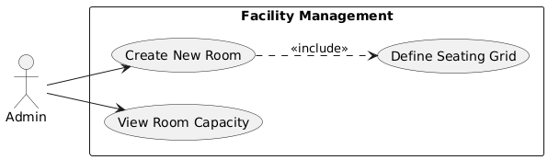
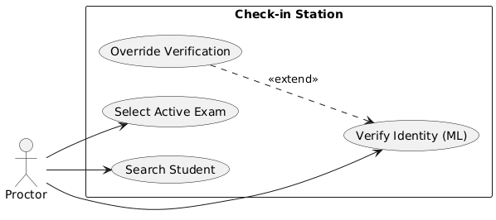
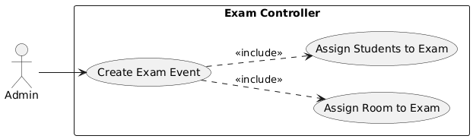
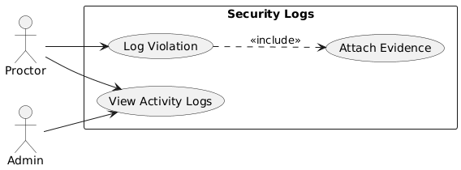

B. Sequence Diagrams

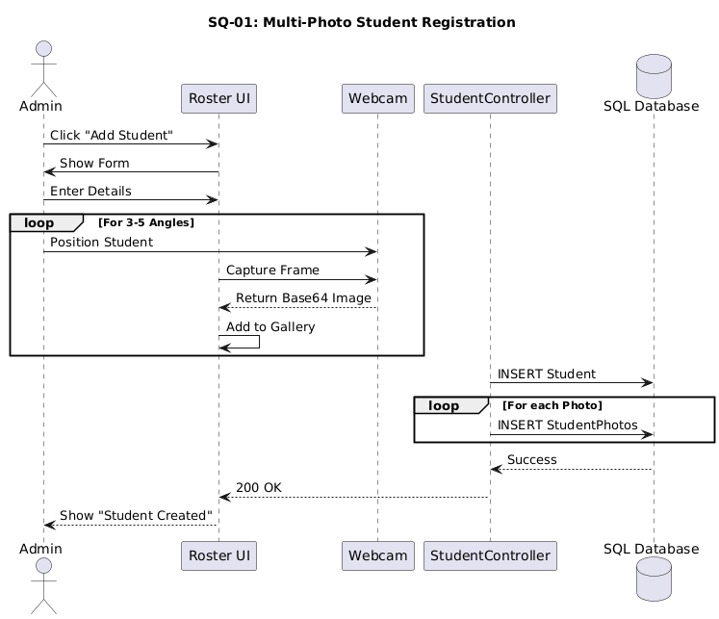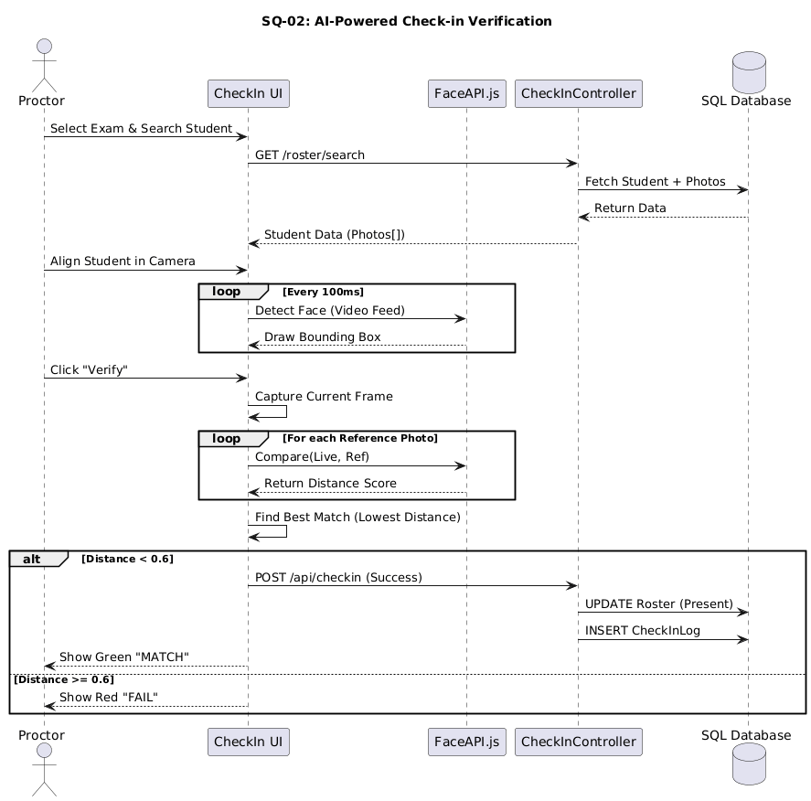

C. Activity Diagram
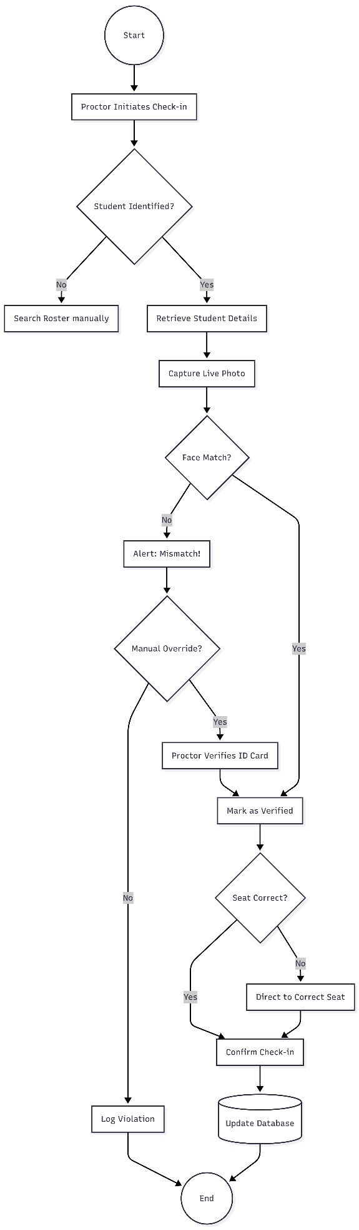

D. Data Dictionary

Data Definition Commands
These commands create the tables, define primary keys, foreign keys, and necessary constraints by MS SQL.

User Table
CREATE TABLE User (
UserID INT IDENTITY(1,1) PRIMARY KEY,
Username NVARCHAR(50) NOT NULL UNIQUE,
PasswordHash NVARCHAR(255) NOT NULL,
Role NVARCHAR(20) NOT NULL CHECK (Role IN ('Admin', 'Proctor')),
FullName NVARCHAR(100)
);

Student Table
CREATE TABLE Student (
StudentID INT IDENTITY(1,1) PRIMARY KEY,
UniversityID NVARCHAR(50) NOT NULL UNIQUE,
FullName NVARCHAR(100) NOT NULL,
Email NVARCHAR(100),
ReferencePhotoUrl NVARCHAR(MAX), -- Path or URL to stored image
FaceEmbedding NVARCHAR(MAX) -- Stored as JSON string if needed, or rely on client-side matching
);

StudentPhoto Table
CREATE TABLE StudentPhoto (
PhotoID INT IDENTITY(1,1) PRIMARY KEY,
StudentID INT FOREIGN KEY REFERENCES Students(StudentID),
PhotoUrl NVARCHAR(MAX) NOT NULL,
CreatedAt DATETIME DEFAULT GETDATE()
);

Room Table
CREATE TABLE Room (
RoomID INT IDENTITY(1,1) PRIMARY KEY,
RoomName NVARCHAR(50) NOT NULL,
Capacity INT,
LayoutConfig NVARCHAR(MAX) -- JSON string describing rows/cols
);

5. Seat Table
CREATE TABLE Seats (
SeatID INT IDENTITY(1,1) PRIMARY KEY,
RoomID INT FOREIGN KEY REFERENCES Rooms(RoomID) ON DELETE CASCADE,
RowLabel NVARCHAR(10),
ColLabel NVARCHAR(10),
IsAccessible BIT DEFAULT 1, -- 1=Normal, 0=Broken or Gap
Status NVARCHAR(20) DEFAULT 'Active'
);

Exam Table
CREATE TABLE Exam (
ExamID INT IDENTITY(1,1) PRIMARY KEY,
CourseCode NVARCHAR(20) NOT NULL,
ExamName NVARCHAR(100) NOT NULL,
StartTime DATETIME NOT NULL,
DurationMinutes INT NOT NULL,
RoomID INT FOREIGN KEY REFERENCES Rooms(RoomID),
CreatedBy INT FOREIGN KEY REFERENCES Users(UserID)
);

ExamRoster Table
CREATE TABLE ExamRoster (
RosterID INT IDENTITY(1,1) PRIMARY KEY,
ExamID INT FOREIGN KEY REFERENCES Exams(ExamID),
StudentID INT FOREIGN KEY REFERENCES Students(StudentID),
AssignedSeat NVARCHAR(20),
Status NVARCHAR(20) DEFAULT 'Scheduled' CHECK (Status IN ('Scheduled', 'Present', 'Absent')),
CheckInTime DATETIME,
UNIQUE(ExamID, StudentID)
);

CheckInLog Table
CREATE TABLE CheckInLog (
LogID INT IDENTITY(1,1) PRIMARY KEY,
RosterID INT FOREIGN KEY REFERENCES ExamRoster(RosterID),
Timestamp DATETIME DEFAULT GETDATE(),
MLConfidenceScore FLOAT,
IsMatch BIT,
IsSeatCorrect BIT,
CapturedImagePath NVARCHAR(MAX)
);

Violation Table
CREATE TABLE Violation (
ViolationID INT IDENTITY(1,1) PRIMARY KEY,
ExamID INT FOREIGN KEY REFERENCES Exams(ExamID),
StudentID INT FOREIGN KEY REFERENCES Students(StudentID),
Reason NVARCHAR(100),
Notes NVARCHAR(MAX),
EvidenceImagePath NVARCHAR(MAX),
ReportedAt DATETIME DEFAULT GETDATE(),
ReportedBy INT FOREIGN KEY REFERENCES Users(UserID)
);

Data Manipulation Commands (Sample Data)
These commands populate the tables with meaningful sample data.

Seed Users
INSERT INTO Users (Username, PasswordHash, Role, FullName) VALUES ('admin', '$2b$10$YourHashedPasswordHere', 'Admin', 'System Administrator');

INSERT INTO Users (Username, PasswordHash, Role, FullName) VALUES ('proctor1', '$2b$10$YourHashedPasswordHere', 'Proctor', 'Jane Doe Proctor');

Seed Rooms
DECLARE @Rooms TABLE (Name NVARCHAR(50), Cap INT, Cfg NVARCHAR(MAX));
INSERT INTO @Rooms VALUES
('Hall A', 30, '{"rows":5,"cols":6}'),
('Hall B', 64, '{"rows":8,"cols":8}'),
('Auditorium', 150, '{"rows":10,"cols":15}'),
('Lab 1', 20, '{"rows":4,"cols":5}'),
('Lab 2', 20, '{"rows":4,"cols":5}'),
('Lecture Hall 101', 60, '{"rows":6,"cols":10}'),
('Seminar Room A', 24, '{"rows":3,"cols":8}');

MERGE INTO Rooms AS Target
USING @Rooms AS Source
ON Target.RoomName = Source.Name
WHEN NOT MATCHED BY TARGET THEN
INSERT (RoomName, Capacity, LayoutConfig) VALUES (Source.Name, Source.Cap, Source.Cfg);

Seed Students
DECLARE @ManualStudents TABLE (
UniversityID NVARCHAR(50),
FullName NVARCHAR(100),
Email NVARCHAR(100),
ReferencePhotoUrl NVARCHAR(MAX)
);

INSERT INTO @ManualStudents (UniversityID, FullName, Email, ReferencePhotoUrl) VALUES
('U2024001', 'James Smith', 'u2024001@university.edu', 'https://ui-avatars.com/api/?name=James+Smith&background=0D8ABC&color=fff'),
('U2024002', 'Mary Johnson', 'u2024002@university.edu', 'https://ui-avatars.com/api/?name=Mary+Johnson&background=1D9ABC&color=fff'),
('U2024003', 'John Williams', 'u2024003@university.edu', 'https://ui-avatars.com/api/?name=John+Williams&background=2DABC0&color=fff'),
('U2024004', 'Patricia Brown', 'u2024004@university.edu', 'https://ui-avatars.com/api/?name=Patricia+Brown&background=3DBCC4&color=fff'),
('U2024005', 'Robert Jones', 'u2024005@university.edu', 'https://ui-avatars.com/api/?name=Robert+Jones&background=4DCDD8&color=fff'),
('U2024006', 'Jennifer Garcia', 'u2024006@university.edu', 'https://ui-avatars.com/api/?name=Jennifer+Garcia&background=5DDDE0&color=fff'),
('U2024007', 'Michael Miller', 'u2024007@university.edu', 'https://ui-avatars.com/api/?name=Michael+Miller&background=6DEEF4&color=fff'),
('U2024008', 'Linda Davis', 'u2024008@university.edu', 'https://ui-avatars.com/api/?name=Linda+Davis&background=7DFF08&color=fff'),
('U2024009', 'William Rodriguez', 'u2024009@university.edu', 'https://ui-avatars.com/api/?name=William+Rodriguez&background=8E001C&color=fff'),
('U2024010', 'Elizabeth Martinez', 'u2024010@university.edu', 'https://ui-avatars.com/api/?name=Elizabeth+Martinez&background=9F1120&color=fff'),
('U2024011', 'David Hernandez', 'u2024011@university.edu', 'https://ui-avatars.com/api/?name=David+Hernandez&background=A02234&color=fff'),
('U2024012', 'Barbara Lopez', 'u2024012@university.edu', 'https://ui-avatars.com/api/?name=Barbara+Lopez&background=B13348&color=fff'),
('U2024013', 'Richard Gonzalez', 'u2024013@university.edu', 'https://ui-avatars.com/api/?name=Richard+Gonzalez&background=C2445C&color=fff'),
('U2024014', 'Susan Wilson', 'u2024014@university.edu', 'https://ui-avatars.com/api/?name=Susan+Wilson&background=D35570&color=fff'),
('U2024015', 'Joseph Anderson', 'u2024015@university.edu', 'https://ui-avatars.com/api/?name=Joseph+Anderson&background=E46684&color=fff'),
('U2024016', 'Jessica Thomas', 'u2024016@university.edu', 'https://ui-avatars.com/api/?name=Jessica+Thomas&background=F57798&color=fff'),
('U2024017', 'Thomas Taylor', 'u2024017@university.edu', 'https://ui-avatars.com/api/?name=Thomas+Taylor&background=0688AC&color=fff'),
('U2024018', 'Sarah Moore', 'u2024018@university.edu', 'https://ui-avatars.com/api/?name=Sarah+Moore&background=1799C0&color=fff'),
('U2024019', 'Charles Jackson', 'u2024019@university.edu', 'https://ui-avatars.com/api/?name=Charles+Jackson&background=28AAD4&color=fff'),
('U2024020', 'Karen Martin', 'u2024020@university.edu', 'https://ui-avatars.com/api/?name=Karen+Martin&background=39BBE8&color=fff'),
('U2024021', 'Christopher Lee', 'u2024021@university.edu', 'https://ui-avatars.com/api/?name=Christopher+Lee&background=4ACCF0&color=fff'),
('U2024022', 'Lisa Perez', 'u2024022@university.edu', 'https://ui-avatars.com/api/?name=Lisa+Perez&background=5BDD04&color=fff'),
('U2024023', 'Daniel Thompson', 'u2024023@university.edu', 'https://ui-avatars.com/api/?name=Daniel+Thompson&background=6CEE18&color=fff'),
('U2024024', 'Nancy White', 'u2024024@university.edu', 'https://ui-avatars.com/api/?name=Nancy+White&background=7DFF2C&color=fff'),
('U2024025', 'Paul Harris', 'u2024025@university.edu', 'https://ui-avatars.com/api/?name=Paul+Harris&background=8E0040&color=fff'),
('U2024026', 'Betty Sanchez', 'u2024026@university.edu', 'https://ui-avatars.com/api/?name=Betty+Sanchez&background=9F1154&color=fff'),
('U2024027', 'Mark Clark', 'u2024027@university.edu', 'https://ui-avatars.com/api/?name=Mark+Clark&background=A02268&color=fff'),
('U2024028', 'Margaret Ramirez', 'u2024028@university.edu', 'https://ui-avatars.com/api/?name=Margaret+Ramirez&background=B1337C&color=fff'),
('U2024029', 'Donald Lewis', 'u2024029@university.edu', 'https://ui-avatars.com/api/?name=Donald+Lewis&background=C24490&color=fff'),
('U2024030', 'Sandra Robinson', 'u2024030@university.edu', 'https://ui-avatars.com/api/?name=Sandra+Robinson&background=D355A4&color=fff'),
('U2024031', 'George Walker', 'u2024031@university.edu', 'https://ui-avatars.com/api/?name=George+Walker&background=E466B8&color=fff'),
('U2024032', 'Ashley Young', 'u2024032@university.edu', 'https://ui-avatars.com/api/?name=Ashley+Young&background=F577CC&color=fff'),
('U2024033', 'Kenneth Allen', 'u2024033@university.edu', 'https://ui-avatars.com/api/?name=Kenneth+Allen&background=0688E0&color=fff'),
('U2024034', 'Kimberly King', 'u2024034@university.edu', 'https://ui-avatars.com/api/?name=Kimberly+King&background=1799F4&color=fff'),
('U2024035', 'Steven Wright', 'u2024035@university.edu', 'https://ui-avatars.com/api/?name=Steven+Wright&background=28AA08&color=fff'),
('U2024036', 'Donna Scott', 'u2024036@university.edu', 'https://ui-avatars.com/api/?name=Donna+Scott&background=39BB1C&color=fff'),
('U2024037', 'Edward Torres', 'u2024037@university.edu', 'https://ui-avatars.com/api/?name=Edward+Torres&background=4ACC30&color=fff'),
('U2024038', 'Michelle Nguyen', 'u2024038@university.edu', 'https://ui-avatars.com/api/?name=Michelle+Nguyen&background=5BDD44&color=fff'),
('U2024039', 'Brian Hill', 'u2024039@university.edu', 'https://ui-avatars.com/api/?name=Brian+Hill&background=6CEE58&color=fff'),
('U2024040', 'Emily Flores', 'u2024040@university.edu', 'https://ui-avatars.com/api/?name=Emily+Flores&background=7DFF6C&color=fff'),
('U2024041', 'Ronald Green', 'u2024041@university.edu', 'https://ui-avatars.com/api/?name=Ronald+Green&background=8E0080&color=fff'),
('U2024042', 'Dorothy Adams', 'u2024042@university.edu', 'https://ui-avatars.com/api/?name=Dorothy+Adams&background=9F1194&color=fff'),
('U2024043', 'Anthony Nelson', 'u2024043@university.edu', 'https://ui-avatars.com/api/?name=Anthony+Nelson&background=A022A8&color=fff'),
('U2024044', 'Melissa Baker', 'u2024044@university.edu', 'https://ui-avatars.com/api/?name=Melissa+Baker&background=B133BC&color=fff'),
('U2024045', 'Kevin Hall', 'u2024045@university.edu', 'https://ui-avatars.com/api/?name=Kevin+Hall&background=C244D0&color=fff'),
('U2024046', 'Deborah Rivera', 'u2024046@university.edu', 'https://ui-avatars.com/api/?name=Deborah+Rivera&background=D355E4&color=fff'),
('U2024047', 'Jason Campbell', 'u2024047@university.edu', 'https://ui-avatars.com/api/?name=Jason+Campbell&background=E466F8&color=fff'),
('U2024048', 'Stephanie Mitchell', 'u2024048@university.edu', 'https://ui-avatars.com/api/?name=Stephanie+Mitchell&background=F5770C&color=fff'),
('U2024049', 'Matthew Carter', 'u2024049@university.edu', 'https://ui-avatars.com/api/?name=Matthew+Carter&background=068820&color=fff'),
('U2024050', 'Rebecca Roberts', 'u2024050@university.edu', 'https://ui-avatars.com/api/?name=Rebecca+Roberts&background=179934&color=fff');

-- Merge into Students (Idempotent Insert)
MERGE INTO Students AS Target
USING @ManualStudents AS Source
ON Target.UniversityID = Source.UniversityID
WHEN NOT MATCHED BY TARGET THEN
INSERT (UniversityID, FullName, Email, ReferencePhotoUrl)
VALUES (Source.UniversityID, Source.FullName, Source.Email, Source.ReferencePhotoUrl);

-- Populate Photos Table (Idempotent)
INSERT INTO StudentPhotos (StudentID, PhotoUrl)
SELECT s.StudentID, s.ReferencePhotoUrl
FROM Students s
WHERE s.ReferencePhotoUrl IS NOT NULL
AND NOT EXISTS (SELECT 1 FROM StudentPhotos WHERE StudentID = s.StudentID);

Seed Exams
DECLARE @AdminID INT = (SELECT TOP 1 UserID FROM Users WHERE Role = 'Admin');
-- Rooms
DECLARE @HallA INT = (SELECT RoomID FROM Rooms WHERE RoomName = 'Hall A');
DECLARE @HallB INT = (SELECT RoomID FROM Rooms WHERE RoomName = 'Hall B');
DECLARE @Audit INT = (SELECT RoomID FROM Rooms WHERE RoomName = 'Auditorium');

IF NOT EXISTS (SELECT 1 FROM Exams WHERE CourseCode = 'CS101' AND ExamName = 'Midterm Exam')
INSERT INTO Exams (CourseCode, ExamName, StartTime, DurationMinutes, RoomID, CreatedBy) VALUES
('CS101', 'Midterm Exam', DATEADD(DAY, 2, GETDATE()), 90, @HallA, @AdminID);

IF NOT EXISTS (SELECT 1 FROM Exams WHERE CourseCode = 'MATH202' AND ExamName = 'Calculus Final')
INSERT INTO Exams (CourseCode, ExamName, StartTime, DurationMinutes, RoomID, CreatedBy) VALUES
('MATH202', 'Calculus Final', DATEADD(DAY, 4, GETDATE()), 120, @HallB, @AdminID);

IF NOT EXISTS (SELECT 1 FROM Exams WHERE CourseCode = 'ENG101' AND ExamName = 'Literature Quiz')
INSERT INTO Exams (CourseCode, ExamName, StartTime, DurationMinutes, RoomID, CreatedBy) VALUES
('ENG101', 'Literature Quiz', GETDATE(), 60, @Audit, @AdminID);

Seed Roster
-- CS101 (Hall A, Cap 30) - Add 25 students
DECLARE @Exam1 INT = (SELECT TOP 1 ExamID FROM Exams WHERE CourseCode = 'CS101' ORDER BY ExamID DESC);

INSERT INTO ExamRoster (ExamID, StudentID, AssignedSeat, Status)
SELECT TOP 25
@Exam1, StudentID,
CONCAT(CHAR(65 + (ROW_NUMBER() OVER(ORDER BY StudentID)-1)/6), (ROW_NUMBER() OVER(ORDER BY StudentID)-1)%6 + 1),
'Scheduled'
FROM Students
WHERE StudentID BETWEEN (SELECT MIN(StudentID) FROM Students) AND (SELECT MIN(StudentID) + 24 FROM Students)
AND NOT EXISTS (SELECT 1 FROM ExamRoster WHERE ExamID = @Exam1 AND StudentID = Students.StudentID);

-- MATH202 (Hall B, Cap 64) - Add next 25 students
DECLARE @Exam2 INT = (SELECT TOP 1 ExamID FROM Exams WHERE CourseCode = 'MATH202' ORDER BY ExamID DESC);

INSERT INTO ExamRoster (ExamID, StudentID, AssignedSeat, Status)
SELECT TOP 25
@Exam2, StudentID,
CONCAT(CHAR(65 + (ROW_NUMBER() OVER(ORDER BY StudentID)-1)/8), (ROW_NUMBER() OVER(ORDER BY StudentID)-1)%8 + 1),
'Scheduled'
FROM Students
WHERE StudentID >= (SELECT MIN(StudentID) + 25 FROM Students)
AND NOT EXISTS (SELECT 1 FROM ExamRoster WHERE ExamID = @Exam2 AND StudentID = Students.StudentID);

E. Links

Jira : https://oswinberke9.atlassian.net/jira/software/projects/ESS/summary
Bitbucket : https://bitbucket.org/berkecanakyuz/examsecuritysystem/src/main/

