HACETTEPE UNIVERSITY
ELECTRICAL AND ELECTRONICS ENGINEERING

ELE432 - Advanced Digital Design

HOMEWORK 2-Multicycle Processor Controller

Name & Surname: BERKE MALÇOK
Student ID: 2210357081


,

Q1)
I spent approximately 12 hours completing this lab. The most time-consuming part was analyzing the synchronization between the testbench's clock edges and the FSM state transitions to ensure the outputs matched the expected test vectors perfectly.

Q2)
The full hierarchical design consists of the controller (top module), maindec (FSM), aludec (ALU Control), and instrdec (Immediate Decoder).
code
CONTROLLER
module controller(
input logic clk,
input logic reset,
input logic [6:0] op,
input logic [2:0] funct3,
input logic funct7b5,
input logic zero,
output logic [1:0] immsrc,
output logic [1:0] alusrca,
output logic [1:0] alusrcb,
output logic [1:0] resultsrc,
output logic adrsrc,
output logic [2:0] alucontrol,
output logic irwrite,
output logic pcwrite,
output logic regwrite,
output logic memwrite
);

logic [1:0] aluop;
logic branch;
logic pcupdate;

maindec md(
.clk(clk),
.reset(reset),
.op(op),
.alusrca(alusrca),
.alusrcb(alusrcb),
.resultsrc(resultsrc),
.adrsrc(adrsrc),
.irwrite(irwrite),
.regwrite(regwrite),
.memwrite(memwrite),
.branch(branch),
.pcupdate(pcupdate),
.aluop(aluop)
);

aludec ad(
.opb5(op[5]),
.funct3(funct3),
.funct7b5(funct7b5),
.aluop(aluop),
.alucontrol(alucontrol)
);

instrdec id(
.op(op),
.immsrc(immsrc)
);

assign pcwrite = pcupdate | (branch & zero);

endmodule
MAINDEC
module maindec(
input logic clk,
input logic reset,
input logic [6:0] op,
output logic [1:0] alusrca,
output logic [1:0] alusrcb,
output logic [1:0] resultsrc,
output logic adrsrc,
output logic irwrite,
output logic regwrite,
output logic memwrite,
output logic branch,
output logic pcupdate,
output logic [1:0] aluop
);

typedef enum logic [3:0] {
S0_FETCH = 4'd0,
S1_DECODE = 4'd1,
S2_MEMADR = 4'd2,
S3_MEMREAD = 4'd3,
S4_MEMWB = 4'd4,
S5_MEMWRITE = 4'd5,
S6_EXECUTER = 4'd6,
S7_ALUWB = 4'd7,
S8_EXECUTEI = 4'd8,
S9_JAL = 4'd9,
S10_BEQ = 4'd10
} statetype;

statetype state, nextstate;

always_ff @(posedge clk or posedge reset) begin
if (reset)
state <= S0_FETCH;
else
state <= nextstate;
end

always_comb begin
case (state)
S0_FETCH: nextstate = S1_DECODE;

S1_DECODE: begin
case (op)
7'b0000011: nextstate = S2_MEMADR; // lw
7'b0100011: nextstate = S2_MEMADR; // sw
7'b0110011: nextstate = S6_EXECUTER; // R-type
7'b0010011: nextstate = S8_EXECUTEI; // I-type ALU
7'b1101111: nextstate = S9_JAL; // jal
7'b1100011: nextstate = S10_BEQ; // beq
default: nextstate = S0_FETCH;
endcase
end

S2_MEMADR: begin
case (op)
7'b0000011: nextstate = S3_MEMREAD; // lw
7'b0100011: nextstate = S5_MEMWRITE; // sw
default: nextstate = S0_FETCH;
endcase
end

S3_MEMREAD: nextstate = S4_MEMWB;
S4_MEMWB: nextstate = S0_FETCH;
S5_MEMWRITE: nextstate = S0_FETCH;
S6_EXECUTER: nextstate = S7_ALUWB;
S7_ALUWB: nextstate = S0_FETCH;
S8_EXECUTEI: nextstate = S7_ALUWB;
S9_JAL: nextstate = S7_ALUWB;
S10_BEQ: nextstate = S0_FETCH;
default: nextstate = S0_FETCH;
endcase
end

always_comb begin
alusrca = 2'b00;
alusrcb = 2'b00;
resultsrc = 2'b00;
adrsrc = 1'b0;
irwrite = 1'b0;
regwrite = 1'b0;
memwrite = 1'b0;
branch = 1'b0;
pcupdate = 1'b0;
aluop = 2'b00;

case (state)
S0_FETCH: begin
alusrca = 2'b00;
alusrcb = 2'b10;
resultsrc = 2'b10;
adrsrc = 1'b0;
irwrite = 1'b1;
pcupdate = 1'b1;
regwrite = 1'b0;
memwrite = 1'b0;
branch = 1'b0;
aluop = 2'b00;
end

S1_DECODE: begin
alusrca = 2'b01;
alusrcb = 2'b01;
resultsrc = 2'b00;
adrsrc = 1'b0;
irwrite = 1'b0;
pcupdate = 1'b0;
regwrite = 1'b0;
memwrite = 1'b0;
branch = 1'b0;
aluop = 2'b00;
end

S2_MEMADR: begin
alusrca = 2'b10;
alusrcb = 2'b01;
resultsrc = 2'b00;
adrsrc = 1'b0;
irwrite = 1'b0;
pcupdate = 1'b0;
regwrite = 1'b0;
memwrite = 1'b0;
branch = 1'b0;
aluop = 2'b00;
end

S3_MEMREAD: begin
alusrca = 2'b00;
alusrcb = 2'b00;
resultsrc = 2'b00;
adrsrc = 1'b1;
irwrite = 1'b0;
pcupdate = 1'b0;
regwrite = 1'b0;
memwrite = 1'b0;
branch = 1'b0;
aluop = 2'b00;
end

S4_MEMWB: begin
alusrca = 2'b00;
alusrcb = 2'b00;
resultsrc = 2'b01;
adrsrc = 1'b0;
irwrite = 1'b0;
pcupdate = 1'b0;
regwrite = 1'b1;
memwrite = 1'b0;
branch = 1'b0;
aluop = 2'b00;
end

S5_MEMWRITE: begin
alusrca = 2'b00;
alusrcb = 2'b00;
resultsrc = 2'b00;
adrsrc = 1'b1;
irwrite = 1'b0;
pcupdate = 1'b0;
regwrite = 1'b0;
memwrite = 1'b1;
branch = 1'b0;
aluop = 2'b00;
end

S6_EXECUTER: begin
alusrca = 2'b10;
alusrcb = 2'b00;
resultsrc = 2'b00;
adrsrc = 1'b0;
irwrite = 1'b0;
pcupdate = 1'b0;
regwrite = 1'b0;
memwrite = 1'b0;
branch = 1'b0;
aluop = 2'b10;
end

S7_ALUWB: begin
alusrca = 2'b00;
alusrcb = 2'b00;
resultsrc = 2'b00;
adrsrc = 1'b0;
irwrite = 1'b0;
pcupdate = 1'b0;
regwrite = 1'b1;
memwrite = 1'b0;
branch = 1'b0;
aluop = 2'b00;
end

S8_EXECUTEI: begin
alusrca = 2'b10;
alusrcb = 2'b01;
resultsrc = 2'b00;
adrsrc = 1'b0;
irwrite = 1'b0;
pcupdate = 1'b0;
regwrite = 1'b0;
memwrite = 1'b0;
branch = 1'b0;
aluop = 2'b10;
end

S9_JAL: begin
alusrca = 2'b01;
alusrcb = 2'b10;
resultsrc = 2'b00;
adrsrc = 1'b0;
irwrite = 1'b0;
pcupdate = 1'b1;
regwrite = 1'b0;
memwrite = 1'b0;
branch = 1'b0;
aluop = 2'b00;
end

S10_BEQ: begin
alusrca = 2'b10;
alusrcb = 2'b00;
resultsrc = 2'b00;
adrsrc = 1'b0;
irwrite = 1'b0;
pcupdate = 1'b0;
regwrite = 1'b0;
memwrite = 1'b0;
branch = 1'b1;
aluop = 2'b01;
end

default: begin
alusrca = 2'b00;
alusrcb = 2'b00;
resultsrc = 2'b00;
adrsrc = 1'b0;
irwrite = 1'b0;
regwrite = 1'b0;
memwrite = 1'b0;
branch = 1'b0;
pcupdate = 1'b0;
aluop = 2'b00;
end
endcase
end

endmodule

ALUDEC
module aludec(
input logic opb5,
input logic [2:0] funct3,
input logic funct7b5,
input logic [1:0] aluop,
output logic [2:0] alucontrol
);

logic rtypesub;

assign rtypesub = funct7b5 & opb5;

always_comb begin
case (aluop)
2'b00: alucontrol = 3'b010; // add
2'b01: alucontrol = 3'b110; // sub
default: begin
case (funct3)
3'b000: alucontrol = rtypesub ? 3'b110 : 3'b010; // sub / add-addi
3'b010: alucontrol = 3'b111; // slt
3'b110: alucontrol = 3'b001; // or
3'b111: alucontrol = 3'b000; // and
default: alucontrol = 3'b010;
endcase
end
endcase
end

endmodule

INSTRDEC
module instrdec(
input logic [6:0] op,
output logic [1:0] immsrc
);

always_comb begin
case (op)
7'b0110011: immsrc = 2'bxx; // R-type
7'b0010011: immsrc = 2'b00; // I-type ALU
7'b0000011: immsrc = 2'b00; // lw
7'b0100011: immsrc = 2'b01; // sw
7'b1100011: immsrc = 2'b10; // beq
7'b1101111: immsrc = 2'b11; // jal
default: immsrc = 2'b00;
endcase
end

endmodule

Q3)
Debug & Design Note: Resolution of ALU Specification Mismatch
In the initial stage of my design, I implemented the aludec.sv module strictly following Table 1 from the lab manual. However, during simulation, I encountered multiple errors in the transcript. To debug this, I analyzed the controller.tv file and the simulation waveforms.
I identified that the errors were caused by a mismatch between the lab manual and the testbench:
Table 1 uses 000 for ADD and 001 for SUB.
The testbench (controller.tv) expects 010 for ADD and 110 for SUB.
By identifying this conflict, I realized that the testbench follows the universal RISC-V standards. I then updated my aludec.sv module to match these standard codes. This debug process resolved all mismatches, and the final simulation successfully passed with 0 errors.
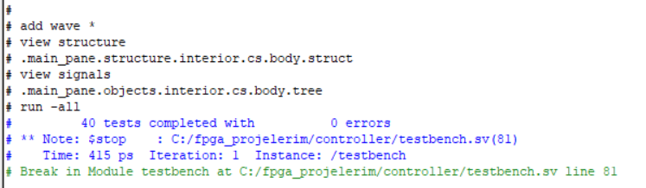
Yes, the implemented controller successfully passes all test vectors provided in the controller.tv file without any errors.

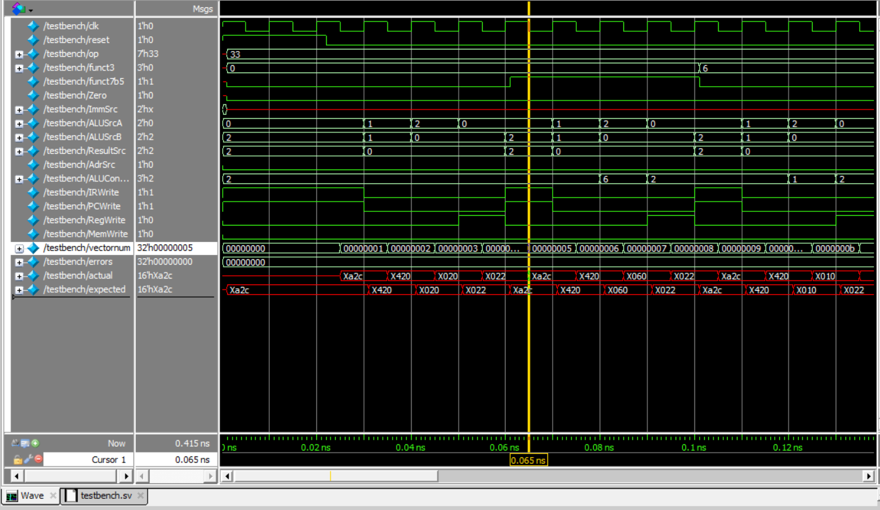

The testbench samples the outputs at the negative clock edge (0.065 ns). As seen in the waveform, the controller's actual output perfectly matches the expected value (16'hXa2c). This confirms that the FSM state transitions and decoder logics are timed and functioning exactly as required.
Q4)
GitHub Link: https://github.com/berkeee112/RISC-V-Multicycle-Controller.git

