HACETTEPE UNIVERSITY
ELECTRICAL AND ELECTRONICS ENGINEERING

ELE432 - Advanced Digital Design

PRELIMINARY WORK III - Multicycle Processor

Name & Surname: BERKE MALÇOK
Student ID: 2210357081



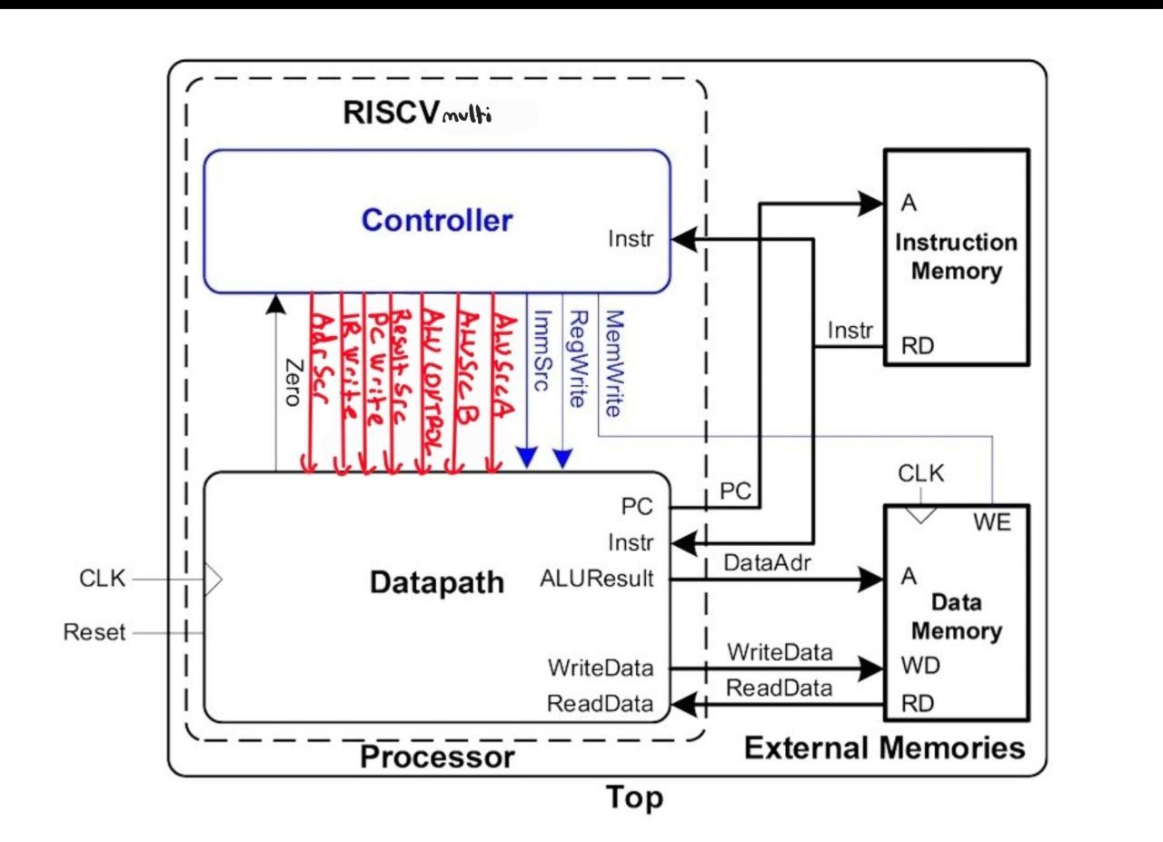
1)
The total time spent on this lab is approximately 4 hours. Since the single-cycle processor and the controller design were already completed in Lab 2 and Homework 2, the implementation of the multicycle processor took less time.
2)

3)
The design follows a hierarchical structure as shown below:
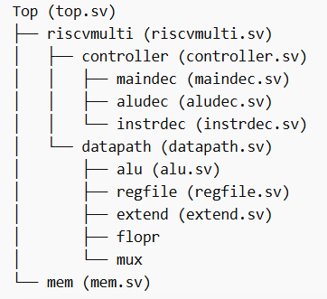

top.sv
module top(
input logic clk, reset,
output logic [31:0] WriteData, DataAdr,
output logic MemWrite
);

logic [31:0] ReadData;

riscvmulti rvmulti(
.clk(clk),
.reset(reset),
.MemWrite(MemWrite),
.Adr(DataAdr),
.WriteData(WriteData),
.ReadData(ReadData)
);

mem mem1(
.clk(clk),
.we(MemWrite),
.a(DataAdr),
.wd(WriteData),
.rd(ReadData)
);

endmodule
Riscvmulti.sv
module riscvmulti(
input logic clk, reset,
output logic MemWrite,
output logic [31:0] Adr, WriteData,
input logic [31:0] ReadData
);

logic [6:0] op;
logic [2:0] funct3;
logic funct7b5;
logic Zero;

logic [1:0] ImmSrc;
logic [1:0] ALUSrcA, ALUSrcB;
logic [1:0] ResultSrc;
logic AdrSrc;
logic [2:0] ALUControl;
logic IRWrite, PCWrite, RegWrite;

logic [31:0] Instr;

controller c(
.clk(clk),
.reset(reset),
.op(op),
.funct3(funct3),
.funct7b5(funct7b5),
.zero(Zero),
.immsrc(ImmSrc),
.alusrca(ALUSrcA),
.alusrcb(ALUSrcB),
.resultsrc(ResultSrc),
.adrsrc(AdrSrc),
.alucontrol(ALUControl),
.irwrite(IRWrite),
.pcwrite(PCWrite),
.regwrite(RegWrite),
.memwrite(MemWrite)
);

datapath dp(
.clk(clk),
.reset(reset),
.ImmSrc(ImmSrc),
.ALUSrcA(ALUSrcA),
.ALUSrcB(ALUSrcB),
.ResultSrc(ResultSrc),
.AdrSrc(AdrSrc),
.ALUControl(ALUControl),
.IRWrite(IRWrite),
.PCWrite(PCWrite),
.RegWrite(RegWrite),
.ReadData(ReadData),
.Zero(Zero),
.Adr(Adr),
.WriteData(WriteData),
.Instr(Instr)
);

assign op = Instr[6:0];
assign funct3 = Instr[14:12];
assign funct7b5 = Instr[30];

endmodule

4)
Step | PC | Instr | State | Result | Result Notes
3 | 0x00 | 0x00500113 | S0: Fetch | 4 | PC + 4
4 | 0x04 | 0x00500113 | S1: Decode | X | OldPC + immediate
5 | 0x04 | 0x00500113 | S8: ExecuteI | X | ALUResult = x0 (0) + 5 = 5
6 | 0x04 | 0x00500113 | S7: ALUWB | 5 | Result=ALUOUT
7 | 0x04 | 0x00C00193 | Fetch | 8 | PC + 4
8 | 0x08 | 0x00C00193 | S1: Decode | X | OldPC + immediate
9 | 0x08 | 0x00C00193 | S8: ExecuteI | X | ALUResult = x0 (0) + 12 = 12
10 | 0x08 | 0x00C00193 | S7: ALUWB | 12 | Result = ALUOUT
11 | 0x08 | 0x0021C233 | Fetch | 12 | PC + 4
12 | 0x0C | 0x0021C233 | S1: Decode | X | Register read
13 | 0x0C | 0x0021C233 | S6: ExecuteR | X | ALUResult = 12 xor 5 = 9
14 | 0x0C | 0x0021C233 | S7: ALUWB | 9 | Result = ALUOUT
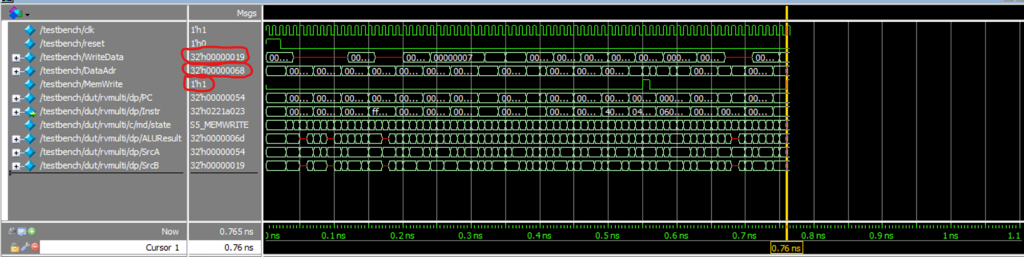
5)
The waveform shows that the processor successfully passes the testbench.
When MemWrite is asserted, the value 25 (0x19) is written to memory address 104 (0x68).
This confirms that the processor executes instructions correctly and produces the expected result.

6)
github link : https://github.com/berkeee112/riscv-multicycle-lab3.git

