Mark Berkery Assignment 1_2

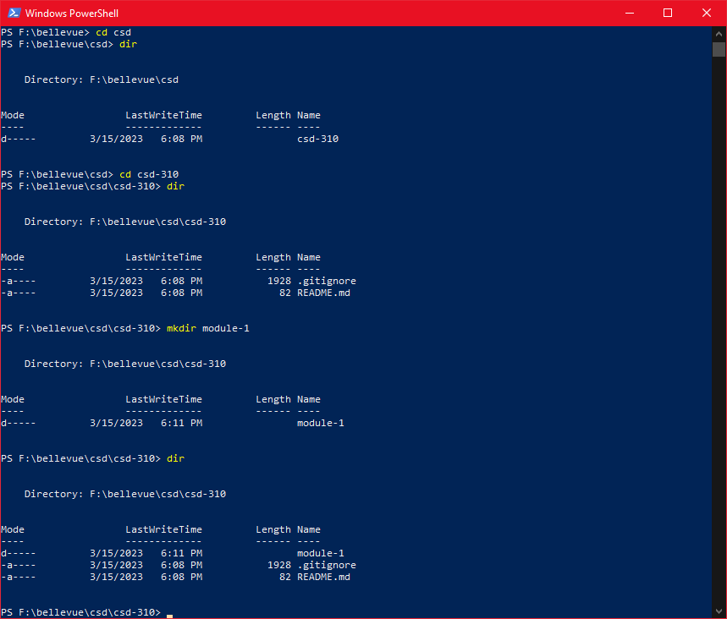

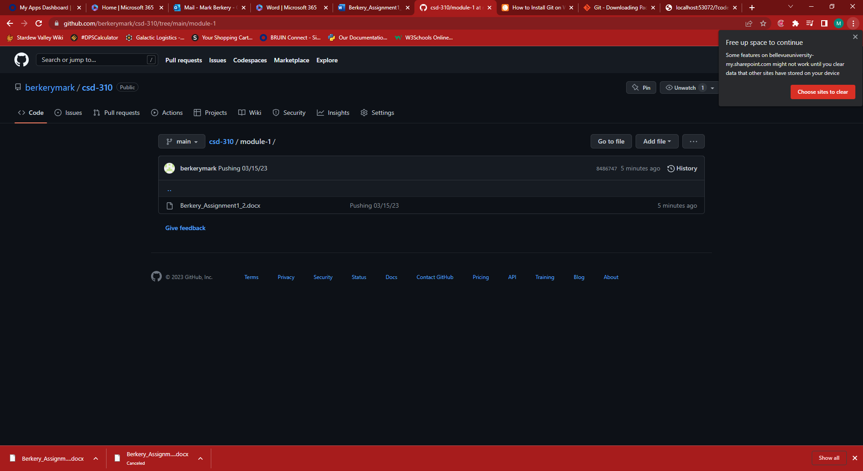

<https://github.com/berkerymark/csd-310/tree/main/module-1>