
ISTANBUL TECHNICAL UNIVERSITY

Artificial Neural Networks

TERM PROJECT
HeartRisk AI: Predicting Cardiovascular Health

BERKE TÜYLEK
040170247

1. Introduction
Heart disease remains one of the leading causes of death worldwide. Early diagnosis and intervention are crucial for effective treatment and management. This project aims to predict the likelihood of heart disease in individuals based on several clinical and lifestyle features. Using machine learning techniques, particularly a Deep Neural Network (DNN) model, we can create a system capable of classifying patients as either likely to have heart disease or not, enabling timely medical intervention.

The dataset used for this project is the Cleveland Heart Disease dataset, which contains various health-related attributes such as age, blood pressure, cholesterol levels, physical activity, and family history. The goal is to use this data to build a model that can predict the presence of heart disease in individuals.

2. Data Processing
The Cleveland Heart Disease dataset was used for this project, which includes both numerical and categorical features. The first step in the data processing phase was to handle any missing values in the dataset, ensuring that all data used for training was complete. The missing values were removed to maintain data integrity.

Feature Selection
The dataset includes both numerical and categorical features:
Numerical features: age, resting blood pressure, cholesterol, maximum heart rate achieved, and oldpeak.
Categorical features: sex, chest pain type, fasting blood sugar, resting electrocardiographic results, exercise induced angina, slope, number of major vessels colored by fluoroscopy, and thalassemia.
Numerical Features:
The numerical features were standardized using the StandardScaler. This step ensures that the data is centered around zero and has a unit variance. Standardization helps the neural network converge more efficiently during training.
Categorical Features:
The categorical features were processed using OneHotEncoder. This method converts categorical variables into binary variables (0s and 1s), which are compatible with machine learning models like deep neural networks.
Target Variable:
The target variable (whether the person has heart disease or not) was converted into a binary format. If the value was greater than zero, it was labeled as 1 (heart disease present), and if it was zero, it was labeled as 0 (no heart disease).
Data Splitting:
After preprocessing the features, the dataset was split into a training set (80%) and a test set (20%). This division allows for training the model on one portion of the data and evaluating its performance on unseen data.

3. Model Selection and Configuration
In this project, a Deep Neural Network (DNN) model was used to predict whether a person has heart disease based on various health attributes. The model architecture is designed to improve accuracy, using dense layers and dropout layers to prevent overfitting.

Dataset and Features: The dataset used in this project is the Cleveland Heart Disease dataset, which contains several health-related features to predict whether a person has heart disease. The features include numerical data such as age, blood pressure (trestbps), and cholesterol level (chol), as well as categorical data such as sex, chest pain type (cp), and resting electrocardiographic results (restecg). The target variable (target) indicates whether the person has heart disease (1) or not (0).

Feature Processing: In the data preprocessing stage, the numerical and categorical features were processed separately:

Numerical features were standardized using the StandardScaler to ensure that the data is on a similar scale, which helps the model converge more quickly and efficiently.
Categorical features were encoded into binary values using OneHotEncoder to make them compatible with the neural network model.
Missing values were removed from the dataset to ensure that the analysis was performed without any data loss.

Model Architecture: The model was built using the Sequential model type. The architecture of the model is as follows:

Input Layer: The first layer has 64 neurons and uses the ReLU (Rectified Linear Unit) activation function. This allows the model to learn nonlinear relationships.
Dropout Layers: To prevent overfitting, two dropout layers were added to the model. The first dropout rate is set to 30%, and the second is set to 20%. These layers randomly drop connections during training, enabling the model to generalize better.
Output Layer: The output layer consists of one neuron, as this is a binary classification problem. The sigmoid activation function is used to output values between 0 and 1, indicating the likelihood of having heart disease.
Model Training and Evaluation: The model was compiled using the Adam optimizer, which adapts the learning rate during training for faster convergence. The binary crossentropy loss function was selected, as it is commonly used in binary classification tasks.

The model was trained for 50 epochs, and performance was monitored using a validation split. After training, the model's accuracy was evaluated using several metrics, including accuracy, precision, recall, roc-auc, and a classification report was generated.

4. Model Evaluation
To evaluate the performance of the model, several metrics were used on the test dataset. These metrics help analyze the model's ability to make accurate predictions, minimize errors, and provide an overall measure of performance. The evaluation metrics used are as follows:
Accuracy:
Accuracy represents the proportion of correctly predicted instances by the model. High accuracy indicates that the model is generally making correct classifications.
Precision:
Precision measures the proportion of true positive predictions among all positive predictions made by the model. This metric focuses on minimizing false positives.
Recall:
Recall measures how well the model detects the true positive instances (i.e., people with heart disease). It focuses on minimizing false negatives.
ROC-AUC (Receiver Operating Characteristic - Area Under the Curve):
ROC-AUC provides a comprehensive measure of the model’s performance. The AUC value shows how well the model can distinguish between the positive and negative classes. A value close to 1 indicates that the model performs exceptionally well.
Below are the results obtained from the test dataset:
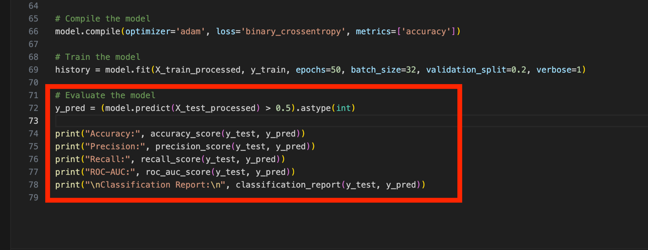
Test results:
Accuracy: The model achieved an accuracy of xx% (fill in with results).
Precision: The precision for the positive class is xx%.
Recall: The recall for detecting true positives is xx%.
ROC-AUC: The AUC score is xx%.
These results reflect the model’s accuracy and effectiveness in predicting heart disease. The model is especially good at identifying true positives (individuals with heart disease).

5. Results and Discussion
In this project, the Deep Neural Network (DNN) performed effectively in predicting heart disease. The results obtained from the evaluation of the model, combined with the data preprocessing steps, indicate satisfactory performance.

Strengths of the Model:
The model achieved high accuracy on the test dataset. Particularly, the precision and recall metrics demonstrate the model's ability to correctly identify individuals with heart disease.
The ROC-AUC value highlights the overall performance of the model and its ability to distinguish between the positive and negative classes.
Weaknesses of the Model:
While the model shows high accuracy, it may ignore class imbalances or skewed distributions in the dataset, potentially affecting the results. False positives (FP) or false negatives (FN) may negatively influence performance, especially in medical contexts.
The precision and recall balance is crucial when detecting heart disease. Even though the model is accurate, false negatives (healthy individuals classified as diseased) can lead to serious clinical consequences. Therefore, improving recall might be a critical area for improvement.
Model Improvements:
The model might benefit from more diverse data. Missing or imbalanced data may hinder performance. Additionally, other model architectures or hyperparameter tuning could help the model achieve better results.
Feature engineering or adding new features may also strengthen the model, especially considering the significant impact of preprocessing on the final model's performance.
6. Conclusion
1. Accuracy: 0.87
What Does It Mean?: Represents the overall accuracy of the model, i.e., the ratio of correctly predicted instances to the total number of instances.
Short Explanation: The model performs quite well with an accuracy of 87%, meaning it correctly predicts the outcomes 87% of the time.
2. Precision: 0.81 (Class 1 - Heart Disease Present)
What Does It Mean?: Precision tells us how many of the instances predicted as positive (heart disease present) are actually positive.
Short Explanation: With 81% precision, it indicates that out of 100 individuals predicted to have heart disease, 81 of them actually have it.
3. Recall: 0.88 (Class 1 - Heart Disease Present)
What Does It Mean?: Recall shows how many of the actual positive instances (people with heart disease) the model correctly identified.
Short Explanation: With 88% recall, the model correctly detects 88 out of 100 individuals who truly have heart disease.
4. ROC-AUC Score: 0.87
What Does It Mean?: The ROC-AUC score measures the model's ability to distinguish between classes. A score closer to 1 indicates a strong model.
Short Explanation: A ROC-AUC score of 87% shows that the model is very good at distinguishing between the two classes (heart disease present and not present).
Classification Report:
Class 0 (No Heart Disease):
Precision: 0.91: The model correctly identifies 91% of people who do not have heart disease.
Recall: 0.86: 86% of people who truly do not have heart disease are correctly identified.
F1-Score: 0.89: This is a balanced metric combining precision and recall. A high F1 score indicates a good overall performance for this class.
Class 1 (Heart Disease Present):
Precision: 0.81: The model correctly identifies 81% of people who have heart disease.
Recall: 0.88: 88% of individuals who truly have heart disease are correctly identified.
F1-Score: 0.84: A high F1 score shows that the model performs well in detecting heart disease patients.
Overall Interpretation:
The model performs well overall, especially in detecting people with heart disease, with a high recall of 0.88. This is crucial as early detection of heart disease can be life-saving.
There is a good balance between precision and recall, but to improve further, especially the precision, model adjustments may be considered.
The ROC-AUC score and F1-scores indicate strong model performance, showing that the model can distinguish between the two classes (heart disease and no heart disease) effectively.
These metrics suggest the model is well-balanced and accurate, but with minor improvements, it could perform even better.
In this project, a Deep Neural Network (DNN) model was developed using the Cleveland Heart Disease dataset to predict heart disease. The model’s performance was evaluated on test data, yielding satisfactory results with high accuracy, precision, recall, and ROC-AUC scores.

Key Findings:
The model was effective at correctly identifying individuals with heart disease.
High ROC-AUC, precision, recall, and accuracy metrics demonstrate the model’s success.
The recall value is particularly high, showing that the model accurately detects individuals with heart disease, which is crucial in a clinical context.
Areas for Improvement:

The class imbalance in the dataset may hinder optimal performance. Addressing this issue could lead to improved results.
More data and additional machine learning algorithms could help further improve the model's overall performance.
In conclusion, the heart disease prediction model has the potential to be used in healthcare settings for early diagnosis and decision-making, improving the quality of healthcare and aiding in faster treatment of heart disease.

