**CME2102 Project Based Learning IV**

**Final Project Report**

CAR MONITOR

Group/Section: 4 / Mansur Toçoğlu

Group Members:

* Mesut Soylu
* Berkin Akaydın
* Fethan Us

IZMIR / 2016

Contents

Introduction 2

Problem Definition 2

Solution Strategy 2

Methods 2

Results 2

Draft Solution 2

Improvements 2

Conclusion 2

Appendix A: Codes 2

Appendix B: Screenshots 2

Introduction

Problem Definition

In this project our goal is read a car's sensors and display it in a android application.

Solution Strategy

We look up in internet to find which car has which sensor. After we find them we crate our uml design. It means we decide on our classes. Then we started to code

Methods

At the beginning of this project, we thought about or classes to start properly. After that we draw our UML. We haven't encountered any problems except using intent. We had to look for data transfering between two activity. We had to pass some variables between two / three activity to save data. Rest of them was easy.

Results

Draft Solution

We think we have done our project well. Intent was only problem but we solved it.

Improvements

We used ArrayLists at the beginning but when intent problem showed up, we changed them into Arrays.

Experimentation

Conclusion

We learnt car's sensors, UML Class Design, Android Programming.

Appendix A: Codes

Include all your project codes here. Try to limit the amount of code you use inside other sections of the report. Make references to complete code listing here if needed.

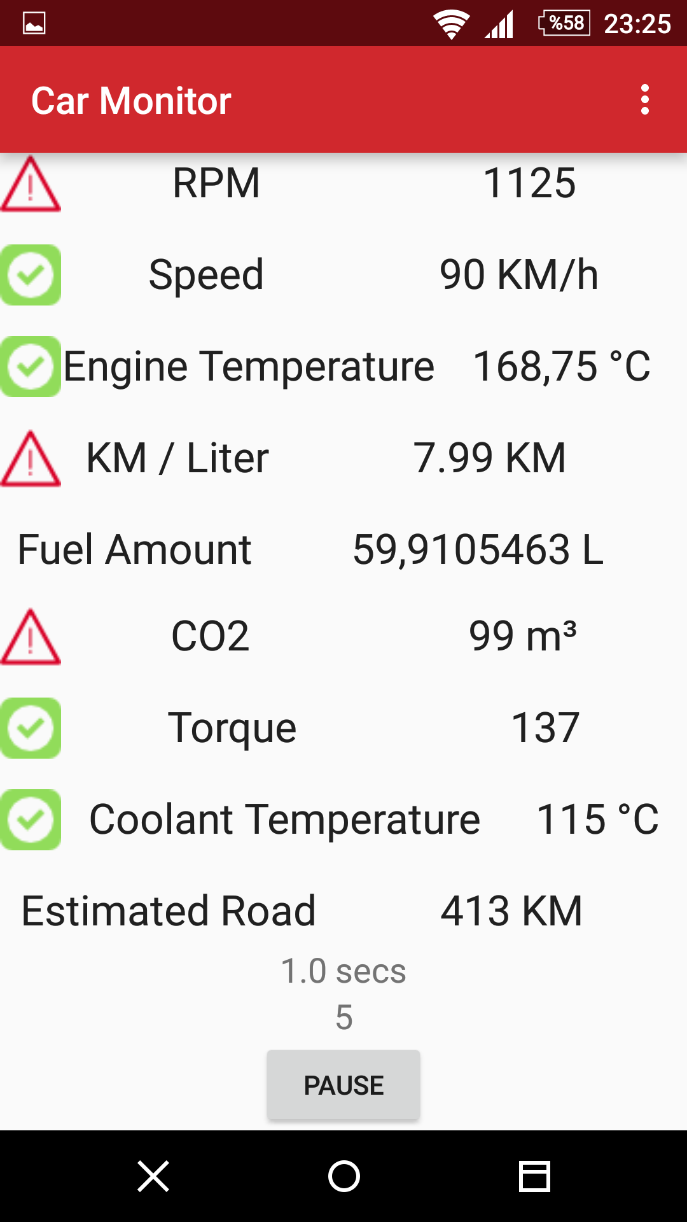Appendix B: Screenshots

