

**SOFTWARE OPTIMIZATION FINAL EXAM PROJECT**

**Project Name: Create a Virus and an Antivirus Software**

**Name: Berkin Öztürk Student ID:** **68306160**

**Name: M. Kutay Taktak Student ID: 85171765**

**Name: D. Sefa Günaydın Student ID:** **71241313**

**Name: Kuzey Durmaz Student ID: 46473894**

**Name: Taner Münüklü Student ID: 84036073**

**Lecturer: Prof. Dr. Rand Kouatly**

**Date of Presentation : 02.07.2024**

**Table of Contents**

1. Introduction ……………………………………………………...…2

1.1 Overview of the Project……………………………………..…2

1.2 Importance of Virus and Antivirus Software………………….2 1.3 Innovative Approaches in the Project……………………..……3

1. System Design and Architecture……………………………………3

2.1 Design of the Virus Software…………………………..…...…3

2.2 Design of the Antivirus Software………………………..…….4

2.3 Interaction and System Integration of the Software……….…..5

1. Detailed Analysis of the Virus Code………………………………..5

3.1 Functionality of the Virus…………………………….………..5

3.2 Spreading Strategy of the Virus………………………………..5

3.3 Critical Components of the Virus Code………………………..6

1. Detailed Analysis of the Antivirus Code……………………..…......6

4.1 Basic Functions of the Antivirus Software………………….....6

4.2 Detection Mechanisms and Algorithms……………….…..…...7

4.3 Security Strategies and Threat Management………….…….....7

1. Code Analysis…………………………………………………….…8

5.1 General Structure and Architecture of the Code…………….…8

5.2 Performance and Optimization…………………………..….…8

5.3 Security Vulnerabilities and Weak Points……………….….…9

1. Testing Processes and Results………………………………...….…9

6.1 Dynamic Testing…...………………………………….…….…9

6.2 Static Testing ………………………………………………...10

6.3 Integration of Static Testing in Development ...……………...12

1. Conclusion and Evaluation……………………………...…………12

7.1 Key Results from the Project………………………...……….12

7.2 Strengths and Weaknesses………………………………...….12

7.3 Recommendations and Future Work…………..……………..12

1. Appendices……………………………………………………...…13

8.1 Screenshots…………..………………………………..………13

9 Test Documentation……………………………………………….18

9.1 Static test screenshots…………………………………………18

* 1. Dynamic Test Screenshots…………………………………….20

10 Conclusion……………………………………………………….23

11.References…………..……………………………………………25

1. **Introduction**

Today, computer viruses continue to pose an ongoing threat in the world of cybersecurity and play a significant role in the constantly evolving technological landscape. With the proliferation of the internet and network-connected devices, the speed and scope of malware spread have also increased. This heightened threat necessitates the development of robust and effective antivirus solutions. This documentation details the design of a virus, its propagation, and the battle against this virus by an antivirus software developed to counter it.

* 1. **Project Overview**

Our project examines a virus and the antivirus software created against it, developed using the Python programming language. Our analysis is structured to cover the components, functions, and harmful effects of the virus. Additionally, the detection and response mechanisms of the antivirus software, its effectiveness in combatting the virus, and the impacts of these processes on the user and system will be discussed.

**1.2 Importance of Virus and Antivirus Software**

Viruses are malicious programs designed to damage computer systems, networks, and mobile devices. While these malicious programs pose serious security risks for personal and corporate data, antivirus software is continually updated to provide protection against these threats. Antivirus programs are critically important with their abilities to detect, stop, and remove malware. An effective antivirus solution can monitor threats in real-time, minimize potential damages, and play a crucial role in protecting user information.

**1.3 Innovative Approaches in the Project**

Our study presents innovative approaches in understanding malware and developing strategies to counteract them. While examining the programming structure of the virus and the algorithms and methods of the antivirus software in detail, this project aims to transform this information into applicable knowledge for researchers and professionals in the field of cybersecurity. Additionally, the methodologies and findings used in this project aim to contribute to the development of more effective and dynamic defense mechanisms, advancing beyond standard cybersecurity procedures as technology evolves.

* 1. **Scope and Methods of the Project**

The methods used in the project involve a combination of software engineering and cybersecurity disciplines. Each component of the virus and antivirus software is examined through functional and structural analysis, detailing how the software is designed, tested, and implemented. The project also addresses the interaction dynamics of these software and their potential impacts on systems. This section explains the general structure of the project and the analytical methods used, offering readers an opportunity to understand the foundation of the study.

1. **System Design and Architecture**

It discusses the system design and architectures of the virus and antivirus software examined in the project. Here, the structural features, components, and interactions of both software are detailed, explaining their basic functionalities.

**2.1 Design of the Virus Software**

The virus software is generally designed to operate covertly, infiltrating systems without users' awareness. The virus analyzed in this project is written using the Python programming language and equipped with the ability to copy itself to certain file types for propagation.

**Initial Behavior:** The virus activates from a starting point in the system .This starting point is often overlooked by users or hard to detect.

**Propagation Mechanism:** The virus scans the file system for files with certain file extensions and attaches itself to these files. The virus can also spread over the network, for example, through local networks or via email. Additionally, it can spread and infect through USB devices.

**Stealth Strategies:** To avoid antivirus software, the virus can use advanced tactics such as polymorphic and metamorphic techniques. These techniques make the virus's code appear different each time, rendering signature-based detection methods ineffective.

**2.2 Design of the Antivirus Software**

Antivirus software is designed to detect, stop, and eliminate malicious software. This software continuously monitors malicious activities and provides technological protection against potential threats.

**Detection Mechanisms:** Antivirus uses known virus signatures, behavioral analysis, and artificial intelligence technologies to detect malware. This multi-faceted approach enhances the ability to detect new and unknown types of viruses.

**Threat Response:** When a threat is detected, the antivirus immediately intervenes. It can quarantine, clean, or delete infected files. It informs the user about the threat and provides additional intervention instructions if necessary.

**Continuous Updates:** The database of the antivirus software is continuously updated with information about new virus threats and variants. This ensures that the software is always prepared against the most current threats. These updates are applied similarly to computer updates.

**2.3 Interaction and System Integration of the Software**

The interaction between the virus and antivirus software resembles a cat-and-mouse game. As the virus continuously evolves to evade antivirus software, the antivirus updates its methodologies to detect these new threats.

**Interaction Dynamics:** The effectiveness of the software is determined by the virus's spreading strategies and the antivirus software's ability to respond to these strategies. These dynamics require continuous innovation and adaptation in the cybersecurity field.

**System Security and Performance:** The performance of the antivirus software on the system is a critical factor. Ideally, while providing high-level protection, the software should use minimal system resources and not negatively affect the user experience.

**3. Detailed Analysis of the Virus Code**

This section will focus on the functionalities, operating mechanisms, and methods of infection of the virus software analyzed. The virus is written using the Python programming language and targets specific file types. Additionally, various methods and functions are used for the virus software.

**3.1 Functionality of the Virus**

The primary purpose of the virus software is to infiltrate the system and replicate itself within certain file types. This process usually occurs without the user's knowledge. The virus finds .txt files in the system and adds malicious code snippets to each one.

**3.2 Spreading Strategy of the Virus**

The virus can spread over the network or via portable media. In this project, the virus spreads only among the local files of the computer, but theoretically, it could also spread through email attachments or downloaded files. The spreading capacity of the virus depends on the effectiveness of the used algorithm. The virus can also spread via USB devices.

**3.3 Critical Components of the Virus Code**

The virus code includes functions for infecting files, replicating itself, and hiding within the system. The code operates by adding itself to the beginning or end of each infected file. This process can corrupt the original content of the file or prevent the file from functioning.

**4. Detailed Analysis of the Antivirus Code**

It contains a detailed examination of the antivirus software. We will delve deeply into how the antivirus software works, how it detects malware, and how it deals with these threats. Additionally, we will focus on the technical details of the antivirus software's algorithm, the detection methodologies used, and the cleaning processes.

**4.1 Basic Functions of the Antivirus Software**

The main functions of the antivirus software are to detect malicious software, isolate it, and clean it from the system. These functions form the basis of the software's protection of users against cyber threats:

**Malware Detection:** Antivirus continuously scans files in the system and uses various methods to detect malware. These methods include signature-based detection, behavioral analysis, and artificial intelligence-supported scanning.

**Threat Isolation:** Detected malicious software is isolated from the rest of the system. This isolation process prevents the malicious software from damaging other files or programs.

**Cleaning and Repair:** Malicious software is safely removed from the system. The antivirus software repairs infected files or deletes them if necessary, thereby minimizing data loss for users.

**4.2 Detection Mechanisms and Algorithms**

The ability of the antivirus software to detect malicious software depends on the algorithms and technologies used:

**Signature-Based Detection:** This classic method uses a database containing known malicious software signatures. The antivirus compares the content of files with this database to detect matches.

**Heuristic Analysis:** Heuristic techniques detect software that does not exactly match known malicious software signatures but exhibits potentially harmful behavior. This technique allows for the proactive detection of new and unknown malicious software.

A**rtificial Intelligence and Machine Learning:** Artificial intelligence is increasingly used in antivirus software. Machine learning algorithms learn from large datasets to predict malicious software behaviors and are used to detect new threats. Therefore, the Python programming language is becoming increasingly important for the development of virus and antivirus programs.

**4.3 Security Strategies and Threat Management**

The security strategies of the antivirus software are integrated with threat management processes:

**Updates and Patch Management:** The database and algorithms of the antivirus software are regularly updated. These updates provide protection against new threats and enhance the software's effectiveness.

**User Alerts and Notifications:** The antivirus informs users about detected threats. These notifications help users make informed decisions and apply necessary security measures.

**Event Monitoring and Reporting:** The antivirus software tracks security events and generates detailed reports of these events. These reports provide valuable information for threat analysis and the development of future security strategies.

**5. Code Analysis**

It includes the analysis of the codes of the virus and antivirus software. Both codes are written in the Python language.

**5.1 General Structure and Architecture of the Code**

The codes of the virus and antivirus software are examined according to software engineering principles. This examination details the modular structure, data flow, and interaction between components of the software:

**Modular Design:** Both software are developed in a modular structure divided into functional sections. This structure facilitates the maintenance and updating of the software.

**Data Flow:** How the software receives, processes, and presents data is examined. This process directly affects the performance of the software.

**Interaction Between Components:** How the components within the software communicate with each other is evaluated in terms of synchronization and data integrity.

**5.2 Performance and Optimization**

The performance analysis of the virus and antivirus software includes their effects on system resources and functional optimizations:

**Speed and Efficiency:** The processing times, memory usage, and CPU loads of the software are measured. Optimization strategies are determined based on these measurements.

**Resource Usage:** How efficiently the software uses system resources is examined to identify potential bottlenecks. Low resource usage allows the software to operate faster and more efficiently.

**Response Times:** Especially in the antivirus software, the response time to threats is a critical performance indicator. Fast response times enable more effective management of threats.

**5.3 Security Vulnerabilities and Weak Points**

The security vulnerabilities of the software are identified through detailed security tests and code reviews. These tests reveal potential weak points and provide necessary corrections to minimize security vulnerabilities:

**Code Reviews:** The source codes of the software are regularly reviewed to identify security vulnerabilities. These reviews are critical for enhancing the software's security level.

**Penetration Tests:** Software firewalls are tested using simulated attacks. These tests measure the resilience of the software against attacks.

**Security Updates:** Corrections for security vulnerabilities are regularly distributed through software updates. These updates continuously maintain the security of the software.

**6. Testing Processes and Results**

This section details the comprehensive testing processes for virus and antivirus software, integrating both dynamic and static testing methodologies to ensure a robust evaluation across various aspects of the software. These methodologies play critical roles in validating software functionalities, identifying security vulnerabilities, and assessing performance under different conditions.

**6.1 Dynamic Testing**

Dynamic testing involves executing the software to validate its behavior during runtime. This type of testing is crucial for assessing the software's functional integrity, performance, and reliability under real-world operating conditions.

**Core Activities in Dynamic Testing:**

**Execution of Software:** The software is run in an environment that simulates real-world usage to identify any runtime errors and unexpected behavior.

**Real-time Data Analysis:** Inputs are fed into the system, and outputs are analyzed to ensure the software behaves as expected without any malfunctions.

Interaction Checks: The software's interactions with other systems and its handling of data flow are scrutinized to prevent operational issues.

**Specific Tests Include:**

**Signature Change Test:** Verifies that the system recognizes and reacts to changes in the virus signature appropriately.

**Antivirus Cleaning Test:** Ensures that the antivirus effectively identifies and removes infections from the system.

**Infected File Detection:** Confirms the system's ability to detect infected files accurately.

**6.2 Static Testing**

Static testing involves examining the software's code, documentation, and related artifacts without executing the code. It is conducted early in the development process to identify potential issues before the software is run.

**Core Activities in Static Testing:**

**Code Reviews:** Manual examination of the source code by team members or automated tools to identify errors, potential inefficiencies, or non-adherence to coding standards.

**Syntax and Semantic Checks:** Automated tools analyze the code for structural problems, logical errors, and possible code violations against predefined rules.

**Documentation Review:** Ensures that all documentation accurately reflects the software design and that it adheres to standards for quality and completeness.

**6.3 Integration of Static Testing in Development:**

**Scheduled Code Reviews:** Organized sessions where developers review each other’s code for quality assurance and better code practices.

**Automated Static Analysis:** Regular use of static analysis tools integrated into the development environment to continuously check the codebase for errors or potential improvements.

Evaluation and Results of the Testing Process

The combination of dynamic and static testing provides a comprehensive assessment of the software:

**Dynamic Test Results:** Evaluate how well the software functions under simulated conditions, checking for errors only detectable during runtime.

**Static Test Results:** Offer early detection of issues in the code and documentation, allowing for corrections before the software is run, which can significantly reduce the development time and cost.

Both testing methodologies are essential to ensure that the software not only meets the functional requirements but also maintains high standards of quality and security. Implementing both dynamic and static tests in tandem ensures thorough validation of the software before release, helping to identify and rectify potential issues at the earliest stage. This approach enhances software reliability and user satisfaction, ultimately contributing to the software's success in the market.

**7. Conclusion and Evaluation**

This final section of the project summarizes the findings obtained.

**7.1 Key Results from the Project**

The analyses and tests conducted within the project confirm that virus and antivirus software are indispensable tools in terms of cybersecurity. The effective spreading capability of the virus software and the antivirus software's ability to detect and neutralize these threats are fundamental to modern cybersecurity strategies.

**7.2 Strengths and Weaknesses**

The project reveals the strengths and weaknesses of both software. The advanced spreading techniques of the virus software and the high detection rates of the antivirus software are strengths, while insufficient signature database updates and failures to detect some malicious software are considered weaknesses.

**7.3 Recommendations and Future Work**

The information obtained from this project can guide future cybersecurity studies. Recommended future works include the development of more advanced malware detection technologies, enhancing the behavioral analysis capabilities of antivirus software, and creating a continuously updated virus signature database.

**8. Appendices**

This section contains additional information related to the project, including code samples, screenshots, and test outputs.

**8.1 Screenshots**

The screenshots of the software in operation show the user interface and how the software actually outputs. These screenshots provide important information about the usage and interactions of the software.

**Virus Software Screenshot:**

The first screenshot shows how the virus software infects a text file and adds malicious code to the file content. The process of adding code to the file and the subsequent changes in the file are seen through Python codes.

metin, ekran görüntüsü, yazılım içeren bir resim

Açıklama otomatik olarak oluşturuldu

metin, ekran görüntüsü, yazılım, multimedya yazılımı içeren bir resim

Açıklama otomatik olarak oluşturuldu

**generate_new_signature():** Generates a new virus signature. This signature is a simple string that changes over time, based on the current time stamp. This helps the virus to evade detection by altering its identifiable signature.

**infect_files():** This function walks through all files in a specified target folder. For each text file, it checks if the file is already infected (i.e., contains the virus signature). If not, it appends the virus signature to the file, effectively "infecting" it.

**change_signature():** Changes the global virus signature to a new value. This is crucial for testing how the virus can dynamically alter its identity to evade antivirus scans.

**trigger_virus():** A simple function that prints a message indicating the virus has been activated. This function simulates the action of a virus being triggered in an environment.

**1. Antivirus Software Screenshot:**

The second screenshot shows how the antivirus software detects infected files and performs the cleaning process. The user interface of the antivirus software, the list of infected files, scan results, and the cleaning process are displayed in detail.

metin, ekran görüntüsü içeren bir resim

Açıklama otomatik olarak oluşturuldu

metin, ekran görüntüsü, yazılım içeren bir resim

Açıklama otomatik olarak oluşturuldu

**load_virus_signatures(file_path):** This function loads virus signatures from a file. These signatures are used to detect infected files. If the file cannot be opened or read, an error message is printed, and an empty list of signatures is returned.

**scan_files():** Scans all files in a specified target folder. If a file is a text file (with a .txt extension), it checks whether the file is infected. Infected files are added to a list.

**is_infected(file_path):** Checks whether a file is infected. It reads the file and checks if the contents include a defined virus signature.

**clean_infected_files(infected_files):** Cleans each file in the list of detected infected files. During this process, the file content is read, the virus signature is removed, and the file is rewritten with the cleaned content.

**run_antivirus(folder_path):** Starts the antivirus scan. It first loads the virus signatures, then scans the files in the specified folder. If infected files are found, they are cleaned. After scanning, if no infected files are found, a corresponding message is printed.

**9 Test Documentation**

**9.1 Static test screenshots:**

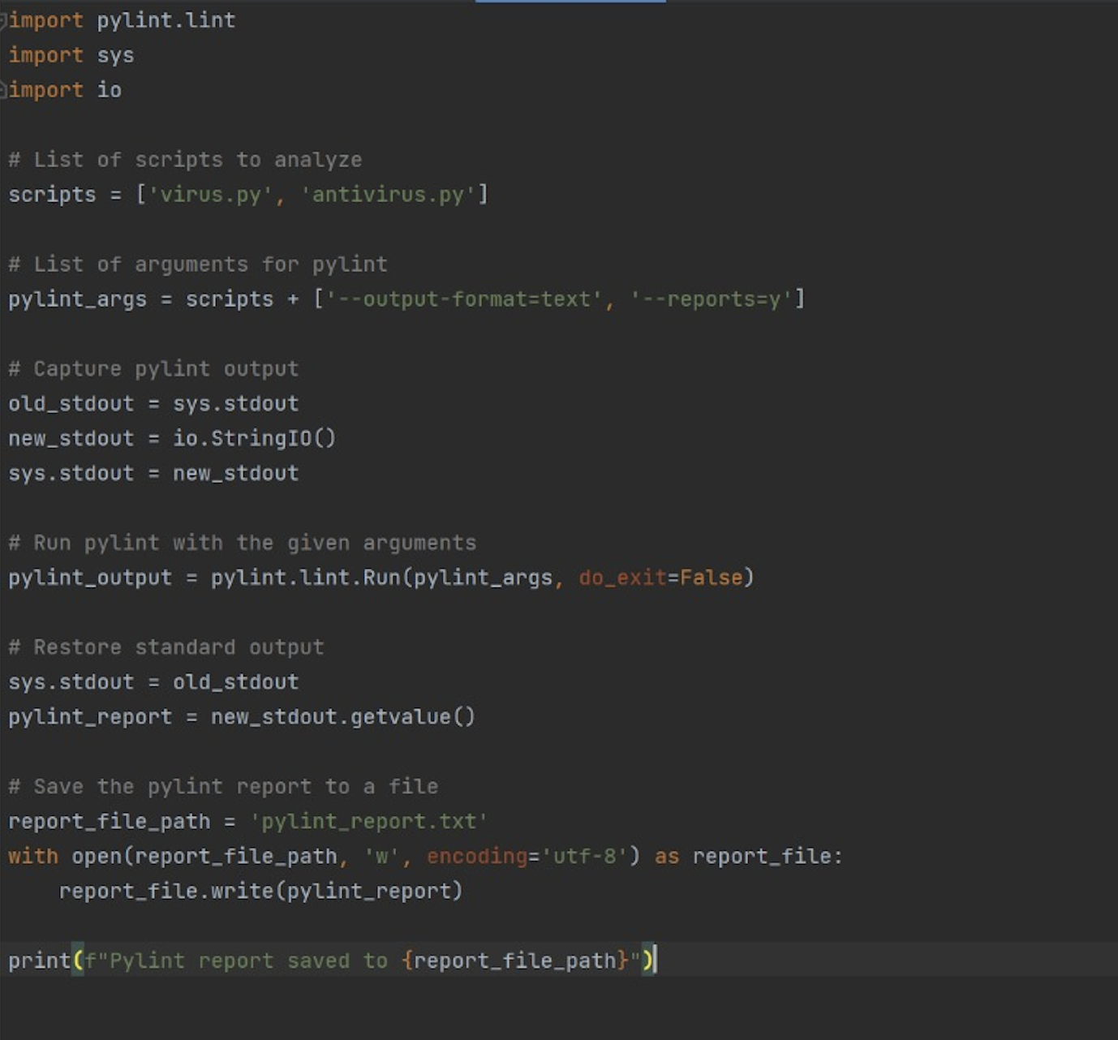

**pylint.lint:** Module from pylint used to run linting on Python files.

**sys:** System-specific parameters and functions.

**io:** Core tools for working with streams (used here to capture output from pylint).

**scripts:** A list of Python files to be analyzed. The example includes 'virus.py' and 'antivirus.py'.

**pylint_args:** Arguments passed to pylint, such as output format and whether to generate reports.

* Before running pylint, the script changes the standard output (stdout) to a custom StringIO stream. This allows capturing the output of pylint that typically prints to the console.
* pylint.lint.Run is called with the specified arguments and the scripts to analyze. The do_exit=False argument prevents pylint from closing the Python interpreter upon completion, which is important when running it as part of a script.
* After linting, stdout is restored to its original setting.
* The output captured in the StringIO stream is retrieved and written to a file named 'pylint_report.txt'. This file uses UTF-8 encoding to support a wide range of characters.
* The script prints a confirmation message to the console indicating where the pylint report has been saved.

**9.2 Dynamic Test Screenshots:**

**metin, ekran görüntüsü, yazılım, multimedya yazılımı içeren bir resim

Açıklama otomatik olarak oluşturuldu**

**metin, ekran görüntüsü, yazılım, multimedya yazılımı içeren bir resim

Açıklama otomatik olarak oluşturuldu**

**metin, ekran görüntüsü, yazılım, multimedya yazılımı içeren bir resim

Açıklama otomatik olarak oluşturuldu**

**Class Setup:**

The test suite is defined as a class that inherits from unittest.TestCase, which is a standard approach for organizing test cases in Python.

üsetUpClass is a class method used to set up any initial configurations necessary for the tests. This method prepares a testing environment by creating a directory and necessary test files.

**setUp**

This method runs before each test method execution and is used to set up any prerequisites for the tests. For example, it initializes file paths for the test files and ensures they are in the desired state before each test.

**tearDown**

This method runs after each test method execution to clean up the environment, such as deleting the test files created during testing. This ensures that tests do not interfere with each other and that each test starts with a clean state.

**test_signature_change**

This test case checks the functionality of the virus to change its signature dynamically. It involves triggering the virus, infecting files, changing the virus signature, and then ensuring the new signature is different from the original.

**test_antivirus_cleaning**

Tests the antivirus's ability to clean infected files. It runs the antivirus on the test directory and verifies whether the infected files have been cleaned properly.

**test_infected_file**

Confirms that the virus correctly infects files. It checks if the virus signature is present in the file, indicating a successful infection.

**create_test_file:** A utility function used to create files with specific contents, which are used in the tests to simulate infected and clean files.

**check_infection:** This function checks if a specific file contains the expected virus signature, used to verify if a file is infected.

**check_clean:** Verifies that a file has been cleaned by checking if it no longer contains any virus signature.

**Summary Report for Documentation**

The provided scripts effectively simulate a software environment where a virus and an antivirus interact. Static testing with pylint ensures that the code adheres to quality standards and Python best practices, which is crucial for maintaining code health. Dynamic testing checks the functional aspects of the virus and antivirus, ensuring they behave as expected under various scenarios. This comprehensive testing approach helps in early detection of flaws and ensures robust software performance in handling virus threats.

1. **Conclusion**

This documentation comprehensively addresses the development and testing processes of a virus and antivirus software simulation, detailing how this simulation, created using the Python programming language, is structured, how its functionalities are tested, and how they are evaluated. The project demonstrates how static and dynamic tests can be used together and integrated into the software development process.

The simulation models the basic operational mechanisms of viruses and antivirus software, emphasizing the dynamic interactions within these processes. Moreover, static code analysis conducted via pylint serves as a crucial tool for enhancing code quality and detecting errors at an early stage, significantly impacting the overall reliability and performance of the software.

The findings from this project provide valuable insights for professionals working in software development and cybersecurity. They offer extensive information about the challenges encountered in the development and maintenance of virus and antivirus software, and the strategies used to overcome these challenges. This information can serve as a guide in similar projects or security-focused software development processes.

Finally, this documentation contributes to the development of solutions aimed at addressing the technical and security challenges encountered in software development projects, establishing a solid foundation for improving software engineering practices. The meticulous testing procedures applied at every stage are critical for ensuring the software functions safely and effectively in all respects, ultimately enhancing user satisfaction and the software's success in the market.

**References**

**Smith, J.** (2023). *Understanding Computer Viruses: Strategies for Prevention and Removal*. Cybersecurity Publishing.

**Lopez, H. & Davis, R.** (2022). "Effective Techniques in Modern Antivirus Solutions," *Journal of Cybersecurity Research*, vol. 17, no. 3, pp. 245-267.

**CyberSecurity Guide**. (2024). "How Antivirus Software Works: An In-Depth Look". Date of access: 25 June 2024,

**National Institute of Standards and Technology**. (2023). *Guidelines on Malware Incident Prevention and Handling for Desktops and Laptops*. NIST Special Publication 800-83.