Project Name: ML_Datasets
Student Name and Surname: Berkin Şen
Student Number: 23040102063
Video Presentation Link: https://youtu.be/XJwC56zzAbM
1.Introduction
This report shows a quantitative evaluation of supervised classifiers and unsupervised clustering algorithms applied to two standard tests: the Breast Cancer dataset and the Wine Quality dataset. First objective is making a test of model stabilty, impact of scalings and performance values like distance based, decision boundary and group learning methods. Breast Cancer dataset has 569 samples, 30 bio features and 2 target classes. Wine Quality dataset has 178 samples, 13 chemical feature that obtained from the chemical analysis of the wines produced.

2. Experimental Setup
This dataset executed 144 model, 132 of these models are classifier and 12 of these are K-Means. I used K-Nearest Neighbours (KNN), Linear, RBF, Poly SVM, Desicion Tree and Random Forest algorithms for this dataset. Also I tested K and K+1 cluster numbers for K-Means clustering.
3.Data Training and Methods
To get correct result and avoiding data leakage i split datasets into %80 of training and %20 of testing. Also I used 3 different random seeds, theese are 42.10 and 100.
Then I used “StandardScaler” because distance based models like KNN, SVM and K-Means need scaled data. To avoiding data leakage i just used “fit_transform” on training data and used “transform” on test data. Lastly I did not use scaling for Desicion Tree and Random Forest because they use treshold logic so they do not need scaled features.

4.Classifier Summaries
Model | Scaling | Mean_Accuracy | Std_Accuracy | Mean_Precision | Mean_Recall | Mean_F1
Decision Tree (depth=3) | No | 0.8888888888888888 | 0.09622504486493759 | 0.8918350168350169 | 0.9020112603445938 | 0.8924352457032195
Decision Tree (depth=5) | No | 0.8981481481481483 | 0.080187537387448 | 0.9021083854417188 | 0.9094186677520012 | 0.9025397090818364
Decision Tree (depth=7) | No | 0.8981481481481483 | 0.080187537387448 | 0.9021083854417188 | 0.9094186677520012 | 0.9025397090818364
Decision Tree (unconstrained) | No | 0.8981481481481483 | 0.080187537387448 | 0.9021083854417188 | 0.9094186677520012 | 0.9025397090818364
KNN (K=1) | Yes | 0.9259259259259259 | 0.01603750747748965 | 0.9227833894500561 | 0.9433862433862434 | 0.9266226217046473
KNN (K=11) | Yes | 0.9259259259259259 | 0.03207501495497924 | 0.9197851531184864 | 0.9421516754850088 | 0.9234508963106997
KNN (K=3) | Yes | 0.9166666666666666 | 0.02777777777777779 | 0.9126823793490461 | 0.9372134038800706 | 0.9175437376257632
KNN (K=5) | Yes | 0.9259259259259259 | 0.01603750747748965 | 0.920763187429854 | 0.9433862433862434 | 0.926529797050419
KNN (K=7) | Yes | 0.9166666666666666 | 0.02777777777777779 | 0.9126823793490461 | 0.9372134038800706 | 0.9175437376257632
KNN (K=9) | Yes | 0.8981481481481483 | 0.042431256434776264 | 0.894388327721661 | 0.9223985890652558 | 0.8970474583059543
Random Forest (depth=5 | trees=100) | No | 0.9814814814814815 | 0.03207501495497922 | 0.9777777777777777 | 0.9876543209876543 | 0.981118373275236
Random Forest (trees=10) | No | 0.8796296296296297 | 0.05782405554072587 | 0.8955752308693485 | 0.8983075566408901 | 0.8878373825120209
Random Forest (trees=100) | No | 0.9814814814814815 | 0.03207501495497922 | 0.9777777777777777 | 0.9876543209876543 | 0.981118373275236
Random Forest (trees=200) | No | 0.9814814814814815 | 0.03207501495497922 | 0.9777777777777777 | 0.9876543209876543 | 0.981118373275236
Random Forest (trees=50) | No | 0.9722222222222222 | 0.02777777777777779 | 0.9708333333333332 | 0.9791073124406457 | 0.9730896994401106
SVM (Linear C=0.1) | Yes | 0.9629629629629629 | 0.04243125643477633 | 0.957351290684624 | 0.9735449735449736 | 0.9617039562000002
SVM (Linear C=1.0) | Yes | 0.9259259259259259 | 0.04243125643477635 | 0.921788088454755 | 0.9440103106769774 | 0.9266605057060319
SVM (Linear C=10.0) | Yes | 0.9259259259259259 | 0.04243125643477635 | 0.921788088454755 | 0.9440103106769774 | 0.9266605057060319
SVM (Poly d=3) | Yes | 0.9814814814814815 | 0.016037507477489603 | 0.9856481481481482 | 0.9835164835164836 | 0.984024682202905
SVM (RBF C=0.1) | Yes | 0.9722222222222222 | 0.027777777777777818 | 0.9745824255628177 | 0.9767331433998101 | 0.9740857454092748
SVM (RBF C=1.0) | Yes | 0.9814814814814815 | 0.01603750747748965 | 0.98070987654321 | 0.9852801519468186 | 0.9822607752778532
SVM (RBF C=10.0) | Yes | 0.9537037037037037 | 0.04243125643477628 | 0.9566250742721332 | 0.9643874643874645 | 0.9561514265461634

Model | Scaling | Mean_Accuracy | Std_Accuracy | Mean_Precision | Mean_Recall | Mean_F1
Decision Tree (depth=3) | No | 0.9473684210526315 | 0.00877192982456139 | 0.9473805640720347 | 0.9398710598485994 | 0.9432354151986427
Decision Tree (depth=5) | No | 0.9502923976608187 | 0.013399344137297807 | 0.9468976302207613 | 0.9468522535959717 | 0.9467369798890927
Decision Tree (depth=7) | No | 0.9473684210526315 | 0.00877192982456139 | 0.9433862140585036 | 0.9442881510318691 | 0.9437795409367297
Decision Tree (unconstrained) | No | 0.9327485380116959 | 0.033209990326317364 | 0.9263735201960163 | 0.9352283219720401 | 0.9290371300590746
KNN (K=1) | Yes | 0.9619883040935672 | 0.022075539284417352 | 0.9613314664823079 | 0.9581899598173989 | 0.9596253256547375
KNN (K=11) | Yes | 0.9619883040935672 | 0.0182602280654924 | 0.9650090449003491 | 0.9555593435103051 | 0.9596886407959411
KNN (K=3) | Yes | 0.9649122807017543 | 0.017543859649122834 | 0.9659920493151803 | 0.9600146467583649 | 0.9627559426387585
KNN (K=5) | Yes | 0.9619883040935672 | 0.02532238022761518 | 0.9620944097082095 | 0.9583226879235488 | 0.9600691603358208
KNN (K=7) | Yes | 0.9619883040935672 | 0.018260228065492407 | 0.9635737251987001 | 0.9566132862141471 | 0.9597132981487455
KNN (K=9) | Yes | 0.97953216374269 | 0.018260228065492407 | 0.9802002851582822 | 0.9773491447020998 | 0.9785306699437752
Random Forest (depth=5 | trees=100) | No | 0.9678362573099415 | 0.005064476045523041 | 0.9674912728375705 | 0.9645385422681759 | 0.9657540943168756
Random Forest (trees=10) | No | 0.9590643274853802 | 0.005064476045523041 | 0.9554324873116636 | 0.9582420576215908 | 0.9566532780281071
Random Forest (trees=100) | No | 0.9707602339181287 | 0.01012895209104604 | 0.969946777122343 | 0.9688120465416802 | 0.9690199940199941
Random Forest (trees=200) | No | 0.9736842105263158 | 0.008771929824561403 | 0.97243283570756 | 0.9722134070858979 | 0.972043510446556
Random Forest (trees=50) | No | 0.9678362573099415 | 0.0050644760455230645 | 0.9660846900343225 | 0.9657176805901714 | 0.965624591527637
SVM (Linear C=0.1) | Yes | 0.9766081871345028 | 0.005064476045523017 | 0.979308918953306 | 0.9712747496136199 | 0.9748896100543015
SVM (Linear C=1.0) | Yes | 0.9590643274853802 | 0.0050644760455230645 | 0.9558611685120101 | 0.9572239490839464 | 0.9563749765890522
SVM (Linear C=10.0) | Yes | 0.9532163742690059 | 0.020257904182092147 | 0.9482901257732208 | 0.9523819693582457 | 0.9499917124917125
SVM (Poly d=3) | Yes | 0.8801169590643275 | 0.02025790418209213 | 0.919029647762818 | 0.8403429350273205 | 0.8599559496802707
SVM (RBF C=0.1) | Yes | 0.9502923976608187 | 0.013399344137297783 | 0.9516724525428167 | 0.9438375695293949 | 0.9469725624833152
SVM (RBF C=1.0) | Yes | 0.9736842105263158 | 0.008771929824561417 | 0.9725202421916316 | 0.9728132111520816 | 0.9721477816715912
SVM (RBF C=10.0) | Yes | 0.9736842105263158 | 0.00877192982456139 | 0.972263249243359 | 0.9726880155339283 | 0.9722072751484516

As we see in summary tables, Random Forest reached the best accuracy on both datasets. Results are %100 on Wine and %96.49 on Breast Cancer. I apply “StandardScaler” for improve performance of KNN and SVM models.

5.K-Means Summaries
Dataset | K_Clusters | Mean_ARI | Std_ARI | Mean_Silhouette | Mean_Inertia
cancer | 2 | 0.6593 | 0.0098 | 0.3439 | 1.159
cancer | 3 | 0.5106 | 0.0 | 0.3143 | 1.006
wine | 3 | 0.8974 | 0.0 | 0.2848 | 1.277
wine | 4 | 0.7529 | 0.0170 | 0.2532 | 1.177

As we see in summary tables, algortihm achieved higher Adjusted Rand Index (ARI) score on Wine dataset ((ARI = 0.897) compared to the Breast Cancer dataset (ARI = 0.659). This shows that features in the Wine dataset are more clearly separated for unsupervised clustering.

6.Required Figures

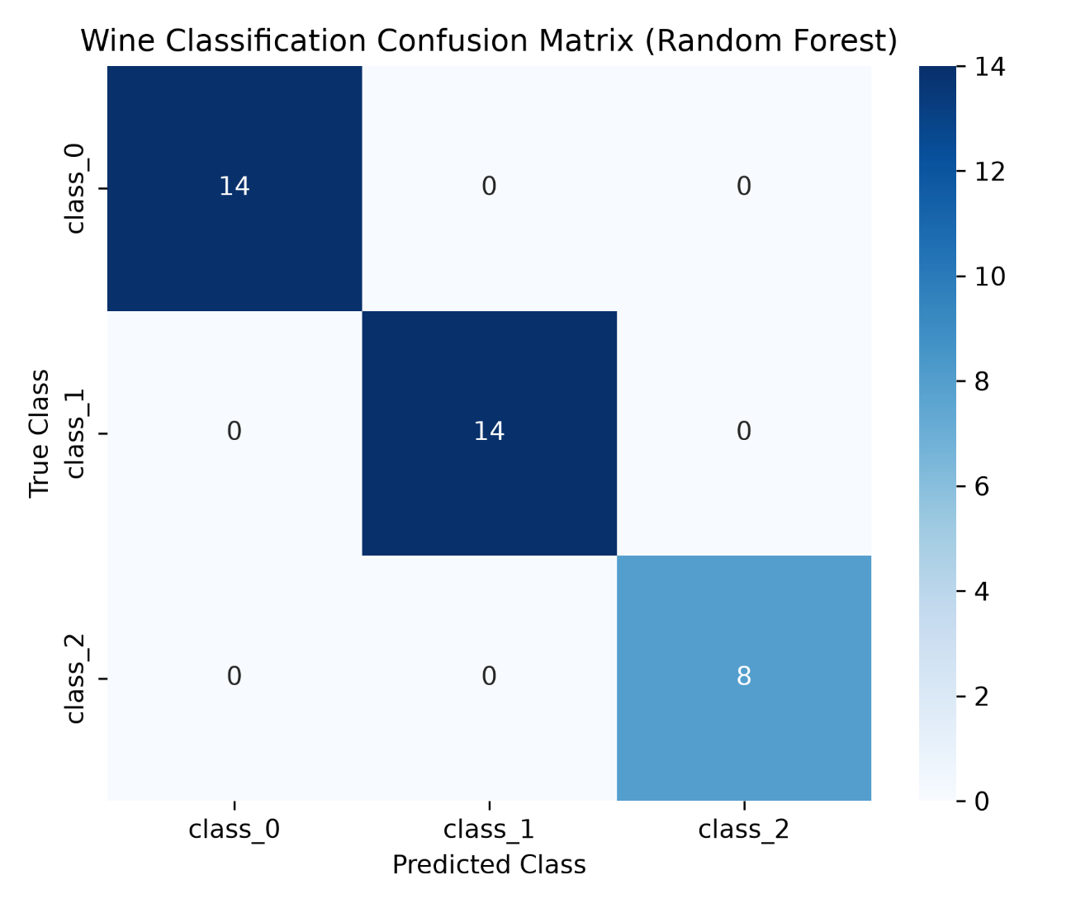
Figure 1: Confusion matrix of Random Forest model on Wine Quality dataset (100% test accuracy).
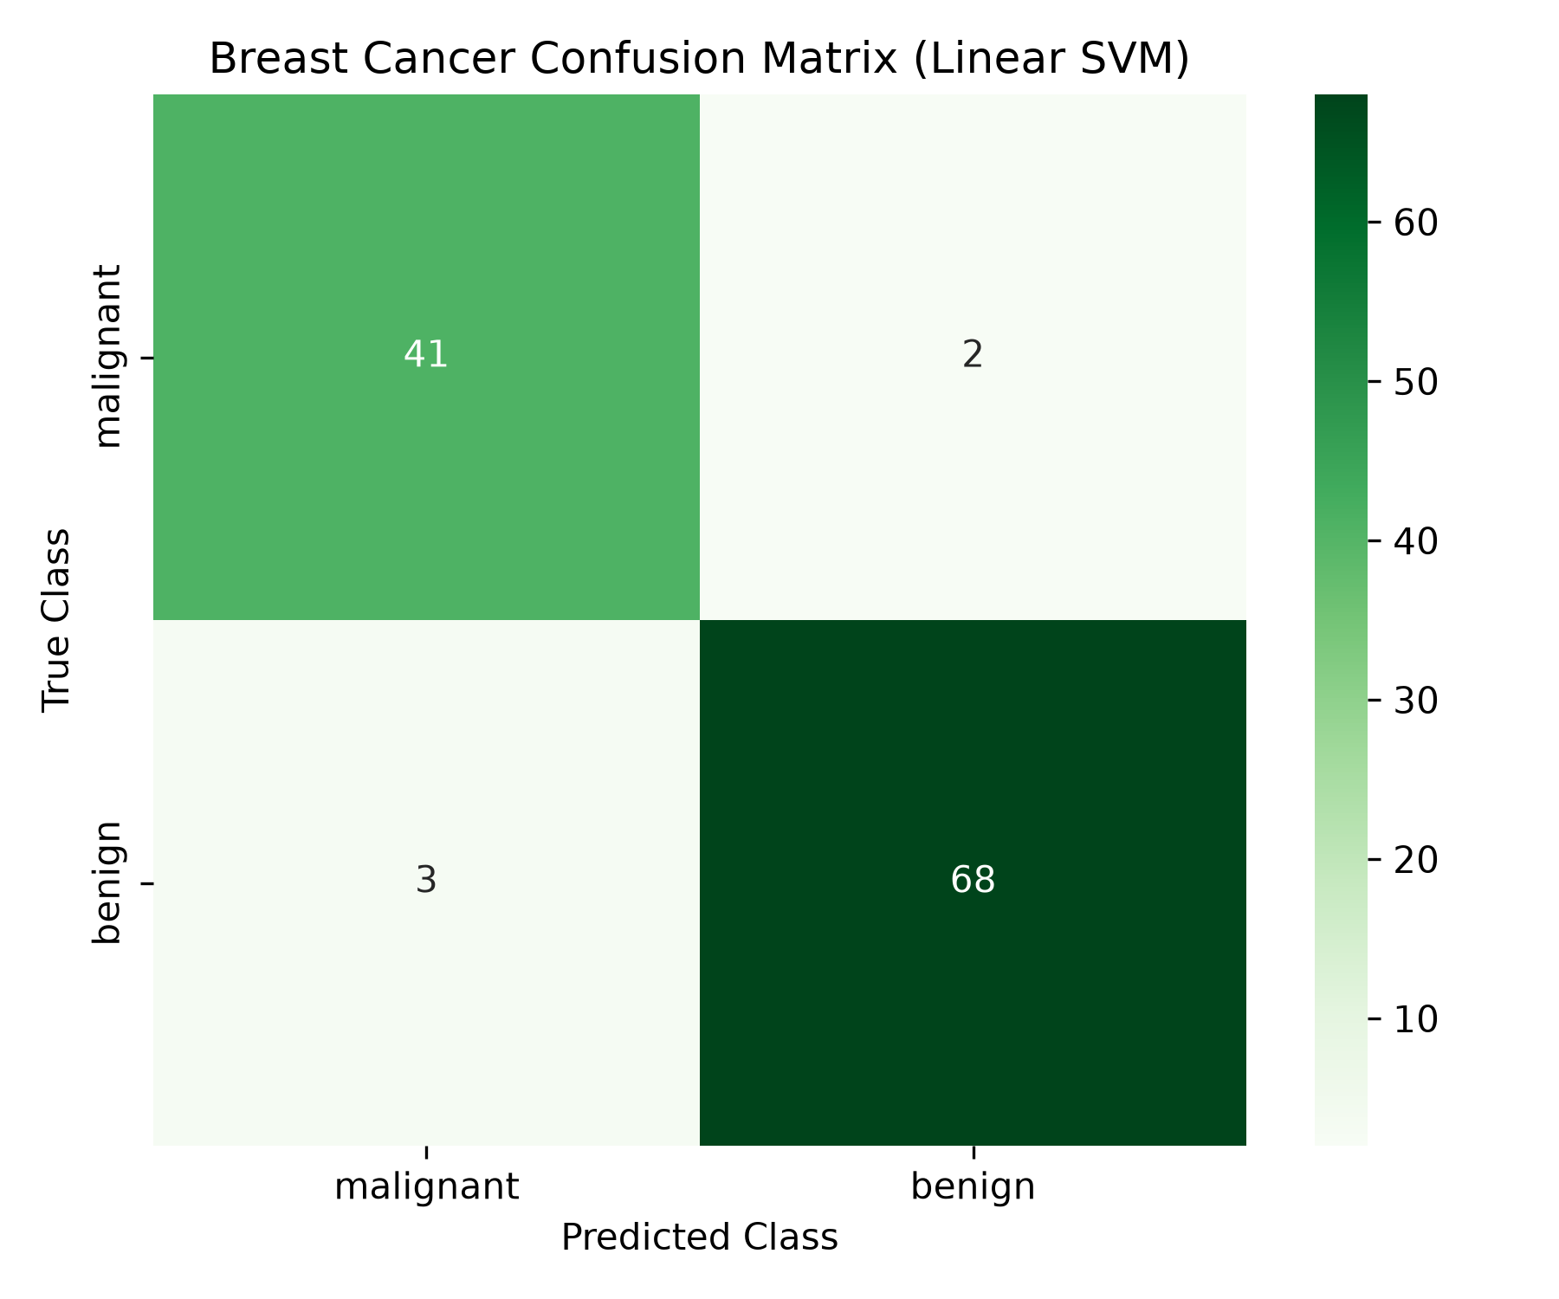
Figure 2: Confusion matrix of Random Forest model on Breast Cancer dataset.
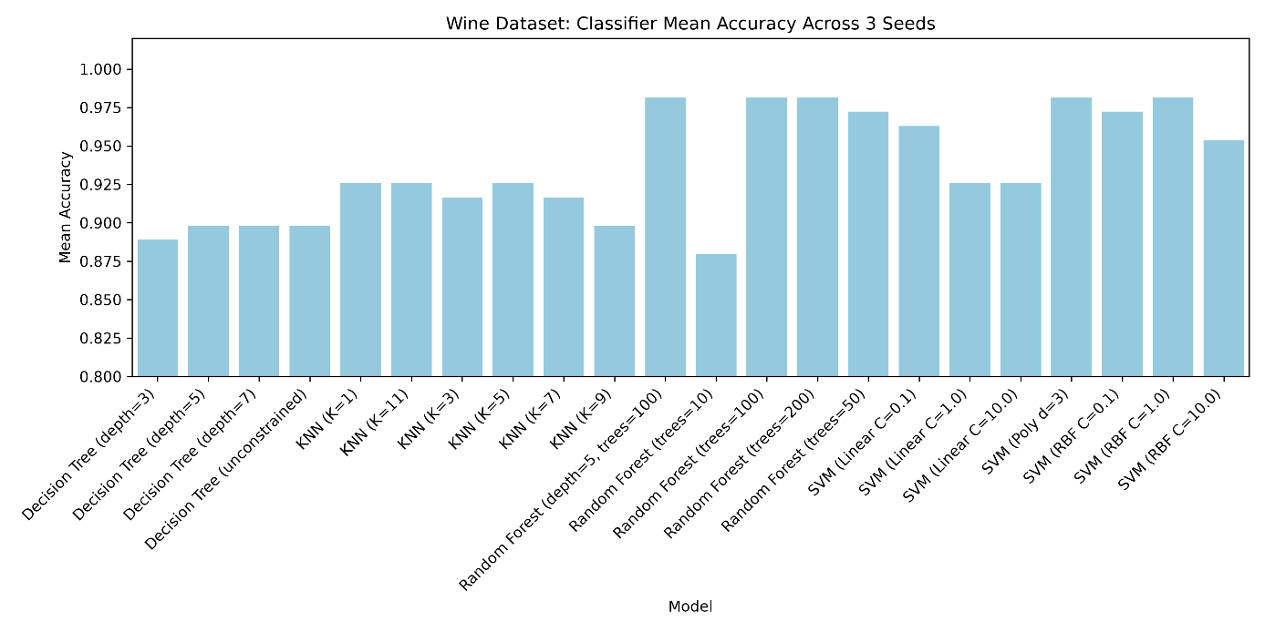
Figure 3: Accuracy comparison of supervised classifiers to different random seeds on Wine Quality dataset.

7. Comparison Dataset
In this projecet, I compared standard classifiers and clustering models on two different datasets. Wine dataset is small dataset with 13 chemical features, so linear models like SVM and KNN reached high performance. Breast Cnacer dataset has 30 complex features, Random Forest and Decision Tree models reached higher performance. Summary, feature scaling using “StandardScaler” show us to be reliable for distance based algorithms, tree based models show us effective performance without scaling.

