**Transform Coding**

We can see that DCT has better quality when compared with DFT. This is because of the reason that in DCT low frequency components are emphasized and as we are speech processing it gives much better results. For high compression rates, it is very audible. In the following figures, you can see the error signals of DFT and DCT . For your convenience, sound signal is multiplied by 108 to see the difference of error signals easier.

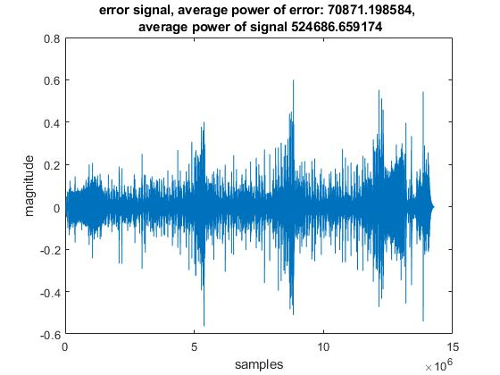

Figure : Error signal of a sound signal compressed with DCT(Blocksize=429 , 99% compression)

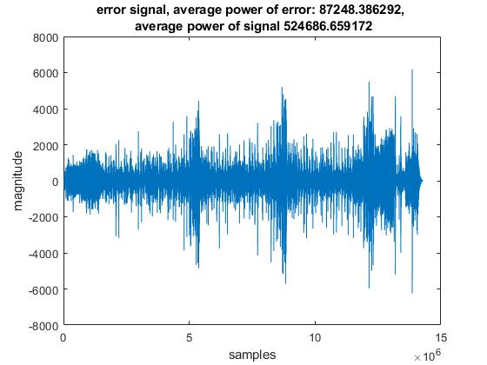

Figure : Error signal of a sound signal compressed with DFT(Blocksize=429 , 99% compression)

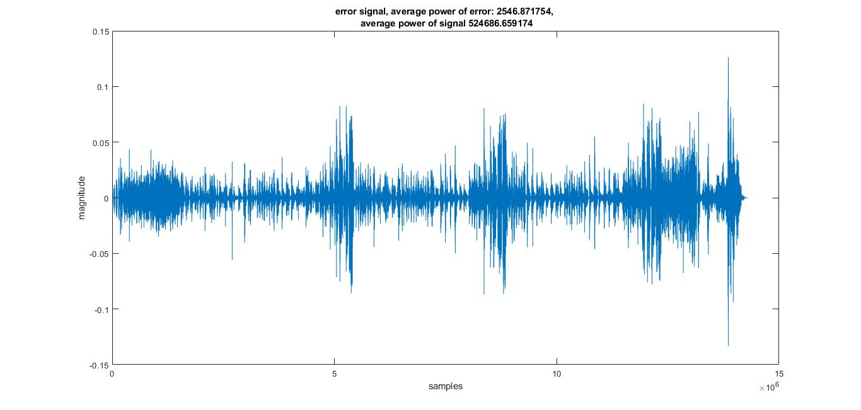

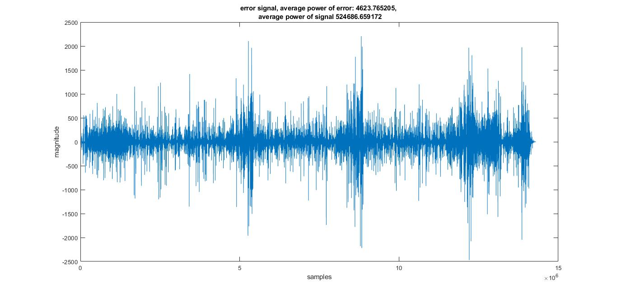Figure : Error signal of a sound signal compressed with DCT(Blocksize=429 , 90% compression)

Figure : Error signal of a sound signal compressed with DFT(Blocksize=429 , 90% compression)

We can see that , more high frequency components exist in the frequency response of DFT and DCT . This is because DFT is calculated with the extension of input signal to make it periodic and artificial discontinuities occur . This is not the case in DCT as DCT makes input signal periodic by adding its symmetric to its right and then shifts it. Therefore in DCT , artificial high frequency components do not appear and it enhances the quality. You can see it in figures below.

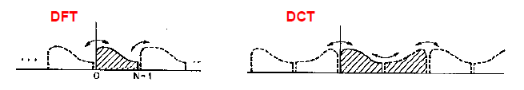

Figure : Comparison of DFT and DCT



Figure : Comparison of DFTs of original signal and DFT thresholded signal

Figure : Comparison of DFTs of original signal and DCT thresholded signal

For %90 compression rate and an input signal’s DFT which has 28252*501=14154252 coefficients , number of coefficients set to zero is 12861500 which is approximately 90% of the coefficients. It is nearly the same for DCT as compression rate is the same.