Rayleigh resolution (in radians)
$$Δθ_{Rayleigh}=\frac{lambda}{aTx}$$

\Delta \theta_{Rayleigh}=\frac{lambda}{aTx}

aTx: Tx aperature
lambda: $λ$

$$Δθ_{desired}=\frac{Δθ_{Rayleigh}}{oversamplingrate}$$

\Delta \theta_{desired}=\frac{\Delta\theta_{Rayleigh}}{oversamplingrate}

sector=35 * pi/180;
% Size of image sector [rad]
$$sector=\frac{35}{180}*π$$

N_lines = round(sector/dThetaDesired)+1;
% Number of emit lines in image
$$N_lines=\frac{sector}{Δθ_{desired}}$$
N\_lines = \frac{sector}{\Delta\theta_{desired}}

$$Δθ_{emit}=\frac{sector}{N_lines-1}$$

\Delta\theta_{emit} = \frac{sector}{N\_lines-1}

$$Δθ_{receive}=\frac{sector}{N_lines-1}$$

Hilbert transformation:
Benefit of
Instantaneous amplitude
Instantaneous frequency

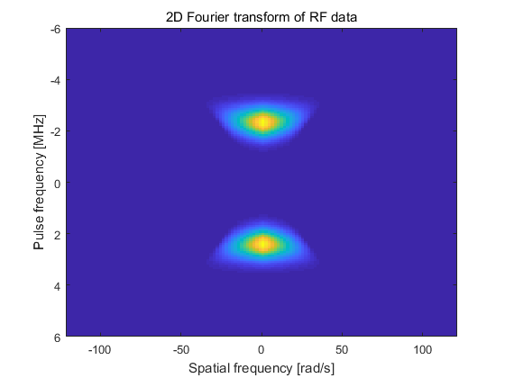
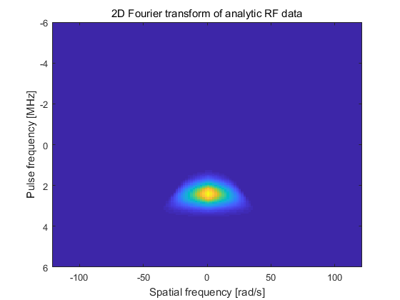
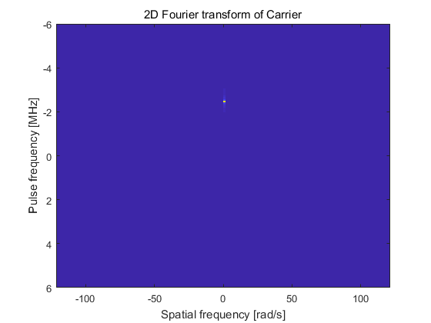
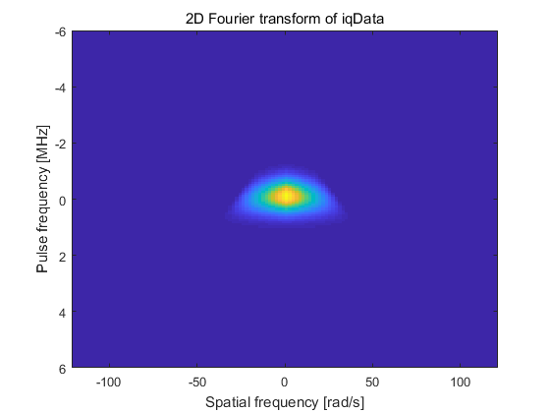
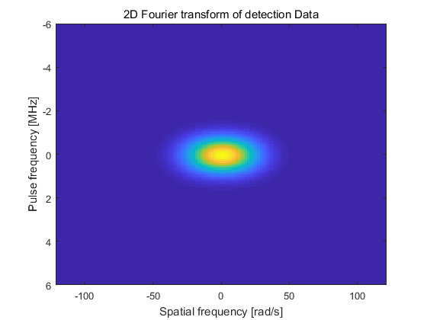

Matlab transpose and ctranspose has some difference:
Transpose is B = A.' returns the nonconjugate transpose of A, that is, interchanges the row and column index for each element. If A contains complex elements, then A.' does not affect the sign of the imaginary parts. For example, if A(3,2) is 1+2i and B = A.', then the element B(2,3) is also 1+2i.

Ctranspose is B=A’ returns the conjugate transpose of A.

Use calc_scat_all to do the test and plot a waveform like this:
