MEDT8007: **Simulation Methods in Ultrasound Imaging**

Marco M. Voormolen page **1** of 1

**Exercise 1**

In this exercise we will explore Huygens’ principle and closed form spatial in pulse response method for acoustic field calculations, along with some general properties of field calculations. To make the calculations less complex we will not involve ourselves with the correct amplitude and timing of the calculated quantities.

**1. Huygens’ principle**

a) We start-out with the parameter space set-up in the m-script *exercise_1.m*. Complete the quadruple for-loop by filling in the correct expression to calculate the spatial impulse response in the frequency domain using Huygens’ principle (see sub-subsection 2.1.1, first paragraph, page 100).

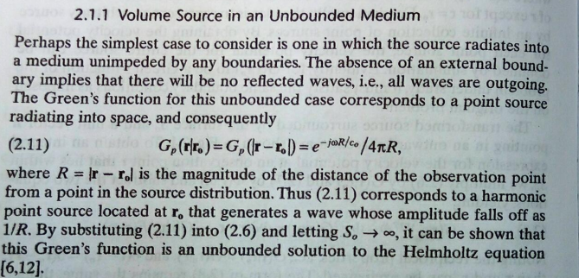

Impulse response: Green’s function for unbounded case.

b) Plot the normalized magnitude of the calculated impulse responses for the observation points. Remember we are dealing with a complex amplitude function and we are only interested in its magnitude here.



Matlab Note: the complex “j” in matlab is “1i”.

exp(-1i*k(i)*R(m,n))/R(m,n);

Matlab Note: the vector design concept.

r =[x_0(q) - x_1(m) y_0-y_1(n) z_0];

R = sqrt(sum(r.*r));

Blue is the Huygen’s principle

Red is using Bessel function to approximation.

This figure shows the center has biggest response!

We can find different pattern for different frequency, z position(depth).

c) Compare the directivity of the aperture, from part b, with the one of formula 3.33 on page 160.

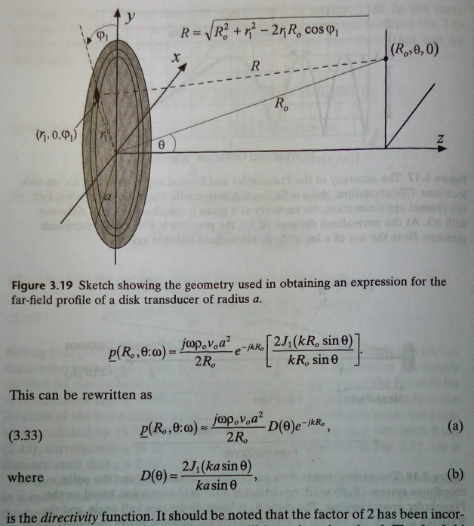

d) What is the most prominent reason for the observed differences? Compare a double spatial resolution with a double axial coordinate of the observation points.

**2. Acoustic field**

a) Change the x-coordinate of the observation points to a single value (e.g. 0 or 5e-3m) and set the frequency range to: 0:df:floor(N_FFT/2)*df. Now calculate the pressure signal in the observation point using the spatial impulse response, which is calculated in the quadruple for loop, and the excitation signal s. To accomplice this you could use the MatLab function:

=ifftmmv(, N_FFT);

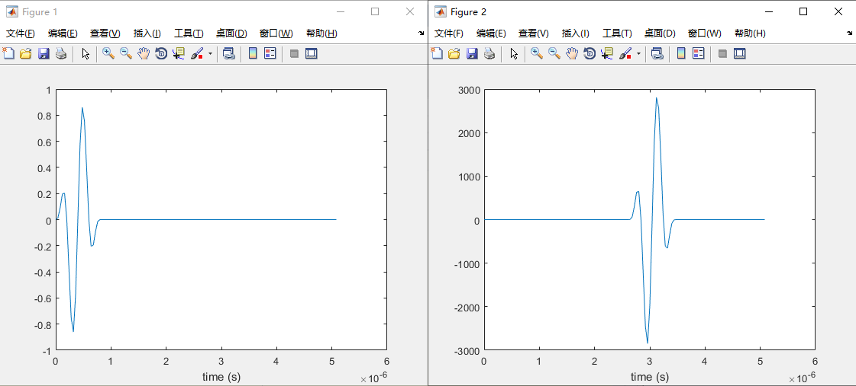

b) What is the alternative procedure to calculate the pressure signal, using the same variables?

Using time-domain convulsion method to get the pressure signal

Impulse response of huygen’s method h(n)

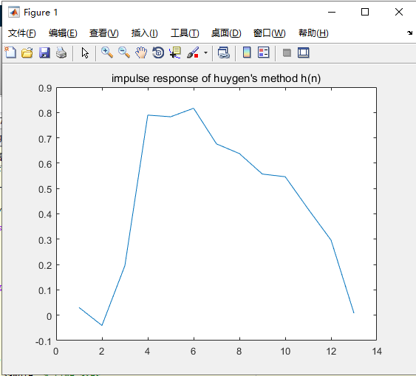

**3. Spatial impulse response**

a) Compare the algorithm described in the first paragraph of sub-subsection 3.3.1 (page 151) with the MatLab function: sirmmv(a, x_0, y_0, z_0, f_Sample, c_0).

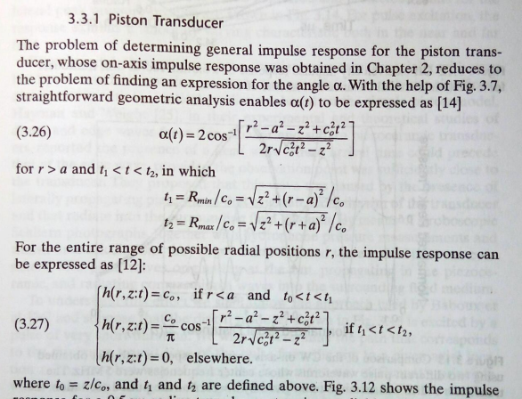

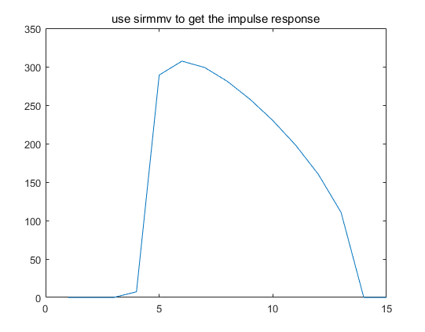

b) Calculate the pressure signal in the observation point closed form expression of sirmmv.

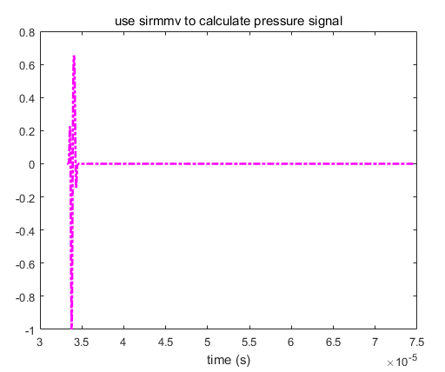

c) Using the result from part b as a reference what can you say about the accuracy of

Huygens’ principle (e.g. decrease the spatial resolution by a factor 2)? At this spatial

resolution what happens if you move the observation point to x_0=10e-3 and

z_0=25e-3? How can you explain this effect?

d) Using the tic toc functions, as is used with the quadruple for-loop, what can you say about the calculation speed of Huygens’ principle and the closed form spatial impulse response method?



4. Use Field-II to analyze the SIR when the aperture is set to focus on

use the same setup as 1.1,

this should use xdc_focused_array to create TX and RX aperture

5. Use Field-II to analyze the SIR when the aperture is set to focus on

set the steering angle of your transmit and receive beam to -35 degrees. The focus can either be changed by changing the initial *focus* parameter, or it can be set to a new value using for example *xdc_focus(yourAperture, 0, newFocusPoint)*.

See the example2_8/example2_9.

SIR 会发生变化， 但是原因是什么？ 从原始计算(green function)如何计算得来？