Department of Computer Technology and Information Systems

## CTIS 487 - Mobile Application Development

FALL 2019 - 2020

# **Lab Guide #2**

|  |
| --- |
| **OBJECTIVES :** Basic Views |
| **Instructor :** Neşe ÖZÇELİK  **Assistant :**  Leyla SEZER |

* Create a new project and create your virtual device carefully, then make the following design by using design and blueprint windows.
* Make the following application according to the instructions.
* Change the layout to the LinearLayout vertical.
* Basic Views;
  + TextView; the text is Guide 2 Basic View,
  + TextView; the text is Movies,
  + 3 Radio Button ; Dora, SpiderMan and Kid_King,
  + 1 RadioButtonGroup,
  + 1 TextView: show the users selection,
  + Button: text is SELECT,
  + ImageView: put the given three images to the drawable folder,
  + Finally; seekBar; progress is 4 max is 15.

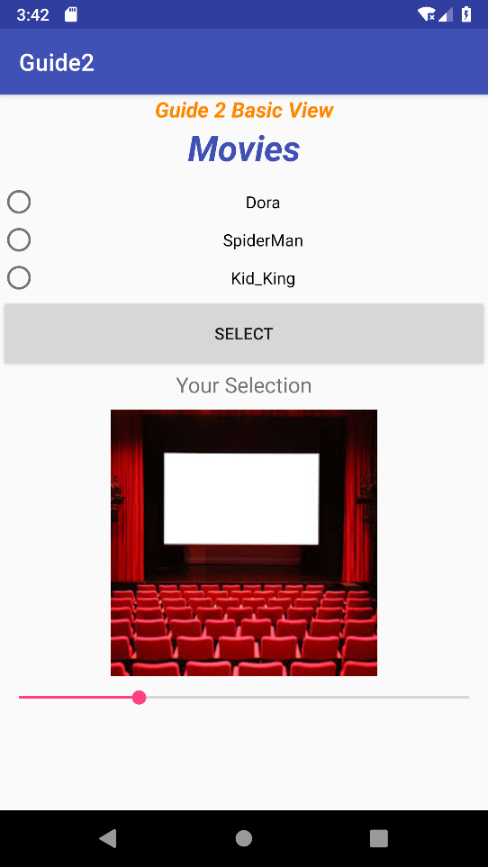

* Give an id for each views, please use the format given below.
  + TextView; txtG2
  + TextView; txtFMovies
  + 3 Radio Button ; rdbtnFirst, rdbtnSecond, rdbtnThird
  + 1 RadioButtonGroup; rdbtngrp1
  + 1 TextView; txtSelected
  + Button; btnSelect
  + ImageView; imgMovies
  + SeekBar; sbChange
* Please examine the activity_main.xml to help for preparing the application.

**activity_main.xml**

<?xml version="1.0" encoding="utf-8"?>

<LinearLayout xmlns:android="http://schemas.android.com/apk/res/android"

xmlns:app="http://schemas.android.com/apk/res-auto"

xmlns:tools="http://schemas.android.com/tools"

android:layout_width="match_parent"

android:layout_height="match_parent"

android:orientation="vertical"

tools:context=".MainActivity">

<TextView

android:id="@+id/txtG2"

android:layout_width="match_parent"

android:layout_height="wrap_content"

android:text="@string/txtLG2"

android:textAlignment="center"

android:textColor="@android:color/holo_orange_dark"

android:textSize="18sp"

android:textStyle="bold|italic"

android:typeface="normal" />

<TextView

android:id="@+id/txtMovie"

android:layout_width="match_parent"

android:layout_height="50dp"

android:text="@string/txtMovie"

android:textAlignment="center"

android:textColor="@color/colorPrimary"

android:textSize="30sp"

android:textStyle="bold|italic"

tools:text="@string/txtMovie" />

<RadioGroup

android:id="@+id/rdbtngrp1"

android:layout_width="match_parent"

android:layout_height="wrap_content"

android:layout_gravity="center" >

<RadioButton

android:id="@+id/rdbtnFirst"

android:layout_width="match_parent"

android:layout_height="wrap_content"

**android:onClick="checkedRadio"**

android:text="@string/rdFirst"

android:textAlignment="center"

tools:text="@string/rdFirst" />

<RadioButton

android:id="@+id/rdbtnSecond"

android:layout_width="match_parent"

android:layout_height="wrap_content"

**android:onClick="checkedRadio"**

android:text="@string/rdSecond"

android:textAlignment="center" />

<RadioButton

android:id="@+id/rdbtnThird"

android:layout_width="match_parent"

android:layout_height="wrap_content"

**android:onClick="checkedRadio"**

android:text="@string/rdThird"

android:textAlignment="center" />

</RadioGroup>

<Button

android:id="@+id/btnApply"

android:layout_width="match_parent"

android:layout_height="62dp"

**android:onClick="display"**

android:text="@string/btnSelect" />

<TextView

android:id="@+id/txtSelected"

android:layout_width="match_parent"

android:layout_height="33dp"

android:text="@string/txtSelection"

android:textAlignment="center"

android:textSize="18sp" />

<ImageView

android:id="@+id/imgMovie"

android:layout_width="match_parent"

android:layout_height="wrap_content"

android:contentDescription="@string/movie_hint"

app:srcCompat="@drawable/movie" />

<SeekBar

android:id="@+id/sbChange"

android:layout_width="match_parent"

android:layout_height="36dp"

android:progress="4"

android:max="15"

/>

</LinearLayout>

* After Running the project see the screenshots how it will works.
* When the user select one of the RadioButton, the Toast message will be shown in the screen.
* When the user select one of the RadioButton and clicks on the SELECT button TextView shows the message “Your Choice is: Dora” as int the screen.
* According to the user’s selection the image of the movie must be change as shown below.

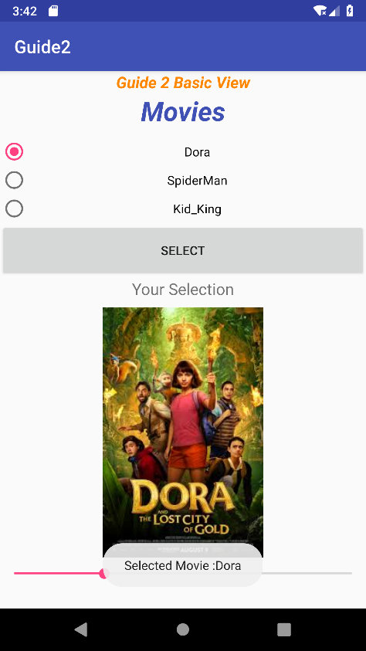 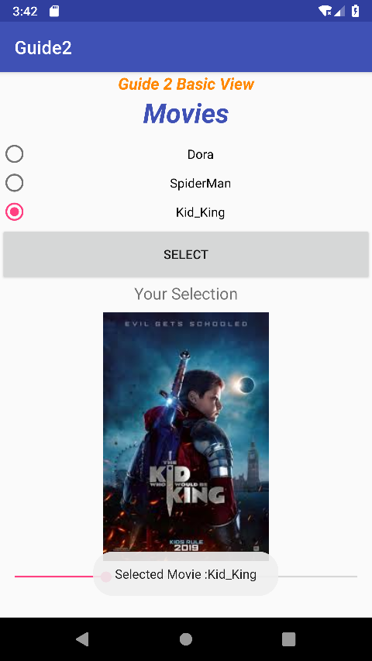

* Finally, when the user changes the progress of the SeekBar, TextView shows the message “SeekBar:9”
* Examine the MainActivity.java content which is given below.

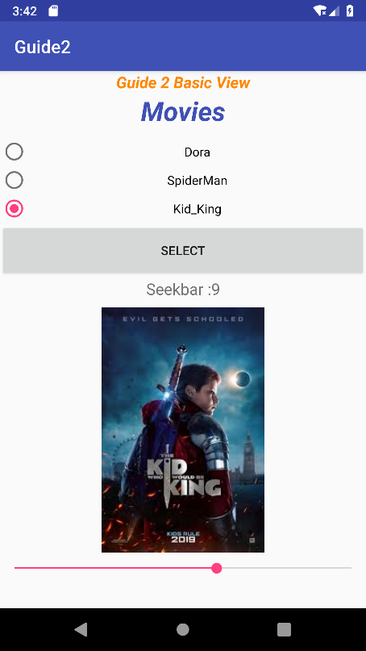

**MainActivity.java**

public class MainActivity extends AppCompatActivity {

RadioButton rd1,rd2,rd3,radioButton;

ImageView img;

RadioGroup radioGroup;

TextView textView;

Button btnApply;

SeekBar seek;

protected void onCreate(Bundle savedInstanceState) {

super.onCreate(savedInstanceState);

setContentView(R.layout.activity_main);

radioGroup = findViewById(R.id.rdbtngrp1);

rd1 = findViewById(R.id.rdbtnFirst);

rd2 = findViewById(R.id.rdbtnSecond);

rd3 = findViewById(R.id.rdbtnThird);

textView = findViewById(R.id.txtSelected);

img = findViewById(R.id.imgMovie);

btnApply = findViewById(R.id.btnApply);

seek = findViewById(R.id.sbChange);

**seek.setOnSeekBarChangeListener(new SeekBar.OnSeekBarChangeListener()** {

public void onProgressChanged(SeekBar seekBar, int progress, boolean b) {

textView.setText("Seekbar :"+progress);

}

public void onStartTrackingTouch(SeekBar seekBar) {

}

public void onStopTrackingTouch(SeekBar seekBar) {

}

});

}

public void checkedRadio(View view)

{

**int radioID = radioGroup.getCheckedRadioButtonId();**

radioButton = findViewById(radioID);

if(radioButton == rd1)

img.setImageDrawable(getResources().getDrawable(R.drawable.dora));

else if(radioButton == rd2)

img.setImageDrawable(getResources().getDrawable(R.drawable.spiderman));

else

img.setImageDrawable(getResources().getDrawable(R.drawable.kid_king));

Toast.makeText(this,"Selected Movie :"+radioButton.getText(),Toast.LENGTH_LONG).show();

}

public void display(View view)

{

int radioID = radioGroup.getCheckedRadioButtonId();

radioButton = findViewById(radioID);

textView.setText("Your choice is:"+radioButton.getText());

}

}