Department of Computer Technology and Information Systems

## CTIS 487 - Mobile Application Development

FALL 2018 - 2019

# **Lab Guide #3**

|  |
| --- |
| **OBJECTIVES :** Usage of Basic Views |
| **Instructor :** Neşe ÖZÇELİK  **Assistant :**  Leyla SEZER |

* Create a new project and create your virtual device carefully, then make the following design by using design and blueprint windows.
* Make the following application according to the instructions.
* Change the layout to the LinearLayout vertical.
* Basic Views;
  + TextViews (Two Animation; blank and color)
  + Two Button (Change Background, Clear)
  + Frame Layout for ImageView
  + Spinner
  + Table Layout
  + Edit Text, CheckBox

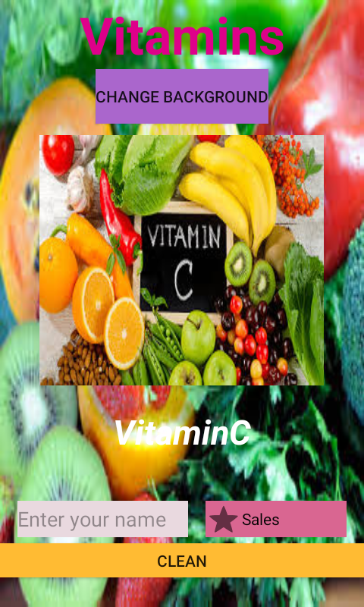

* Please examine the activity_main.xml to help for preparing the application.

**activity_main.xml**

<?xml version="1.0" encoding="utf-8"?>

<LinearLayout xmlns:android="http://schemas.android.com/apk/res/android"

xmlns:app="http://schemas.android.com/apk/res-auto"

xmlns:tools="http://schemas.android.com/tools"

android:id="@+id/linearLayout"

android:layout_width="match_parent"

android:layout_height="match_parent"

android:background="@drawable/vitamins1"

android:orientation="vertical"

tools:context=".MainActivity">

<TextView

android:id="@+id/tvAnimation1"

android:layout_width="match_parent"

android:layout_height="wrap_content"

android:text="@string/tvAnimation"

android:textAlignment="center"

android:textColor="#FFFFFEFF"

android:textSize="45sp"

android:textStyle="bold" />

<Button

android:id="@+id/btnChangeBackg"

android:layout_width="wrap_content"

android:layout_height="wrap_content"

android:layout_gravity="center"

android:background="@android:color/holo_purple"

android:text="@string/btnChange"

android:textAlignment="center" />

<FrameLayout

android:layout_width="250dp"

android:layout_height="250dp"

android:layout_gravity="center"

android:paddingTop="10dp"

android:paddingBottom="20dp">

<ImageView

android:id="@+id/imageView"

android:layout_width="match_parent"

android:layout_height="match_parent"

android:contentDescription="@string/imvHp"

android:onClick="onClick"

android:scaleType="fitXY"

app:srcCompat="@drawable/vitamins2" />

</FrameLayout>

<TextView

android:id="@+id/tvAnimation2"

android:layout_width="match_parent"

android:layout_height="wrap_content"

android:text="@string/tvAlpha"

android:textAlignment="center"

android:textColor="#FFFFFEFF"

android:textSize="30sp"

android:textStyle="bold|italic" />

<Spinner

android:id="@+id/spinner"

android:layout_width="match_parent"

android:layout_height="35dp"

android:background="#FF7C2C4A"

android:entries="@array/types"

android:visibility="invisible" />

<TableLayout

android:layout_width="match_parent"

android:layout_height="wrap_content"

android:layout_marginTop="5dp"

android:stretchColumns="1">

<TableRow>

<EditText

android:id="@+id/etName"

android:layout_width="150dp"

android:layout_height="match_parent"

android:layout_marginLeft="15dp"

android:background="@color/colorAccent"

android:hint="@string/tagName"

android:inputType="textPersonName" />

<CheckBox

android:id="@+id/checkBox"

style="?android:attr/starStyle"

android:layout_width="wrap_content"

android:layout_height="wrap_content"

android:layout_marginLeft="15dp"

android:layout_marginRight="15dp"

android:background="#FFD96691"

android:text="@string/check" />

</TableRow>

</TableLayout>

<Button

android:id="@+id/btnClean"

android:layout_width="match_parent"

android:layout_height="30dp"

android:layout_marginTop="5dp"

android:background="@android:color/holo_orange_light"

android:onClick="onClick"

android:text="@string/btnClean" />

</LinearLayout>

* After Running the project see the screenshots how it will works.
* Textview1 should be Color Animation, Textview2 should be blink animation.

**BLINK**

private void blink() {

final Handler handler = new Handler();

new Thread(new Runnable() {

@Override

public void run() {

int timeToBlink = 500; //in milliseconds

try {

Thread.sleep(timeToBlink);

} catch (Exception e) {

}

handler.post(new Runnable() {

@Override

public void run() {

//TextView textView2 = (TextView) findViewById(R.id.tvAnimation2);

if (textView2.getVisibility() == View.VISIBLE)

textView2.setVisibility(View.INVISIBLE);

else

textView2.setVisibility(View.VISIBLE);

blink();

}

});

}

}).start();

}

* Call in **MainActivity.onCreate**

**COLOR ANIMATION**

**In onCreate:**

//color animation

colorAnim = ObjectAnimator.ofInt(textView1, "textColor", RED, BLUE);

colorAnim.setDuration(3000);

colorAnim.setEvaluator(new ArgbEvaluator());

colorAnim.setRepeatCount(ValueAnimator.INFINITE);

colorAnim.setRepeatMode(ValueAnimator.REVERSE);

colorAnim.start();

* When user Click to Change Background button, background will be changed.
* When the user click on the “VITAMIN C” the image also change to “VITAMIN D”.

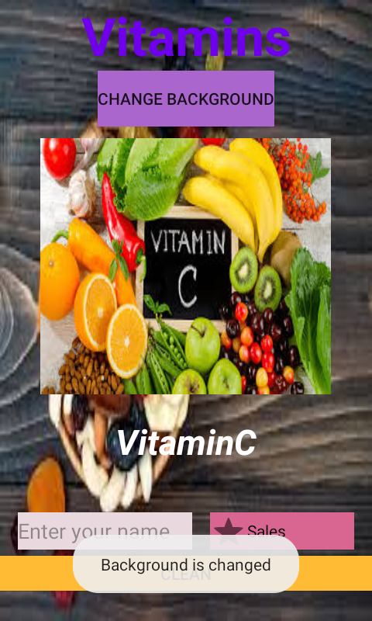 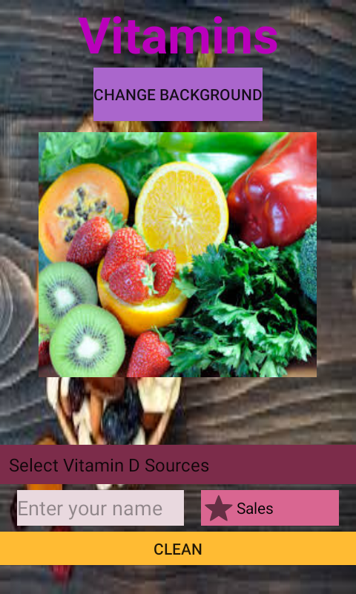

* When the image is VITAMIN D, the spinner shown and user can select the Source of the VITAMIN D.

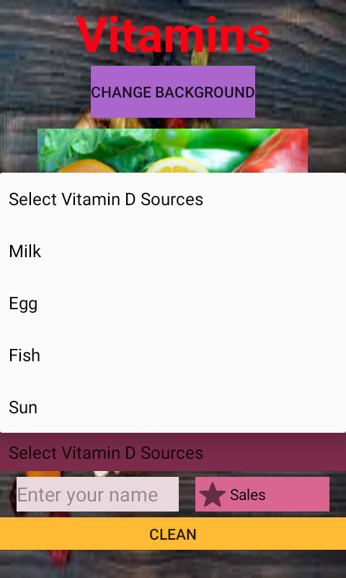 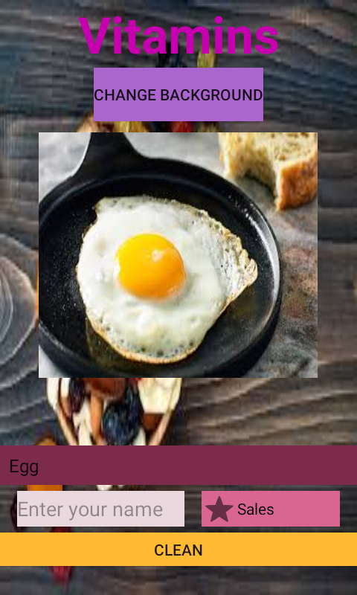

* When choose an item from Spinner, ImageView will be changed and alert dialog will be opened as shown.

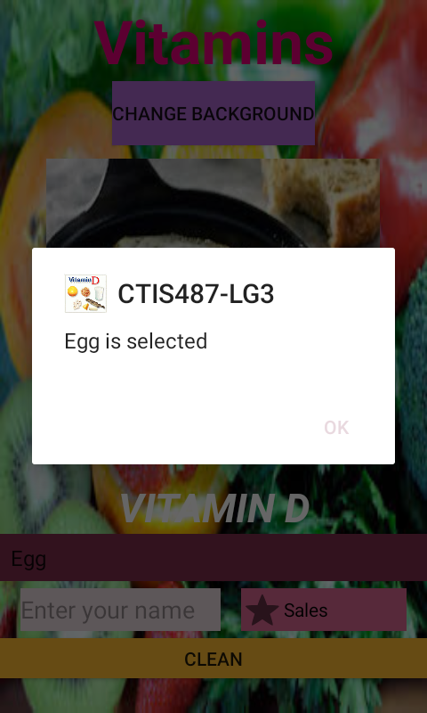

* In Edit Text; when user is typing, toast message will be appearing and inform to the user.

**In onCreate:**

**Typing handling**

etName.addTextChangedListener(new TextWatcher() {

public void beforeTextChanged(CharSequence s, int start, int count, int after) {

}

public void onTextChanged(CharSequence s, int start, int before, int count) {

boolean flagCleanButtonPressed = btnClean.isPressed();

if (flagCleanButtonPressed)

flagCleanButtonPressed = false;

else

displayToast("Your just typed\n" + s.toString());

}

public void afterTextChanged(Editable s) {

}

});

**Alert Dialog**

private void makeAndShowDialogBox(String message) {

AlertDialog.Builder mDialogBox = new AlertDialog.Builder(this);

// set message, title, and icon

mDialogBox.setTitle("CTIS487-LG3");

mDialogBox.setMessage(message);

mDialogBox.setIcon(R.drawable.vitamind);

mDialogBox.setPositiveButton("Ok",

new DialogInterface.OnClickListener() {

public void onClick(DialogInterface dialog, int whichButton) {

}

});

mDialogBox.create();

mDialogBox.show();

}

* The CheckBox is checked / unchecked Toast message will be appear.

**In onCreate:**

//CheckBox Handling

check = (CheckBox) findViewById(R.id.checkBox);

check.setOnClickListener(new View.OnClickListener() {

public void onClick(View view) {

if (((CheckBox) view).isChecked())

displayToast("You click checkbox");

else

displayToast("You uncheck checkbox");

}

});

* Finally, when the click the Clean Button, Edit Text will be cleaned.

**In onCreate:**

colorAnim = ObjectAnimator.ofInt(textView1, "textColor", RED, BLUE);

colorAnim.setDuration(3000);

colorAnim.setEvaluator(new ArgbEvaluator());

colorAnim.setRepeatCount(ValueAnimator.INFINITE);

colorAnim.setRepeatMode(ValueAnimator.REVERSE);

colorAnim.start();

* **HINT\*\*** Hiding Status Bar - Title Bar & Locking the orientation to Portrait

//Hiding title bar using code

//Call hide method before setContentView method!

**getSupportActionBar().hide();**

**Otherwise application will terminated abnormally.**

setContentView(R.layout.activity_main);

getWindow().setFlags(WindowManager.LayoutParams.FLAG_FULLSCREEN, WindowManager.LayoutParams.FLAG_FULLSCREEN);

// Locking the orientation to Portrait

setRequestedOrientation(ActivityInfo.SCREEN_ORIENTATION_PORTRAIT);

* **HINT\*\*** Try to change the Orientation to LANDSCAPE by using the following code segment, then run it.
* **What happened? Can you change it?**
  + **setRequestedOrientation(ActivityInfo.LANDSCAPE);**