Department of Computer Technology and Information Systems

## CTIS 487 - Mobile Application Development

FALL 2019 - 2020

# **Lab Guide #4**

|  |
| --- |
| **OBJECTIVES:** Intent + Constraint Layout |
| **Instructor :** Neşe ŞAHİN ÖZÇELİK  **Assistant :**  Leyla SEZER |

**STEP 1. Open another activity.**

* Create two activities (MainActivity, SecondActivity). Over app folder right click and select **New**, select **Activity,** select **Empty Activity** and then give the second activity class name and xml file name.

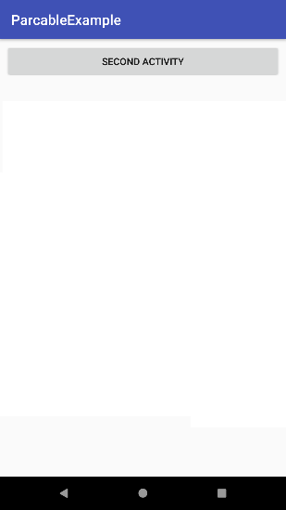 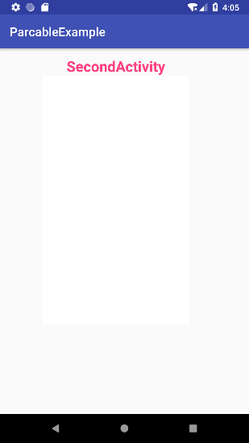

* If user clicks on the **SECOND ACTIVITY** button, second activity will be opened.

**MainActivity;**

public void onClick(View view) {

Intent intent = **= new Intent(this, SecondActivity.class);**

startActivity(intent);

}

* Run your application and see that second activity can be opened.

**STEP 2. Open another activity.**

* **Create third activity (ThirdActivity) and add THIRD ACTIVITY Button to MainActivity.**
* If user clicks on the **THIRD ACTIVITY** button, ThirdActivity will be opened.

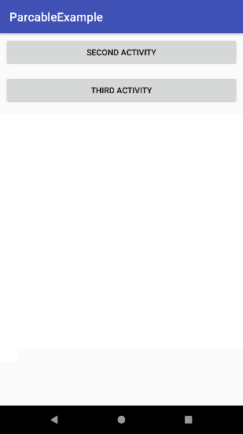 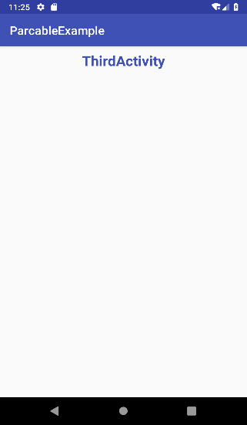

* Modify the onClick method of MainActivity**;**

public void onClick(View view) {

switch (view.getId()) {

case R.id.btn_second:

intent = new Intent(this, SecondActivity.class);

break;

case R.id.btn_third:

intent = new Intent(this, ThirdActivty.class);

break;

}

startActivity(intent);

}

* Run your application and see that SecondActivity and ThirdActivity can be opened.

**STEP 3. Send data to another activity**

* Add Five EditText on MainActivity
* When SECOND ACTIVITY button is clicked, edit text values will send to SecondActivity
* Form the Second Activity, get these values, concatenate first two string and find the average of three integers.

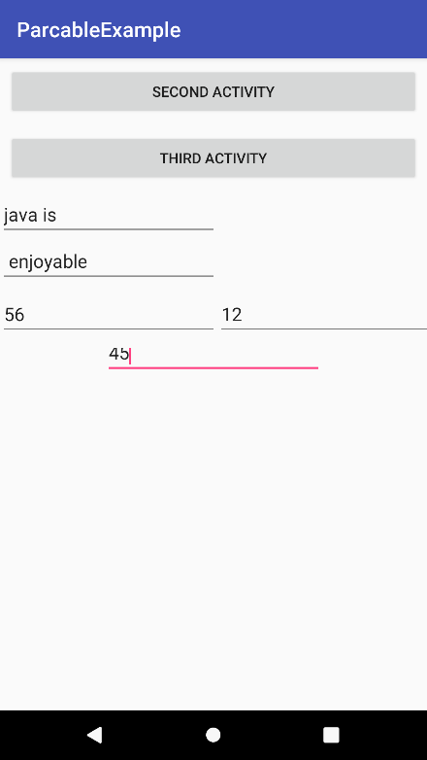

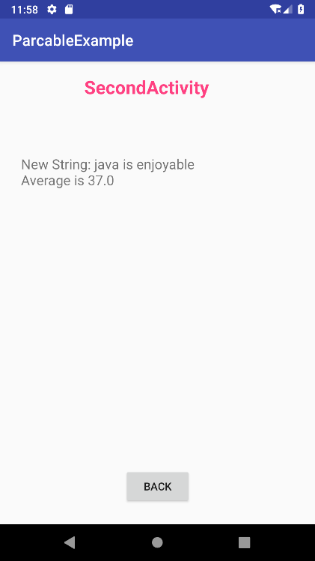

* Modify the **onClick** method of **MainActivity** to send data. You may use **direct** or **bundle** method.

public void onClick(View view) {

Intent intent = null;

if (view.getId() == R.id.btnSecond) {

intent = new Intent(this, SecondActivity.class);

curentRequestcode = requestCode1;

int num1 = Integer.parseInt(etNum1.getText().toString());

int num2 = Integer.parseInt(etNum2.getText().toString());

int num3 = Integer.parseInt(etNum3.getText().toString());

String str1 = etStr1.getText().toString();

String str2 = etStr2.getText().toString();

Bundle b = new Bundle();

b.putInt("num1", num1);

b.putInt("num2", num2);

b.putInt("num3", num3);

b.putString("str1",str1);

b.putString("str2",str2);

intent.putExtras(b);

} else if (view.getId() == R.id.btnThird) {

intent = new Intent(this, ThirdActivity.class);

curentRequestcode = requestCode2;

}

startActivity(intent);

}

* Modify the **onCreate** method of **SecondActivity** to **get data**. If you use direct method in MainActivity, to get the data use direct method. If Bundle method is used in MainActivity, to get data use bundle method.

public void onCreate(…) {

… … … …

tvRes = findViewById(R.id.txtRes);

intent = getIntent();

Bundle b = intent.getExtras();

int num1 = b.getInt("num1");

int num2 = b.getInt("num2");

int num3 = b.getInt("num3");

String str1 = b.getString("str1");

String str2 = b.getString("str2");

double res = (num1+num2+num3) / 3;

String str = str1.concat(str2);

tvRes.setText("New String: "+str);

tvRes.append("\nAverage is " + res );

… … … …

}

**STEP 3.When SecondActivity is closed, return to the MainActivity.**

* Put the button **BACK** in second and third activities. When the user click on these buttons, current activity will be closed and execution will returned to the MainActivity.

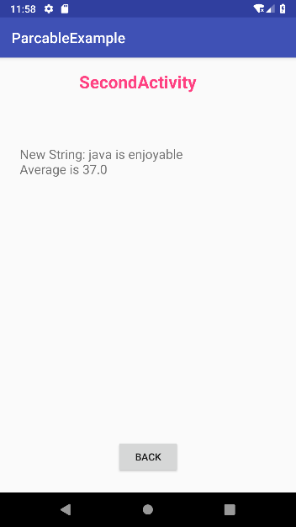

* Write onClick method for the BACK buttons of SecondActivity and ThirdActivity

public void onClick(View view) {

finish();

}

* Modify the **onClick** method of the **MainActivity**

Instead of startActivity(intent) use startActivityForResult(intent,curentRequestcode);

int requestCode1 = 1;

int requestCode1 = 2;

…. … …

… … …

public void onClick(View view) {

Intent intent = null;

if (view.getId() == R.id.btnSecond) {

intent = new Intent(this, SecondActivity.class);

curentRequestcode = requestCode1;

int num1 = Integer.parseInt(etNum1.getText().toString());

int num2 = Integer.parseInt(etNum2.getText().toString());

int num3 = Integer.parseInt(etNum3.getText().toString());

String str1 = etStr1.getText().toString();

String str2 = etStr2.getText().toString();

Bundle b = new Bundle();

b.putInt("num1", num1);

b.putInt("num2", num2);

b.putInt("num3", num3);

b.putString("str1",str1);

b.putString("str2",str2);

intent.putExtras(b);

} else if (view.getId() == R.id.btnThird) {

intent = new Intent(this, ThirdActivity.class);

curentRequestcode = requestCode2;

} else if (view.getId() == R.id.btnCreate) {

intent = new Intent(this, ThirdActivity.class);

curentRequestcode = requestCode2;

Bundle b = new Bundle();

b.putParcelable("book", book);

intent.putExtras(b);

}

startActivityForResult(intent, curentRequestcode);

}

**STEP 4.When SecondActivity is closed, execution will returned to the MainActivity and send data/result to the MainActivity.**

* Modify the **onClick** method of the **SecondActivity;**

public void onClick(View view) {

Intent intent = new Intent();

**intent.putExtra("res",msg);**

//msg is the calculated result.

//Direct or bundle method can be used to send data to the MainActivity which is the caller of //SecondActivity

**setResult(RESULT_OK, intent);**

finish();

}

* From the MainActivity, to get data/result(s) from SecondActivity override the **onActivityResult**() method in the MainActivity

protected void onActivityResult(int requestCode, int resultCode, @Nullable Intent data) {

if(resultCode == RESULT_OK){

String msg = data.getStringExtra("res");

}

}

**STEP 5. (Send an object to another activity)**

* Import a spinner with three book type “ART, MUSIC, SCIENCE”**.**
* When the user selects the book type from the spinner, create Book object according to the users choice
* When THIRD ACTIVITY button is clicked, send book object to the ThirdActivity and display book information on ThirdActivity.

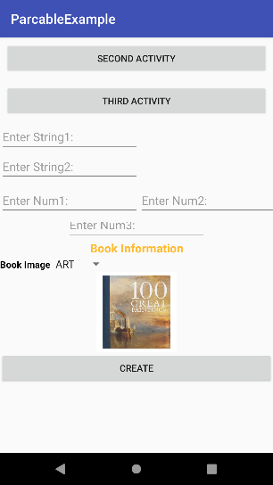 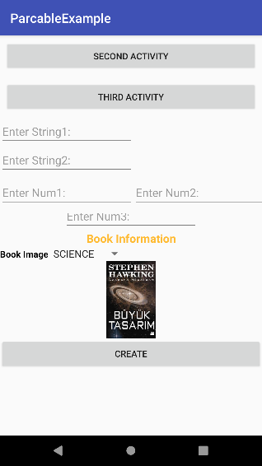 

* Define an integer array to store image ids in MainActivity.
  + Int[] imgIds = {R.drawable.art, R.drawable.science, R.drawable.music}
* Create **Book** class

import android.os.Parcel;

import android.os.Parcelable;

public class Book implements **Parcelable** {

String name;

int id;

int price;

int imgId;

public Book(String name, int id, int price,int imgId) {

this.name = name;

this.id = id;

this.price = price;

this.imgId = imgId;

}

protected **Book(Parcel in)** {

name = in.readString();

id = in.readInt();

price = in.readInt();

imgId = in.readInt();

}

@Override

public void **writeToParcel(Parcel dest, int flags)** {

dest.writeString(name);

dest.writeInt(id);

dest.writeInt(price);

dest.writeInt(imgId);

}

public static final **Creator<Book> CREATOR = new Creator<Book>()** {

@Override

public Book createFromParcel(Parcel in) {

return new Book(in);

}

@Override

public Book[] newArray(int size) {

return new Book[size];

}

};

public int **describeContents**() {

return 0;

}

public String getName() {

return name;

}

public int getId() {

return id;

}

public int getPrice() {

return price;

}

public void setName(String name) {

this.name = name;

}

public void setId(int id) {

this.id = id;

}

public void setPrice(int price) {

this.price = price;

}

public int getImgId() {

return imgId;

}

public void setImgId(int imgId) {

this.imgId = imgId;

}

@Override

public String toString() {

return "Book{" +

"name='" + name + '\'' +

", id=" + id +

", price=" + price +

'}';

}

@Override

}

* Modify the **onCreate** method of the **MainActivity** to catch the item selected event of spinner.

public void onCreate(…) {

… … … …

//Spinner Selection

spBook.setOnItemSelectedListener(new AdapterView.OnItemSelectedListener() {

@Override

public void onItemSelected(AdapterView<?> parent, View view, int i, long l) {

if (i == 0) {

book = new Book("ART", 1, 2500,ImgIds[0]);

img.setImageResource(R.drawable.art);

} else if (i == 1) {

img.setImageResource(R.drawable.science);

book = new Book("SCIENCE", 2, 300,ImgIds[1]);

} else {

img.setImageResource(R.drawable.music);

book = new Book("MUSIC", 3, 3500,ImgIds[2]);

}

}

@Override

public void onNothingSelected(AdapterView<?> adapterView) {

}

});

… … …

* Modify the **onClick** method of the **MainActivity to send book object to ThirdActivity.**

public void onClick(View view) {

Intent intent = null;

if (view.getId() == R.id.btnSecond) {

intent = new Intent(this, SecondActivity.class);

curentRequestcode = requestCode1;

int num1 = Integer.parseInt(etNum1.getText().toString());

int num2 = Integer.parseInt(etNum2.getText().toString());

Bundle b = new Bundle();

b.putInt("num1",num1);

b.putInt("num2",num2);

intent.putExtras(b);

} else if (view.getId() == R.id.btnThird) {

intent = new Intent(this, ThirdActivity.class);

curentRequestcode = requestCode2;

**Bundle b = new Bundle();**

**b.putParcelable("book", book);**

**intent.putExtras(b);**

}

**startActivityForResult(intent,curentRequestcode);**

}

* Modify the **onCreate** method of the **ThirdActivity** to get book object.

public void onCreate(…) {

… … … …

txtBook = findViewById(R.id.txtBook);

img = findViewById(R.id.imgBook);

intent = getIntent();

Bundle b = intent.getExtras();

Book book = (Book) b.getParcelable("book");

txtBook.setText(book.toString());

img.setImageResource(book.getImgId());

}

**STEP 6.When ThirdActivity is closed, execution will returned to the MainActivity and send data/result(s) to the MainActivity.**

* Modify the **onClick** method of the **ThirdActivity;**

public void onClick(View view) {

Intent intent = new Intent();

**intent.putExtra("res",msg);**

//msg value is “Object book recived”

**setResult(RESULT_OK, intent);**

finish();

}

* From the MainActivity, to get data/result(s) from ThirdActivity , **modify** the **onActivityResult**() method in the MainActivity. Remember, this method also will be called when secondActivity is closed. So, you need to identify from which activity execution is returned to MainActivity.

protected void onActivityResult(int requestCode, int resultCode, @Nullable Intent data) {

if(resultCode == RESULT_OK){

String msg = data.getStringExtra("res");

if(**requestCode == requestCode1**){ //Return from Secondactivity

Toast.makeText(this,msg, Toast.LENGTH_LONG ).show();

}

else { //Return form Main Activity

makeAndShowDialog(“Comes from ThirdActivity.”);

}

}

}

