Department of Computer Technology and Information Systems

## CTIS 487 - Mobile Application Development

FALL 2019 - 2020

# **Lab Guide #5**

|  |
| --- |
| **OBJECTIVES :** Intent + Customized Spinner + RecyclerView + Customized Dialog |
| **Instructor :** Neşe ŞAHİN ÖZÇELİK  **Assistant :**  Leyla SEZER |

Create the following design. If the user clicks on the first TextView, Spinner will be displayed with the Cities when the user selects city from the spinner Second Activity will be opened selected city’s image and its name. If the user clicks on the second TextView, Recyclerview will be seen and countries can be seen, when the user selects the country from the recylerview, selected country image with its money type shown in the dialog as shown below.

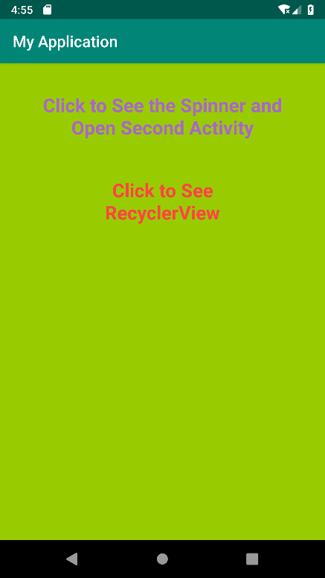 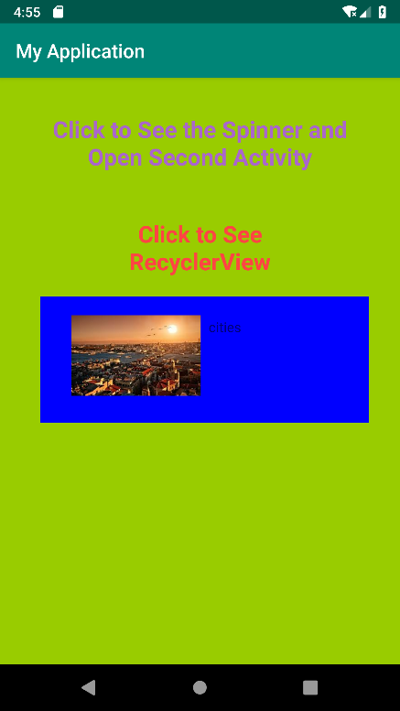

**STEP 1:**

**Create custom spinner and catch item select event.**

* As customized spinner item city image and next to it city name will be displayed, get the cityspinner_layout.xml and import it to your project (save xml file under layout folder)

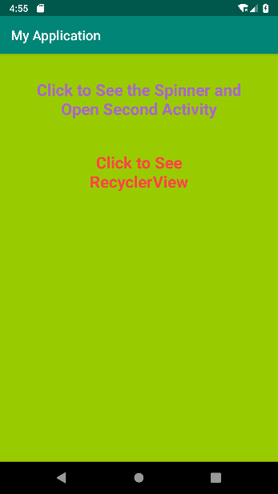 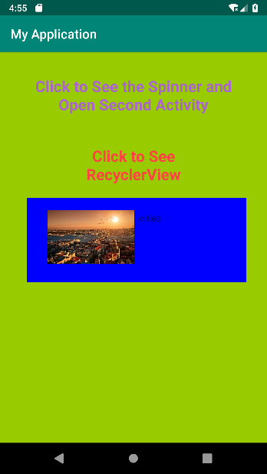 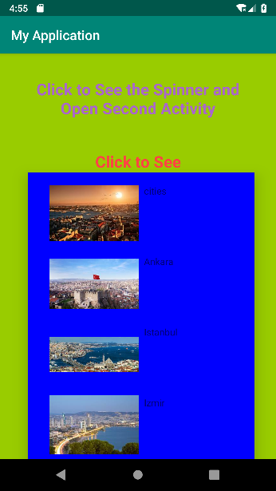

**To create custom spinner**

**Create the Class CitySys;**

ArrayList is defined as static so that through the application ArrayList can be used via class name.

public class CitySys {

public static ArrayList<City> spinnerValues = new ArrayList<City>();

public static void prepareData1(){

spinnerValues.add(new City("cities",R.drawable.turkey));

spinnerValues.add(new City("Ankara",R.drawable.ankara));

spinnerValues.add(new City("Istanbul",R.drawable.istanbul));

spinnerValues.add(new City("Izmir",R.drawable.izmir));

spinnerValues.add(new City("Konya",R.drawable.konya));

}

public static ArrayList<City> getSpinnerValues() {

return spinnerValues;

}

public static City getItem(int selectedPos) {

return spinnerValues.get(selectedPos);

}

}

**Create the MainActivity;**

public class MainActivity extends AppCompatActivity {

TextView tv1,tv2;

Spinner spCities;

Intent intent;

MySpinnerAdapter spinnerAdapter;

boolean isDefaultSelected=true;

@Override

protected void onCreate(Bundle savedInstanceState) {

super.onCreate(savedInstanceState);

setContentView(R.layout.activity_main);

tv1 = (TextView) findViewById(R.id.txtSpinner);

spCities = findViewById(R.id.spCity);

CitySys.prepareData();

CountrySys.prepareData();

spinnerAdapter = new MySpinnerAdapter(getBaseContext(), R.layout.cityspinner_layout);

spCities.setAdapter(spinnerAdapter);

}

public void clickSP(View view) {

**spCities.setVisibility(View.VISIBLE);**

**recyclerCountries.setVisibility(View.INVISIBLE);**

spCities.setOnItemSelectedListener(new AdapterView.OnItemSelectedListener() {

@Override

public void onItemSelected(AdapterView<?> adapterView, View view, int i, long l) {

if(isDefaultSelected)

{

According to the selected item position display city image and city name

isDefaultSelected=false;

}

else

{

**Intent intent = new Intent(MainActivity.this, SecondActivity.class);**

**int selectedItem = spCities.getSelectedItemPosition();**

**Bundle b=new Bundle();**

**b.putInt("City",selectedItem);**

**Toast.makeText(getBaseContext()," "+selectedItem,Toast.LENGTH_LONG).show();**

**intent.putExtras(b);**

**startActivity(intent);**

}

}

}

}

* Create **MySpinnerAdapter** class
  + Put the City ArrayList, LayoutInflator for the data members
  + Put the constructor() and call base class constructor

**super(context, resource, values);**

last parameter (values) corresponds to ArrayList<City>. with this parameter ArrayAdapter can decide how many items will be.

* + override **getDropDownView()** call the function getCustomView(). getDropDownView() method will be called to design the drop down items of spinner. It is called for each drop down item by the ArrayAdapter. How many time will be called is changed according to the array list size.
  + override **getView()** call the function getCustomView(). getView() method will be called by the ArrayAdapter to design the selected item of spinner.
  + Implement getCustomView() that returns the designed view object. Design of selected item and drop down items are same. So same code can be used to design them and call this method from getView() and getDropDownView() methods.

public class MySpinnerAdapter **extends ArrayAdapter<City>** {

private Context context;

private int layoutResourceId;

**private LayoutInflater inflator;**

**private ArrayList<City> spinnerItemValues;**

private boolean flag=false;

public MySpinnerAdapter(Context context, int resource, List values) {

**super(context, resource, values);**

**this.context = context;**

this.layoutResourceId = resource;

**spinnerItemValues = (ArrayList<City>) values;**

}

/* getDropDownView method will be called to design the items of spinner. It is called for each drop down item. How many time will be called is changed according to the arraylist size.

*/

public View **getDropDownView**(int position, View convertView, ViewGroup parent) {

**return** getCustomView(position, convertView, parent);

}

/* getView method will be called to design the selected item of spinner.*/

public View **getView**(int position, View convertView, ViewGroup parent) {

**return** getCustomView(position, convertView, parent);

}

/* design of selected item and drop down items are same. So same code can be used to design them.

*/

public View getCustomView(int position, View convertView, ViewGroup parent) {

inflator = (LayoutInflater)context.getSystemService(Context.LAYOUT_INFLATER_SERVICE);

View rowView rowView = inflator.inflate(layoutResourceId,parent,false);

ConstraintLayout itemLayout = **rowView**.findViewById(R.id.itemLayout);

TextView tv_main = **rowView**.findViewById(R.id.tv_main);

ImageView leftPic = **rowView**.findViewById(R.id.left_pic);

if(flag)

itemLayout.setBackgroundColor(Color.MAGENTA);

else

itemLayout.setBackgroundColor(Color.BLUE);

flag =!flag;

City item = CitySys.getItem(position);

tv_main.setText(item.getName());

leftPic.setImageResource(item.getImgId());

**return rowView;**

}

}

**STEP 2.** When the user click the image inside the secondActivity, screen goes to the MainActivity. Use finish() function. Second activitiy shows the selected city object and its name.

**Create the class SecondActivity;**

public class SecondActivity extends AppCompatActivity {

Intent intent;

ImageView img;

TextView txt1;

int pos;

@Override

protected void onCreate(Bundle savedInstanceState) {

super.onCreate(savedInstanceState);

setContentView(R.layout.activity_second);

img = findViewById(R.id.imCity);

txt1 = findViewById(R.id.txtCityInfo);

intent = getIntent();

Bundle b = intent.getExtras();

int city = b.getInt("City");

img.setImageResource(CitySys.getItem(city).getImgId());

txt1.setText(CitySys.getItem(city).getName()); ("KONYA");

}

public void onclick(View view) {

finish();

}

}

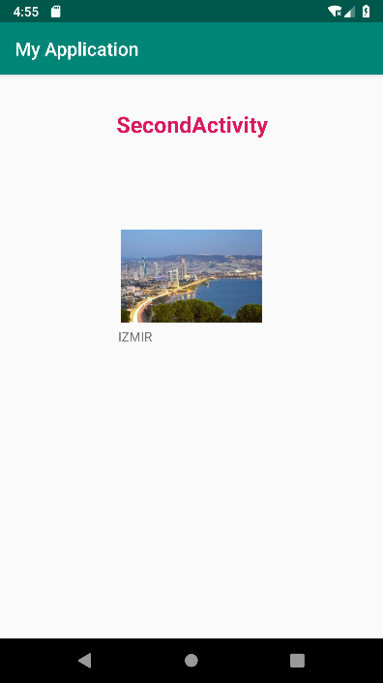

**STEP 3. RecyclerView;**

When the user clicks on the second TextView, the recycler will be seen and the countries will be selected from the user. According to the user’s choice, customized dialog shows the country with its money name as in the shown below.

**To create custom recyclerview**

**Create the class CountrySys**;

public class CountrySys {

public static ArrayList<Country> arrRecyclerCountry = new ArrayList<Country>();

public static void prepareData() {

arrRecyclerCountry.add(new Country(R.drawable.turkey, "Turkey", "Money is TL"));

arrRecyclerCountry.add(new Country(R.drawable.america, "America", "Money is Dollar"));

arrRecyclerCountry.add(new Country(R.drawable.italy, "Italy", "Money is Euro"));

arrRecyclerCountry.add(new Country(R.drawable.france, "France", "Money is Euro"));

arrRecyclerCountry.add(new Country(R.drawable.germany, "Germany", "Money is Euro"));

arrRecyclerCountry.add(new Country(R.drawable.india, "India", "Money is Rupi"));

}

public static ArrayList<Country> getArrRecyclerCountry() {

return arrRecyclerCountry;

}

}

**Write following part to the MainActivity**;

public class MainActivity extends AppCompatActivity {

.

.

.

RecyclerView recyclerCountries;

LinearLayoutManager layoutManager;

MyRecyclerViewAdapter adapter;

@Override

protected void onCreate(Bundle savedInstanceState) {

super.onCreate(savedInstanceState);

setContentView(R.layout.activity_main);

tv1 = (TextView) findViewById(R.id.txtSpinner);

spCities = findViewById(R.id.spCity);

tv2 = findViewById(R.id.txtRecycler);

recyclerCountries = findViewById(R.id.recyclerCountry);

}

public void clickTxt(View view) {

layoutManager = new LinearLayoutManager(this);

layoutManager.setOrientation(LinearLayoutManager.VERTICAL);

recyclerCountries.setLayoutManager(layoutManager);

recyclerCountries.hasFixedSize();

adapter = new MyRecyclerViewAdapter(this, CountrySys.getArrRecyclerCountry());

recyclerCountries.setAdapter(adapter);

recyclerCountries.setVisibility(View.VISIBLE);

spCities.setVisibility(View.INVISIBLE);

}

}

**Create the class MyRecyclerViewAdapter**;

public class MyRecyclerViewAdapter extends RecyclerView.Adapter<MyRecyclerViewAdapter.MyRecyclerViewItemHolder> {

private Context context;

private ArrayList<Country> recyclerItemValues;

//Custom Dialog

int selected;

Button btnDialogDone;

TextView nameOfHouse;

TextView houseWords;

ImageView houseLogo;

Country currentSelectedHouse;

public MyRecyclerViewAdapter(Context context, ArrayList<Country> values) {

this.context = context;

this.recyclerItemValues = values;

}

@NonNull

@Override

public MyRecyclerViewItemHolder onCreateViewHolder(@NonNull ViewGroup viewGroup, int i) {

LayoutInflater inflator = LayoutInflater.from(viewGroup.getContext());

View itemView = inflator.inflate(R.layout.recycler_layout, viewGroup, false);

MyRecyclerViewItemHolder mViewHolder = new MyRecyclerViewItemHolder(itemView);

return mViewHolder;

}

@Override

public void onBindViewHolder(@NonNull MyRecyclerViewItemHolder myRecyclerViewItemHolder, int i) {

final Country sm = recyclerItemValues.get(i);

myRecyclerViewItemHolder.name.setText(sm.getName());

myRecyclerViewItemHolder.words.setText(sm.getWords());

myRecyclerViewItemHolder.img.setImageResource(sm.getLogo());

myRecyclerViewItemHolder.parentLayout.setOnClickListener(new View.OnClickListener() {

@Override

public void onClick(View view) {

Toast.makeText(context, "Clicked on item " + sm.getName(), Toast.LENGTH_LONG).show();

makeAndShowDialogBox(sm.getName(),sm.getLogo(),sm.getWords());

}

});

myRecyclerViewItemHolder.img.setOnClickListener(new View.OnClickListener() {

@Override

public void onClick(View view) {

Toast.makeText(context, "Clicked on " + sm.getName() + " Image of item", Toast.LENGTH_LONG).show();

makeAndShowDialogBox(sm.getName(),sm.getLogo(),sm.getWords());

}

});

myRecyclerViewItemHolder.name.setOnClickListener(new View.OnClickListener() {

@Override

public void onClick(View view) {

Toast.makeText(context, "Clicked on " + sm.getName() + " TextView of item", Toast.LENGTH_LONG).show();

makeAndShowDialogBox(sm.getName(),sm.getLogo(),sm.getWords());

}

});

}

@Override

public int getItemCount() {

return recyclerItemValues.size();

}

class MyRecyclerViewItemHolder extends RecyclerView.ViewHolder {

TextView name, words;

ImageView img;

ConstraintLayout parentLayout;

public MyRecyclerViewItemHolder(@NonNull View itemView) {

super(itemView);

name = itemView.findViewById(R.id.rec_tv);

words = itemView.findViewById(R.id.rec_exp);

img = itemView.findViewById(R.id.rec_img);

parentLayout = itemView.findViewById(R.id.constLayout);

}

}

private void makeAndShowDialogBox(String hname, int logo, String hWords) {

AlertDialog.Builder mDialogBox = new AlertDialog.Builder(context);

// set message, title, and icon

mDialogBox.setTitle(hname);

mDialogBox.setMessage(hWords);

mDialogBox.setIcon(logo);

// Set three option buttons

mDialogBox.setPositiveButton("Ok",

new DialogInterface.OnClickListener() {

public void onClick(DialogInterface dialog, int whichButton) {

// whatever should be done when answering "YES" goes

// here

}

});

mDialogBox.create();

mDialogBox.show();

}

}

