CI/CD Project

Berkutov S.A.

Kiev 2021

Task: create automated system of building project and push it to Target Server.

Stages:

* Running a bash script for installing Terraform
* Using Terraform to create two AWS EC2 instances.
* Using Ansible to install Docker
* Using Docker to execute Jenkins in container
* Using Jenkins to Deploy index.html from Github to Target Server.

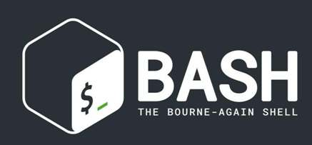  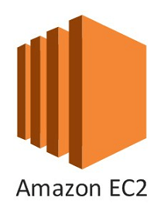 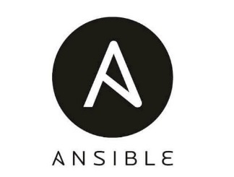

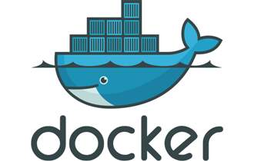 

Bash script.

This is my bash script for installing terraform.

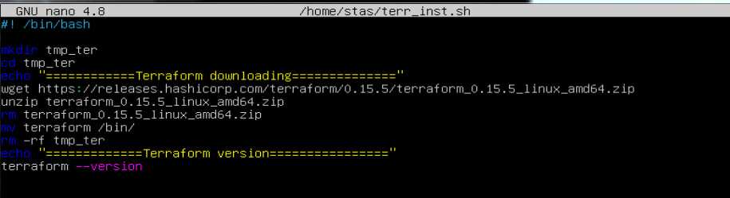

The result of the script execution.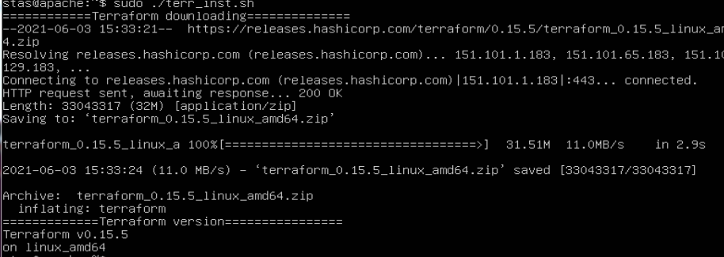

Terraform.

This is my Terraform script for creating two AWS EC2 instances.

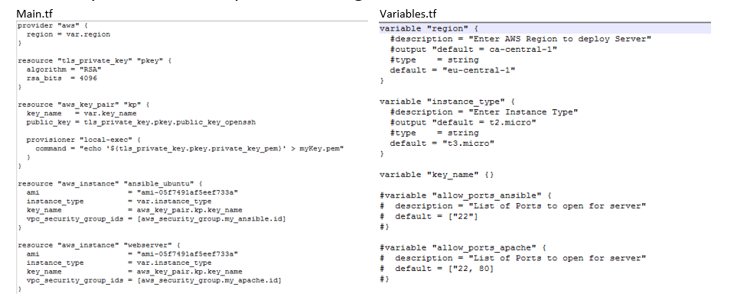

The result or Terraform script.



Ansible.

This is my Ansible script to install Docker.

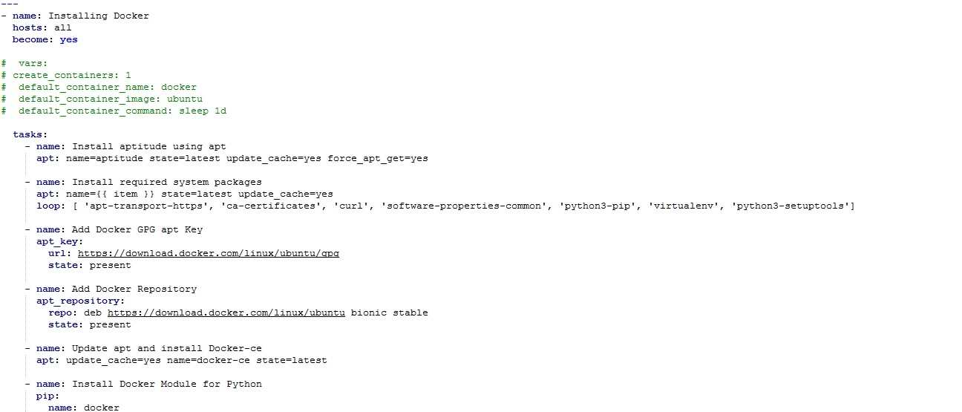

I run Jenkins in a container with the command

sudo docker run –p 8080:8080 –p 50000:50000 –d –v jenkins_home:/var/jenkins_home jenkins/jenkins:lts

In Jenkins, I set up a build that picks up files frog Github after receiving notifications by webhook.

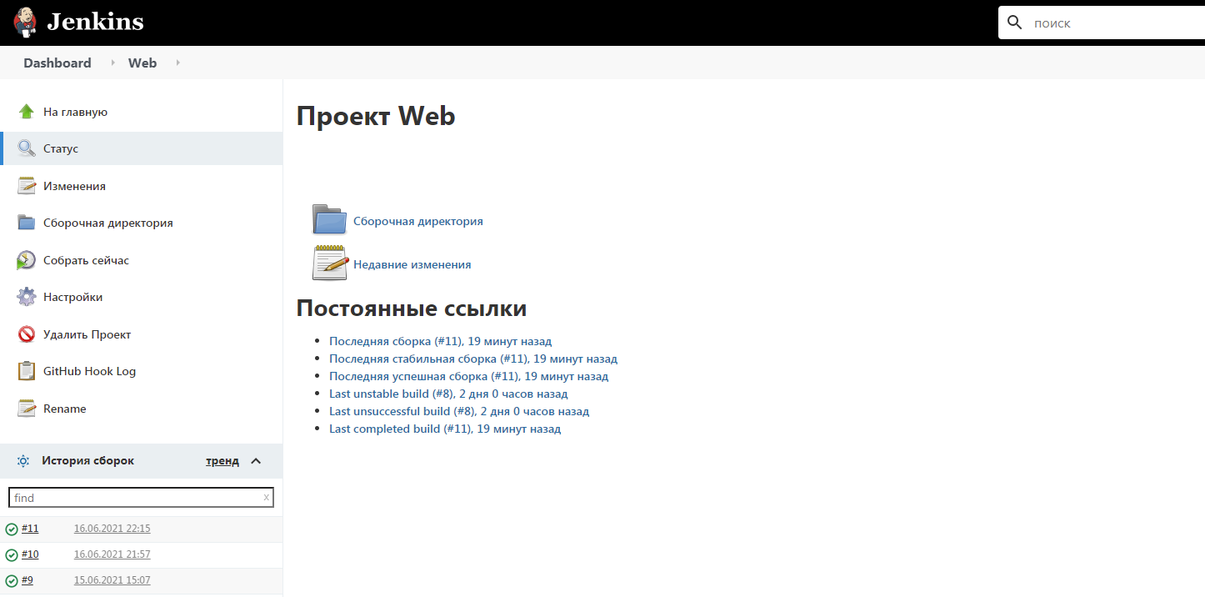

We can see the result of the work on the webserver, which is configured on the AWS EC2 instance.

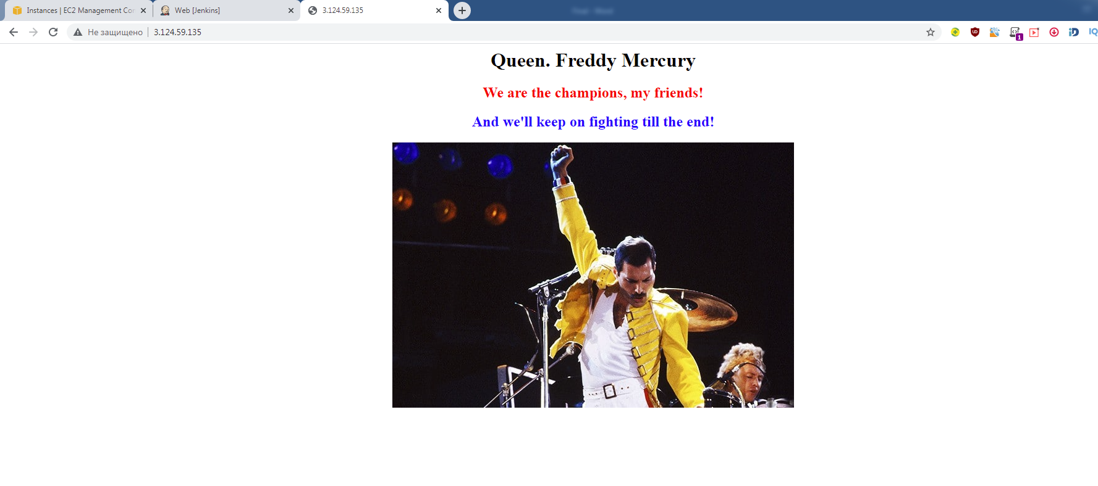

That’s all!

Thanks for attention.

