**ISTANBUL TECHNICAL UNIVERSITY**

**ELECTRICAL-ELECTRONICS FACULTY**

**MICROWAVE IMAGING OF PERFECT ELECTRIC CONDUCTING (PEC) CYLINDERS: A MACHINE LEARNING APPROACH**

**SENIOR DESIGN PROJECT**

**Ali AYDIN**

**Berk VAROL**

**Görkem GÜZEL**

**ELECTRONICS AND COMMUNICATION ENGINEERING DEPARTMENT**

**January 2023**

**ISTANBUL TECHNICAL UNIVERSITY**

**ELECTRICAL-ELECTRONICS FACULTY**

**MICROWAVE IMAGING OF PERFECT ELECTRIC CONDUCTING (PEC) CYLINDERS: A MACHINE LEARNING APPROACH**

**SENIOR DESIGN PROJECT**

**Ali AYDIN**

040170108

**Berk VAROL**

040170059

**Görkem GÜZEL**

040170219

**ELECTRONICS AND COMMUNICATION ENGINEERING DEPARTMENT**

**Project Advisor: Prof. Dr. Ali YAPAR**

**January 2023**

**İSTANBUL TEKNİK ÜNİVERSİTESİ**

**ELEKTRİK-ELEKTRONİK FAKÜLTESİ**

**MÜKEMMEL ELEKTRIK İLETKEN SILINDIRLERIN MIKRODALGA GÖRÜNTÜLENMESI: BIR MAKINA ÖĞRENMESI YAKLAŞIMI**

**LİSANS BİTİRME TASARIM PROJESİ**

**Ali AYDIN**

040170108

**Berk VAROL**

040170059

**Görkem GÜZEL**

040170219

**Project Advisor: Prof. Dr. Ali YAPAR**

**ELEKTRONİK VE HABERLEŞME MÜHENDİSLİĞİ BÖLÜMÜ**

**Ocak 2023**

We are submitting the Senior Design Project Report entitled as “Microwave Imaging of Perfect Electric Conducting (Pec) Cylinders: A Machine Learning Approach”. The Senior Design Project Report has been prepared as to fulfil the relevant regulations of the Electronics and Communication Engineering Department of Istanbul Technical University. We hereby confirm that we have realized all stages of the Senior Design Project work by ourselves, and we have abided by the ethical rules with respect to academic and professional integrity.

**Name SURNAME: Ali AYDIN**

(Student ID): 040170108

**Name SURNAME: Berk VAROL**

(Student ID): 040170059

**Name SURNAME: Görkem GÜZEL**

(Student ID): 040170219

FOREWORD

This paper aims to work on a machine learning approach to solve inverse electromagnetic scattering problem. This problem covers a wide variety of topics, to work on such a topic made us consider the correlations between problems and taught us a lot on how to troubleshoot & look from another perspective when necessary. This project consisted of heavy algorithms and researches. During this process our project advisor, Prof. Dr. Ali YAPAR & Research Assistant Furkan Şahin helped us perfectly. In this part of this paper, we would like to thank them for their help & contribution.

|  |  |
| --- | --- |
| January 2023 | Ali Aydın  Berk Varol  Görkem Güzel |

**TABLE OF CONTENTS**

**Page**

FOREWORD 5

TABLE OF CONTENTS 7

ABBREVIATIONS 8

SYMBOLS 9

LIST OF TABLES 10

LIST OF FIGURES 11

SUMMARY 12

ÖZET 13

1. INTRODUCTION 15

1.1 Problem Statement 15

1.2 Requirements and Specifications 15

1.3 Objectives 15

1.4 Literature Review 16

2. Application of the Problem 18

2.1 The Problem, Electromagnetic Wave Source 18

2.2 Understanding the Concept of Green’s Function 19

2.3 Calculating the Green’s Function 20

2.3.1 Calculating Current Density 20

2.3.2Method of Moments Approach 21

2.3.3 Calculating overall Green’s Function 21

2.4Generating a 2D cut of a cylinder/Random Cylinders 23

2.5 Method of Moments Method on a Perfectly Circular PEC, Comparison with Arithmetic Method 24

2.6 Creating A Data Set for the Machine Learning Algorithm 30

2.7 Data Pre-processing 31

2.8 Convolutional Neural Network Application for Inverse Scattering 32

3. Numerical Results 35

3.1 Direct Problem 35

3.2 Inverse Problem, Machine Learning Approach 37

4. CONCLUSIONS, LAST ARGUMENTS & COMMENTS 47

REFERENCES, QUOTINGS AND FOOTNOTES 50

CURRICULUM VITAE 51

**ABBREVIATIONS**

**PEC:** Perfectly Electric Conducting

**CNN**: Convolutional Neural Network

**EM**: Electromagnetic

**NDT**: Non-Destructive Testing

**TM**: Transverse Magnetic

**MoM**: Method of Moments

**ReLU**: Rectified Linear Unit

**Y_pred**: the predicted geometry from CNN

**Y_test**: The actual geometry of the one predicted with CNN

**SYMBOLS**

$E_{i}$**:** Incident Wave

$k$**:** Propagation Constant

$w$**:** Angular Frequency

$f$**:** Frequency

$H_{0}$**:** Hankel Function

$ϵ$**:** Permittivity

$μ$**:** Permeability

$I$**:** Current

$J$**:** Current Density

$G$**:** Green’s Function

***ρ***: Observer Point

***φ:*** Angle of the Point Observed

$λ:$ Wavelength

LIST OF TABLES

**Page**

Table 2.1 : CNN Arcitecture. 34

Table 3.1 : Scattered Wave Data. 35

Table 3.2 : $ρ$ Data Error! Bookmark not defined.

Table 3.3 : A Cut of Actual Shape. 45

Table 3.4 : A Cut of Prdecited Shape. Error! Bookmark not defined.

Table 3.5 : Error Per Each Point. 46



MICROWAVE IMAGING OF PERFECT ELECTRIC CONDUCTING (PEC) CYLINDERS: A MACHINE LEARNING APPROACH

**SUMMARY**

The goal of this project is to develop a machine learning algorithm that can reconstruct the shape of a perfectly electric conducting cylinder illuminated with electromagnetic waves. To do this, the project begins by illuminating the cylinder with electromagnetic waves and solving the direct scattering problem using the method of moments in MATLAB. This is done by placing antennas in a circle around a section of the cylinder and comparing the results with another analytical approach.

The method of moments involves expressing the unknown currents on the surface of the cylinder in terms of a set of basis functions, which are chosen to satisfy the boundary conditions of the problem. These basis functions are then expanded in a series and the coefficients of the series are determined by enforcing the boundary conditions at the discrete points where the antennas are located. This results in a system of linear equations that can be solved using matrix algebra.

Once the direct scattering problem has been solved, the next step is to generate a dataset of values by illuminating a number of randomly generated cylindrical shapes with electromagnetic waves and solving the corresponding direct scattering problems. This dataset is then used to train a convolutional neural network (CNN) to reconstruct the shape of the cylinder with a precision of 90%.

Training the CNN involves adjusting the weights and biases of the network in order to minimize the error between the predicted output and the true output. This is typically done using an optimization algorithm, such as stochastic gradient descent, which iteratively adjusts the weights and biases in the direction that reduces the error.

In order to achieve a high level of accuracy, it is often necessary to optimize the architecture of the CNN, as well as the hyperparameters such as the learning rate and the batch size. This can involve trial and error, as well as techniques such as cross-validation and grid search. Additionally, it may be necessary to pre-process the data in order to improve the performance of the network, for example by normalizing the input or augmenting the training set with additional examples.

The final result of the project should be an efficient algorithm that is able to reconstruct the shape of the cylinder with an accuracy rate of 94%, with a normal error rate of 6%. This algorithm is flexible and can be adapted for use in other specific cases, particularly in industries that utilize image processing techniques and electromagnetic imaging, such as the medical and military industries.

**Mükemmel Elektrik İleten Silindirlerin Mikrodalga Görüntülenmesi : Bir Makine Öğrenmesi Yaklaşımı**

**ÖZET**

Bu projenin amacı, Elektromanyetik Dalgalarla Aydınlatılmış Mükemmel Elektrik İletken Silindir Geometrilerin, Saçılan Dalga verilerini kullanarak yeniden oluşturmasını amaçlayan bir Makine Öğrenimi Algoritması elde etmektir.

Bu proje, MATLAB’da Momentler Yöntemi kullanarak Doğrudan saçılım problemini çözmeye çalışarak başlar. Öncelikle Mükemmel silindirin bir kesitini çevreleyen bir daire üzerinde antenler yerleştirerek ölçüme başlanır.Bu raporda doğrusal bir kaynakdan saçılan dalgaya göre araştırma yapılmıştır. Fakat bu yaklaşımdan farklı yaklaşımlar getirerek farklı projeler geliştirmek mümkündür. Mesela sonsuz bir silindir yerine 3 boyutlu farkı şekillerin ışımasında noktasal veya doğrusal kaynak kullanmak farklı sonuçlar getirecektir.

Bu projede direkt problemi çözmek için Momentler metodu kullanılmıştır. Bu yöntemde, silindir kesitleri küçük birer hücre gibi ele alınır ve her bir hücre için ayrı ayrı sonuçlar hesaplanır. Hücreler dalga boyuna kıyasla en az 20 kat daha küçük seçilmelidir ki, bu sayede ölçümler çözünürlük açısından verimi yüksek sonuçlar verir.

Momentler metodu ile elde edilen saçılan dalga verilerinden oluşan sonuçlar başka bir analitik yaklaşımla karşılaştırılmıştır. Bu yaklaşımın sonuçları bu projede momentler metodu ile oldukça tutarlı sonuçlar vermiştir ve iki metodun da işlevselliği bu şekilde kanıtlanmıştır. Sonraki adım, rastgele silindirik şekiller üretmek ve bunları Elektromanyetik Dalgalarla aydınlatmaktır. Bunun sağlanması için öncelikle silindir kesiti olan çember yerine daha büyük rastgeleliğe sahip şekiller üreten bir kod yazılmıştır ve bir döngüye sokularak farklı rastgele geometriler için direkt problem tekrar tekrar çözülmüş ve 5000 datalık bir veri kümesi hazırlanmıştır.

Direkt problemin çıktısı, ardılı olarak bir Yapay Sinir Ağına girdi olarak kullanılmalıdır. Bu nedenle sıradaki adım, hangi Yapay Sinir Ağı Algoritmasının kullanılacağına karar vermektir. Lineer Regresyon, Çok Katmanlı Perceptron vb birçok yöntem gözden geçirilerek ,Konvolüsyonel Yapay Sinir Ağı’nın bu sorunu çözmek için en verimli yol olacağı bulunmuştur. Konvolusyonel Sinir Ağı çoğunlukla görüntü işleme problemlerinde kullanılan, çok boyutlu dataların konvolusyonlarını alarak incelenmesine olanak sağlayan oldukça karmaşık bir sinir ağıdır. Siyah, beyaz, gri temalı gri ölçütlü görüntü işleme projeleri inceleyen Konvolüsyonel ağ çalışmalarından esinlenerek bu proje için de bu ağın adapte edilebileceği gözlemlenmiştir.

Bir sonraki aşama olarak saçılan dalga ve dalganın saçıldığı şekile ait konum bilgileri bir matriste toplanmıştır. Bu matris daha sonra Konvolüsyonel Ağa girebilmek üzere girdiler ve çıktılar olarak ve aynı zamanda test ve eğitm kümeleri olarak ayırılmıştır. Ardılı olarak oluşturulan girdi matrisinin boyutları algoritmaya uygun olması amacıyla tekrar manipüle edilmiştir ve algoritmaya verilmiştir.

Yapay Sinir Ağı, bu girdilerle şekilleri en az %90 doğruluk oranına sahip olacak şekilde yeniden üretme amacıyla eğitilir. Bu eğitim için veri kümemiz dörde bir oranında 3 oran test 1 oran eğitim kümesi olacak şekilde güncellenir.

Yüksek verimli bir algoritma çeşitli datalar içeren geniş bir test kümesi gerekliliği doğurur. Fakat verimli bir algoritma için kalabalık bir eğitim kümesi tek gerekli şart değildir. Algoritmanın iç yapısı, öğrenme hızı, tüm algoritmanı işleme hızı, veri çeşitliliği, iterasyon sayısı algoritmanın doğru çalışma oranını ciddi bir şekilde etkileyen faktörlere birkaç örnektir.

Bir algoritmada yüksek hassasiyet elde etmek için,algoritmayı daha verimli bir hale getirmek amacıyla birçok optimizasyon yöntemi ve süreci vardır. Bunlara örnek verecek olursak, algoritmanın bazı katmanlarda bazı nöronları özellikle es geçmesi, çok fazla veya çok az iterasyona girmemesi, Geniş bir eğitim kümesine ve test kümesine sahip olması, öğrenme hızının ayarlanması ve girdi verisinin verimli bir şekilde hazırlanması örnek gösterilebilir.

Bu projenin sonuçları, normal hata oranının 6% aralığında olduğunu, %94-96 hassasiyet ile hedeflendiği şekilde verimli sonuçlar alınabildiğini göstermiştir.İterasyon proseslerindeki kayıplar ve verimlilikteki değişiklikler beklenildiği gibi sonuçlar vermiştir.

Konvolüsyonel Yapay Sinir Ağı kullanım alanları bakımından oldukça esnek bir Ağ’dır.Konvolüsyonel Sinir Ağlarıyla ilgili farklı makalelerde benzer sorunlara yönelik farklı mimariye sahip birçok farklı yaklaşım bulunur. Ayrıca Konvolüsyonel Ağlar sadece elektromanyetik görüntüleme problemlerinde değil daha farklı araştırma konularında da kullanılabilir ağlardır.

Bu projede sunulan veri üretme, ön işleme süreçleri ve algoritmanın kendisi oldukça verimli bulunmuştur ancak bu sorunu ele almak için bu yöntemin tek yöntem olmadığını not etmekte fayda vardır.Özellikle giriş için hazırlanan verinin analiz edilip yapay sinir ağına adapte edilmesi geliştirmeye oldukça hazır bir süreçtir.

Bu projede sunulan yalaşımın birçok spesifik kullanım alanları vardır. Özellikle Görüntü isleme ve Elektromanyetik Görüntüleme Tekniklerinin kullanıldığı Savunma & Sağlık Endüstrilerinde Faydalanabilinecek bir kaynak niteliği taşır.Örnek vermek gerekirse, sağlık elektroniği cihazlarına bakıldığı zaman elektromanyetik dalgaların görüntüleme için sıklıkla kullanıldığı görülebilir. Aynı şekilde savunma sanayinde, mayın bulma ve radar benzeri uygulamalarda sıklıkla elektronik görüntüleme yöntemleri kullanılmaktadır.

1. **INTRODUCTION** 
   1. **Problem Statement**

The problem is to find the shape of an electromagnetically Illuminated PEC Cylinder by using Machine learning algorithms from the input data of an inverse scattering problem. Our approach will be able to create a reliable solution for a non-linear, ill posed problem with higher efficiency. These types of scattering problems with non-linear systems are rather hard to find a solution for. Therefore, this approach will lead to an efficient algorithm that renders the PEC Cylinder with minimum effort & error. This Algorithm and this approach to the inverse scattering problem can be used in Military Industry, Health Industry (with Bio-Medical Imaging), and Geosciences etc. The algorithm produced eventually can be adapted to these industries easily.

* 1. **Requirements and Specifications**

The goal is to create an algorithm which can solve the inverse scattering problem and reproduce the shape with minimum 90% accuracy. With an adaptation of this algorithm to a user-friendly software several industries can easily utilize this algorithm. However, each industry would need to do specific updates on the algorithm. For example, in the Military Industry and NDT technologies the PEC cylinder should no longer be considered PEC but rather be a Di-electric material. The target beneficiary group for this project can vary to different industries such as Non-Destructive Testing (NDT) technologies, Material Science Applications, Military Industries, and GeoSciences & Biomedical Imaging.

**1.3 Objectives**

The objective is to create an algorithm which reproduces the shape of a PEC cylinder by taking data from scattering problems and eventually inverse scattering problems. By doing this in two parts, the first part being the Direct Problem and the other part being the Machine Learning approach, the objective is to achieve a shape with an error of %10 for the given PEC Cylinder.

The main weakness with this problem is that it's an Ill-posed problem & a nonlinear problem, thus by the nature of it, small mistakes can cause a big difference in the outcome of the problem.

There are several articles on solving Inverse Scattering Problem with different approaches. However with Machine Learning approaches, with the freedom to choose whichever architecture and with the wide variety of possibilities with the trade-offs in accuracy of these different architectures, there is still a room for improvement.

**1.4 Literature Review**

According to C.-YLin and Y.-W Kiang’s paper on the same problem, for the 2D conducting scatterers, various deterministic techniques have been proposed such as differential evolution algorithm, genetic algorithms, and neural networks. However, in the given paper a minimization problem approach was used. [1] This approach is fast and new, however, is only related to the problem on a 2D plane thus would be a limited approach for us. Same approach can be seen on the paper of C.-C Chiu where they also talked on the two-dimensional case and utilized Particle Swarm Optimization. However, they also recommended a Neural Network Approach is also possible. [2]

During the scattering phase of the project, the cylinder whose shape will be restored will be illuminated. At this stage, which EM wave gives faster, and more accurate results is one of the issues to be investigated. In Hajihashemi's research, when level-set shape reconstruction algorithm was used for TE polarization, the results obtained were compared with TM polarization for 3 different configurations. Looking at the results, as seen in Table 1, TM polarization gave the same accurate result using shorter CPU time. [3]

In this study, a set of nonlinear equations will be solved by a machine learning algorithm to obtain a cylinder shape. Like this work, Mhamdi turned the imaging problem into an optimization problem and provided a solution to the imaging problem by using genetic algorithms (GA) and particle swarm optimization (PSO) algorithms in a hybrid way. According to Mhamdi's work, this hybrid method, called genetical swarm optimization (GSO), gives very good results for the object whose shape is desired. Mhamdi also states that such a method is quite flexible and can be easily modified to solve larger problems. [4]

The goal of this study is to present a quick, one-step iterative approach for imaging extended perfectly conducting cracks with the Dirichlet boundary condition. They offer a topological derivative-based electromagnetic imaging function that operates at many nonzero frequencies to reconstruct the geometry of cracks using scattered field data measured at the boundary. The imaging function's characteristics are thoroughly investigated for both symmetric and non-symmetric incident field directions. This research illustrates why the use of symmetrical incident fields operating at different frequencies ensures a successful reconstruction. Various numerical simulations using noise-corrupted data are used to evaluate the proposed technique's performance, efficacy, resilience, and limits. [5]

The experimental validation of a shape reconstruction approach based on the Kirchhoff approximation for conducting objects from scattered field measurements is the subject of this research. Measured data is gathered in a controlled environment using a reflection mode with a finite observation domain and a multiview/multistatic/multifrequency configuration in a reflection mode with a finite observation domain. The results demonstrate the usefulness of the technique, which uses a basic strategy and a threshold process to account for opinion diversity.[6]

**2.0 APPLICATION OF THE PROBLEM**

**2.1 The Problem, Electromagnetic Wave Source**

In the direct scattering problem, a PEC Cylinder of an unknown shape will be illuminated with EM Waves. This event is roughly figured down below.

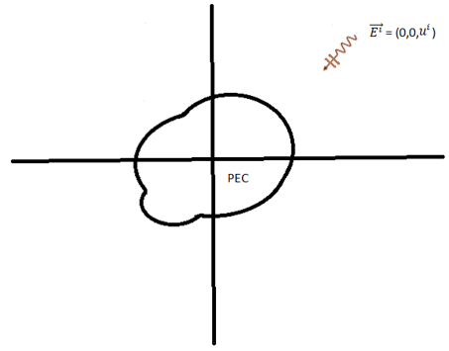

**Figure 2.1 :** Basic Model of the PEC Cylinder Illumination

The electromagnetic wave can be represented as

$E^{i}=\left(0,0,u_{i}\right)$, $u_{i} can either be a line source or a plane wave.$

On plane wave case,

$u_{i}\left(x1,x2\right)=e^{-i*k_{0}*(x1cosθi+x2sinsin θ i)}*e^{-iwt}$ [1]

$k_{0}=w*\sqrt{ϵ0*μ0}$ [2]

On Line, source case,

$u^{i}\left(x_{1},x_{2}\right)=-\frac{w*μ0}{4}*I_{0}*H_{0}^{1}(k_{0}*\left|x-x^{\left(s\right)}\right|)$ [3]

This last function that get produced is called the Hankel Function of First kind with 0 order. This Function can be easily implemented on MATLAB by using Bessel function.

**2.2 Understanding the Concept of Green’s Function.**

With the electromagnetic illumination caused on the Cylinder on the part 2.1, it’s to be seen consequently that, Currents with different densities are to be measured on the surface of the Cylinder would be generated. But why is this current needed?

Let’s think of an observer observing the scattered EM waves coming from the scatters from the surface caused by a line source on a different location.

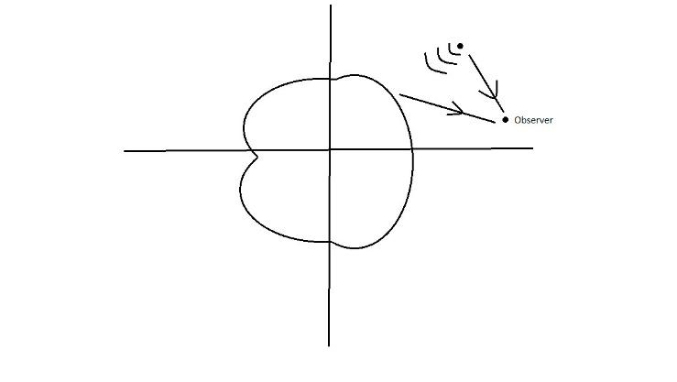

**Figure 2.2**: Observer

One can see that this observer will not only observe The Scattered waves but also the incident wave directly reaching to the observation point.

$E^{total}=E^{line}+E^{scattered}→u^{sum}=u^{incident}+u^{s}$ [4]

However, the wanted data in this case would be the ones sourced from the surface currents;

For a random $x_{1},x_{2}$ point;

$u^{s}\left(x_{1},x_{2}\right)=i*w*μ\int{G\left(x;y\right)*Js\left(y\right)ds(y)}$ [5]

In here $G\left(x;y\right)$ is the Green’s Function, which will be elaborated further on the paper. And the $Js\left(y\right)$ is the Current Density function.

One can easily see that the next problem to be seen in this case would be Calculating these functions, $G\left(x;y\right)$ and $Js(y)$.

**2.3 Calculating the Green’s Function**

The Green’s function, a mathematical function used in a variety of scientific principles such as physics, mechanics and electromagnetic field theory that was introduced by George Green in 1793 to 1841. Green's function is a concept that can be introduced as an impulse response of an inhomogeneous linear differential operator defined on a domain with specified initial conditions or boundary conditions. It can be useful for understanding and analysing electromagnetic properties of complex structures. With the help of the superposition theorem, the amplitude of the source is unimportant, and any source and any observation point at the same location can be easily analysed using Green's function and convolution. The mathematical Formulations for Green’s Function are given below.

$Green^{'}s Function=\frac{i}{4}*H_{0}^{1}\left(k_{0}\left|x-y\right|\right),$ [6]

$|x-y|=\sqrt{{\left(x1-y1\right)}^{2}-{\left(x2-y2\right)}^{2}}$ [7]

**2.3.1 Calculating the Current Density**

To calculate the current density, function one will take advantage of the boundary conditions.

$\vec{n }x \vec{E}|_{Γ}=0→E_{tan}=0→u|_{Γ}=0$ [8]

$\left(u^{i}+u^{j}\right)|_{Γ}=0→ \int_{Γ}{i*ω*μ*G\left(x;y\right)*Js\left(y\right)ds\left(y\right)}={-u}^{i}(x)$ [9]

In fact, for the method of moments approach a matrix approach has been implemented (Presented later on this paper).

**2.3.2 Method of moments approach**

In the calculations of the Green Function, one can use several different methods. However, we decided on using Method of Moments (MoM) for our project. MoM is based simply on dividing the object into small cells and considering the electric field, current density and dielectric permittivity inside every cell is the same as the centre of the cell.

**2.3.3 Calculating overall Green's function.**

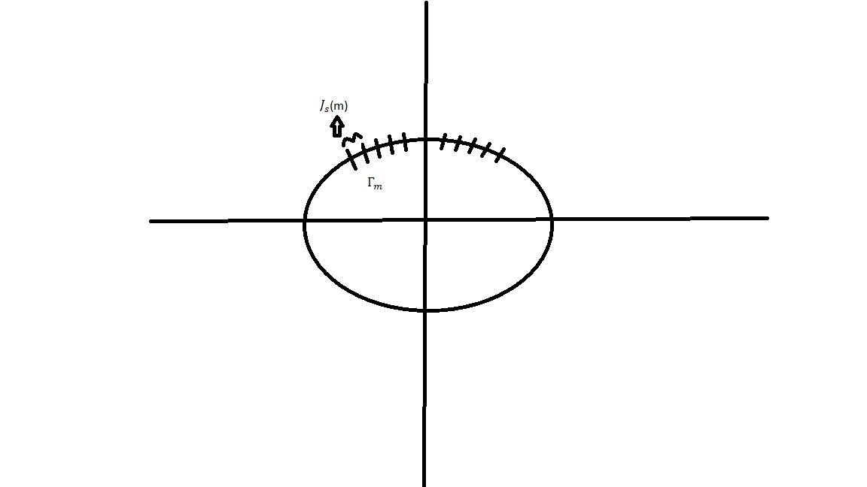

**Figure 2.3:** Method of Moments

With the explanations given before one can easily modify the function $-u^{i}$ as

$-u^{i}\left(x\right)=\sum{}\int_{Γm}{i*ω*μ*G\left(x;y\right)*j_{s}\left(y\right)ds\left(y\right)}= \sum_{m=1}^{M}{}J_{m}*\int_{Γm}{i}*ω*μ*G\left(x;y\right)ds(y)$ [10]

By solving this equation, one would be able to reach to a matrix of values for $E→u$

$\left[Z_{nn} \right]*\left[\begin{aligned}j_{1} \\ j_{2} \\ … \\ j_{n}\end{aligned}\right]=\left[u_{i} \right]$ [11]

This calculation has been completed successfully and is presented later on this paper.

**2.4 Generating a 2D cut of a cylinder/ random cylinders**

The cylindrical section whose shape to be regained can be thought of as a circle. This circle can be expressed and plotted mathematically in the cylindrical coordinate system.

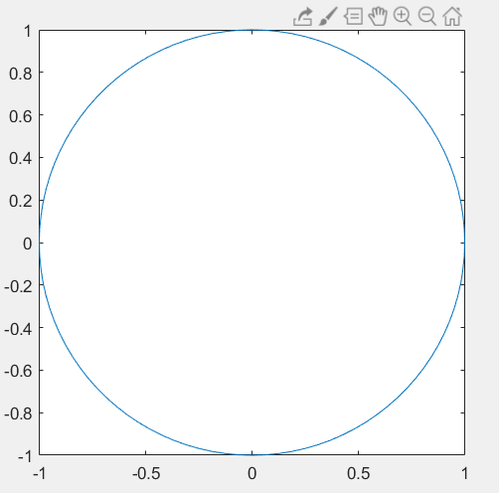

**Figure 2.4: $ρ=0.5$**

If one defines ρ as a function rather than an integer when plotting the circle, then one get a non-smooth shape with a non-constant radius. This function can be select as ρ(θ)= $∑{ a}_{n}$ cos(θ)+ $b_{n}$ sin(θ). In that case the surfave would lose its perfectly circular shape and Thus by progresing this function we can generate unlimited amounts of 2D cuts of Infinite Cylinders.

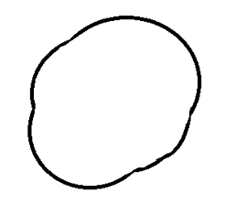

**Figure 2.5:** Shape generated by $ρ$ as a function

By adding random integers and cosines and sinus variables into our radius function, a successful code to generate random cylinders has been achieved.

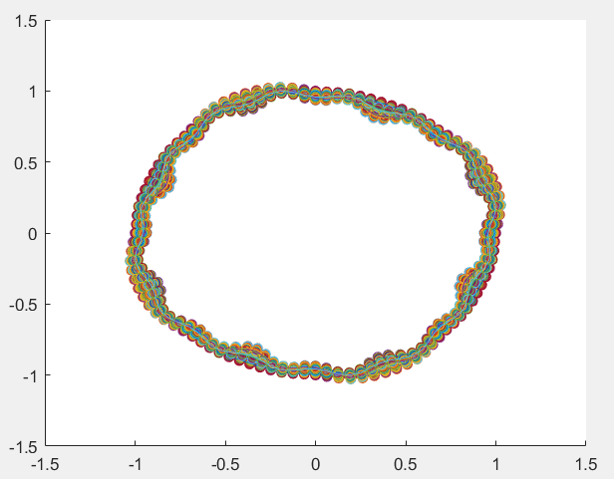

**Figure 2.6:** 100 different cylinder cuts with random geometries

**2.5 Method of Moments Method on a Perfectly Circular PEC, Comparison with Arithmetic Method**

The next step for the progress was to create the Algorithm in order for Method of Moments approach to work efficiently on any given cylindrical geometry. The algorithm has been successfully achieved. The goal was to firstly make the algorithm work for a perfect circular geometry (1cm radius all around), with the incident wave parallel with x axis. Where the frequency is equal to $f=3*{10}^{8}$ Thus; $λ=1$



**Figure 2.7:** The geometry to be observed

With this calculation the output, which is the scattered wave data for each point, looked like the figure below;

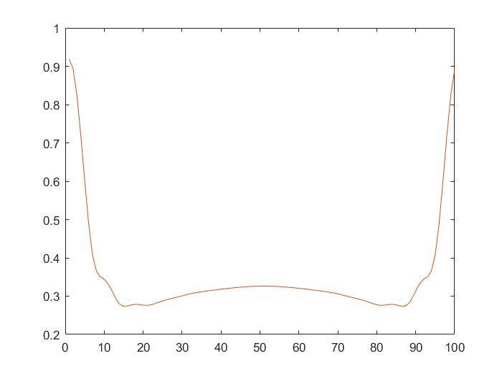

**Figure 2.8:** Scattered wave for each point calculated using MoM put on a graph for 100 points

The output shows the points that are directly illuminated with the incident wave has the highest Scattered Wave and it decreases gradually as expected reaching to the dark side of the circle.

Even though outputs seem reasonable at first glance. One still needs to see how efficient the algorithm by solving this problem with another approach. Therefore, the algorithm utilizing analytic method is used.

In analytic method scattered wave is calculated by below equations.

$E_{z}^{s}= -E_{0} \sum_{n=-∞}^{∞}{{\left(-j\right)}^{n}ε_{n}\frac{J_{n\left(βa\right)}}{H_{n}^{\left(2\right)}\left(βa\right)}H_{n}^{\left(2\right)}\left(βρ\right)coscos \left(nφ\right)}$ [11]

$$ρ=observer point$$

$$φ=angle of the point observed$$

$$ε_{n}=\{\left\{\begin{aligned}1 n=0 \\ 2 n ≠0\end{aligned}\right.$$

When the two algorithms for the same geometry are compared, one can see the scattered wave outputs for 1 cm radius & observation points 5cm away from the centre of the geometry, are as below.

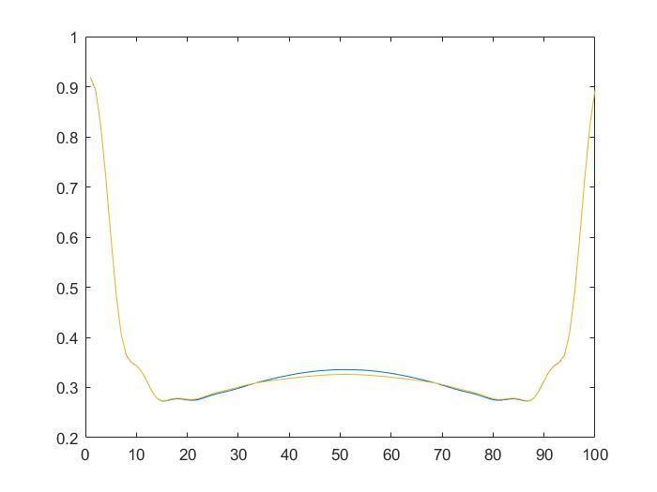

**Figure 2.9:** MoM and Arithmetic Algorithm Results

One can see that the results are very similar in fact matches with each other for same geometry with the incident wave having a 0-degree angle towards x axis.To make sure the Method of Moments Algorithm works efficiently the algorithm is worked in different variant scenarios. The outputs are presented below.

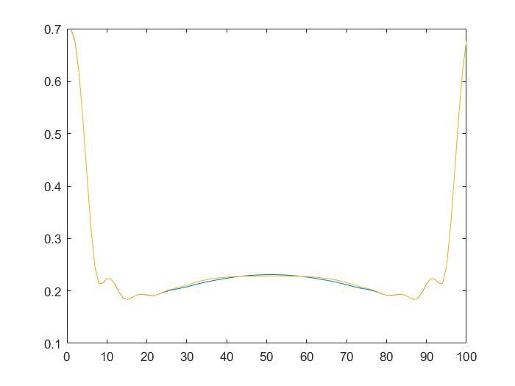

**Figure 2.10:** Results for observation point at 10cm distance from centre

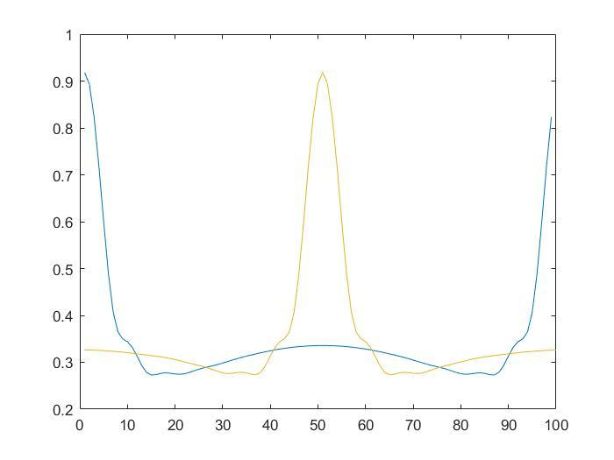

**Figure 2.11:** Results for Incident wave coming with a 180 degree angle

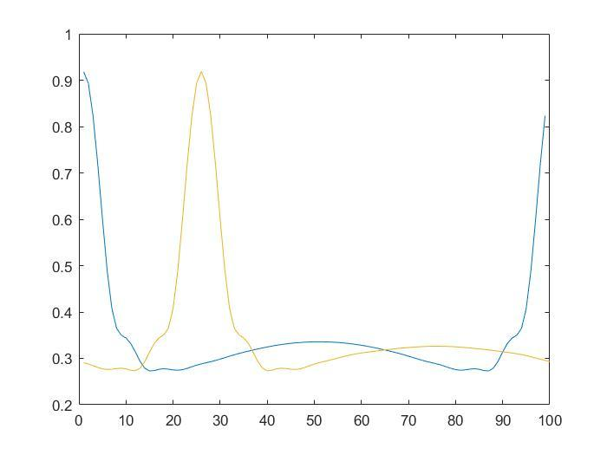

**Figure 2.12:** Results for Incident wave coming with a 45 degree angle.

One can see that these results are mathematically correct for different incident wave and observation conditions. However, the angle change on the Incident wave causes a phase shift in the outputs. This is because for our Method of Moments algorithm the first point of observation starts from the cross point with x axis and each point follows each other with a counterclockwise manner. However, for the Arithmetical algorithm the first point observed is the point that the incident wave arrives perpendicularly. Thus, the outputs are actually reasonable and phase shift is as expected, the highest scattered wave data is always for the point where the incident wave arrives first.

**2.6 Creating A Data Set for the Machine Learning Algorithm**

Now that it is observed that the Method of Moments Algorithm creates efficient results, the next step is to create a dataset to train the Machine Learning Algorithm by making the algorithm work repeatedly many times for random shapes we generated previously.

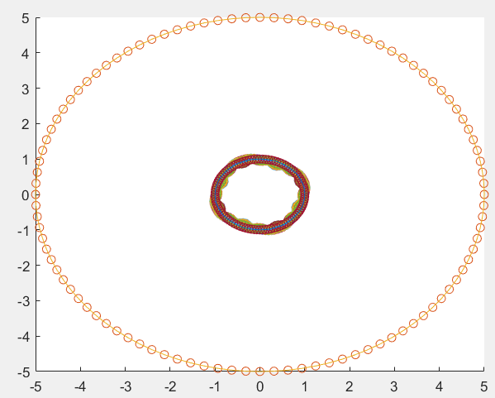

**Figure 2.13 :** different cylinder cuts observed from 5cm distance

This Algorithm used to create real and imaginary components of the scattered wave, x,y coordinates , p equivalent of the coordinate with the angle related to the p for 5000 different geometries with 100 observation points.

**2.7 Data Pre-processing**

A data set of 5000 different shapes, with 100 scattered wave information and 100 location data is created for the machine learning algorithm. The data is stored in an excel document with the organisation presented below.

5000 rows of data for 5000 shapes, 100 real components of the scattered field data 100 imaginer component 100 radius data, the radius data is ;

[12]

**Figure 2.14 :** Dataset

The data is then firstly divided into a test group and a training group for training the machine learning algorithm and testing its efficiency with the ratio of 25% to 75% from its rows. Then the data is divided by its column. The Input test & train data should be the scattered wave values as it should be the necessary information for one to construct the shape. The output data is the last 100 columns of data.

Thus, the Input test and train data would be in the shape of;

$\left(\# of geometries \right)x\left(measurment points*2\right)= \left(\# of geometries \right)x200$ [13]

These datasets are then reshaped into a 3-D tensor of size;

*Shape* = $\left(\# of geometries \right)x5 x 5x 8$ [14]

This manipulation is done to prepare the data for the algorithm for a Convolutional Neural Network Algorithm to reconstruct the geometry.

**2.8 Convolutional Neural Network Application for Inverse Scattering**

When deciding on which algorithm to use several different approaches were considered, however other Multi-Layer Neural Networks were not found as efficient as a Convolutional Neural Network as the dimensions for input and output data is bigger in dimension than a 2-D array. Linear Regression did not gave efficient result in trials with very low accuracy and not very efficient working flow .Convolutional Neural Networks are known to be utilized for Tuple data, thus the process to try to solve inverse scattering problem with Convolutional Neural Networks begin.

Convolutional Neural Network is a type of Neural Network which is mostly used for Image Processing problems as it has a grand skill of recognising patterns and feature. Therefore, it would be the suitable approach to solve the inverse scattering problem.

CNN algorithms consist of several layers. Such as Convolutional Layer, Pooling Layer, Flattening Layer & Dense Layers.

Convolutional Layers: Apply Filters to the input data to produce an output feature map.

Pooling layers: The size of the feature map gets reduced in this layer by utilizing down sampling the data.

Fully connected layers: These layers connect neurons to from the layer before to the next one and are generally used to make final predictions.

Dense Layers: Is a fully connected layer that’s generally in the end of the architecture.

Flattening Layer: A layer to flatten multi-dimensional input data into a single dimension.

The algorithm used Consists of a simple architecture of 2 Convolutional Layer followed up with one Max Pooling Layer and one Flattening Layer.

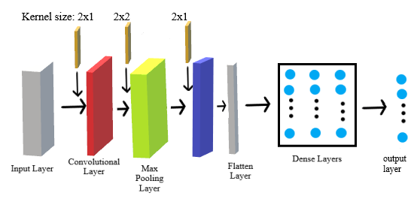

**Figure 2.15:** CNN Architecture

The network Configuration on the previous figure shows that the input goes through a Convolutional Layer of Kernel Size 3x1 following up with a 3x10 Kernel size Pooling Layer, a Flattening Layer and 3 Dense layers of different numbers of hidden layer units.

The activation function for Convolutional Layer is chosen as “tanh”(first layer), “selu” (second layer), we found out that using a mix of selu and tanh functions in convolutional layer gave better results. The rest of the layers use relu activation as recommended on other papers as it has a high efficiency for this kind of applications.

$\tanh\left(x\right)=\frac{2}{1+e^{-2x}}-1$ [15]

$SeLU\left(z\right)=\left\{\begin{aligned}z, z>0 \\ αe^{x}-α, otherwise\end{aligned}\right.$ [16]

General Information about the architecture is given below.

1. CNN Architecture

|  |  |
| --- | --- |
| **Optimizer Parameters** | **Model Parameters** |
| Batch Size=50 | # of Dense Layers= 2 |
| Epochs=30 | # of Dense L. Units = Ua |
| Learning Rate= 0.001 | Ua=400,100 |

From trying other architectures for this problem, several conclusions have been delivered.

One of the first conclusions to be obtained wasthe more complexity meant better accuracy until some point, and very high epoch can cause over-fitting problem while very small batch size can end up with very slow algorithm.

However, with trial-and-error interesting results can be obtained. For instance, more complex architecture such as one with more than 5 dense layers or too many epochs could easily end up with an overfitting issue.

Over-fitting is the phenomena where the algorithm gets trained too well with the train data provided to it where it fails to work for other datasets. There are several ways to deal with over-fitting which is later stated on this paper.

The most important part of the coding process is to find the best trade off locations between different scenarios in order to improve the network.

There are 2 hidden layers with different units utilized in this algorithm.(given in Table 2.1)

The output layer is a matrix of shapes with 100 columns each willed with shape reconstruction data, $ρ$.

**3.0 NUMERICAL RESULTS**

**3.1 Direct Problem**

The Results are created for Method of Moments in conditions of

$f=3*{10}^{8}$ Thus; $λ=1$ the cell size should be $w_{n}<\frac{λ}{20}$ therefore

for 100 cells.

The data obtained from this calculations is as presented below.

**Table 3.1:** Scattered Wave Data

|  |  |  |  |  |
| --- | --- | --- | --- | --- |
|  | POINT 1 | POINT 2 | POINT 3 | POINT 4 |
| SHAPE 1 | -0.887411789836157 - 0.265110062507821i | -0.894319600949449 - 0.175966496000257i | -0.835876521959856 - 0.101574355966946i | -0.705049249437525 - 0.125796678669332i |
| SHAPE 2 | -0.971277916820880 - 0.0589377121471580i | -0.933250073385018 - 0.0716539976247572i | -0.823946126060019 - 0.161695336793226i | -0.652405596604831 - 0.281074962308405i |
| SHAPE 3 | -0.953697207907321 - 0.106464711339011i | -0.936665012971905 - 0.0694937348627869i | -0.849886985880220 - 0.107834222587722i | -0.702927780029682 - 0.204141262459575i |
| SHAPE 4 | -0.969914554578531 - 0.0641263018177732i | -0.936736839897778 - 0.0664434188600041i | -0.833392005723033 - 0.146473162073467i | -0.667291146511120 - 0.265722636166026i |
| SHAPE 5 | -0.901787768783518 - 0.219989103719717i | -0.875613661063681 - 0.196150673888049i | -0.794287088903451 - 0.190788144540023i | -0.648820109264753 - 0.247397629051190i |
| SHAPE 6 | -0.825321006543889 - 0.355126460244033i | -0.845067485601495 - 0.271942096536591i | -0.811187829699474 - 0.174557935816048i | -0.696693945511211 - 0.155613955196319i |
| SHAPE 7 | -0.819393840019952 - 0.355934304107717i | -0.817096131528489 - 0.323057340409485i | -0.777076033064837 - 0.269968104952731i | -0.664085678288391 - 0.274355887929482i |
| SHAPE 8 | -0.887411789836157 - 0.265110062507821i | -0.894319600949449 - 0.175966496000257i | -0.835876521959856 - 0.101574355966946i | -0.705049249437525 - 0.125796678669332i |

**Table 3.2: $ρ data$**

|  |  |  |  |  |
| --- | --- | --- | --- | --- |
|  | POINT 1 | POINT 2 | POINT 3 | POINT 4 |
| SHAPE 1 | 0.987842977394785 | 1.01026559743217 | 1.03649792986000 | 1.04645987287714 |
| SHAPE 2 | 1.05787167119687 | 1.05605180821004 | 1.04200920931828 | 1.01956137288423 |
| SHAPE 3 | 1.04310432248702 | 1.05501921286909 | 1.05713667044470 | 1.04913290885529 |
| SHAPE 4 | 1.05473460133569 | 1.05600168252641 | 1.04561480506275 | 1.02564776855047 |
| SHAPE 5 | 1.00171436806985 | 1.00685317025345 | 1.01338426939216 | 1.00711914305819 |
| SHAPE 6 | 0.960914315964529 | 0.983555858899751 | 1.01578599662729 | 1.03636843808813 |
| SHAPE 7 | 0.959412005091473 | 0.970063194372653 | 0.991002927367129 | 1.00181215150574 |
| SHAPE 8 | 0.947408664222780 | 0.971399077653373 | 1.00821929141643 | 1.03443899326042 |

**Figure 3.1** **:** MoM and Arithmetic Algorithm Results Comparison for Scat. Wave

**3.2 Inverse Problem, Machine Learning Approach**

One can see that the epochs were enough as our mean squared error loss graphic was as shown below

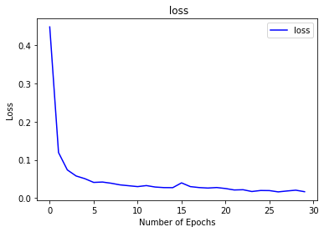

**Figure 3.2:** Loss Figure with accordance to epochs

Comparing this loss figures with Validation Loss Figures

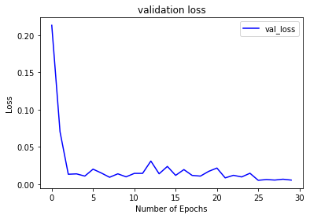

**Figure 3.3:** ValidationLoss Figure with accordance to epochs

One can see that these figures do not differ a lot in values that is a good sign to see that the code doesn’t have a problem with over-fitting data.

When looked at the accuracy graphs.

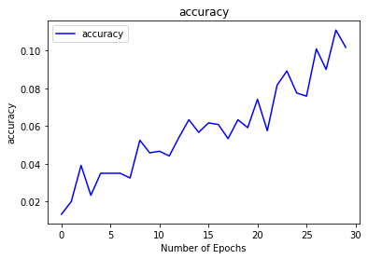

**Figure 3.4:** Accuracy with accordance to epochs

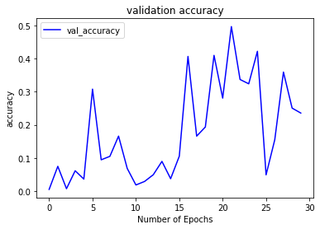

**Figure 3.5:** ValidationAccuracy with accordance to epochs

During the Epoch Process Accuracy Improved drastically with each epoch as expected. However it must be noted that the train set is not big enough to achieve the goal norm accuracy in epoch measurements. It wouldn’t be necessary to achieve this accuracy in epochs process.

Epoch 1/30

24/24 [==============================] - 2s 70ms/step - loss: 0.4485 - accuracy: 0.0133 - val_loss: 0.2135 - val_accuracy: 0.0053

Epoch 2/30

24/24 [==============================] - 1s 58ms/step - loss: 0.1192 - accuracy: 0.0200 - val_loss: 0.0704 - val_accuracy: 0.0750

Epoch 3/30

24/24 [==============================] - 1s 57ms/step - loss: 0.0738 - accuracy: 0.0392 - val_loss: 0.0133 - val_accuracy: 0.0075…

…

…

Epoch 25/30

24/24 [==============================] - 1s 53ms/step - loss: 0.0198 - accuracy: 0.0776 - val_loss: 0.0146 - val_accuracy: 0.4222

Epoch 26/30

24/24 [==============================] - 1s 54ms/step - loss: 0.0196 - accuracy: 0.0759 - val_loss: 0.0051 - val_accuracy: 0.0493

Epoch 27/30

24/24 [==============================] - 1s 53ms/step - loss: 0.0162 - accuracy: 0.1009 - val_loss: 0.0062 - val_accuracy: 0.1552

Epoch 28/30

24/24 [==============================] - 1s 53ms/step - loss: 0.0186 - accuracy: 0.0901 - val_loss: 0.0055 - val_accuracy: 0.3596

Epoch 29/30

24/24 [==============================] - 1s 54ms/step - loss: 0.0206 - accuracy: 0.1109 - val_loss: 0.0066 - val_accuracy: 0.2507

Epoch 30/30

24/24 [==============================] - 1s 55ms/step - loss: 0.0167 - accuracy: 0.1018 - val_loss: 0.0054 - val_accuracy: 0.2358

Several example geometries Reconstructed with the algorithm

**Figure 3.6:** Random Geometry Reconstructed, scattered points given

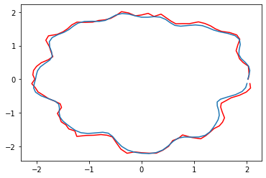

**Figure 3.7:** Random Geometry Reconstructed

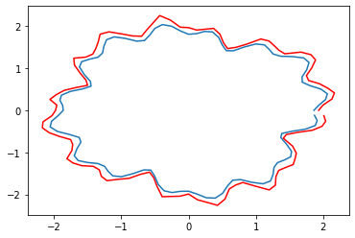

**Figure 3.8:** Random Geometry Reconstructed

**Figure 3.9:** Random Geometry Reconstructed



**Figure 3.10:** Random Geometries Reconstructed, low epoch amount

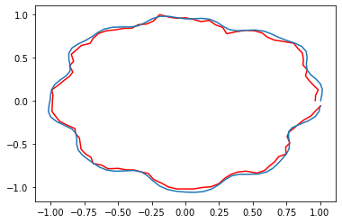

**Figure 3.11:** Example Geometries Reconstructed, high Batch size

**Figure 3.12:** Random Geometry Reconstructed

The red lines are the predicted shape while the blue ones are the real counterpart of the shape generated. As one can observe the predicted shapes recognises the characteristics of the shape with some precision as is consistent with different geometries.

In the beginning, some similarities between the shapes predicted was creating the question of an over-fitting possibility. To prevent this, different prevention techniques are applied. Such as pre-processing data into almost equal size matrices, using a reasonable epoch size, but also integrating the dataset with different random shape generation functions. For doing that we simply increased the randomness of the shape in MATLAB by putting more random variables in the shape generator. Later Integrating this data to be used in both test and train matrixes. Later on to checking on the shapes generated; we achieve much more sufficient reconstruction results.



**Figure 3.13:** Random Geometry Reconstructed after the necessary changes

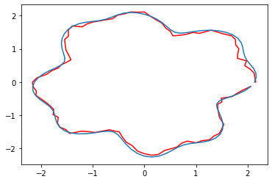

**Figure 3.14:** Random Geometry Reconstructed after the necessary changes

One can see that with the present changes in the algorithm, different shapes generated efficiently.

Checking the matrix results of the measurements;

**Table 3.3 :** a cut of actual shape results

|  |  |  |  |  |  |  |  |  |  |  |  |  |
| --- | --- | --- | --- | --- | --- | --- | --- | --- | --- | --- | --- | --- |
| Parameters | 1 | | | 2 | 3 | | 4 | | 5 | | … | |
| Shape 1 | | | 1.93864 | 2.0017 | 2.08276 | | 2.10855 | | 2.04695 | | … | |
| Shape 2 | | 1.86624 | | 1.96337 | | 2.09616 | | 2.16454 | | 2.12009 | | … |
| Shape 3 | | 1.94272 | | 2.00498 | | 2.08589 | | 2.09666 | | 1.99871 | | … |
| Shape 4 | | 2.00954 | | 2.07109 | | 2.13471 | | 2.15393 | | 2.11598 | | … |
| Shape 5 | | 1.90408 | | 1.94927 | | 2.02298 | | 2.03131 | | 1.9304 | | … |
| Shape 6 | | 2.00539 | | 2.07525 | | 2.14551 | | 2.16795 | | 2.12501 | | … |
| Shape 7 | | 1.94954 | | 1.97639 | | 2.02061 | | 2.01435 | | 1.92689 | | … |
| Shape 8 | | 2.01002 | | 2.03884 | | 2.0667 | | 2.07092 | | 2.04366 | | … |
| … | | …. | | … | | … | | … | |  | | … |

**Table 3.4 :** a cut of predicted shape results

|  |  |  |  |  |  |  |  |  |  |  |  |  |
| --- | --- | --- | --- | --- | --- | --- | --- | --- | --- | --- | --- | --- |
| Parameters | 1 | | | 2 | 3 | | 4 | | 5 | | … | |
| Shape 1 | | | 1.95995 | 2.0294 | 2.10402 | | 2.12871 | | 2.04825 | | … | |
| Shape 2 | | 1.95048 | | 2.03933 | | 2.19845 | | 2.22708 | | 2.14685 | | … | |
| Shape 3 | | 1.97883 | | 2.07779 | | 2.08791 | | 2.09859 | | 1.99804 | | … | |
| Shape 4 | | 1.91385 | | 2.01071 | | 2.0282 | | 2.03458 | | 1.97801 | | … | |
| Shape 5 | | 2.00392 | | 2.09661 | | 2.22273 | | 2.19741 | | 2.08301 | | … | |
| Shape 6 | | 1.96915 | | 2.04297 | | 2.11173 | | 2.08565 | | 2.04066 | | … | |
| Shape 7 | | 2.05364 | | 2.09525 | | 2.22133 | | 2.20598 | | 2.11913 | | … | |
| Shape 8 | | 2.07993 | | 2.08152 | | 2.12881 | | 2.1578 | | 2.10085 | | … | |
| … | | …. | | … | | … | | … | |  | | … | |

**Table 3.5:** error per each point

|  |  |  |  |  |  |  |  |  |  |  |
| --- | --- | --- | --- | --- | --- | --- | --- | --- | --- | --- |
| Parameters | 1 | 2 | 3 | | 4 | | 5 | | … | |
| Shape 1 | 0.0109913 | 0.0138362 | 0.0102077 | | 0.00956405 | | 0.000635681 | | … | |
| Shape 2 | 0.0451384 | 0.0386884 | | 0.0487984 | | 0.0288911 | | 0.0126245 | | … |
| Shape 3 | 0.0185881 | 0.0363135 | | 0.0009679 | | 0.000925109 | | 0.000332747 | | … |
| Shape 4 | 0.0476186 | 0.0291543 | | 0.0498934 | | 0.055412 | | 0.0652018 | | … |
| Shape 5 | 0.0524321 | 0.0755879 | | 0.0987416 | | 0.0817735 | | 0.0790559 | | … |
| Shape 6 | 0.0180731 | 0.0155556 | | 0.0157465 | | 0.0379621 | | 0.0396935 | | … |
| Shape 7 | 0.053397 | 0.0601372 | | 0.0993364 | | 0.095133 | | 0.0997671 | | … |
| Shape 8 | 0.0451384 | 0.0386884 | | 0.0487984 | | 0.0288911 | | 0.0126245 | | … |
| … | …. | … | | … | | … | |  | | … |

The measurements inputted to the machine learning algorithm gave a norm error of 6%. Calculated by the function given below.

$norm error=\frac{≪Y_{pred}-Y_{test}≫}{≪Y_{test}≫}*100$ [17]

$$Y_{pred}=the predicted geometry from CNN$$

$$Y_{test}=the actual geometry of the one predicted with CNN$$

**4. CONCLUSIONS, LAST ARGUMENTS & COMMENTS**

##### In the beginning of the project, Method of Moments give such efficient results to move with, as it gave a extremely low error rate and basically overlapping results with the arithmetical algorithm itself.

Since this project requires one to deal with multiple dimensions of information it is hard to work with many machine learning algorithms and an elaborate approach is rather well needed.

##### The project presented created electromagnetic scattered wave data utilizing method of moments and later used this data to construct the shapes necessary utilizing a convolutional neural network. The calculations were done for a lossless space & a perfectly electric conducting cylinder. This could be altered for another research with a lossy space and non-perfectly electric conducting geometries.

##### The results obtained from this research were consistent with the goals set for it, the norm error reached with the results were consistent with the goals set for it. This CNN Approach can be adapted to other 3-d electromagnetic scattering applications. with especially big changes in data pre-processing and architecture, good results are still possible to achieve as CNN is a very flexible tool to use.

The algorithm was optimized as much as possible with trade-offs in the architecture. These trade-offs can be altered for possible different uses of the approach.

Treating the problem similar to a grayscale image processing problem and utilizing the CNN, some of the trade-off examples can be given as, having optimal number of epochs. to prevent overwriting & overfitting the data, but also to have processing speed epoch shouldn’t be so much. however, very low epochs can end up in big loss, low resolution & bad accuracy. to have more elaborate measurements batch size should be at an appropriate level, however, very low batch size could expand the processing time for each epoch. learning rate also needs to be selected in a level where the accuracy improves by time. another example to this is the training set data shouldn’t be so alike for a more flexible learning but instead should have as many varieties as possible. dropping neurons drastically improves the performance, but it must be noted that too many neurons dropped means less interconnections between neurons therefore worse results.

Selecting the algorithm several approaches have been tried, starting with a lot more complicated architecture. However, those algorithms ended up with either very low accuracy or high overfit. One challenge faced during this project was that the input data was so alike. This made overfitting in many cases where improvement on performance was tried on the process. However, using the precautions mentioned before on this paper this situation was improved drastically.

End results were satisfactory and have been double checked with different quality control techniques.

The inverse scattering problem solved with a machine learning approach has many uses cases in medical, military, and geophysics & engineering physics automating imaging process. It’s a great wish to have this paper be a part of the technological improvements & digital revolution of the world.

Realistic constraint wise, only, hardware specifications of the computer may be talked about. Most of the heavy work is creating the training dataset but even lower-level systems are able to provide it efficiently. Since free third-party libraries are used and everything can be stored locally in an Excel file without the need of a server, there’s not a real cost given user has a daily PC to use.

##### REFERENCES

[1**] C.-Y Lin and Y. -W. Kiang** (1996) “Inverse scattering for conductors by the equivalent source method”, IEE Transactions on Antennas and Propogation, vol. 44, no.3, pp.310-316

**[2] Chiu, C., Sun, C. and Fan, Y.,** (2012). Shape reconstruction of 2D perfectly conducting cylinder targets using the particle swarm optimisation. *The Imaging Science Journal*, 60(2), pp.83-89.

**[3] Hajihashemi, M. R., & El-Shenawee, M.** (2009). TE versus TM for the shape reconstruction of 2-D PEC targets using the level-set algorithm. IEEE Transactions on Geoscience and Remote Sensing, 48(3), 1159-1168.

**[4] Mhamdi, B., Grayaa, K., & Aguili, T.** (2011). Hybrid of genetic algorithm with particle swarm optimization to shape reconstruction of perfect conducting cylinders. AEU-international Journal of Electronics and Communications, 65(12), 1032-1039.

**[5] F. Soldovieri, A. Brancaccio, G. Leone and R. Pierri**, (2005) "Shape reconstruction of perfectly conducting objects by multiview experimental data," in *IEEE Transactions on Geoscience and Remote Sensing*, vol. 43, no. 1, pp. 65-71, Jan., doi: 10.1109/TGRS.2004.839432.

**[6] W.-K. Park,** (2012) “Fast shape reconstruction of perfectly conducting cracks by using a multi-frequency topological derivative strategy,” *arXiv [math-ph]*,

**[7]** **A. F. Peterson, S. L. Ray, and R. Mittra**,(1998) *Computational Methods for Electromagnetics*. Wiley-IEEE Press,

**[8] Li, Lianlin & Wang, Longgang & Teixeira, Fernando & Che, Liu & Nehora, Arye & Cui, Tie.** (2018). DeepNIS: Deep Neural Network for Nonlinear Electromagnetic Inverse Scattering.

**[9]** **H. M. Yao, W. E. I. Sha and L. Jiang,** (2019)"Two-Step Enhanced Deep Learning Approach for Electromagnetic Inverse Scattering Problems," in IEEE Antennas and Wireless Propagation Letters, vol. 18, no. 11, pp. 2254-2258, Nov., doi: 10.1109/LAWP.2019.2925578.

**[10]** **Al-Himyari, Bayadir.** (2009). Geometric Shapes Recognition Using Multi-Layer Perceptron Trained By Genetic Algorithm. AL-Qadisyah Journal For Science. 14. 102-112.

**[12]Tezel, N.s & Şimşek, Serkan.** (2007). Neural network approach to shape reconstruction of a conducting cylinder. 7.

**[13]** **S. Albawi, T. A. Mohammed and S. Al-Zawi, (**2017) "Understanding of a convolutional neural network," 2017 International Conference on Engineering and Technology (ICET), , pp. 1-6, doi: 10.1109/ICEngTechnol.2017.8308186.

[**14] B. Gürlek and A. Yapar, (**2011) "An efficient approach for the solution of inverse scattering problems via neural network method," 2011 7th International Conference on Electrical and Electronics Engineering (ELECO), pp. II-214-II-218.

**[15] Z. Lin** (2021) et al., "Study on Low-Frequency Data Learning for Inverse Scattering Problems with High Nonlinearity," 2021 International Applied Computational Electromagnetics Society (ACES-China) Symposium, pp. 1-2, doi: 10.23919/ACES-China52398.2021.9581813.

**[16] L. Han, L. Kuang, T. Song and Q. H. Liu,** (2018,)"A Deep Convolutional Neural Networks-Based Method for Inversion of Rough Surface Parameters," 2018 IEEE International Conference on Computational Electromagnetics (ICCEM), pp. 1-2, doi: 10.1109/COMPEM.2018.8496583

**CURRICULUM VITAE**

**Name Surname : Ali AYDIN**

**Place and Date of Birth : Antalya / 27.07.1998**

**E-Mail : aydinal17@itu.edu.tr**

**CURRICULUM VITAE**



**Name Surname : Berk VAROL**

**Place and Date of Birth : Mersin / 24.04.1999**

**E-Mail : varolb17@itu.edu.tr**

**CURRICULUM VITAE**



**Name Surname : Görkem GÜZEL**

**Place and Date of Birth : Mersin / 11.08.1999**

**E-Mail : guzelgo17@itu.edu.tr**