|  |
| --- |
| VS.FEGE.RxMaxSpeed (bit/s) |
| VS.FEGE.TxMaxSpeed (bit/s) |

Validating the daily maxes average and max values for Rxmaxspeed and Txmaxspeed I found out;

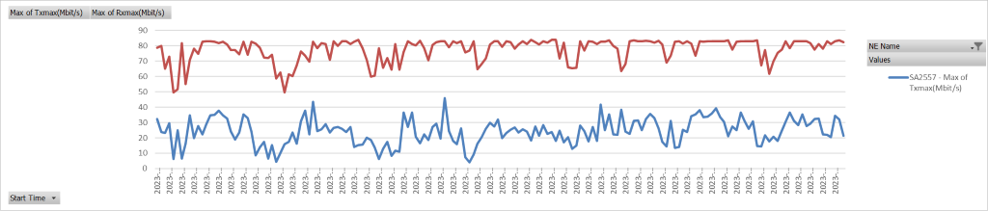

(SA2557) Clearly visible limitation for RxmaxSpeed , Probably due to physical connection as the max peak is almost a straight line.

Unlike the first site this site (SA2587) doesn’t have straight line type of a limitation but Rxmaxspeed cannot pass a specific value on a daily basis so there could be a microwave limitation

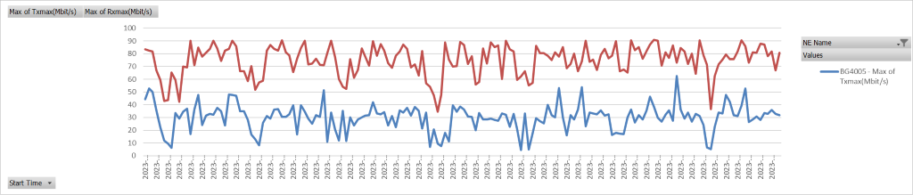

Like Sa2587, BG4005 shows likeliness to not pass a limitation speed value for rxmaxspeed.

Searching for the Tx max values with the same approach the most mathematically problematic sites were the ones which were the test sites. (example given below).