**Berk Yıldız**

**21502040**

1. **Please download the expression dataset obtained from the dset object.   
   Load this file onto Rstudio and report the dimensions of the dataset by   
   answering a) how many samples are there and b) how many genes are there   
   in this dataset.**

There are 32 samples and 45101 genes are there in the dataset.

1. **Generate two subsets called subset50 and subset100 in which the   
   subset contains randomly selected 50 and 100 genes respectively.**
2. **Use these subsets to cluster the samples and make sure the sample   
   labels are showing on the cluster image.**

**Subset50**

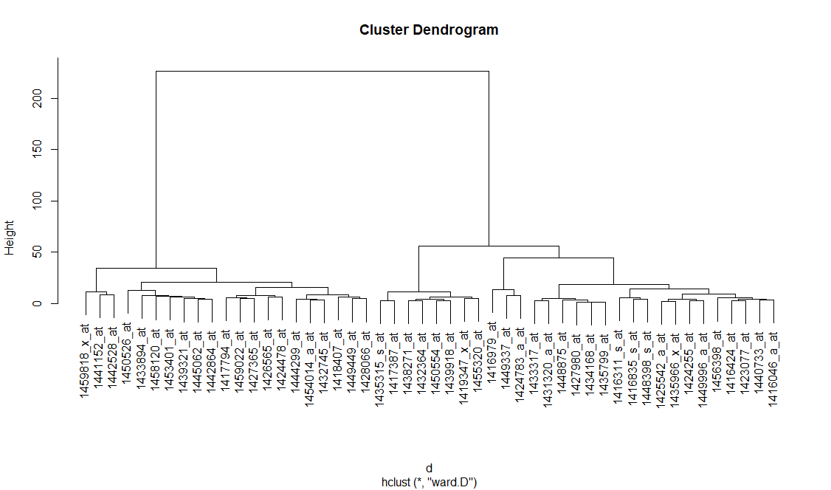

**Subset100**

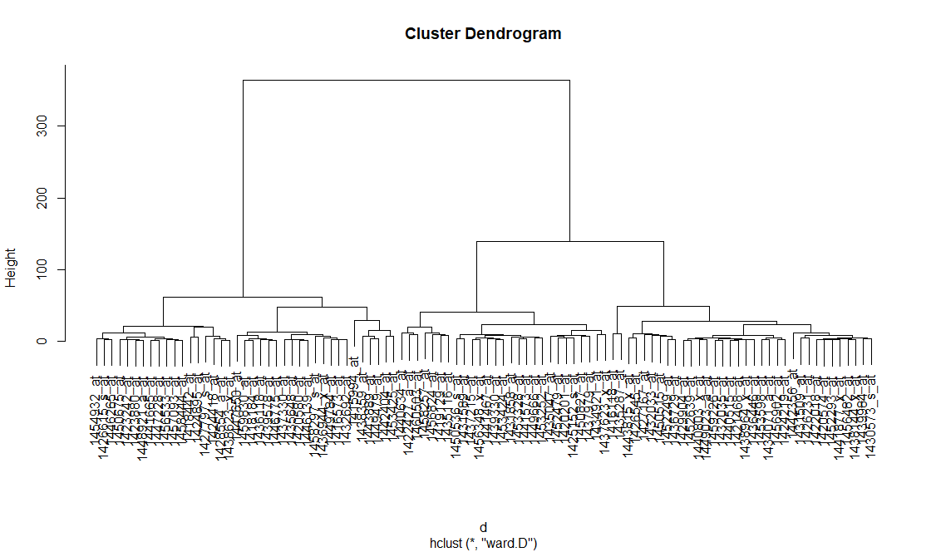

1. **Also generate a heatmap for subset50 and subset100 you generated.**

**Subset50**

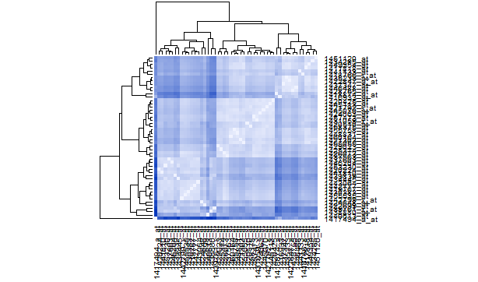

**Subset100**

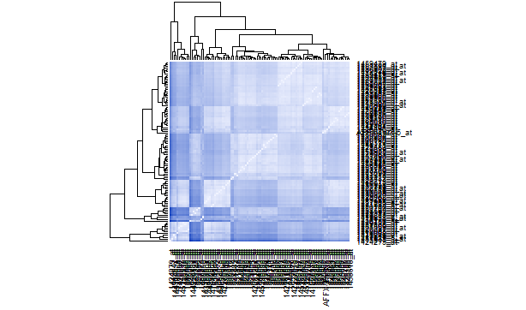

1. **Answer the following question: Does regenerating liver cluster   
   distinctly from liver embryonic development stages based on a randomly   
   selected gene set for a size of a) 50 and b) 100?**

Regenerating liver cluster is slightly different from liver embryonic development stage for a size of 50 and includes some differences for the size 100.

1. **Answer the following question: Does using a different type of   
   distance matrix for the subset50 and subset100 change your answer given   
   to question 5.**

Using a different type of distance matrix does not change my answer.