Berk Yıldız

21502040

Section 3

Group: Cerca Trova

**Fall 2018 Homework 1**

**CS 319 Object-Oriented Software Engineering**

1. Tuesday: 18:00-20:00

Thursday: 18:00-20:00

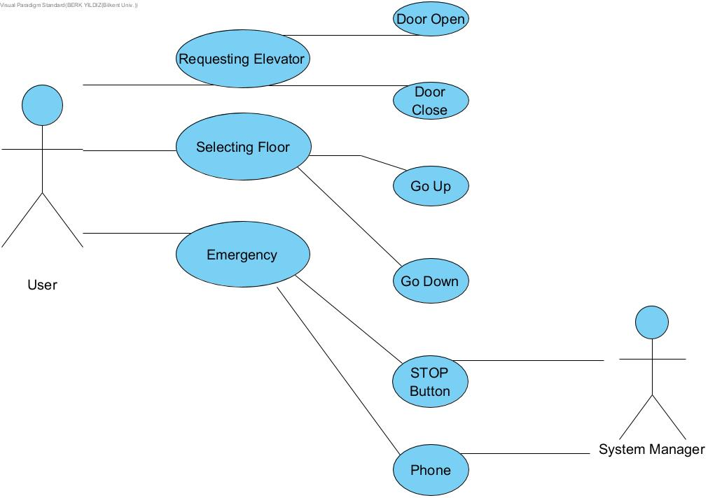



https://github.com/murattuver/Cerca-Trova