Nama : Berlian Alvina

Kelas : 5C

Nim : 18090005

**Source Code**

1. view-data-matakuliah.php : application/views
2. Matakuliah.php : application/controllers
3. v_header.php : application/views
4. v_footer.php : application/views
5. v_index.php : application/views
6. web.php : application/controllers

**Url**

Matakuliah.php :

<http://localhost/pustaka_booking_berlian/index.php/matakuliah>

web.php :

<http://localhost/pustaka_booking_berlian/index.php/web>

**Capture Hasil**

1. Matakuliah.php

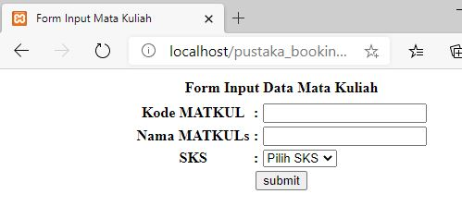

1. web.php

