PROJECT PART 6

**Team**: Omkar Reddy Seelam, Rishabh Berlia, Shivasankar Gunasekaran

**Title**: Rated – Online Movie Review System

**Project Summary**: An Online Movie Rating System in the form of a web application. It is a database of movies which allows the users to access movie reviews and ratings. The users can add/delete/update reviews. Reviews can also be up-voted and shared on social media.

**1.List the features that were implemented (table with ID and title**:

|  |  |  |
| --- | --- | --- |
| **User Requirement** | | |
| ID | Description | User |
| UR-01 | As a new user, I should be able create a role based account | All Actors |
| UR-02 | As an existing user, I should be able to login to the system | All Actors |
| UR-03 | As a User or a Critic, I should be able to view and give rating and review | User, Critic |
| UR-04 | As a User or a Critic, I should be able to delete my rating and review | User, Critic |
| UR-05 | As a user, I should be able to view movie list based on a filter | All Actors |
| **UR-06** | As a User or a Critic, I should be able to up-vote an existing review | User, Critic |
| **UR-07** | As a User or a Critic, I should be able to share any review on social media | User, Critic |
| UR-08 | As an Admin or a Moderator, I should be able to add/remove movie in the list | Admin, Moderator |
| **UR-09** | As an Admin or a Moderator, I should be able monitor reviews | Admin, Moderator |
| **UR-10** | As an Admin, I should be able to promote Users to Critics and Critics to Moderators. | Admin |
| **UR-11** | As an Admin, I should be able to add/remove users | Admin |
| UR-12 | As a Moderator, I should be able to approve request to add movies by a Critic | Moderator |
| UR-13 | As a Critic, I should be able to request to add a movie | Critic |

**2. List the features that were not implemented from Part 2 (table with ID and title)**:

|  |  |  |
| --- | --- | --- |
| **User Requirement** | | |
| ID | Description | User |
| UR-01 | As a new user, I should be able create a role based account | All Actors |
| UR-02 | As an existing user, I should be able to login to the system | All Actors |
| UR-03 | As a User or a Critic, I should be able to view and give rating and review | User, Critic |
| UR-04 | As a User or a Critic, I should be able to modify/delete my rating and review | User, Critic |
| UR-05 | As a user, I should be able to view movie list based on a filter | All Actors |
| UR-06 | As a User or a Critic, I should be able to up-vote an existing review | User, Critic |
| UR-07 | As a User or a Critic, I should be able to share any review on social media | User, Critic |
| UR-08 | As an Admin or a Moderator, I should be able to add/remove movie in the list | Admin, Moderator |
| UR-09 | As an Admin or a Moderator, I should be able monitor reviews | Admin, Moderator |
| UR-10 | As an Admin, I should be able to promote Users to Critics and Critics to Moderators. | Admin |
| UR-11 | As an Admin, I should be able to add/remove users | Admin |
| UR-12 | As a Moderator, I should be able to approve request to add movies by a Critic | Moderator |
| UR-13 | As a Critic, I should be able to request to add a movie | Critic |

**3. Show your Part 2 class diagram and your final class diagram. What changed? Why? If it did not change much, then discuss how doing the design up front helped in the development.**

1. Part 2 class diagram

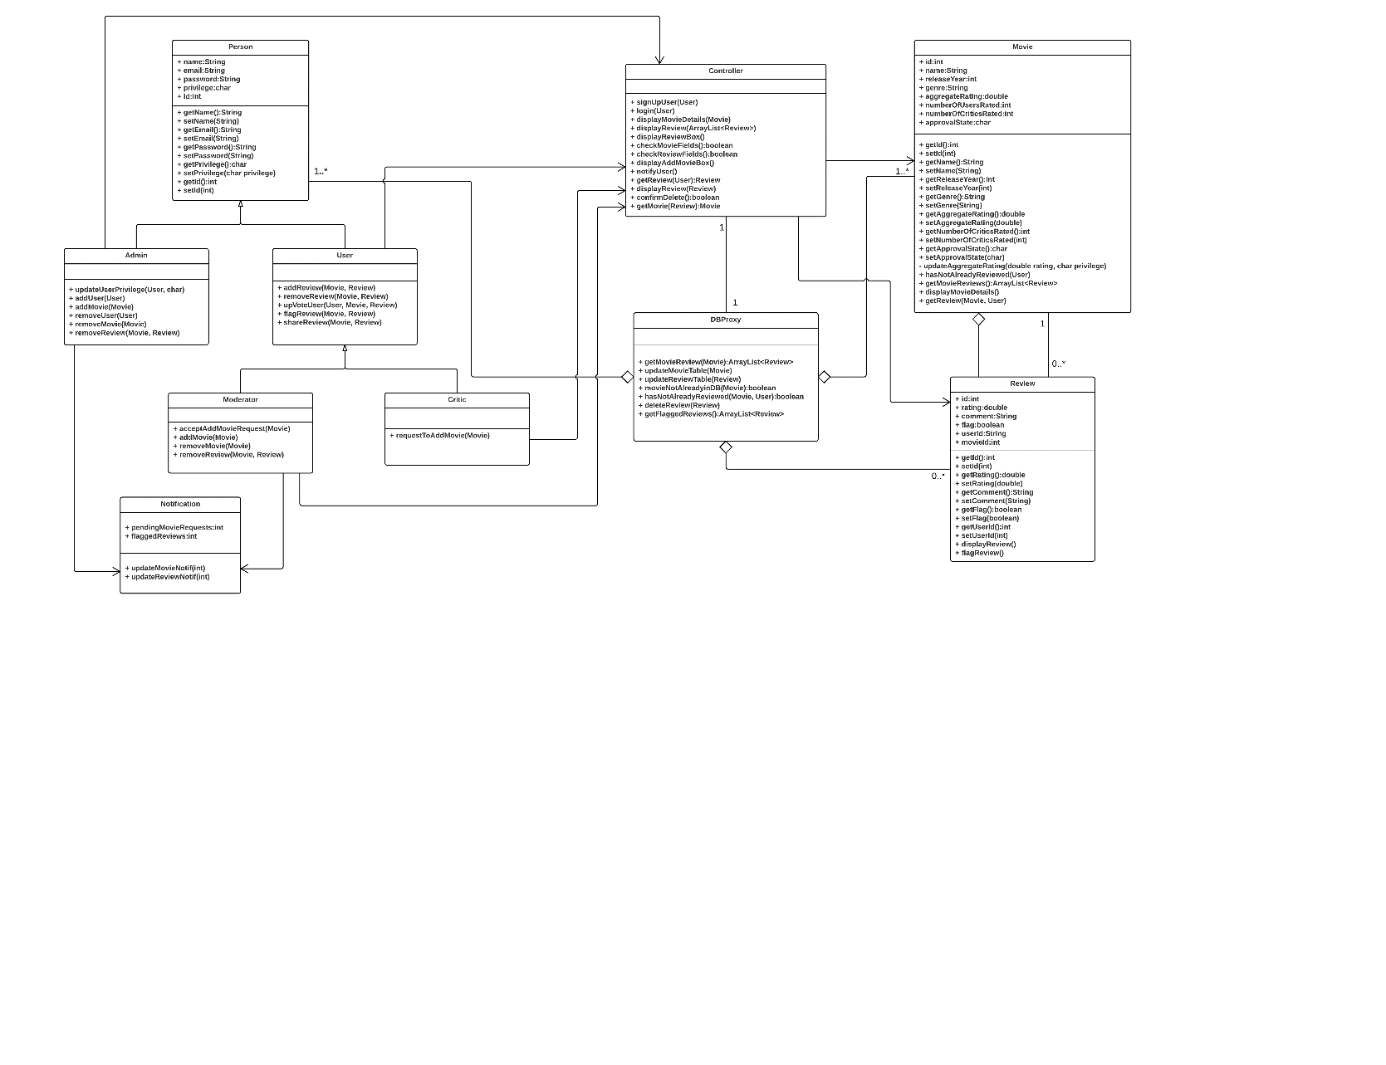

1. Final class diagram
2. What changed and Why?

**4. Did you make use of any design patterns in the implementation of your final prototype? If so, how? Show the classes from your class diagram that implement each design pattern (each design pattern as a separate image in the .PDF). If not, where could you make use of design patterns in your system? Show a class diagram of how you could implement each design pattern and compare how it would change from your current class diagram**:

**5. What have you learned about the process of analysis and design now that you have stepped through the process to create, design and implement a system?**