2023 Fall
Mechatronics and System Design-Mechatronics IV
Final Project Report

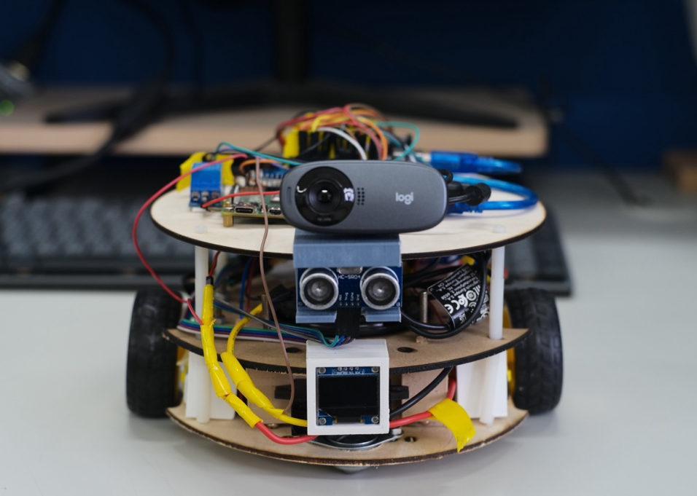

Group VI
Members:
B09611007 陳柏霖 (Po-Lin Chen)
B09611010 鄧世群 (Shih-Chun Deng)
B09611043 陳冠霖 (Guan-Lin Chen)
B08204024 陳冠宇 (Kuan-Yu Chen)

Abstract

This project report outlines the design and development of our compact, agile vacuum robot, engineered for remote operation via video streaming. The report delves into three primary areas of system design: Mechanical Design, Hardware & Electrical Design, and Software & User Interface.

In the Mechanical Design section, the report emphasizes the robot’s three-layer circular structure that enables it to rotate in place and maintain balance, with a strictly limited diameter for improved agility. A novel vacuum design with a ground-level fan and centrifugal dust dispersal mechanism is highlighted, showcasing the team’s unique approach to minimizing space while maintaining cleaning efficiency. The design also incorporates ultrasonic sensors and robotic eyes represented by an LCD display for enhanced functionality and interactivity.

Hardware & Electrical Design details the integration of components within the robot’s circuitry to optimize functionality and power efficiency. A key innovation is the use of a single battery box to operate all devices, which effectively reduces excess weight, setting our design apart from other teams that rely on supplementary mobile power supplies.

Software & User Interface development is recognized for its custom HTML-based control interface, featuring a 'storm' function for intensified vacuum cleaning and a cyberpunk-style visual theme to match the robot's aesthetics.

The report also discusses challenges encountered in the system development, with solutions such as adjustments to the robot's height, wheel support, vacuum nozzle shape for the mechanical aspect, and buffering to address with transmitting delays for the software.

Strategic improvements from Mid-term to Final Testing phases, including enhanced practice, corner detection, and 'storm' mode, significantly reduced the time required to complete tasks.

Overall, this project showcases a successful integration of innovative design, component optimization, and user interface development to create a distinctive and efficient robotic vacuum cleaner.

Outline

- Introduction ……………………………….……….…... 4
- System Design ………………………………….…….… 4
- Mechanical Design ………………………………..……….. 4
  - Overview ………………………………………….…….. 4
  - Vacuum Design ……………………………………..… 5
  - Front Sensor and Robotic Eyes ………………… 6
- Hardware & Electrical Design ………..……………..… 6
- Software & User Interface …..………………………….. 7

- Discussion ……………………………………….………. 9
- Challenges ……………………………………………………… 9
- Test Reviews …………………………………………..………. 9
- Reflections & Suggestions ……………..……….. 10
- Appendix ………………………………….……………. 11
- Members and Teamwork ……………………………… 11

I. Introduction

Our robot is designed to be controlled remotely through video streaming. Its primary functions include navigating around and performing vacuuming tasks. Our core philosophy is to minimize space to enhance the robot's agility. In addition, careful study and design of the vacuum is essential to ensure sufficient cleaning efficiency.
However, fulfilling both requirements simultaneously is not an easy task. In the next chapter, we divided our system design into three main parts: Mechanical Design, Hardware & Electrical Design, and Software & User Interface.

II. System Design

1. Mechanical Design

1.1 Overview
Our robot is comprised of three layers in a circular design, allowing it to rotate in place. Its diameter is restricted to just 18 centimeters for enhanced agility. The main structural components are in the middle (in x, y axis) and underneath (in z axis) to ensure balance.

The top layer mainly consists of an Arduino and RPi, forming the core for computation and control. The middle layer houses the vacuum and motor structures, along with the power control circuit. The lowest layer aligns the omnidirectional wheels, drive wheels, and vacuum nozzle at the same height to ensure the vacuum remains close to the ground, maximizing suction efficiency.

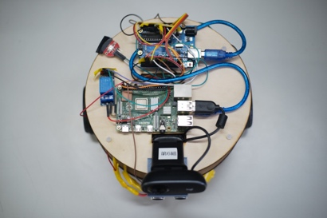 | 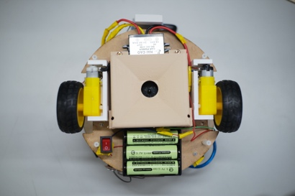 | 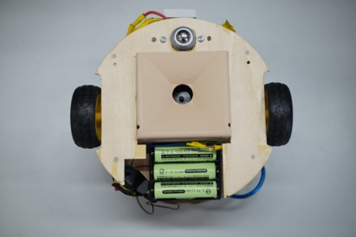
- Top layer | - Middle layer | - Bottom layer

For securing each mechanical component, we strictly use keyholes and screws instead of direct adhesion. Additionally, with an emphasis on superior industrial design, the body of the robot features a combination of wood tones and white. This choice underlines a lightweight, minimalist, and homely style.

1.2 Vacuum Design

Unlike other groups using fan-induced duct flow to direct dust into a collection box, we utilized a fan close to the ground to create a pressure difference, sucking in dust. Then, using centrifugal force, it disperses the dust to settle onto the dustbin.

We adopted this method for two reasons: First, integrating the nozzle and dustbin into a single mechanism reduces space occupation, aligning with our core philosophy. Second, a fan positioned close to the ground minimizes pressure loss.

During the midterm test, we adopted a circular design as shown in Figure (a). However, due to the nozzle being too close to the ground and the opening too narrow, precise alignment was necessary to vacuum up scraps of paper. In the final test version, shown in Figure (b), we precisely adjusted the mechanism's height and enlarged the opening. Additionally, we conceived and validated a fact: a rectangular opening effectively creates turbulence in corners, enhancing the vacuum's cleaning performance.

Figure (c) provides a closer look. The blue region indicates the spatial occupation of the fan. Acting like a pump, the fan generates an airflow (red arrows) that dives into the interior with turbulence induced (orange arrows). The fan then disperses the dust (blue arrows), letting it to settle into the dustbin (grey arrows).

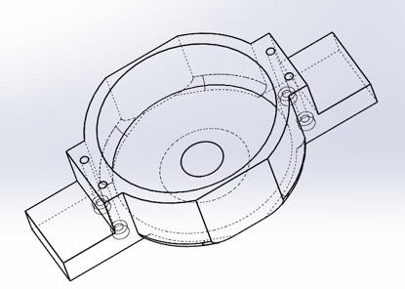 | 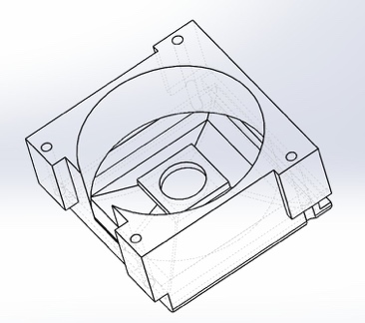 | 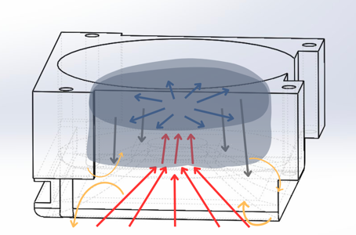
(a) Mid-term Version | (b) Final Version | (c) Fluid Velocity Field

1.3 Front Sensor and Robotic Eyes

During the mid-term test, we employed a video-streaming strategy but encountered visibility issues when the robot was too close to walls. To address this, we installed an ultrasonic sensor at the front for corner detection. Upon detecting a corner, the device activates 'storm' mode, which involves spinning in place with the vacuum on.

In addition, to enhance its appearance and for fun aspects, we equipped the front side with an LCD display that shows different expressions during various states, as illustrated in Figures (a), (b), and (c).

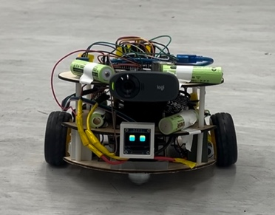 | 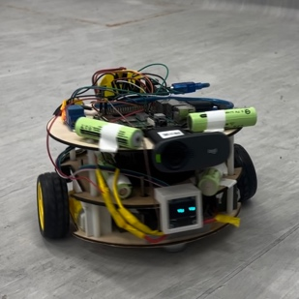 | 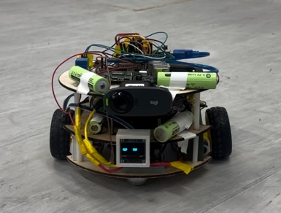
(a) Moving Forward | (b) Turning Left | (c) Turning Right

2. Hardware & Electrical Design

Figure (a) illustrates our focus on achieving seamless integration of diverse components within a comprehensive circuit to augment both the functionality and power efficiency of the robot. The integrated components encompass a battery box, switch, vacuum motor, wheel motor, motor driver, RGB LED, ultrasonic sensor, camera, LCD, relay, power converter, Raspberry Pi, and Arduino Uno.

A notable feature of our approach is the incorporation of a power converter in tandem with a relay, facilitating the robot to operate all devices using only a single battery box. This innovation eliminates the necessity for external power sources, setting our design apart from other teams' configurations that commonly rely on supplementary mobile power supplies.

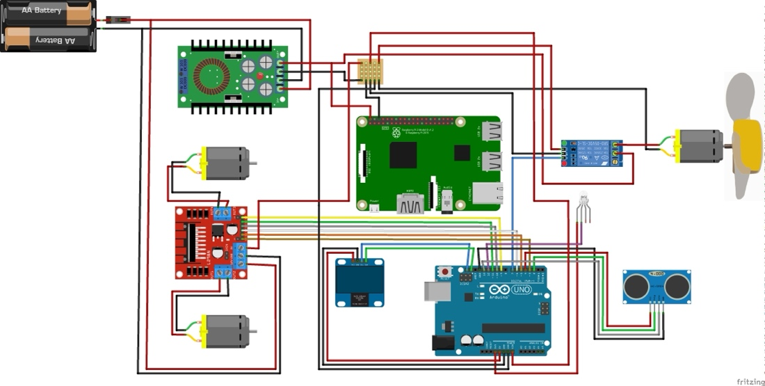
(a)

3. Software & User Interface

Figure (b) represents the user interface developed by our team for this project. Unlike other groups utilizing App Inventor or other pre-existing toolkits, our team constructed the operational interface using HTML. Beyond the fundamental functionalities of basic directional controls for upward, downward, leftward, and rightward movement, our interface incorporates an additional feature known as the 'storm' function, depicted by the lightning cloud icon in Figure (b). This function enables powerful vacuuming upon reaching areas with accumulated dust.

Furthermore, the background design adopts a cyberpunk style to align with the visually striking appearance of our robotic vacuum cleaner. This cohesive design approach aims to ensure consistency between the device's aesthetics and its user interface.

The innovative use of HTML in crafting the interface sets our project apart, offering a tailored and visually engaging control system for the user. This deliberate design choice not only enhances usability but also complements the futuristic and captivating appeal of our robotic cleaner.

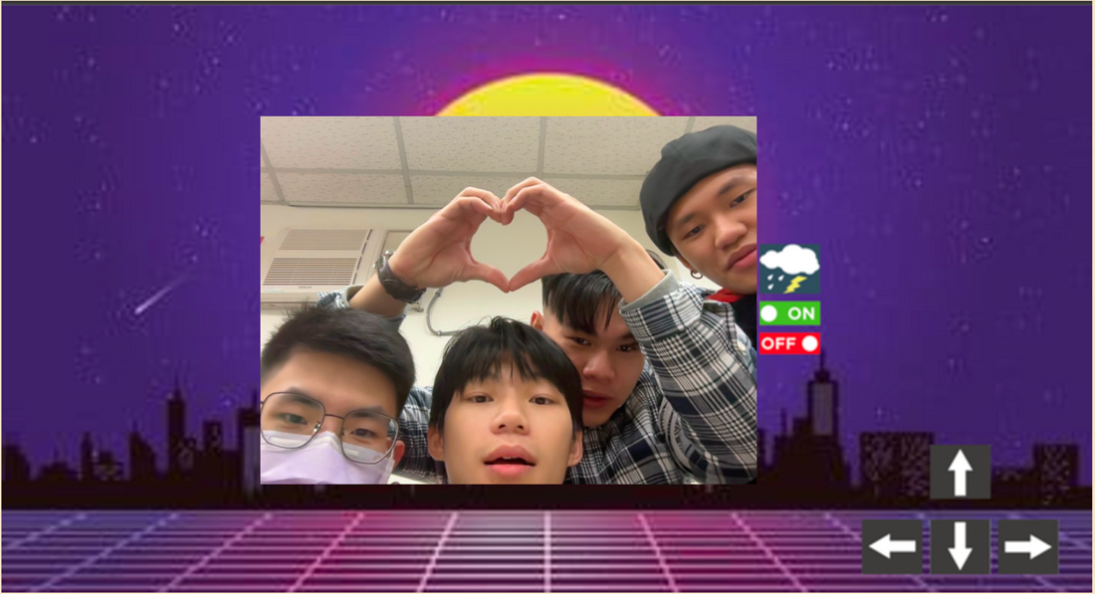
(b)

Figure (c) illustrates the conceptual diagram depicting the intercommunication and interaction between backend programs. Through interface buttons, messages are transmitted to 'main.py,' residing within our Raspberry Pi (RPI), which further relays these instructions via serial transmission to the Arduino for execution. This successful process fulfills the objectives of the class, specifically achieving communication and mechanical integration between the RPI and Arduino.

All these programs are hosted within our RPI, allowing us to utilize SSH from a computer within the same network domain for remote control. Employing these methods and technologies reflects our aim to simulate real-world operational environments for robotic vacuum cleaners. Typically, these operations involve remote communication via the internet from home environments. Therefore, this concept aligns with the core principle driving the initial design of our software.

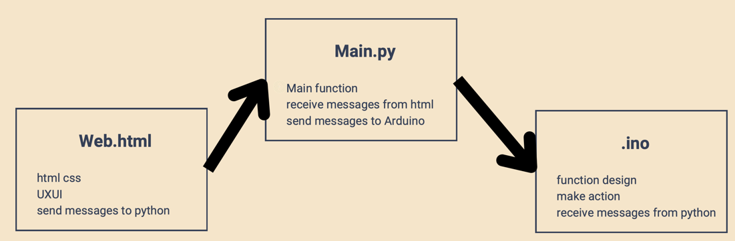
(c)

III. Discussion

- Challenges
  - Mechanical Design

Problems | Solutions
- Our vacuum was designed to be placed under the body of the vehicle, close to the ground.  - The wheels often become splayed outward after running for a while, which caused our vehicle to get stuck during the journey. | - Adjusted vehicle’s height by adding a layer.  - Made precise adjustments of the omni-wheel.  - Redesigned the shape of the vacuum nozzle.  - Designed and installed a bracket for motors.
  - Software System Control

Problems | Solutions
- Delay when using UI buttons during the Mid-term Test, leading to multiple presses.  - Excessive turning angles for left and right movements, making it difficult to accurately reach the targets. | - Introduced a buffer in the main program to alleviate the delay issue.  - Adjusted control parameters for forward, backward, left, and right movements.

- Test Reviews

Midterm Test | Final
- Insufficient testing before the mid-term.  - Couldn't view the floor, preventing us from determining whether we had aligned with the target.  - Wasted time wandering. | - Conducted more practice sessions for both manual and video-streaming control.  - Introduced corner detection and ‘storm’ mode to efficiently complete the task.  - Saved over half of the time during the final test.

- Reflections & Suggestions

- B09611007陳柏霖 (Po-Lin Chen)
關於這堂課，我覺得專題有吸塵的元素蠻有趣的，也可以讓大家發揮創意。不過專題花費的時間其實超過想像，我主要負責的是機構設計，原以為期中之後車體定型就有時間協助軟體開發自走功能，沒想到期中之後車體要加裝一層、3D列印的支架和鎖孔都要更新、吸塵口機構迭代五次，其實也不夠時間做自走車了，剩下的時間只好拿來做角落偵測和機器人眼睛。認真算下來這學期花了68小時課外時間，以3學分的課而言有點多但還可接受。給課程的建議是可以更重視報告的呈現和工業設計，兩者都是系上其他課程未要求卻極為重要的素養，作為Capstone課程若能加強培養必能使同學畢業後更加體面且專業。

- B09611010 鄧世群 (Shih-Chun Deng)
我負責電路設計與實踐的部分，包含線路焊接、硬體系統整合和改善。期中花費許多時間在與設計硬體的組員討論機構和線路的配合，因為我們想要盡可能將整組系統做得更加緊湊，節省空間和重量。組員都是四年級，大家每週的行程都相當不同，因此一開始明確的任務分配變得非常重要。使我們能夠根據任務內容配合出席的組員，更加有效率的完成任務。我認為這堂課的設計還需幾次的嘗試才能夠建立出完整的測試規則，避免太多變因造成不公平的可能。但還是非常感謝教授與助教的用心，大家都在這堂課學習到許多。

- B09611043 陳冠霖 (Guan-Lin Chen)
我主要負責的部分是RPI主程式以及協助部分機構設計以及操作者，期中前我們把軟硬體的連線都大致完成，原本期待期末能以自走的方式呈現，結果期中發現吸塵有些狀況，加上對規則計分不夠熟悉，表現不佳。因此期末我們決定捲土重來，把機構重新修改，改善軟體以及熟練操作，期末有明顯進步。這學期的過程中很感謝組員的互相合作，加上不斷地修改調整以及溝通，讓我們從0開始到最後有一定的成果。也很感謝老師跟助教在這學期的協助，協助我們有一個能展現的舞台，作為大學4年最後一堂必修課，是一個很難忘的回憶。

- B08204024 陳冠宇 (Kuan-Yu Chen)
在這個團隊中，我的主要責任是軟體架構，包括UX/UI設計和不同平台框架 間的溝通。大部分工作其實在期中評估之前就完成了，但由於期中成績不 盡理想，我們後來對程式進行了一些修改，以在專題結束時更加順暢地運 行。我認為這門課作為我們學業的最後一站，主題和內容都非常貼合。在 這個過程中需要的技能都是我們四年學習的累積，和這些同學一起完成最 後的專題任務感覺格外特別。看著大家從一開始的困惑到能夠高效地完成 分派的任務，這種轉變讓人深受觸動。唯一的遺憾是期中時間稍微不足 （雖然在期末有改善），以及某些規則可能使得比賽某些方面不太公平。 但無論如何，我非常感激大家的奉獻，也感謝我們的教授和助教所提供的 指導。

- Appendix
- Members and Teamwork

 | Po-Lin Chen | Shih-Chun Deng | Kuan-Yu Chen | Gaun-Lin Chen
Project Proposal | Mechanical Design,  Materials,  Proofreading, Refinement | System Diagram,  Electrical Design | User Interface | Difficulties
~ Mid-term | components design, manufacturing, assembly | circuits, power, hardware testing | frontend, user interface | backend
Mid-term  Trial & Test | testing | testing | testing, robot operator | testing
~ Final | components iterations, corner detect, robotic eyes | power circuits update | software fine-tuning | component design
Final  Trial & Test | fine-tuning | fine-tuning | fine-tuning | fine-tuning, robot operator
Final  Presentation | Mechanical Design,  slides proofreading | Electrical Design,  presenter | Software & UI,  presenter | Discussion
Final  Report | Abstract, Introduction,  Mechanical Design,  Proofreading, Refinement | Hardware & Electrical Design | Software & User Interface | Discussion

