2023 Fall
Mechatronics and System Design-Mechatronics IV
Final Project Proposal

Group VI:
Members:
B09611007 陳柏霖 (Po-Lin Chen)
B09611010 鄧世群 (Shih-Chun Deng)
B09611043 陳冠霖 (Kaun-Lin Chen)
B08204024 陳冠宇 (Kuan-Yu Chen)

Outline

- System Design
- System Diagram
- Mechanical Design
- Electrical Design
- User Interface

- Materials
- Material List
- Manufactural Methods

- Project Plans
- Gantt Chart
- Roles and Responsibilities

- Difficulties

I. System Design

1. System Diagram
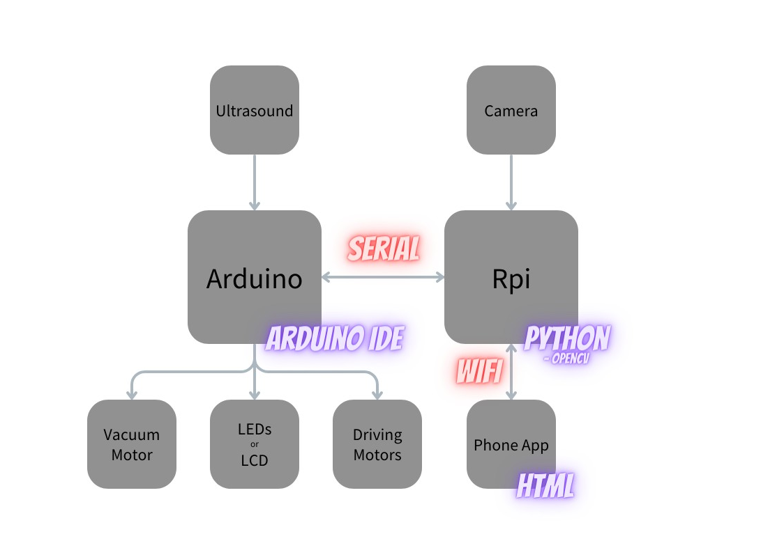
2. Mechanical Design

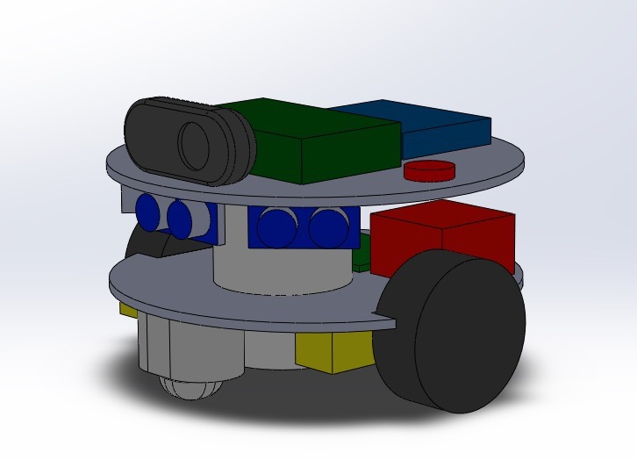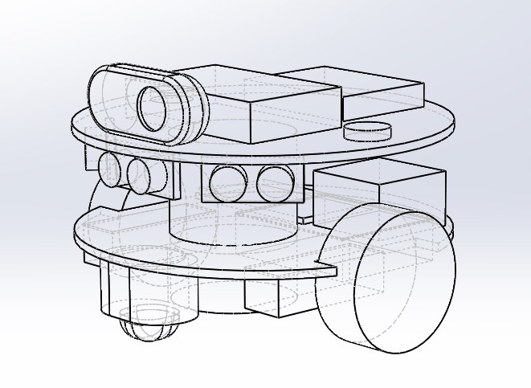
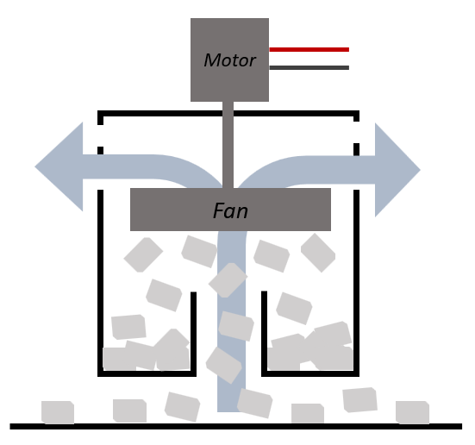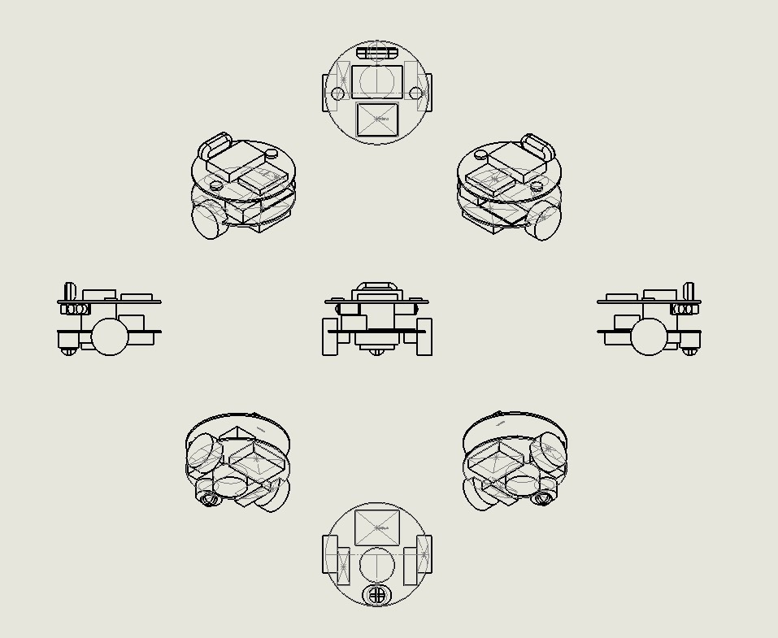
3. Electrical Design

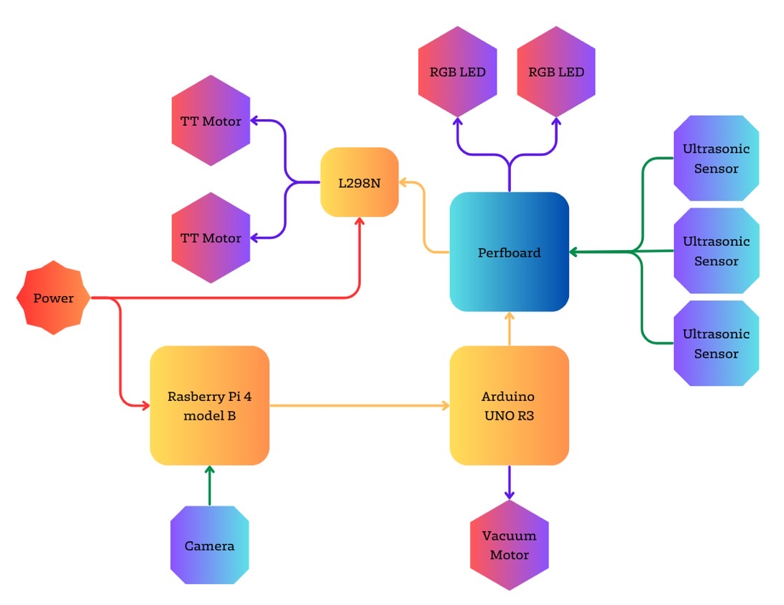

4. User Interface

II. Materials

1. Material List
ID | Part | Source
1 | Raspberry Pi 4 model B | BB Lab
2 | Arduino UNO R3 | BB Lab
3 | Arduino cable | Mechatronics IV
4 | VGA-HDMI cable | Mechatronics IV
5 | DC motor | Mechatronics IV
6 | TT motor*2 | Mechatronics IV
7 | Wheel | Mechatronics IV
8 | Ultrasonic sensor*3 | Mechatronics IV, BB Lab
9 | L298N | Mechatronics IV
10 | Bread Board | Mechatronics IV
11 | Perfboard | BB Lab
12 | MicroSD card | Mechatronics IV
13 | Logitech webcam | Mechatronics IV
14 | 18650 Lithium battery*3 | Mechatronics IV
15 | Battery case | Mechatronics IV
16 | RGB LED | BB Lab
*Additional parts to be purchased: None
2. Manufacturing Methods

ID | Component | Method
A | Undercarriage | Laser cutting
B | Upper Layer | Laser cutting
C | Camera Mount | 3D printing
D | Ultrasonic Sensor Mount | 3D printing
E | Omni-wheel Connector | 3D printing
F | Vacuum Bracket | 3D printing
G | Rpi, Arduino, Perfboard, L298N,  TT Motor, RGB LED, Battery Fixtures | Keyholes and Standoffs

III. Project Plans

1. Gantt Chart
 | 9/  22 | 9/  29 | 10/  6 | 10/  13 | 10/  20 | 10/  27 | 11/  3 | 11/  10 | 11/  17 | 11/  24 | 12/  1 | 12/  8 | 12/  15 | 12/  22
Mech | Mechanical  Design |  | Assembly & Testing |  |  |  |  | New Feature  Implementation |  |  |  | Fine-  Tuning
SW | UI  Design |  | Frontend / Backend  Development |  |  | System  Integration
HW | Unit  Testing |  | Hardware  Integration
Pres | Project  Proposal |  |  |  |  |  |  |  |  |  |  | Final  Presentation

2. Roles and Responsibilities

Work Assignment | Responsible Individual
Mechanical Design | Po-Lin
Manufacturing & Assembly | Po-Lin, Kaun-Lin
Hardware Development | Shih-Chun
Hardware Integration | Shih-Chun, Kaun-Lin
User Interface Design | Kuan-Yu
Software Development | Kuan-Yu
System Integration | Po-Lin, Shih-Chun, Kaun-Lin, Kuan-Yu
Final Presentation | Shih-Chun, Kuan-Yu

IV. Difficulties

