<!-- tp -->

<hr> :- align, noshade,color,size, width

<meta charset="UTF-8"> :- for emoji or symbols

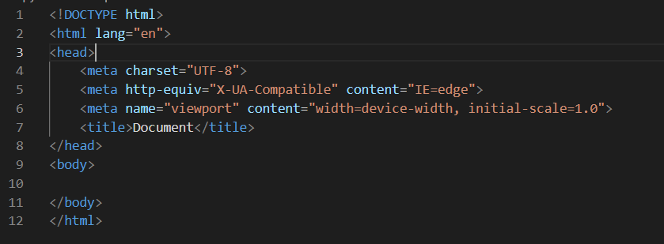

<ul> o/p:-

<li> aniket</li> \* aniket

<li>rathide</li> \* rathide

<li>belin</li> \* belin

</ul>

<ol> o/p attributes:-<ol type=”I”> o/p roman no.

<li> aniket</li> 1. Aniket :-<ol start=”7”> 7se start hoga

<li>rathide</li> 2. rathide

<li>belin</li> 3. belin

</ol>

Img enter

<img src="image address" alt="if img doesnot display type this" height=”100”>

Attribute mdn html se dekhle

Link(a enter)

<a href="link ka address">link ka naam </a>

<strong></strong> and <b></b> are same

<em></em> and <i></i> are same

<table border="1"> //table aise start hoga

        <thead> //heading dikhega bold me

            <tr> //table row

                <th>year </th> //tablehead

                <th>standard</th>

            </tr>

        </thead>

<tbody>

    <tr>

    <td>2019</td>

    <td>10th std</td>

</tr>

<tr>

    <td>2021</td> //tabledata

    <td>12th std</td>

</tr>

</tbody>

    </table>

output

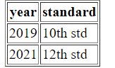

Forms

<form action="">

        <label> your name </label>

        <input type="text" name="dfaa">

        <input type="color" name="" id=""><br>

        <label for=""> du want to call me </label>

        <input type="checkbox" >

        <input type="submit"><br>

        <label for="">password</label>

        <input type="password">

    </form>

Output

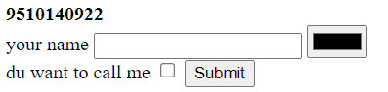

Attributes

