**Group 9**

**Topic and Rationale:**

Our team would like to create visualizations based on the uNoGS (Unofficial Netflix Online Global Search) to gain insight on the shows and movies available in different countries. In addition, we would like to illustrate what countries currently have the highest rating films and tv shows.

**Data Set:**

* <https://unogs.com/>
* 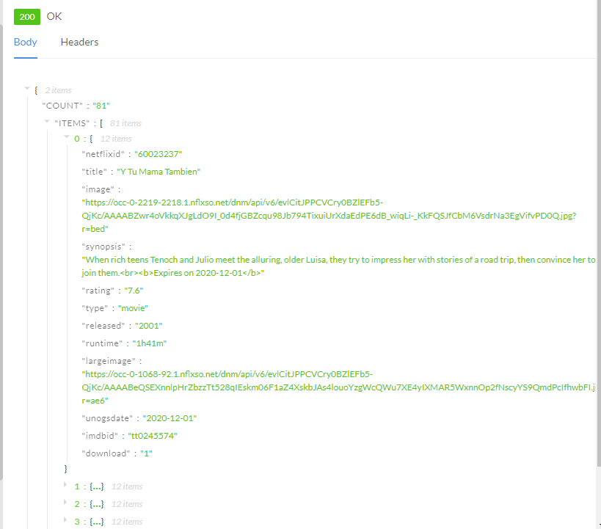

**“Inspiring” Visualizations:**



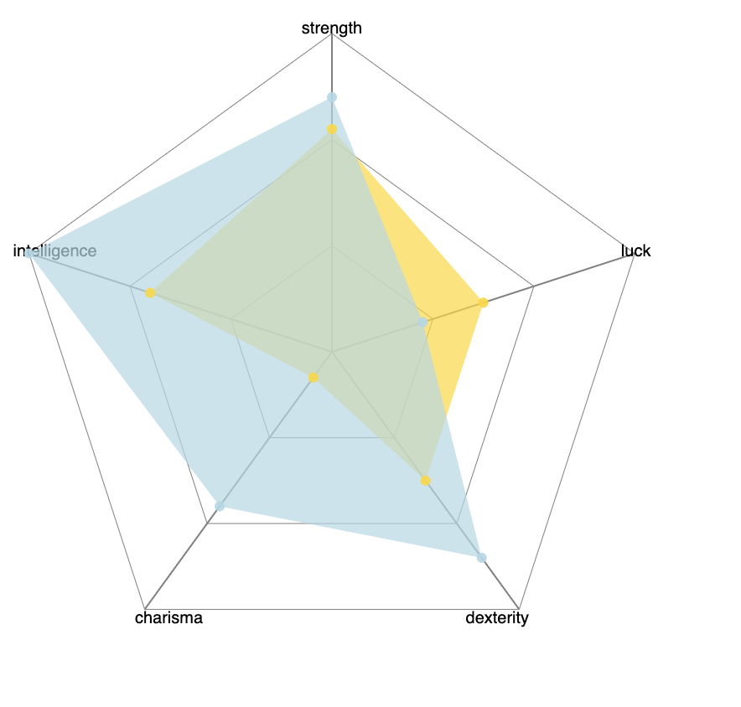

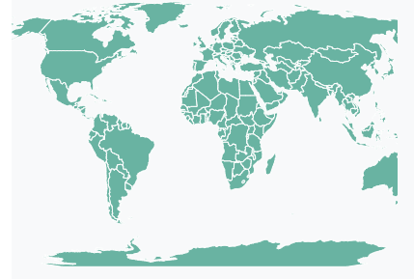

**Sample Dashboards:**

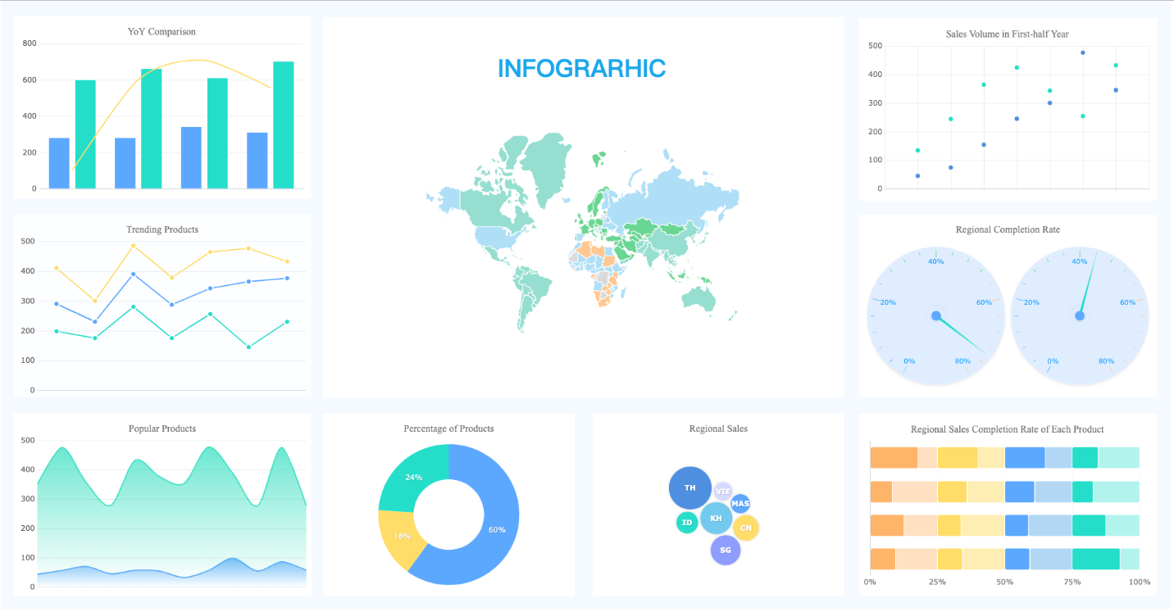

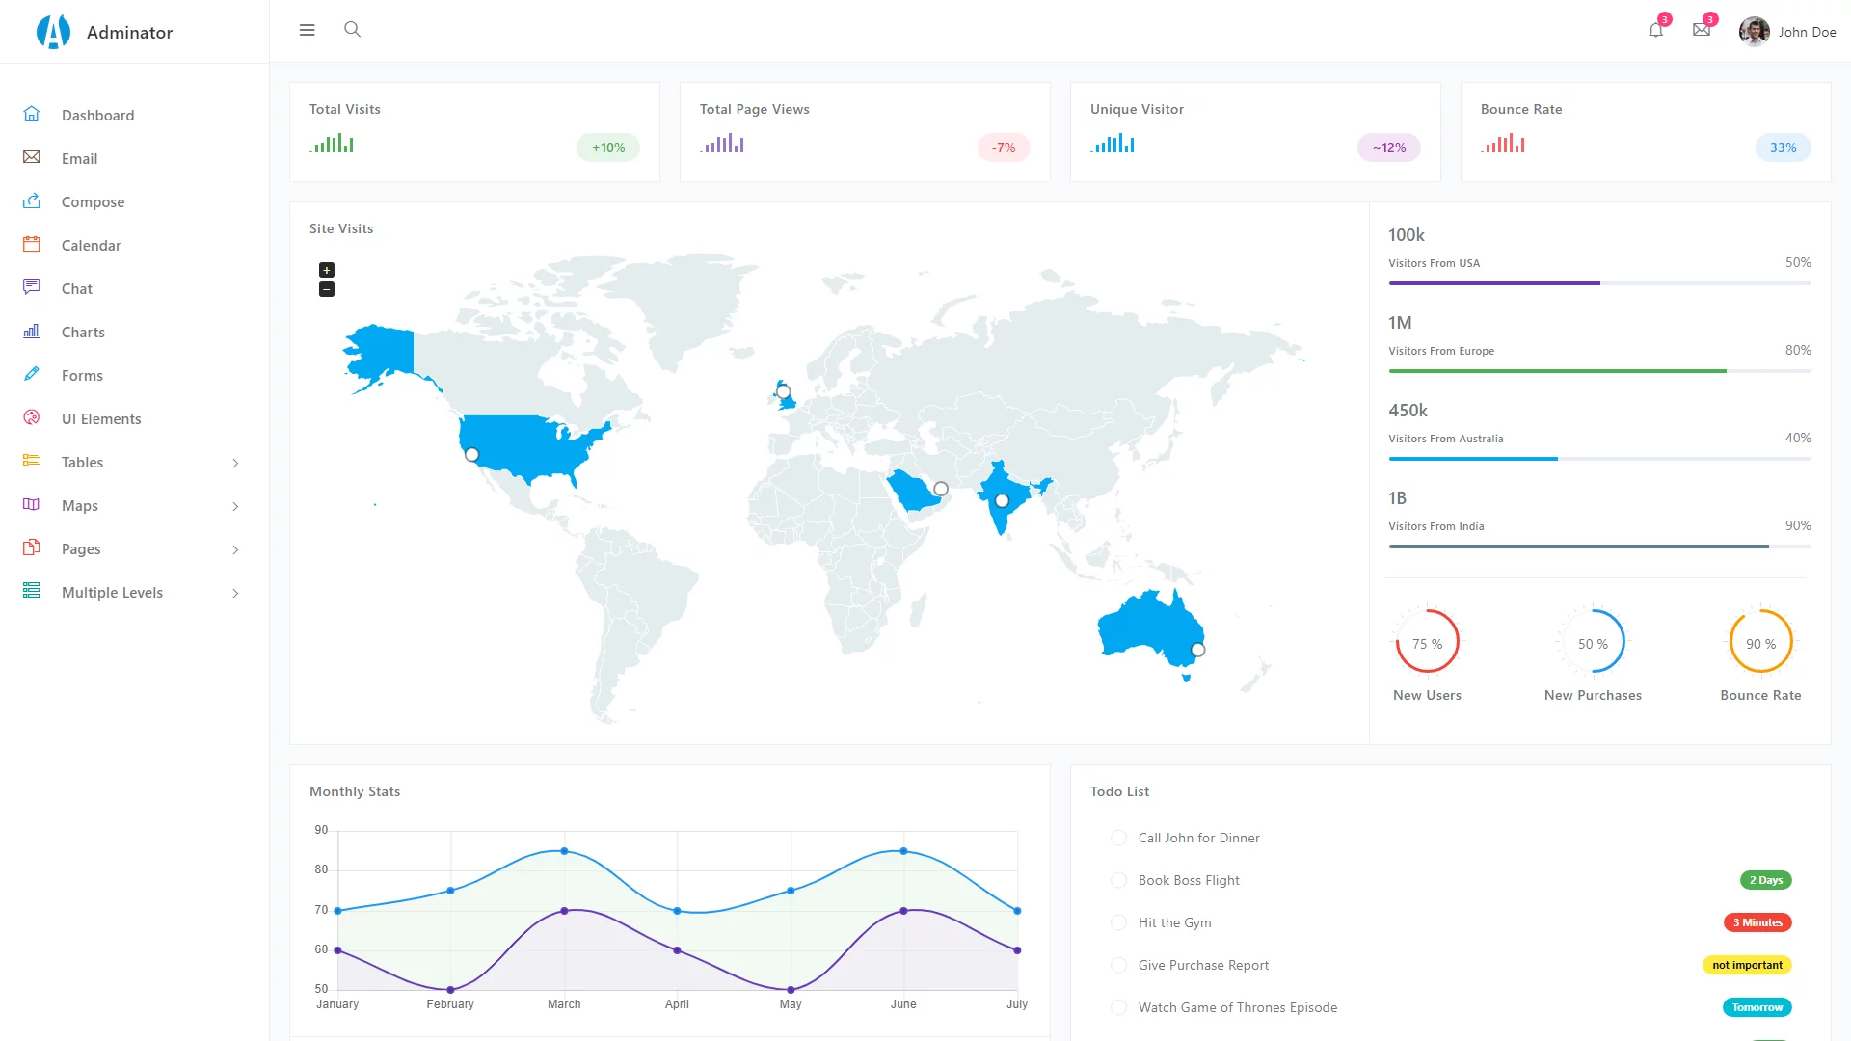

**Github Repo:**

* https://github.com/berlyflores-98/Project-2.git