Covid-19 Dashboard Exercise [Bernardo Martelli]

1. Introduction

Simplified Dashboard to show the number of victims of COVID, divided per country. I do understand that the idea is not novel. Nor it is meant to be a tool to help the community. My only reason is exclusively to learn to work with React/Redux, to learn how to present data graphically and to learn how to fetch information from an API.

2. User Interface Design and Navigation
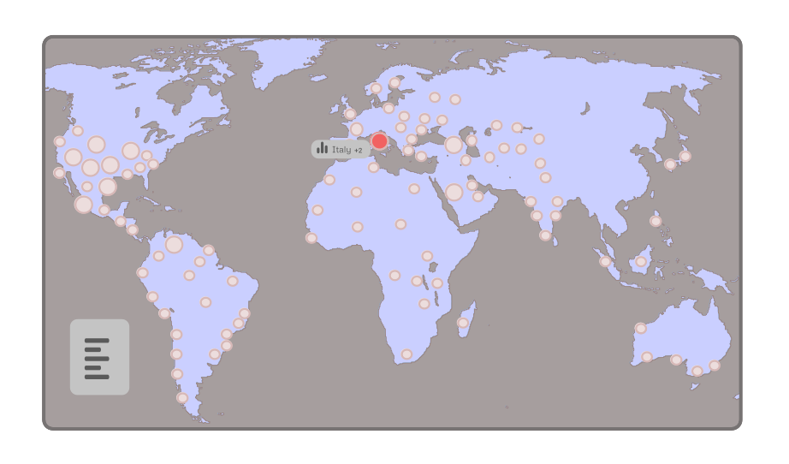
The interface is quite uncomplicated and intuitive. The whole app is composed of a clickable real-time map. Every country triggers an event consisting in selecting and showing the most recent number of victims or infections for that specific country. The user should be able to understand which country is selected. See Link. Figma and Giphy were used to make the UI design and the animation.

3. References

- COVID-19 Dashboard by Johns Hopkins University [https://coronavirus.jhu.edu/map.html]
- Tool to track the spread of Coronavirus [https://covidly.com/]
- Popular Coronavirus tracking site [https://ncov2019.live/]
- COVID-19: WHO page [https://www.who.int/health-topics/coronavirus#tab=tab_1]
- Redux Crash Course with React [https://www.youtube.com/watch?v=93p3LxR9xfM]
- Free API data for Coronavirus [https://covid19api.com/]

