Project title: Dierenasiel Schoten revamp [final]

Idea:

Restyling of an existing website* for an existing animal-shelter in Schoten (Belgium).

Problems to be solved:

I see that the current website is made using a very old
editor, microsoft front page 6.0, and the navigation
system is made using frameset, which is now
obsolete.
Another problem to be fixed is the poor or non-existent
use of CSS. Several other errors need to be corrected.

Goal (client):

Attract sponsors and users, modernize the website, offer users a better user experience, have better interaction with the organization's volunteers.

Goal (learner):

I wanted to know more about the design of UX and UI and to do something useful for the society by helping this organization. by creating a nicer website i want to attract more people to adopt animals. I might redo the complete website in the future.

Expected List of Features:

- Upgrade to HTML5
- CSS update and restyling
- Responsiveness
- Static website
- Contact form
- Pass W3 validator

First wireframe:

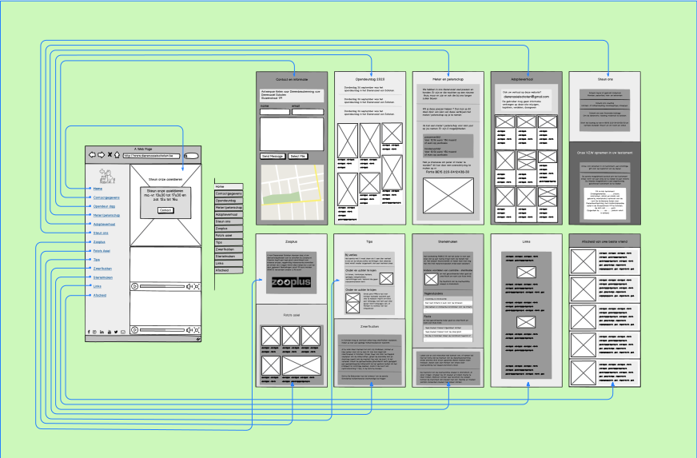
First wireframe (for mobile, bigger file):
https://bit.ly/2XvdsS2

First mockup (for desktop):
https://bit.ly/2ReezBr

Final release:
https://bit.ly/2V1tFMX

Code is available at:
https://bit.ly/2V5jwz3

Implementation:

The proposed initial project goes beyond the actual implementation. It would require more work: get in touch with the organization, implement the part that requires server side programming, correct and change the web site according to client requestes and finally upload it to the hosting service. Instead, a simplified version uploaded on github, is provided. Not all the initial sections were finally implemented. I used Balsamiq and Inkscape to create the first wireframe, then Invision to create an initial HTML mockup. I wanted to create a neutral low-res wireframe without colors, fonts or graphics. Invision offers the possibility to download an offline mockup, that's why I chose it. To speed up the final realization, a template called "Prologue" was used, based on Bootstrap, available on html5up.net.
The site is a simple and clean one-pager. Instead of using different pages, all the different sections are available on a single HTML document. Basic navigation on the left, every section is reachable from the menu, which is always visible.

References:
Old website:

* http://www.dierenasielschoten.be/

Inspirational:

- https://onextrapixel.com/free-bootstrap-wireframing-set-for-powerpoint/
- http://www.jjg.net/ia/visvocab/
- https://www.youtube.com/watch?v=ciL6FxkoLsw/
- https://www.youtube.com/watch?v=4zEYfzjKiK8/
- https://www.youtube.com/watch?v=xuNB19dmI9s/
- https://www.youtube.com/watch?v=KnZrypOaVCg/
- https://www.youtube.com/watch?v=6ec8YIrfbhk/

Similar Websites (comparative):

- https://www.sociovzw.be
- https://dierenasielcanina.be
- http://www.dierenasielsinttruiden.be
- https://dierenasielgenk.be
- https://dierenasiel-tienen.be
- https://www.dierenasielgent.be
- http://www.dierenasielknokke-heist.be
- https://www.dierenasiel-leiestreek.be

