
ZHEJIANG DAHUA VISION TECHNOLOGY CO., LTD.
V1.2.1
Network Speed Dome PTZ
Camera Web 5.0
User's Manual

Foreword

General
This manual introduces the functions and operations of the Network Speed Dome PTZ Camera (hereinafter referred to as "the Camera").

Safety Instructions
The following signal words might appear in the manual.
Signal Words | Meaning
 | Indicates a high potential hazard which, if not avoided, will result in death or serious injury.
 | Indicates a medium or low potential hazard which, if not avoided, could result in slight or moderate injury.
 | Indicates a potential risk which, if not avoided, could result in property damage, data loss, reductions in performance, or unpredictable results.
 | Electrostatic Sensitive Devices.  Indicates a device that is sensitive to electrostatic discharge.
 | Indicates dangerous high voltage.  Take care to avoid coming into contact with electricity.
 | Indicates a laser radiation hazard.  Take care to avoid exposure to a laser beam.
 | Provides methods to help you solve a problem or save time.
 | Provides additional information as a supplement to the text.

Frequently Used Functions
Button | Description
Apply/Save | Save the configurations.
Refresh | Refresh the configurations to the latest.
Default | Restore the configurations to the default.
Clear | Clear the configurations.
Delete | Delete the configurations.

Revision History
Version | Revision Content | Release Time
V1.2.1 | Updated the introduction. | July 2024
V1.2.0 | - Added auto upload of images and events.  - Updated SMD.  - Updated one-click disarm.  - Updated IVS. | June 2024
V1.1.0 | - Added Acupick.  - Added Construction Monitoring.  - Updated IVS. | March 2024
V1.0.7 | ● Added face detection. ● Added app center. | December 2023
V1.0.6 | Updated AI functions. | October 2023
V1.0.5 | - Added maintenance center.  - Updated illuminator function. | September 2023
V1.0.4 | Added low power mode. | August 2023
V1.0.3 | Added descriptions on the power consumption mode and PIR alarm functions. | June 2023
V1.0.1 | Added cellular network function. | August 2022
V1.0.0 | First release. | September 2021

Privacy Protection Notice
As the device user or data controller, you might collect the personal data of others such as their face, audio, fingerprints, and license plate number. You need to be in compliance with your local privacy protection laws and regulations to protect the legitimate rights and interests of other people by implementing measures which include but are not limited: Providing clear and visible identification to inform people of the existence of the surveillance area and provide required contact information.

Interface Declaration
This manual mainly introduces the relevant functions of the device. The interfaces used in its manufacture, the procedures for returning the device to the factory for inspection and for locating its faults are not described in this manual. Please contact technical support if you need information on these interfaces.

About the Manual
- The manual is for reference only. Slight differences might be found between the manual and the product.
- We are not liable for losses incurred due to operating the product in ways that are not in compliance with the manual.
- The manual will be updated according to the latest laws and regulations of related jurisdictions. For detailed information, see the paper user’s manual, use our CD-ROM, scan the QR code or visit our official website. The manual is for reference only. Slight differences might be found between the electronic version and the paper version.
- All designs and software are subject to change without prior written notice. Product updates might result in some differences appearing between the actual product and the manual. Please contact customer service for the latest program and supplementary documentation.
- There might be errors in the print or deviations in the description of the functions, operations and technical data. If there is any doubt or dispute, we reserve the right of final explanation.
- Upgrade the reader software or try other mainstream reader software if the manual (in PDF format) cannot be opened.
- All trademarks, registered trademarks and company names in the manual are properties of their respective owners.
- Please visit our website, contact the supplier or customer service if any problems occur while using the device.
- If there is any uncertainty or controversy, we reserve the right of final explanation.
Table of Contents
Foreword I
1 Overview 1
1.1 Introduction 1
1.2 Functions 1
1.2.1 Basic Functions 1
1.2.2 AI Functions 2
2 Configuration Flow 5
3 Device Initialization 6
4 Setting 9
4.1 Device Login 9
4.2 Local 11
4.3 Camera 13
4.3.1 Setting Image Parameters 13
4.3.2 Setting Encode Parameters 28

4.3.3 Audio.......................................................................................................................................... 39
4.4 Network................................................................................................................................................ 40
    - TCP/IP......................................................................................................................................... 40
    - Port............................................................................................................................................. 43
    - PPPoE..........................................................................................................................................45
    - DDNS.......................................................................................................................................... 46
    - Email...........................................................................................................................................47
    - UPnP........................................................................................................................................... 504.4.7 SNMP.......................................................................................................................................... 50 4.4.8 Bonjour.......................................................................................................................................53 4.4.9 Multicast.....................................................................................................................................54
    - Register.................................................................................................................................... 55
    - QoS........................................................................................................................................... 55
    - Cellular Network......................................................................................................................564.4.13 Platform Access....................................................................................................................... 60
    - Wi-Fi..........................................................................................................................................62
    - Basic Service............................................................................................................................ 64
4.5 PTZ........................................................................................................................................................ 66
    - Configuring Presets...................................................................................................................66
    - Configuring Tour....................................................................................................................... 67 4.5.3 Configuring Scan....................................................................................................................... 68
    - Configuring Pattern.................................................................................................................. 68
    - Configuring Pan.........................................................................................................................69
    - Configuring PTZ Speed............................................................................................................. 70
    - Configuring Idle Motion............................................................................................................71 4.5.8 Configuring Power Up...............................................................................................................71
4.5.9 Configuring PTZ Rotation Limit............................................................................................... 72 4.5.10 Configuring Scheduled Task.................................................................................................. 73
    - Configuring PTZ Maintenance............................................................................................... 74
    - Configuring Protocol.............................................................................................................. 74
4.6 Event..................................................................................................................................................... 75
    - Setting Alarm Linkage.............................................................................................................. 75
    - Setting Exception...................................................................................................................... 84
    - Setting Video Detection............................................................................................................87
    - Setting Smart Motion Detection.............................................................................................. 91
    - Setting Audio Detection........................................................................................................... 924.6.6 Setting One-click Disarm.......................................................................................................... 93
4.6.7 Auto Upload of Events.............................................................................................................. 94
  - Storage................................................................................................................................................. 95
  - System.................................................................................................................................................. 96
    - General.......................................................................................................................................96
    - Power Consumption Mode....................................................................................................... 99
    - Account.................................................................................................................................... 100
    - Peripheral Management.........................................................................................................1085 Low Power Mode......................................................................................................................................... 110
- Live................................................................................................................................................................112
  - Live Page............................................................................................................................................ 1126.2 Configuring Encoding....................................................................................................................... 112
  - Live View Function Bar......................................................................................................................113
  - Window Adjustment Bar...................................................................................................................114
    - Adjustment.............................................................................................................................. 114
    - PTZ Control.............................................................................................................................. 115
    - PTZ Function............................................................................................................................116
    - OSD Information..................................................................................................................... 117
    - Peripheral Management.........................................................................................................118
    - Image Adjustment...................................................................................................................118
6.5 Display Mode..................................................................................................................................... 119
- Record...........................................................................................................................................................122
  - Playback............................................................................................................................................. 122
    - Playing Back Video..................................................................................................................122
    - Clipping Video.........................................................................................................................124
    - Downloading Video................................................................................................................ 125
  - Setting Record Control......................................................................................................................126
  - Setting Record Plan........................................................................................................................... 127
  - Storage............................................................................................................................................... 129
    - Local Storage........................................................................................................................... 130
    - Network Storage..................................................................................................................... 131
- Image............................................................................................................................................................134
  - Playback............................................................................................................................................. 134
    - Playing Back Image.................................................................................................................134
    - Downloading Image................................................................................................................135
  - Setting Snapshot Parameters...........................................................................................................136
  - Setting Snapshot Plan.......................................................................................................................137
  - Storage............................................................................................................................................... 139
    - Local Storage........................................................................................................................... 140
    - Network Storage..................................................................................................................... 141
  - Auto Upload of Images......................................................................................................................143
- AI...................................................................................................................................................................145
  - Configuring Smart Plan.....................................................................................................................145
  - Configuring AcuPick..........................................................................................................................145
  - Configuring People Counting...........................................................................................................146
    - Global Configuration.............................................................................................................. 147
    - People Counting......................................................................................................................147
    - Queue People Counting..........................................................................................................150
    - Viewing People Counting Report.......................................................................................... 152
  - Configuring Face Recognition.......................................................................................................... 153
    - Configuring Face Recognition Rule....................................................................................... 154 9.4.2 Configuring Face Database.................................................................................................... 156 9.4.3 Configuring Arming Alarm.....................................................................................................163
9.4.4 Viewing Face Recognition Results......................................................................................... 164
  - Configuring Face Detection..............................................................................................................164
    - Configuring Face Detection Rule........................................................................................... 164
    - Viewing Face Detection Results.............................................................................................167
  - Configuring IVS..................................................................................................................................167
    - Global Configuration.............................................................................................................. 167
    - Rule Configuration..................................................................................................................174
  - Configuring Construction Monitoring.............................................................................................179
    - Configuring Global Solution.................................................................................................. 179
    - Configuring Preset Solution...................................................................................................185
  - Configuring Video Metadata............................................................................................................ 190
    - Global Configuration.............................................................................................................. 190
    - Rule Configuration..................................................................................................................191
    - Viewing Video Metadata Report............................................................................................194
  - Configuring Tour Plan....................................................................................................................... 194
- Security...................................................................................................................................................... 196
  - Security Status.................................................................................................................................196
  - System Service.................................................................................................................................197
    - 802.1x.....................................................................................................................................197
    - HTTPS.....................................................................................................................................198
  - Attack Defense.................................................................................................................................199
    - Firewall...................................................................................................................................199
    - Account Lockout................................................................................................................... 200
    - Anti-DoS Attack.....................................................................................................................201
  - CA Certificate................................................................................................................................... 202
    - Installing Device Certificate................................................................................................. 202
    - Installing Trusted CA Certificate..........................................................................................205
  - A/V Encryption.................................................................................................................................205
  - Security Warning............................................................................................................................. 206
- Report.........................................................................................................................................................208
- Maintenance Center..................................................................................................................................209
  - One-click Diagnosis.........................................................................................................................209
  - System Information.........................................................................................................................210
    - Viewing Version Information...............................................................................................210
    - Viewing Online User............................................................................................................. 210
    - Viewing Legal Information...................................................................................................210
  - Log Information...............................................................................................................................210
    - Viewing Local Log................................................................................................................. 211
    - Setting Remote Log.............................................................................................................. 212
  - Manager........................................................................................................................................... 212
    - Requirements........................................................................................................................ 212
    - Maintenance..........................................................................................................................21212.4.3 Import/Export........................................................................................................................213
12.4.4 Default................................................................................................................................... 214
  - Update..............................................................................................................................................214
  - Advanced Maintenance.................................................................................................................. 215
    - Export.....................................................................................................................................215
    - Packet Capture...................................................................................................................... 216
    - Run Log.................................................................................................................................. 216
- App Center................................................................................................................................................. 218
  - Application Overview......................................................................................................................218
  - Application.......................................................................................................................................218Appendix 1 Security Commitment and Recommendation........................................................................220

1 Overview

1.1 Introduction
Network Speed Dome PTZ Camera is a combination of traditional camera and network technology. Users can remotely connect to the Camera through the network for configuration and management.
Get the camera IP address before visiting PTZ Camera through network, which can be searched by ConfigTool.
Figure 1-1 Connected through network cable
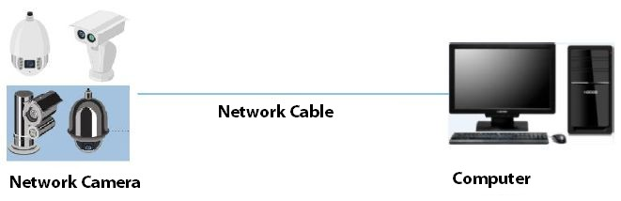
Figure 1-2 Connected through network router or switch
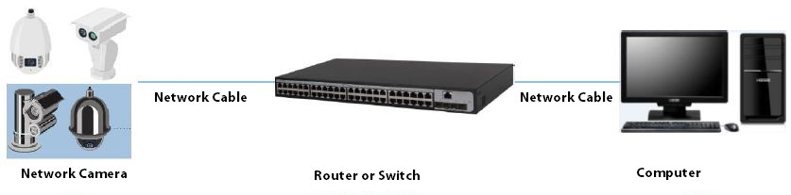

1.2 Functions
Functions might be different depending on the model.

1.2.1 Basic Functions

Real-time Monitoring
- Live view.
- Displays human face, human body, non-motor vehicle, motor-vehicle and other metadata during live view.
- When watching the live view, you can enable audio, and talk to people in the monitoring area to quickly process exceptions.
- Adjust the image to the proper position by PTZ.
- Take a snapshot or three snapshots of the abnormal monitoring image for subsequent viewing and processing.
Record the abnormal monitoring image for subsequent viewing and processing. ● Configure encoding parameters, and adjust live view.

Recording
- Auto recording as scheduled.
- Play back recorded videos and images.
- Download recorded videos and images.
- Record videos when an alarm is triggered.

Account Management
- Add, edit and delete user groups, and manage user authorities by user group. ● Add, edit and delete users, and configure user authorities.
- Change user password.

1.2.2 AI Functions

Alarm
- Set alarm prompt mode and tone by alarm type.
- View alarm messages. Video Detection
- Supports motion detection, video tampering detection, defocus detection and scene changing detection.
- When an alarm is triggered, the system performs linkages such as video recording, alarm output, email sending, PTZ operation and snapshot taking.

Smart Motion Detection
- Supports smart motion detection and the movement range of people, non-motor vehicle and motor vehicle in the image.
- When an alarm is triggered, the system performs linkages such as video recording, alarm output, email sending and snapshot taking.

Audio Detection
- Detects audio input exception and audio intensity change.
- When an alarm is triggered, the system performs linkages such as video recording, alarm output, email sending, PTZ operation and snapshot taking.

IVS
● Supports crossing fence detection, tripwire, intrusion, abandoned object, moving object, fast moving, parking detection, people gathering, loitering detection, and more.
When an alarm is triggered, the system performs linkages such as video recording, alarm output, email sending and snapshot taking.

Face detection
- Supports human face detection and display the related attributes on the Live page.
- When an alarm is triggered, the system performs linkages such as video recording, alarm output, email sending and snapshot taking.

Face Recognition
- Detects human faces, compares them with face images in the database, and links alarm output.
- When an alarm is triggered, the system performs linkages such as video recording, alarm output, email sending and snapshot taking.

People Counting
- Support counting of people number (including the people flow enter/exit the detection area and people stay in the area) and queuing data, and generate report.
- When an alarm is triggered, the system performs linkages such as video recording, alarm output, email sending and snapshot taking.

Video Metadata
- Supports the detection of people, non-motor vehicles, and motor vehicles in the captured video, and displays the related attributes and characteristics on the Live page.
- When an alarm is triggered, the system performs linkages such as alarm output.

Alarm Setting
- Alarms are triggered when an external alarm input device outputs alarms.
- When an alarm is triggered, the system performs linkages such as video recording, alarm output, email sending, PTZ operation and snapshot taking.
AcuPick
Achieve accurate and quick search on the select NVR.

Exception Processing
- Supports SD card error detection, network abnormality detection, illegal access detection, security exception detection, PTZ exception detection and battery detection.
- When SD card error, illegal access and security exception alarm is triggered, the system performs linkages such as alarm output and email delivery.
- When network abnormality alarm is triggered, the system performs linkages such as video recording and alarm output.
- When PTZ abnormality alarm is triggered, the system performs linkages such as alarm output.
When the battery is over-temperature, the system performs linkages such as alarm output, email sending and playing audio.

2 Configuration Flow
Configure the device as needed.
Figure 2-1 Configuration flow
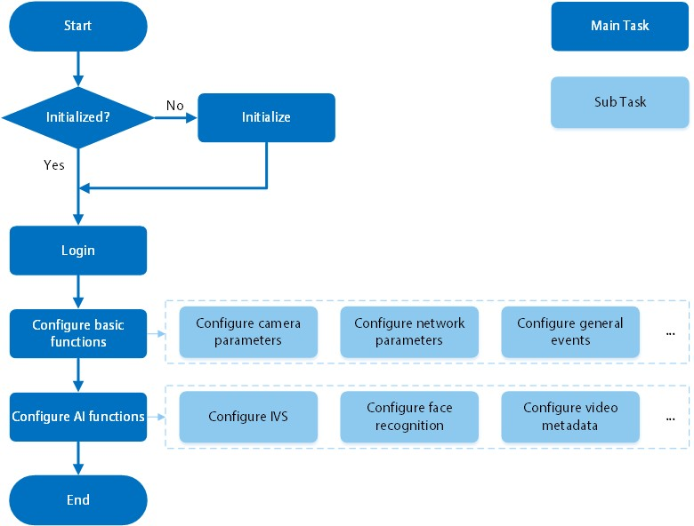
Table 2-1 Flow description
Configuration | Description | Reference
Initialization | Initialize the camera when you use it for the first time. | "3 Device Initialization"
Login | Open the browser and enter the IP address to log in to the webpage. The camera IP address is  192.168.1.108 by default. | "4.1 Device Login"
Configure basic functions | Configure camera parameters, network parameters, general events and more. | "4 Setting"
Configure AI functions | Configure detection rules for AI events. | "9 AI"

3 Device Initialization

Background Information
Device initialization is required for first-time use. This manual is focused on the operation on the webpage. You can also initialize the Camera through ConfigTool, NVR (Network Video Recorder), or platforms such as DSS Pro.
● | To ensure device safety, protect your password after initialization and regularly change it.
● | When initializing the Camera, keep the IP of the computer and IP of the Camera on the same segment.
● | We recommend using Internet Explorer or Google Chrome.

Procedure
Step 1 Open the browser, enter the IP address of the Camera in the address bar, and then press the Enter key.
The IP is 192.168.1.108 by default.
Step 2 Select the area, language, and video standard according to the actual situation, and then click Next.
Figure 3-1 Region setting
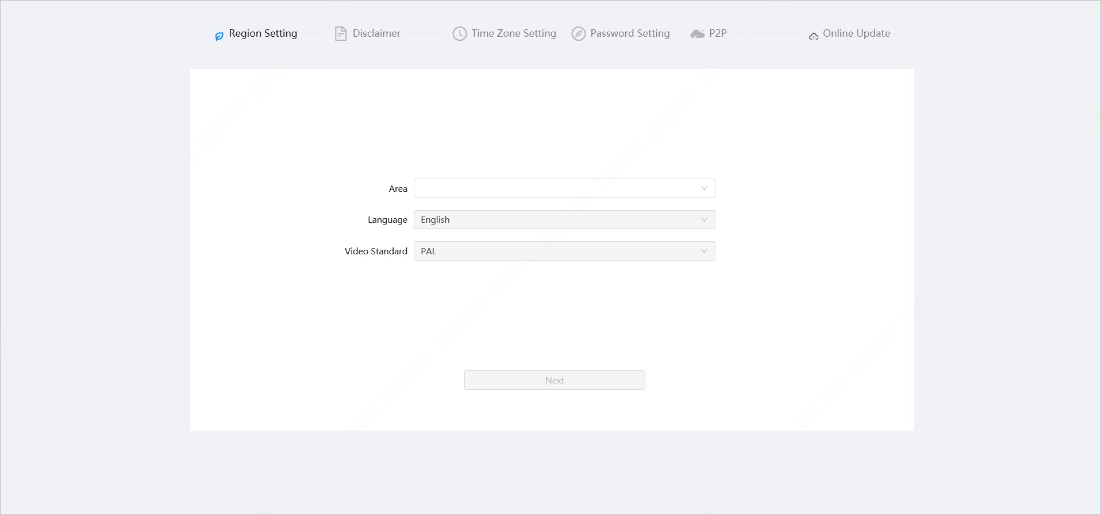
Step 3 Select the I have read and agree to the terms of the Software License Agreement and Privacy Policy check box, and then click Next.
Figure 3-2 Disclaimer
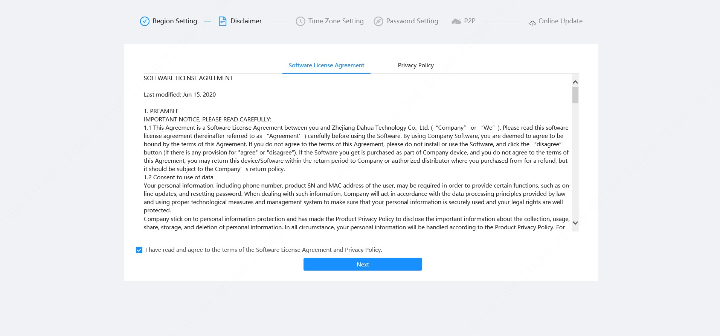
Step 4 Configure the time parameters, and then click Next.
Figure 3-3 Time zone setting
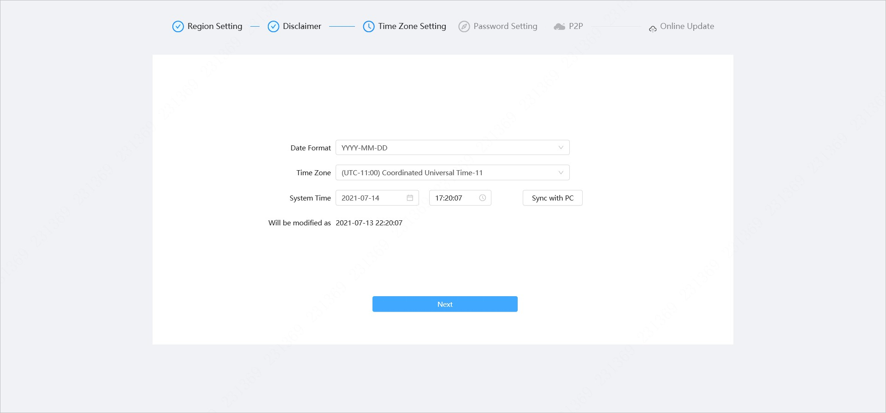
Step 5 Set the password for the admin account.
Figure 3-4 Password setting
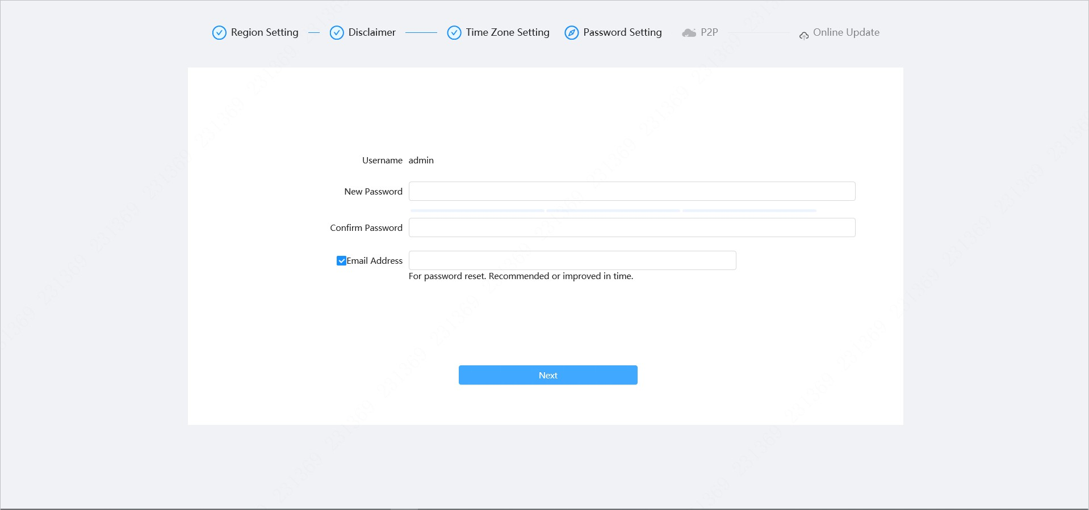
Table 3-1 Description of password configuration
Parameter | Description
Username | The default username is admin.
New Password | The password must consist of 8 to 32 non-blank characters and contain at least two types of characters among upper case, lower
Confirm Password | case, number, and special character (excluding ' " ; : &). Set a high security level password according to the password security notice.
Email Address | Enter an email address for password reset. It is selected by default.  When you need to reset the password of the admin account, a security code for password reset will be sent to the reserved email address.
Step 6 Click Next , and then the P2P page is displayed.
Figure 3-5 P2P
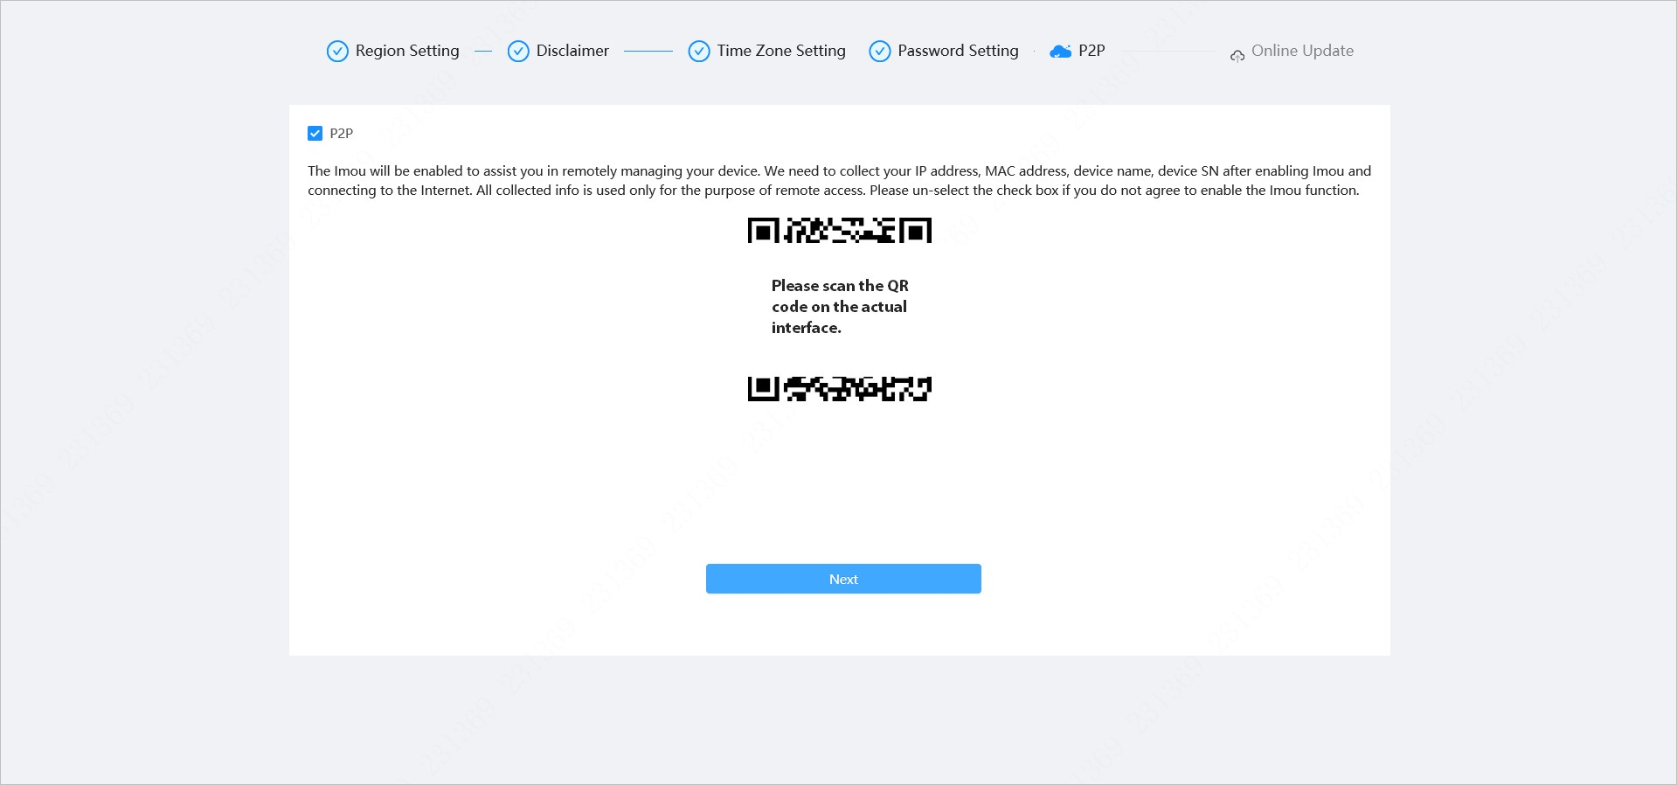
Step 7 Click Next , and then click End to complete the initialization.
Figure 3-6 Online update
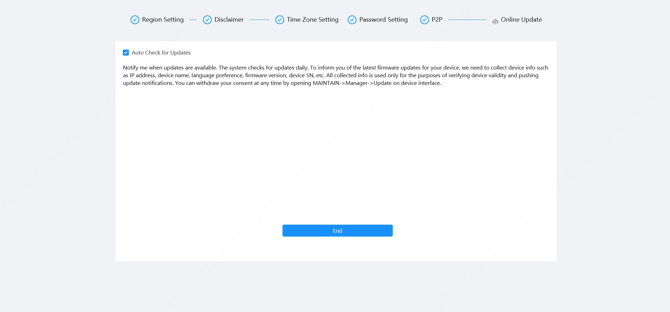

4 Setting
This chapter introduces the basic settings of the Camera, including the configuration of local parameters, camera, network, PTZ, event, storage, system information, log, and more.
You can configure the camera, event and system through two methods. This section uses method 1 as an example.
- Method 1: Click , and then select the corresponding item.
- Method 2: Click the corresponding icon on the main page

4.1 Device Login
Log in to the device webpage through a browser.

Prerequisites
- You need to initialize the Camera before logging in to the webpage. For details, see "3 Device Initialization".
- When logging in to the webpage, keep the IP of the computer and the IP of the Camera on the same network.

Procedure
Step 1 Open the browser, enter the device IP address (192.168.1.108 by default) in the address box, and then press Enter key.
Step 2 Enter the username and password.
The username is admin by default.
Click "Forgot password?" to reset the password through the email address that is set during the initialization. For details, see "4.8.3.2 Resetting Password".
Figure 4-1 Login
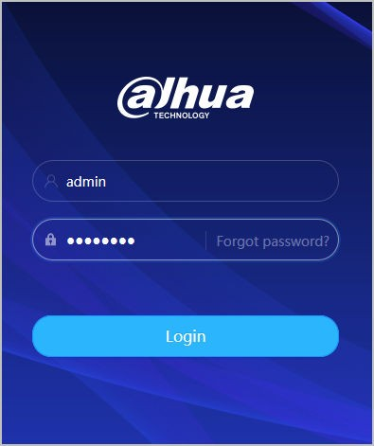
Step 3 Click Login.
The Live page is displayed. For details, see "6.1 Live Page".
Click on the left-upper corner of the page to display the main page.
Figure 4-2 Main page
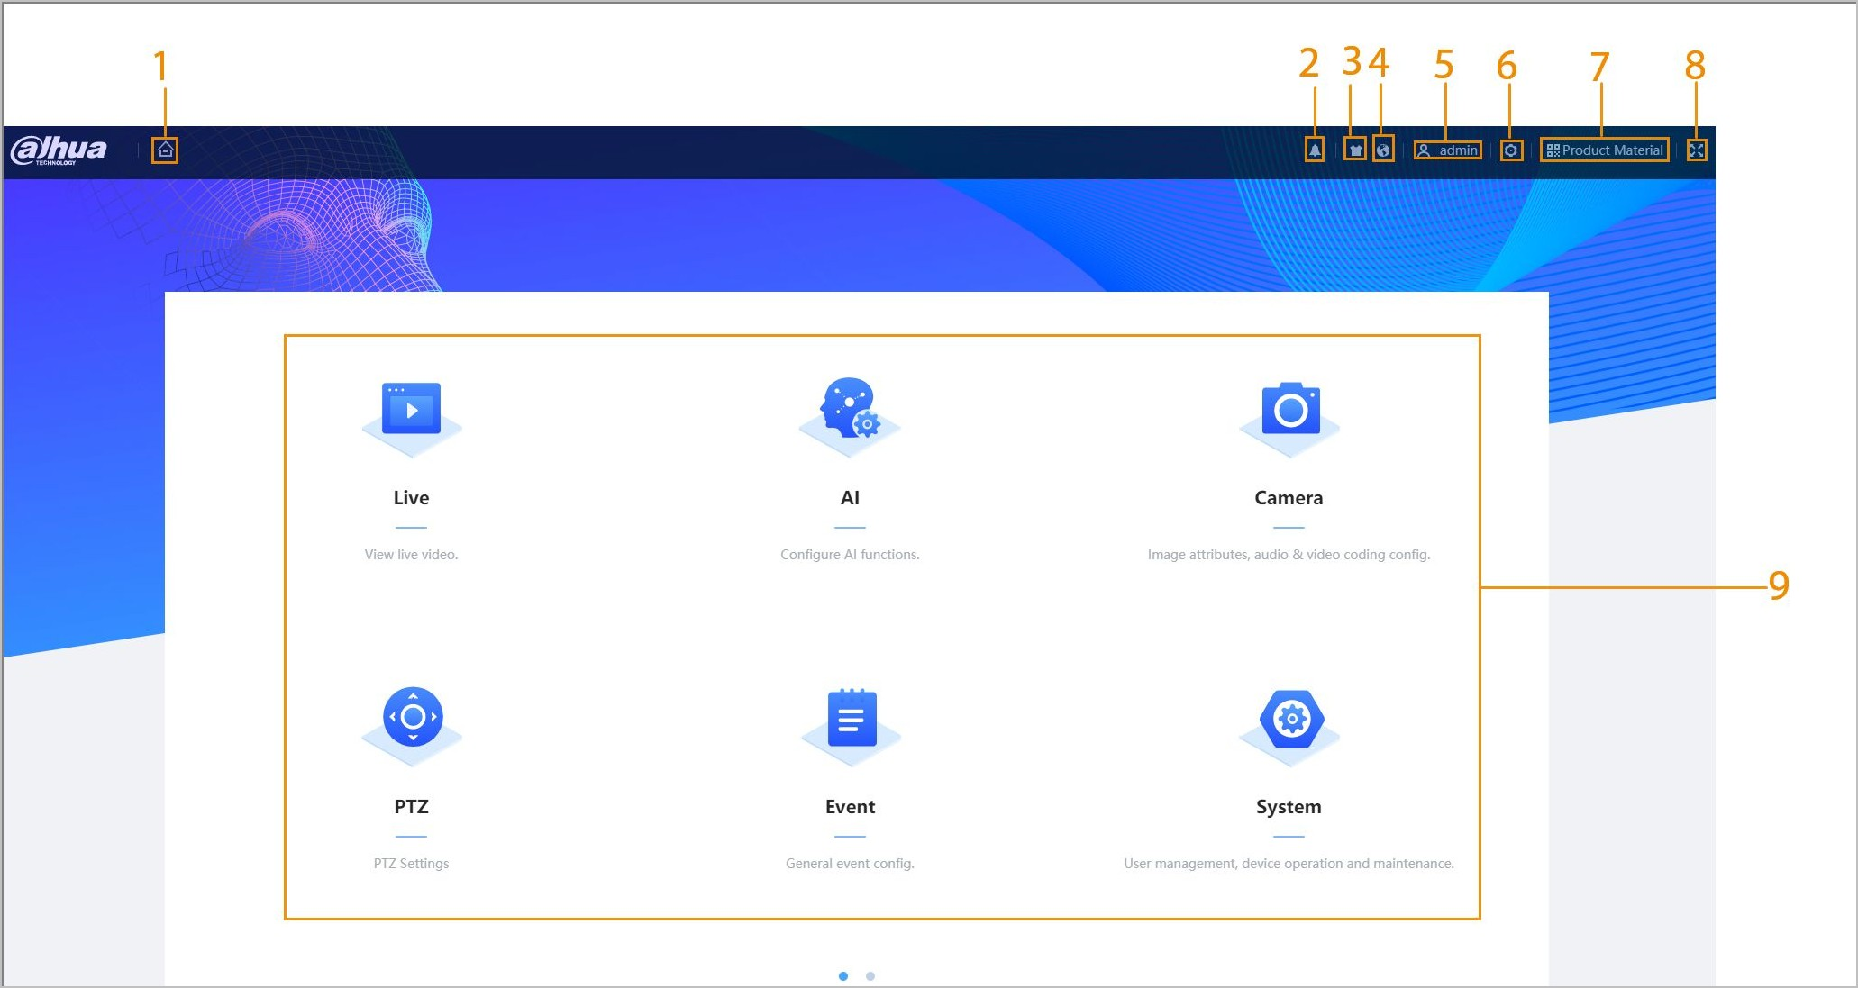
For the first-time login, you need to install the plug-in. Follow the on-screen instructions to complete download and installation.
Table 4-1 Description of main page
No. | Button | Description
1 |  | Display the main page.
2 |  | Subscribe to alarm. For details, see "4.6.1.4.2 Subscribing to Alarm Information".
3 |  | Set the skin.
4 |  | Set the language.
5 |  | - Click and select Restart, and the camera restarts.  - Click and select Logout to go back to the login page.
6 |  | Configure the basic parameters. For details, see "4 Setting".
7 |  | Scan the QR code to obtain the product material.
8 |  | - Click the icon to enter full screen mode.  - Click to exit full screen mode.
9 | Main Page | The main page includes the following modules. Click on the bottom of the page to switch between multiple interfaces.  - Live: View the real-time monitoring image.  - AI: Configure AI functions of the camera.  - Camera: Configure camera parameters, including image parameters, encoder parameters, and audio parameters.  - PTZ: Configuring PTZ functions.  - Event: Configure alarm linkage parameters of general events.  - System: Configure basic system parameters, manage users and peripherals, maintain and upgrade the system.  - Security: Check the device security status and set security functions.  - Record: Configure record functions, play back or download recorded videos.  - Picture: Configure picture functions, play back or download image files.

4.2 Local
You can select protocol and configure the storage path for live snapshot, live record, playback snapshot, playback download, and video clips.

Procedure
Step 1 Select > Local.
Figure 4-3 Local
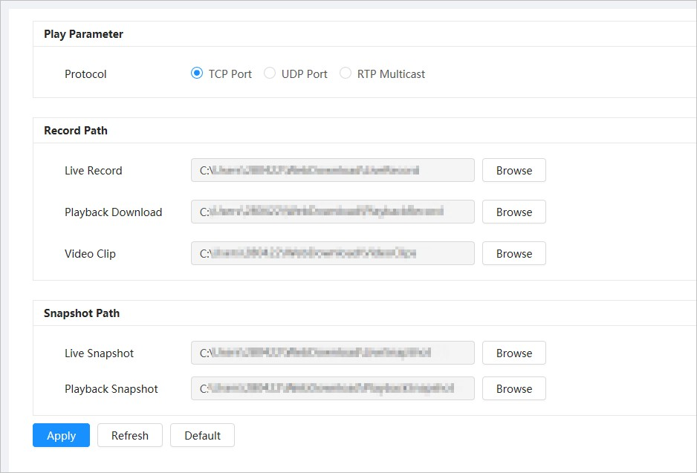
Step 2 Configure play parameters.
Protocol: Network transport protocol type, supporting TCP (Transmission Control Protocol) port, UDP (User Datagram Protocol) port and multicast.
Before selecting Multicast, you need to configure multicast parameters in advance. For details, see "4.4.9 Multicast".
Step 3 Click Browse to select the storage path for live snapshot, live record, playback snapshot, playback download, and video clips.
Table 4-2 Description of local parameter
Parameter | Description
Protocol | You can select the network transmission protocol from TCP , UDP and Multicast.
 |  | Before selecting Multicast , make sure that you have set the Multicast parameters.
Live Record | The recorded video of Live page.  The default path is C:\Users\admin\WebDownload \LiveRecord.
 |  |  |  | "admin" in the path refers to the account being used.
Playback Download | The downloaded video of Playback page.  The default path is C:\Users\admin\WebDownload \PlaybackRecord.
Parameter | Description
Video Clips | The clipped video of Playback page.  C:\Users\admin\WebDownload\VideoClips.
Live Snapshot | The snapshot of Live page.  The default path is C:\Users\admin\WebDownload \LiveSnapshot.
Playback Snapshot | The snapshot of Playback page.  The default path is C:\Users\admin\WebDownload  \PlaybackSnapshot.

Step 4 Click Apply. Related Operations
- Click Refresh to refresh the parameters of the current page.
- Click Default to restore the default parameter values.

4.3 Camera
This section introduces camera configuration, including configuring image parameters, encoder parameters, and audio parameters.
Camera parameters might differ depending on the device.

4.3.1 Setting Image Parameters
Configure image parameters according to the actual situation, including image, exposure, backlight, white balance, Day/Night, and more.

4.3.1.1 Page Layout
Configure camera parameters to improve the image clarity, and ensure that surveillance goes well.
Camera supports two working modes: Self-adaptive and Customized scene. You can select 9 configuration file types, including day, night, general and front light, to set and view the configuration parameters and effects under the corresponding type, including image, exposure and backlight.
Figure 4-4 Camera conditions (common camera)
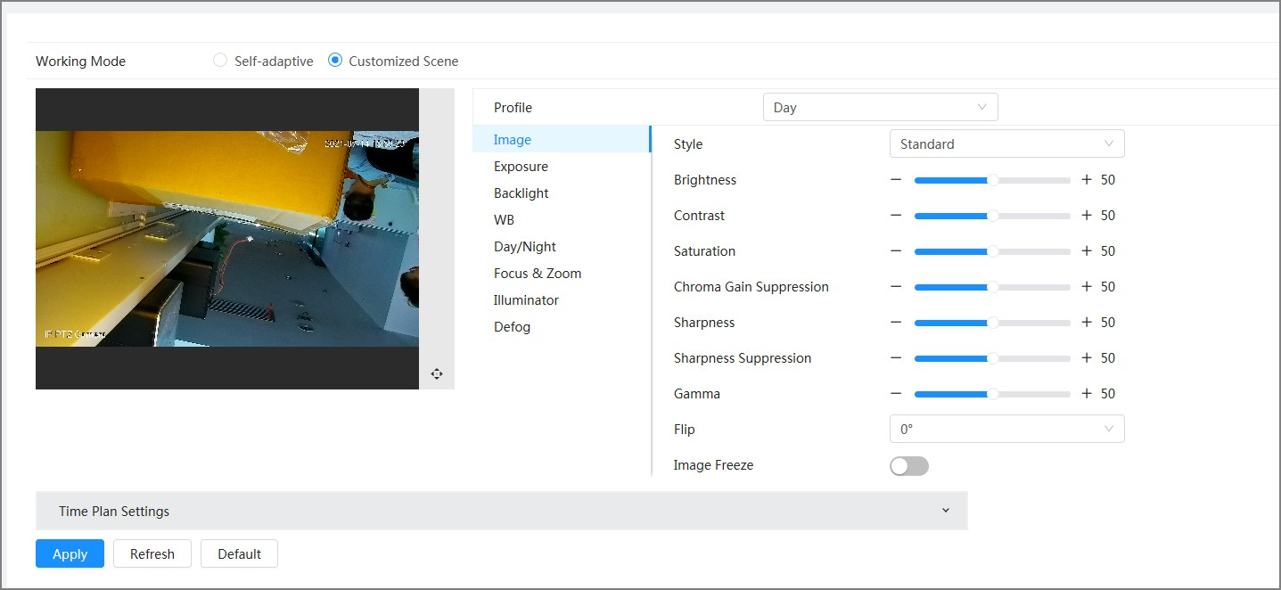
4.3.1.2 Configuring Operating Mode
Select working mode as needed, including self-adaptive and customized scene.

Procedure
Step 1 Click on the upper-right corner of the page, and then select Camera > Image.
Step 2 Select the camera that needs to be configured from the "Channel" drop-down list and then select working mode on the top of the page.
- Self-adaptive: Camera automatically matches the appropriate configuration file type according to different environments.
If you select Self-adaptive, go straight to Step 5 .
- Customized scene: Camera monitors according to the settings of the profile type at different times.
If you select Customized scene, go straight to Step 3 . Step 3 Select configuration file type.
You can select 9 configuration file types, including general , day, night, front light and backlight to set and view the configuration parameters and effects under the corresponding type, including image, exposure and backlight. Step 4 Set time plans.
You can set daily schedule by month.
Figure 4-5 Time plan settings
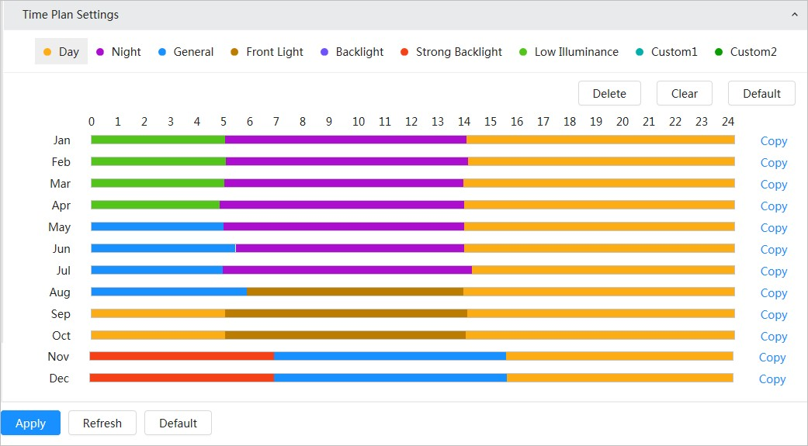
1
.Click
Time Plan Settings
or
to open time plan.
- Click to configure file type, for example general , left-drag on the timeline to set the time period using general type.
In the same way, you can set up separate time periods when applying other file types, including Day , Night and Front Light.
Time period is set as Day and Night by default. Click Delete or Clear before you start setting time period.
- (Optional) Click Copy ; select a month, then click Apply.
Time plan for the current month can be quickly copied to other months.
Step 5 Click Apply.
4.3.1.3 Adjusting Image
You can configure image parameters. The actual parameters of the camera can be adjusted here.

Procedure
Step 1 Click on the upper-right corner of the page, and then select Camera > Image > Image.
Step 2 Select the camera that needs to be configured from the "Channel" drop-down list and then configure parameters.
Figure 4-6 Image
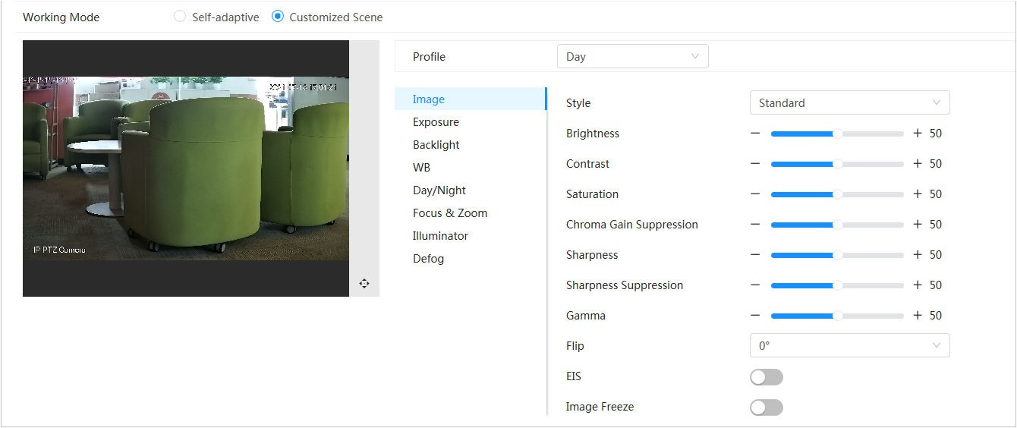
Table 4-3 Description of image parameters
Parameter | Description
Style | Select the image style from soft, standard and vivid.  - Standard: Default image style, which displays the actual color of the image.  - Soft: The hue of the image is weaker than the actual one, and contrast is smaller.  - Vivid: The image is more vivid than the actual one.
Brightness | Change the overall brightness of the image. The higher the value, the brighter the image. The image might be hazy if the value is configured too high.
Contrast | Change the contrast of the image. The higher the value, the greater the contrast between bright and dark areas. If the value is too big, the dark area will be too dark and the bright area will more vulnerable to overexposure.  The image might be hazy if the value is set too small.
Saturation | Set the intensity of colors. The higher the value, the deeper the color. Saturation value does not change image brightness.
Chroma Gain Suppression | Reduce the image color and prevents it from being too strong. The higher the value, the stronger the effect.
 |  | This parameter takes effect only when the Camera is in an environment with low luminance.
Sharpness |  | Change the sharpness of image edges. The higher the value, the clearer the image edges. If the value is too high, image noise is more likely to appear.
Sharpness Suppression |  | Change the sharpness NCT level of the Camera. The higher the value, the stronger the sharpness CNT.
 |  | This parameter takes effect only when the Camera is in an environment with low luminance.
Gamma | Change the image brightness and contrast in a non-linear way. The higher the value, the brighter the image.
Parameter | Description
Flip | Change the display direction of the image.  - Normal: The normal display of the image.  - Reflection: The image flips up and down.
OIS | Optical Image Stabilization (OIS) is used to effectively solve the problem of image shaking during use through ISP algorithm and optical technology, thus presenting clearer images. It is "On" by default.  - This function is available on select models.  - Optical image stabilization and electronic image stabilization cannot be enabled at the same time.
EIS | Electronic image stabilization (EIS) is used to effectively solve the problem of image shaking during use, thus presenting clearer images. It is "Off" by default.  - This parameter takes effect only when the Device is in an environment with low luminance.  - This function is available on select models.  - Optical image stabilization and electronic image stabilization cannot be enabled at the same time.
Image Freeze | After this function is enabled, the image at the called preset is displayed directly if you call a preset or tour, and no images during the rotation of the camera are displayed.

Step 3 Click Apply. 4.3.1.4 Exposure

Background Information
Configure iris and shutter to improve image clarity.
Cameras with WDR do not support long exposure when WDR is enabled in Backlight.

Procedure
Step 1 Click on the upper-right corner of the page, and then select Camera > Image > Exposure.
Step 2 Select the camera that needs to be configured from the Channel drop-down list and then configure parameters.
Figure 4-7 Exposure
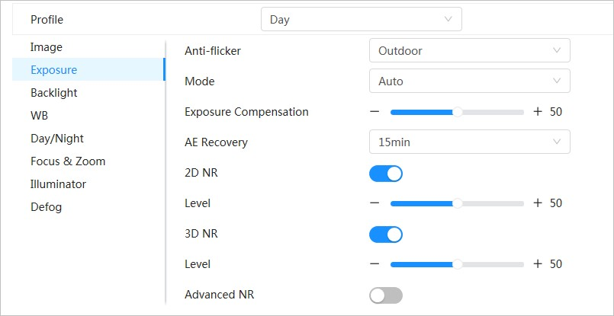
Table 4-4 Description of exposure parameters
Parameter | Description
Anti-flicker | You can select 50Hz , 60Hz, or Outdoor from the list.  - 50Hz : The system adjusts the exposure according to ambient light automatically to ensure that stripes do not appear.  - 60Hz : The system adjusts the exposure according to ambient light automatically to ensure that stripes do not appear.  - Outdoor : If you select Outdoor, the exposure mode can be set to Gain Priority, Shutter Priority and Iris Priority. Different devices support different exposure modes.
Mode | Set the exposure modes. You can select Auto , Manual, Iris Priority, Shutter Priority and Gain Priority. The Auto mode is selected by default.  - Auto : Exposure is automatically adjusted according to scene brightness if the overall brightness of images is in the normal exposure range.  - Manual : You can adjust the Gain, Shutter, and Iris value manually.  - Iris Priority : You can set the iris to a fixed value, and the Camera will adjust the shutter value. If the image brightness is not high enough and the shutter value has reached its upper or lower limit, the system adjusts gain value automatically to ensure the image is at an ideal brightness.  - Shutter Priority : You can customize the shutter range. The Camera automatically adjusts the aperture and gain according to the scene brightness.  - Gain Priority : Gain value and exposure compensation value can be adjusted manually.
Gain | If you select Gain Priority or Manual, you can set gain range to automatically increase the gain of the Camera when the illumination is low, thus obtaining a clear image.
Shutter | Set the effective exposure time. The smaller the value, the shorter the exposure time.
Parameter | Description
Shutter range | If you select Shutter Priority or Manual, and select Shutter as Custom, you can set the shutter range in ms unit.
Iris | You can set the camera luminous flux. The larger the Iris value, the brighter the image.
Exposure  Compensation | You can set the exposure compensation value. The value ranges from 0 to 100. The higher the value is, the brighter the image will be.
Exposure adjustment speed | You can set the exposure adjustment speed. The value ranges from 0 to 100.
Upper gain threshold | You can set the upper gain threshold of exposure. The value ranges from 0 to 100.
Low-speed shutter | In a low luminance environment, snapping images by expending the automatic exposure time effectively reduces image noise, but images of moving objects may be blurred.
Lower  threshold of low-speed shutter | You can set the lower threshold of the low-speed shutter for the Camera. The lower the value, the faster the shutter.
AE Recovery | Automatic exposure is an automated digital camera system that adjusts the aperture and/or shutter speed, based on the external lighting conditions for images and videos. If you have selected an "AE Recovery" time, the exposure mode will be restored to the previous mode after you adjust the Iris value. There are five options: Off, 5 min, 15 min, 1 hour, and 2 hour.
2D NR | Average the pixel of a single frame image with other pixels to reduce image noise. The higher the level is, the lower the noise will be, and images appear to be blurrier.
3D NR | Reduce the noise of multiple-frame (at least two frames) images by using interframe information between two adjacent frames in a video. The higher the level is, the lower the noise will be, and the larger the trailing smear will be.
Level | Noise reduction grade. The value ranges from 0 to 100. The larger the value is, the less the noise will be.
Advanced NR | You can suppress noise in the time-domain and space-domain based on the video filter method.
 |  | Some models do not support advanced noise reduction, time domain grade, or space domain grade.
Time domain grade | You can set the time domain grade. The value ranges from 0 to 100.
Space domain grade | You can set the space domain grade. The value ranges from 0 to 100.
Step 3 Click Apply.
4.3.1.5 Backlight
You can select backlight mode from BLC, WDR and HLS.

Procedure
Step 1 Click on the upper-right corner of the page, and then select Camera > Image > Backlight.
Step 2 Select the camera that needs to be configured from the "Channel" drop-down list and then select a backlight mode from the list.
Figure 4-8 Backlight mode
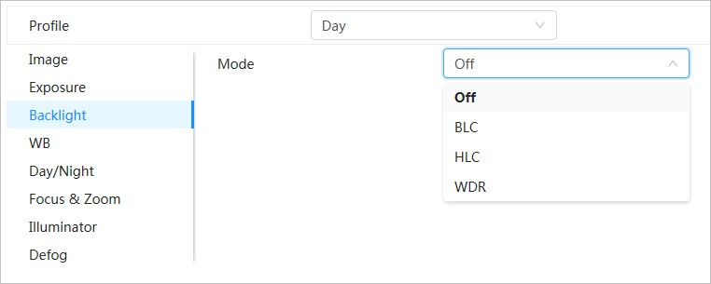
Table 4-5 Description of backlight parameters
Parameter | Description
BLC | Enable BLC, the Camera can get a clearer image of the dark areas on the target when shooting against light. You can select default mode or customized mode.  - When in default mode, the system automatically adjusts exposure according to ambient lighting conditions to ensure the clarity of the darkest area.  - When in customized mode, the system auto adjusts exposure only to the set area according to ambient lighting conditions to ensure the image of the set area is at its ideal brightness.
WDR | The system dims bright areas and compensates for dark areas to ensure the clarity of all areas. The higher the value is, the stronger the darkness will be, but the more intense the noise will be.
 |  | There might be a few seconds of video loss when the device is switching to WDR mode from other modes.
HLC | Enable HLC when extremely strong light is in the environment (such as a toll station or parking lot). The Camera dims strong lights, and reduce the size of Halo zone to lower the brightness of the whole image, so that the Camera can capture human faces or car plate details clearly. The larger the value is, the more obvious the HLS effect will be.
Step 3 Click Apply.

4.3.1.6 White Balance
The white balance function can correct the color deviation to ensure color precision. When in WB mode, white objects are displayed in a white color depending on the environment.

Procedure
Step 1 Click on the upper-right corner of the page, and then select Camera > Image > WB. Step 2 Select the camera that needs to be configured from the "Channel" drop-down list and then configure White Balance Mode.
Figure 4-9 White balance
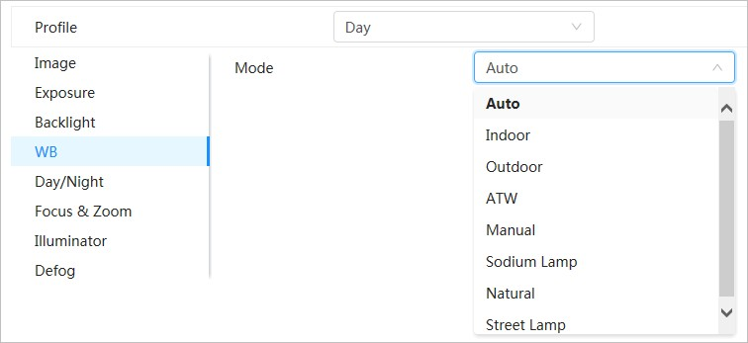
Table 4-6 Description of white balance parameters
Parameter | Description
Auto | The system compensates WB according to color temperature to ensure color precision.
Indoor | The system compensates WB for the general situation of indoor lighting to ensure color precision.
Outdoor | The system auto compensates WB to most outdoor environments with natural or artificial light to ensure color precision.
ATW | When the device is tracked, the system auto compensates WB to ensure color precision.
Manual | Configure red gain and blue gain manually. The system auto compensates WB according to color temperature.
Sodium Lamp | The system compensates WB to sodium lamp to ensure color precision.
Natural Light | The system auto compensates WB to environments without artificial light to ensure color precision.
Street Lamp | The system compensates WB to ensure color precision in outdoor scenes at night.
Step 3 Click Apply.

4.3.1.7 Day/Night
Configure the display mode of the image. The system switches between color and black-and-white mode according to the actual condition.

Procedure
Step 1 Click on the upper-right corner of the page, and then select Camera > Image > Day/ Night.
Step 2 Select the camera that needs to be configured from the Channel drop-down list and then configure parameters.
Figure 4-10 Day/Night mode
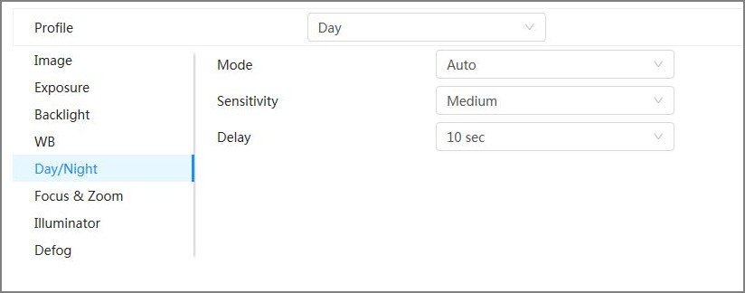
Table 4-7 Description of Day/Night mode parameters
Parameter | Description
Mode | You can select device display mode from Color , Auto, and B/W.
 |  | Day/Night configuration is independent from Profile management configuration.
- Color : The system displays the image in color.
- Auto : The system switches between color and black-and-white according to actual conditions.
- B/W : The system displays black-and-white image.
Sensitivity | This configuration is available only when you set Auto in Mode.  You can configure camera sensitivity when switching between color and blackand-white mode. The higher the sensitivity, the easier it is for the switch to be triggered.
Delay | This configuration is available only when you set Auto in Mode.  You can configure the delay when the Camera switches between color and blackand-white mode. The lower the value is, the faster the Camera switches between color and black-and-white mode.
Step 3 Click Apply.

4.3.1.8 Focus & Zoom
Focus & Zoom (digital zoom) refers to capturing a part of the image to magnify it. The higher the magnification is, the blurrier the images will become.

Procedure
Step 1 Click on the upper-right corner of the page, and then select Camera > Image > Focus & Zoom.
Step 2 Select the camera that needs to be configured from the Channel drop-down list and then configure focus & zoom parameters.
Figure 4-11 Focus & Zoom
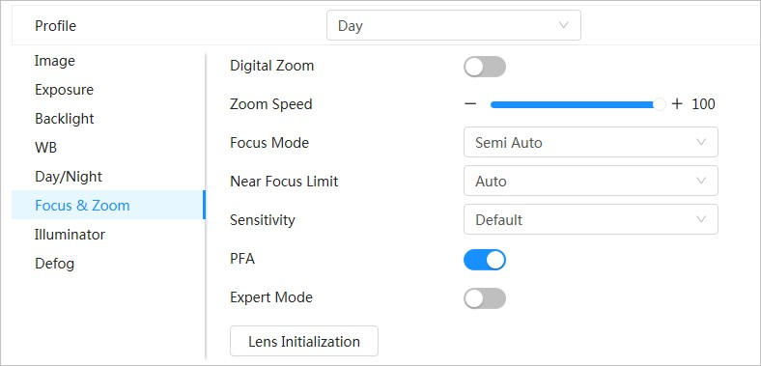
Table 4-8 Description of focus & zoom parameters
Parameter | Description
Digital Zoom | Click to enable the digital zoom function. You can use the digital zoom to continue zooming operation even if the optical zoom is at its maximum value.
Zoom Speed | Adjust the zoom speed of the Camera. The larger the value, the faster the zoom speed.
Focus Mode | Set focus mode.  - Auto : Once there is any movement or change of an object on the video image and the image turns blurry, the Camera will focus again automatically.  - Semi-Auto : The Camera will focus automatically when you click Focus or Zoom or when a preset change or PTZ switch is detected.  - Manual : The Camera cannot focus automatically. You need to adjust the focus manually.
Near Focus Limit | Set the near focus limit of the Camera. If the focus limit is too small, the Camera might get the camera focus on its dome. By changing the focus limit, the focus speed can be changed.
Sensitivity | Trigger the focusing sensitivity of the Camera. The higher the sensitivity, the easier to trigger focus.
Parameter | Description
PFA | Enable PFA. When moving the image, the Camera automatically focuses for a clear image.
Expert Mode | Enable Expert mode. Train the Camera to rotate and focus on the specified route.
Lens Initialization | Click this button, and the lens will be initialized automatically. The lens will be extended to calibrate the zoom and focus.
Step 3 (Optional) Configure expert mode.
1. Enable Expert mode , click Add to add a new scene. Figure 4-12 Expert mode
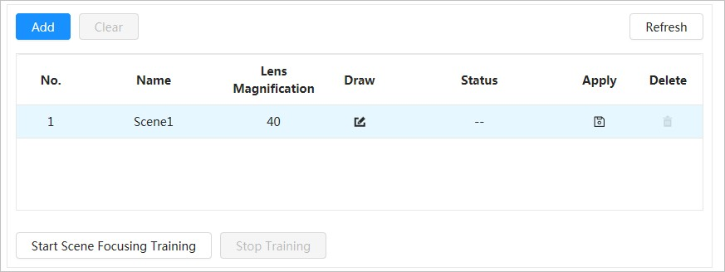
2
.Click
to adjust the video screen and draw the training region on the screen.
Only supports closed model area (triangle and polygons above).
- Double-click Lens Magnification to set focus magnification.
- Click Apply to save settings.
- Click Start Scene Focusing Training.
The scene rotates and automatically focuses to the specified position. After the training is complete, the scene status is displayed as Complete.
Step 4 Click Apply.

4.3.1.9 Illuminator
This configuration is available only when the device is equipped with illuminator. Common illuminators are classified into IR lights, white light, laser lights, and full-spectrum lights.

Procedure
Step 1 Click on the upper-right corner of the page, and then select Camera > Image > Illuminator.
Different device models support different types of illuminators. This manual is for reference only, and might differ from the actual page.
Step 2 Select the camera that needs to be configured from the "Channel" drop-down list, and then configure illuminator mode.
Figure 4-13 Illuminator (1)
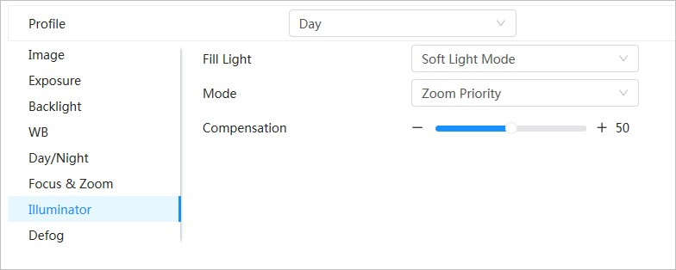
Figure 4-14 Illuminator (2)
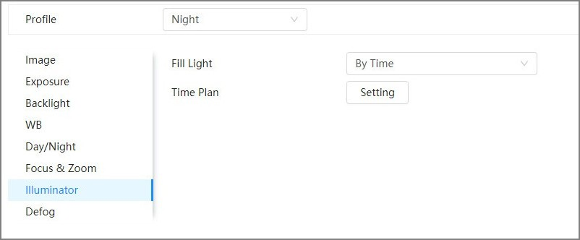
Figure 4-15 Time plan settings
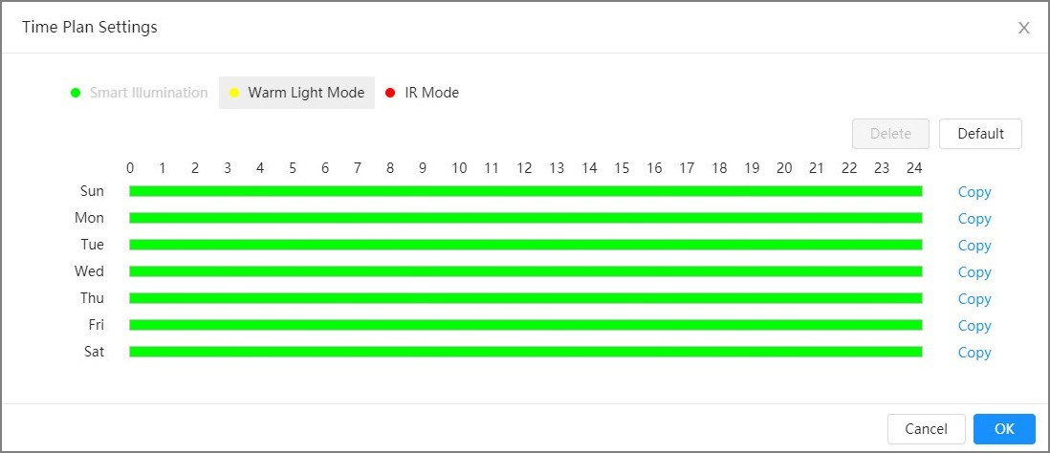
Table 4-9 Description of illuminator parameters
Parameter |  | Description
Fill Light |  | When the Camera is equipped with illuminator, it supports setting illumination mode for illuminator, including IR Mode , White Light Mode, Soft Light Mode, Smart Illumination, and By Time.  - IR Mode : Enable the IR illuminator, and the white light is disabled. You can only capture black and white images after enabling this function.  - White Light Mode : Enable the white light, and the IR illuminator is disabled. You can capture clear scene image after enabling this function.  - Warm Light Mode : Enable the warm light, and the IR illuminator is disabled. You can capture clear scene image after enabling this function.  - Soft Light Mode : Enable both IR illuminator and white light at the same time, and adjust the brightness of 2 illuminators to get clear images.  - Smart Illumination : This function is mainly used at night. Smart illumination applies IR mode in most situations. When an event occurs (perimeter, motion detection and human detection), the camera automatically switches to white light mode to link image capturing and video recording under the full color mode. The white light turns off when the event stops, and then the mode switches to IR mode according to the ambient brightness.  The status of the illuminator mainly depends on time and environment. If the smart illumination is triggered at night and the event continues during the day, the illuminator configured for the daytime will be turned off.  - By Time : Set the illumination solution according to the time period and use different solutions at different time periods.
Mode | Manual | Adjust the brightness of illuminator manually, and then the system will illuminate the image accordingly.
 | Auto | The system adjusts the illuminator intensity according to the ambient lighting condition. Some devices support setting the brightness upper limit and sensitivity of the illuminator.  - Sensitivity: The higher the sensitivity setting, the higher the brightness can turn on the illuminator when the actual scene darkens. When the actual scene becomes bright, a higher brightness is required to turn off the illuminator.  - Brightness upper limit: If the illuminator is too bright, the center of the image may be overexposed. We recommend adjusting the brightness upper limit according to the actual scene. The value range is 0–100, and the default is 100.
Parameter |  | Description
 | SmartIR | The system adjusts the illumination intensity according to the ambient lighting condition.
 |  |  | Only IR illuminator supports the smart IR mode.
 | Zoom Priority |  | The system adjusts the illuminator intensity automatically according to the change of the ambient light. You can configure light Compensation manually to fine-tune the brightness of the illuminator.  - When the ambient light turns darker, the system turns on the low beam lights first, if the brightness is still not enough, it turns on the high beam lights.  - When the ambient light turns brighter, the system dims high beam lights until they are off, and then the low beam lights.  - When the focus reaches certain wide angle, the system will not turn on high beam light in order to avoid over-exposure in short distance.
 |  |  | Some devices support setting the sensitivity of the illuminator.
 | Off |  | Illuminator is off.
Illuminator Delay |  |  | The duration of the illuminator.
 |  |  | When selecting Smart Illumination in the drop-down list next to Fill Light, you need to set Illuminator Delay.
Time Plan |  |  | When selecting By Time in the drop-down list next to Fill Light, you need to set Time Plan. The Camera uses different illumination solutions at different time periods based on the time.  - Click Setting next to Time Plan.  - Select an illumination solution, and then drag on the timeline toselect the time period of the illumination solution.  Different colors represent different illumination solutions on the timeline, as shown in Figure 4-15 .
- Click the selected time period, and then set an accurate start and end time.
- Click Copy , select weeks, and then click Apply.
Time plans for the current week can be quickly copied to other weeks.
Step 3 Click Apply.

4.3.1.10 Defog
The image quality is compromised in foggy or hazy environment, and defog can be used to improve image clarity.

Procedure
Step 1 Select > Camera > Image > Defog.
Figure 4-16 Defog
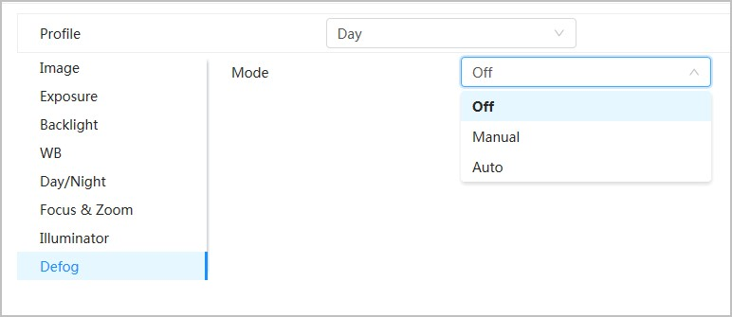
Step 2 Configure defog parameters.
Table 4-10 Description of defog parameters
Defog | Description
Manual | Configure function intensity and atmospheric light mode manually, and then the system adjusts image clarity accordingly. Atmospheric light mode can be adjusted automatically or manually.
Auto | The system adjusts image clarity according to the actual condition.
Off | Defog function is disabled.
Step 3 Click Apply.

4.3.2 Setting Encode Parameters
This section introduces video parameters, such as video, snapshot, overlay, ROI (region of interest) and path.
Click Default , and the device is restored to default configuration. Click Refresh to view the latest configuration.

4.3.2.1 Encode
Configure video stream parameters, such as compression, resolution, frame rate, bit rate type, bit rate, I frame interval, SVC (Scalable Video Coding) and watermark.

Procedure
Step 1 Select > Camera > Encode > Encode.
Figure 4-17 Encode
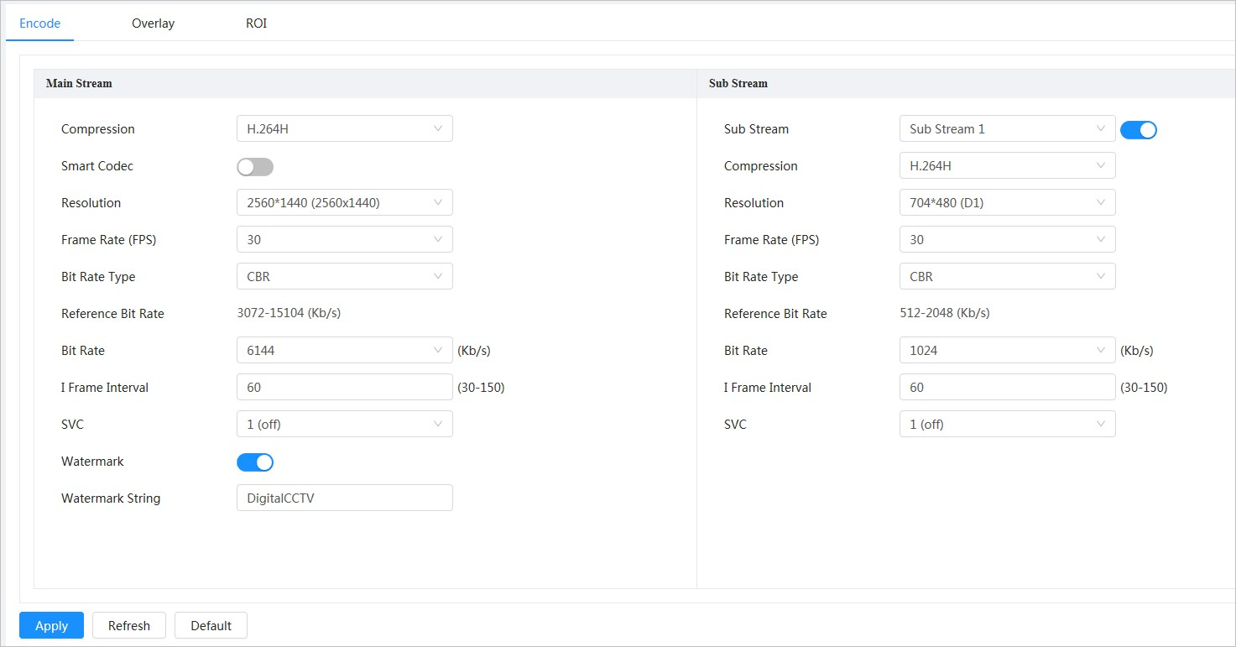
Step 2 Configure encode parameters.
Table 4-11 Description of encode parameters
Parameter | Description
Sub Stream | Click to enable sub stream, it is enabled by default.
 |  | You can enable multiple sub streams simultaneously.
Compression |  | Select encode mode.  - H.264 : It includes H.264B (baseline profile encode mode), H.264 (main profile encode mode) and H.264H (high profile encode mode).  Under the same image quality, the bandwidth of the three decreases in turn.  - H.265 : Main profile encode mode. Compared with H.264, it requires smaller bandwidth.  - MJPEG : Under this mode, the image requires high bit rate to ensure clarity, you are recommended to set the Bit Rate to the biggest value in the Reference Bit Rate.
Smart Codec |  | Click to enable smart codec to improve video compressibility and save storage space.
 |  | After smart codec is enabled, the device would stop supporting the third bit stream, ROI, and smart event detection.
Parameter | Description
Resolution | The resolution of the video. The higher the value is, the clearer the image will be, but the bigger the required bandwidth will be.
Frame Rate (FPS) | The number of frame in one second of video. The higher the value is, the clearer and smoother the video will be.
Bit Rate Type | The bit rate control type during video data transmission. You can select bit rate type from:  - CBR (Constant Bit Rate): The bit rate changes a little and keeps close to the defined bit rate value.  - VBR (Variable Bit Rate): The bit rate changes as monitoring scene changes.
 |  | The Bit Rate Type can only be set as CBR when Encode Mode is set as MJPEG.
Quality | This parameter can be configured only when the Bit Rate Type is set as VBR.  The better the quality is, but the bigger the required bandwidth will be.
Reference Bit Rate | The most suitable bit rate value range recommended to user according to the defined resolution and frame rate.
Max Bit Rate | This parameter can be configured only when the Bit Rate Type is set as VBR.  You can select the value of the Max Bit Rate according to the Reference Bit Rate value. The bit rate then changes as monitoring scene changes, but the max bit rate keeps close to the defined value.
Bit Rate | This parameter can be configured only when the Bit Rate Type is set as CBR.  Select bit rate value in the list according to actual condition.
I Frame Interval | The number of P frames between two I frames, and the I Frame Interval range changes as FPS changes.  It is recommended to set I Frame Interval twice as big as FPS.
SVC | Scaled video coding, is able to encode a high quality video bit stream that contains one or more subset bit streams. When sending stream, to improve fluency, the system will quit some data of related lays according to the network status.  - 1: The default value, which means that there is no layered coding.  - 2, 3 and 4: The lay number that the video stream is packed.
Watermark | You can verify the watermark to check if the video has been tampered.  - Click to enable watermark function.  - Enter watermark string. The string is DigitalCCTV by default.
Watermark String
Step 3 Click Apply.

4.3.2.2 Overlay
Configure overlay information, and it will be displayed on the Live page.
4.3.2.2.1 Privacy Masking
You can enable this function when you need to protect the privacy of some area on the video image.

Procedure
Step 1 Select > Camera > Encode > Privacy Masking. Step 2 Select Enable.
Step 3 Click Add , select Color Block or Mosaic, and then draw the blocks on the screen.
● | You can draw 8 blocks at most. The same screen can add up to 4 mosaic blocks.
● | Click Clear to delete all blocks. Select the block you want to delete, click to delete the corresponding block.
Figure 4-18 Privacy masking
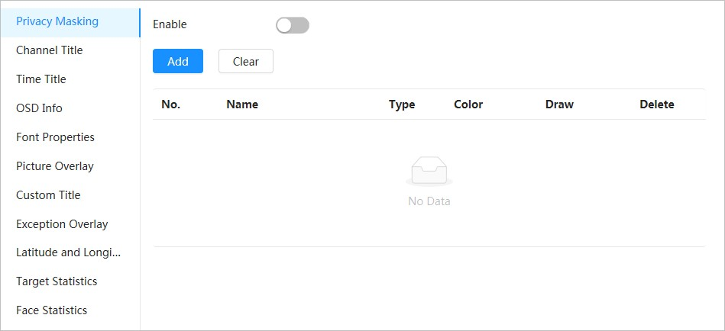
Step 4 Adjust block size to protect the privacy.
Step 5 Click Apply.
4.3.2.2.2 Channel Title You can enable this function when you need to display channel title in the video image.

Procedure
Step 1 Select > Camera > Encode > Overlay > Channel Title. Step 2 Select Enable.
Step 3 Configure channel title, and then select the text alignment.
Click + to add the channel title, and you can add 1 line at most.

