Computer Science II Lab 20A – SORT TIMER Lab Value - 100

Lab Goal : This lab was designed for you to learn how each sort works, how fast each sort works, and why each sort works.

Lab Description : Generate a list of numbers, sort each list with a different sort, and then output the time it took that sort to sort the list of numbers.

Sample Output :
writing #s to file

loading #s from file

linear Search - O(N)
Seconds taken to find 1: 0.0

loading #s from file

The times you see here are a general idea. Your times will vary depending on the type of PC your run the program on.
Quick Sort - N*LogN
Seconds taken to sort list: 0.031
Binary Search
Seconds taken to find 1: 0.0

loading #s from file

Merge Sort - N*LogN
Seconds taken to sort List: 0.031

loading #s from file

Quick Sort - N*LogN
Seconds taken to sort List: 0.016
BONUS OPTION : Output the sort times as a graphical bar chart.

loading #s from file

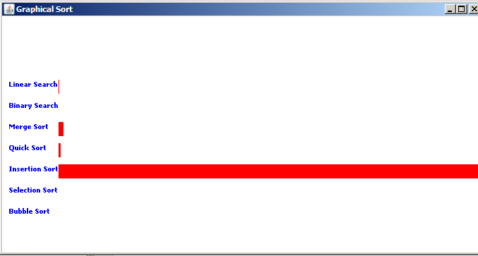
Insertion Sort - N*N
Seconds taken to sort List: 4.64

loading #s from file

Selection Sort - N*N
Seconds taken to sort List: 21.375

loading #s from file

Bubble Sort - N*N
Seconds taken to sort List: 50.235

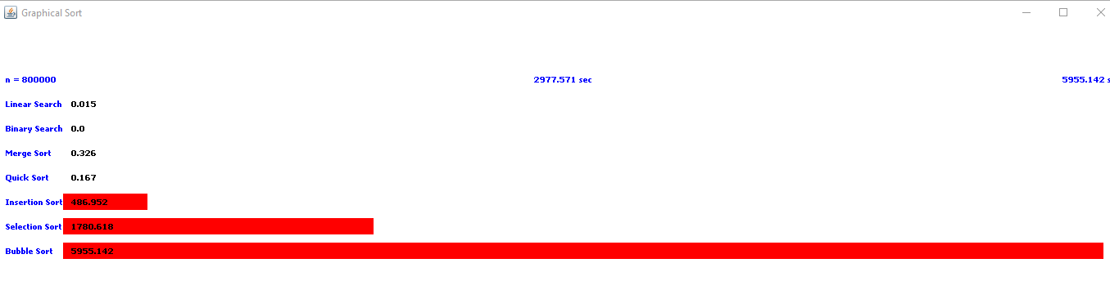
▪0 - 0.015
▪1 - 0.0
▪2 - 0.326
▪3 - 0.167
▪4 - 486.952
▪5 - 1780.618
▪6 - 5955.142

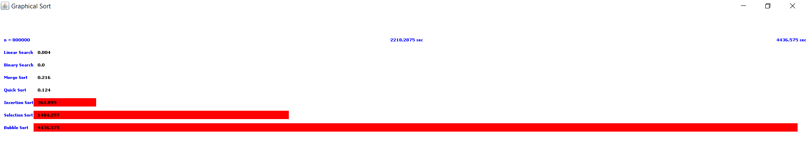
▪0 - 0.004
▪1 - 0.0
▪2 - 0.216
▪3 - 0.124
▪4 - 364.899
▪5 - 1484.297
▪6 - 4436.575

