Team: Mentor CRM

Title: Michael Bernabei, Jose Vieitez, Akash Devgun

Project Summary:

As of today there isn’t any mentor CRM systems worthwhile. Our plan is to build a worthy mentor system that could see real world use. The system would include: profiles, ratings, search, and messaging capabilities.

Requirements:

| Business Requirements | | | |  |
| --- | --- | --- | --- | --- |
| ID | **Requirement** | **Topic Area** | **User** | **Priority** |
| BR-001 | Mentors need to provide at least one email linked to a LinkedIn profile. | Authentication | Mentor | Critical |
| BR-002 | Mentors must provide at least one valid form of contact information. | Profile | System | Critical |
| BR-003 | Companies must provide contact information |  |  | Critical |
| BR-004 | Mentor profiles need to have a rating field. | Profile |  | Critical |
| BR-005 | Mentor profiles need to have a comment box. | Profile |  | Critical |

| User Requirements | | | | |
| --- | --- | --- | --- | --- |
| ID | **Requirement** | **Topic Area** | **User** | **Priority** |
| UR-001 | As an admin, I need to be able to see settings to allow the modification of all mentor profiles in the system. | Mentor Profile | Admin | High |
| UR-002 | The system shall support user roles, e.g. Super, Medium, and guest users. | Authentication |  | Critical |
| UR-003 | As an admin, I need to be able modify all other mentor profiles in the system. |  | Admin | Critical |

| Functional Requirements | | | | |
| --- | --- | --- | --- | --- |
| ID | **Requirement** | **Topic Area** | **User** | **Priority** |
| FR-001 | The system must add information from a mentor’s LinkedIn profile. | Mentor Profile | System | Critical |
| FR-002 | Store a mentor’s LinkedIn profile | Mentor Profile | System, DB, Admin | Critical |
| FR-003 | A company’s name and contact information must be stored in the database | Company Profile | System, DB | Critical |
| FR-004 | A mentor's mentoring history must be stored in the database. |  | System, DB, Mentor | Critical |
| FR-005 | Create Company and Mentor Meeting |  | Admin |  |

| Non-Functional Requirements | | | |  |
| --- | --- | --- | --- | --- |
| ID | **Requirement** | **Topic Area** | **User** | **Priority** |
| NFR-001 | The system should retrieve a LinkedIn Profile in order 1 minute. | Mentor Profile | System | Medium |

Use Cases [Michael Bernabei]:

|  |  |  |  |
| --- | --- | --- | --- |
| Use Case ID: | FR-002 | | |
| Use Case Name: | Store a mentor’s LinkedIn profile | | |
| Created By: | Michael Bernabei | Last Updated By: |  |
| Date Created: | Feb 22, 2016 | Date Last Updated: |  |

|  |  |
| --- | --- |
| Actor: | Administrator, Full Contact API, Database |
| Description: | Store a mentor’s linkedIn in the database. |
| Preconditions: | * System should have parsed the comma separated email address list. * Mentor should have a valid LinkedIn account. |
| Postconditions: | * Mentor’s LinkedIn information is stored in the database. |
| Priority: | Critical |
| Frequency of Use: | Monthly |
| Normal Course of Events: | 1. The administrator provides a list of mentors to upload to the system. 2. The system parses the email addresses. 3. The system calls the Full Contact API passing the mentor email as a parameter. 4. The Full Contact API returns its search results to the system. 5. The results from the Full Contact API are parsed and stored in the database. |
| Alternative Courses: | * LinkedIn information is not available * The Administrator will be alerted to the issue * Contact Must be made with the Mentor in order to retrieve the required information to be stored in the database. |
| Exceptions: | * Mentor’s LinkedIn information is not available. * Administrator login fails. * Full Contact API rejects request from the system. * Full Contact API doesn’t find information on mentors. * System fails to parse the mentor email addresses. |
| Includes: | * Get Full Contact Results |
| Extends: | Store Mentor Profile |
| Special Requirements: | * System needs to have access to Full Contact API |
| Assumptions: | * Mentor has a valid LinkedIn account |
| Notes and Issues: | A developer relationship is required for successful use of the Full Contact API. A developer key must be received from Full Contact before the system can use their API. |

Use Case Sub-diagram [Michael Bernabei]: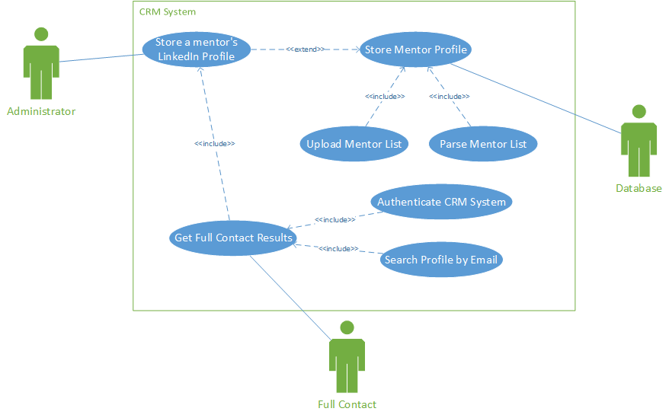

|  |  |  |  |
| --- | --- | --- | --- |
| Use Case ID: | FR-005 | | |
| Use Case Name: | Save Company and Mentor Meeting | | |
| Created By: | Michael Bernabei | Last Updated By: |  |
| Date Created: | Feb 22, 2016 | Date Last Updated: |  |

|  |  |
| --- | --- |
| Actor: | Administrator |
| Description: | Save a meeting with a mentor and a company in the database. |
| Preconditions: | * Administrator has created a link between a given mentor and a company. * The Mentor, Company, and Meeting information are received on the backend. |
| Postconditions: | * Meeting interaction between the company and the mentor are stored in the database. |
| Priority: | Critical |
| Frequency of Use: | Daily |
| Normal Course of Events: | 1. The administrator creates a meeting between a mentor and a company. 2. The company, mentor, and meeting information are checked for time conflicts. 3. If no time conflicts exist the information is stored in the database. |
| Alternative Courses: | * Time conflicts are found and the administrator is alerted. * Mentor and companies are alerted about time conflicts. |
| Exceptions: | * Time conflict exception |
| Includes: | * Create a company and mentor meeting * Check for time conflicts |
| Special Requirements: | Human in the loop |
| Notes and Issues: | While meetings are saved in the database a human in the loop is still required. Consequently a user forgetting to create a meeting can cause conflicts in the system. |

|  |  |  |  |
| --- | --- | --- | --- |
| Use Case ID: | FR-004 | | |
| Use Case Name: | A mentor’s mentoring history must be stored in the database. | | |
| Created By: | Michael Bernabei | Last Updated By: |  |
| Date Created: | Feb 22, 2016 | Date Last Updated: |  |

|  |  |
| --- | --- |
| Actor: | Administrator, Company |
| Description: | A mentor’s meeting interactions history must be shown |
| Preconditions: | * Mentor has mentored at least one company |
| Postconditions: | * Mentor’s mentoring history is stored in the database |
| Priority: | High |
| Frequency of Use: | Weekly |
| Normal Course of Events: | 1. Mentoring confirmation from the company and mentor is received. 2. The administrator will then create a link between the mentor and company indicating successful mentoring occurred. 3. The system will then store the link in the database. |
| Alternative Courses: | * No mentoring confirmation is received. |
| Exceptions: | * Company or Mentor information is not found in the database. |
| Includes: | * Confirm the mentor mentored a company * Get mentor history * Get company history |
| Special Requirements: | Human in the loop |
| Assumptions: | * Mentor has mentored at least one company * Company has been mentored by at least one mentor |
| Notes and Issues: | A human in the loop is required to ensure that a company successfully mentored a company. |

|  |  |  |  |
| --- | --- | --- | --- |
| Use Case ID: | UR-003 | | |
| Use Case Name: | Admin editing usage rights | | |
| Created By: | Michael Bernabei | Last Updated By: |  |
| Date Created: | Feb 22, 2016 | Date Last Updated: |  |

|  |  |
| --- | --- |
| Actor: | Admin, Mentor |
| Description: | A user that signs in with administrative user rights will be able to edit all mentor profiles. |
| Preconditions: | * There is at least one mentor stored in the database |
| Postconditions: | * At least one mentor profile has been edited by the administrator |
| Priority: | Critical |
| Frequency of Use: | Weekly |
| Normal Course of Events: | 1. A user signs in using a valid administrator account. 2. The administrator sees a settings icon which allows the user to edit all other mentor accounts in the system. |
| Alternative Courses: | * User fails to successfully sign in as administrator |
| Exceptions: | * There aren’t any mentor profiles stored in the database |
| Includes: | * Display Administrative Profile View |
| Extends: | * Logon to System |
| Special Requirements: | None |
| Assumptions: | * A user has already successfully created an Administrative account. |
| Notes and Issues: | None |

**Activity Diagram [Michael Bernabei]:**

**Requirement ID: FR-002**

**Use Case ID: Store a mentor’s LinkedIn profile**

**Use Case Description: Store a mentor’s LinkedIn profile in the database**

**Person Who Implemented: Michael Bernabei**

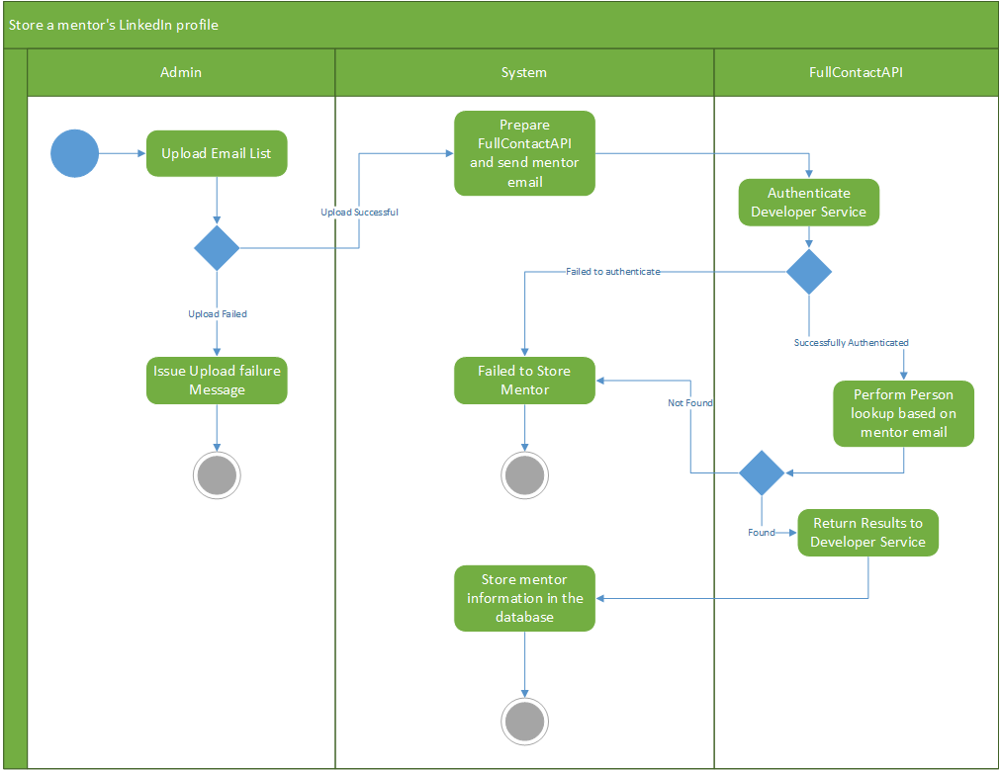

**Database Design:**

*Mission Statement*

The purpose of the Mentor database is to store data on mentors and use the information stored in the database as means to determine how to best pair mentors with companies.

**Data Storage:** SQL Database

**Classes:**

* The MentorModel class will persist information about the mentors
* The CompanyModel class will persist information about the companies
* The User class will persist information about the system users

*Identified Entities/Subjects*

* Mentor
* Mentor Contact Information
* Contact Method
* Status
* State
* Address
* Company
* Meeting
* Skill
* Feedback
* Rating
* Email
* User
* System Role

Mentors

| Name | Type | Description |
| --- | --- | --- |
| Mentor ID | int | A unique identification number given to all mentors in the system. |
| Lastname | char(n) | The last name of a mentor. |
| Middlename | char(n) | The middle name of a mentor. |
| Firstname | char(n) | The first name of a mentor. |
| LinkedIn Email Address | char(n) | A mentor’s LinkedIn email address. |
| Rating | foreign key | The rating value a mentor receives from a company. |
| Feedback | foreign key | The feedback a mentor receives from a company they mentored. |
| Bio | text | The biographical information a mentor provides to the system. |
| Preferred Contact Method | foreign key | The Mentor’s preferred way to be contacted. |
| Contact Information | foreign key | A mentor’s contact information. |
| Status | foreign key | The current status of a mentor, e.g. is the mentor busy, available, etc… |

Mentor Contact Information

| Name | Type | Description |
| --- | --- | --- |
| Contact ID | int | A unique contact ID issued for every mentor added to the system. |
| Mentor Name | foreign key | The mentor’s name. |
| Phone Number | int | The mentor’s number. |
| Address | foreign key | Contact address for a mentor. |
| Email | foreign key | The email address of the mentor. |

Status

| Name | Type | Description |
| --- | --- | --- |
| Status ID | int | A unique status ID for each status type. |
| Status Value | int | A status value indicating the current status of an entity. |

State

| Name | Type | Description |
| --- | --- | --- |
| State ID | int | A unique ID for every state. |
| Name | char(n) | Name of the state. |
| Abbreviation | char(2) | State abbreviation. |

Address

| Name | Type | Description |
| --- | --- | --- |
| Address ID | int | The unique identification for addresses. |
| City Name | char(n) | Name of City in which the mentor resides. |
| Zip Code | int | Zip code. |
| State | foreign key | The state. |
| Street | char(n) | Street number. |

Company

| Name | Type | Description |
| --- | --- | --- |
| Company ID | int | Unique identification number which identifies individual companies. |
| Name | char(n) | Name of the company. |
| Address | foreign key | The address of the company. |

Meeting

| Name | Type | Description |
| --- | --- | --- |
| Meeting ID | int | Unique identification number which identifies individual meetings. |
| Mentor Name | foreign key | The name of the mentor attending the meeting. |
| Company Name | foreign key | The name of the company attending the meeting. |
| Date | datetime | The date of the meeting. |

Skill

| Name | Type | Description |
| --- | --- | --- |
| Skill ID | int | Unique identification number which identifies individual skills. |
| Skill Name | char(n) | Name of the skill. |

Feedback

| Name | Type | Description |
| --- | --- | --- |
| Feedback ID | int | Unique identification number which identifies individual feedback. |
| Feedback | char(n) | Feedback provided by a companies experience with a given mentor. |
| Mentor Name | foreign key | The name of the mentor for which the feedback is for. |
| Company Name | foreign key | Name of the company which provided the feedback |
| Date | datetime | The date for which the feedback was provided. |

Rating

| Name | Type | Description |
| --- | --- | --- |
| Rating ID | int | Unique identification number which identifies individual rating. |
| Rating Value | int | The rating value |

Email

| Name | Type | Description |
| --- | --- | --- |
| Email ID | int | The unique identification for email addresses. |
| Email Address | char(n) | Email addresses. |

User

| Name | Type | Description |
| --- | --- | --- |
| User ID | int | Unique ID for system user names. |
| User Login Name | char(n) | The login name for a user. |

User Role

| Name | Type | Description |
| --- | --- | --- |
| Role ID | int | Unique ID for system role types. |
| Role Type | char(n) | The specific type of role a user of the system can have. |

*Relationship Calculation Table*

|  | Mentor | Mentor Contact Info. | Contact Method | Status | State | Address | Company | Meeting | Skill | Feedback | Rating | Email | User | System Role |
| --- | --- | --- | --- | --- | --- | --- | --- | --- | --- | --- | --- | --- | --- | --- |
| Mentor |  | 1:N | 1:1 | 1:1 | 1:N |  |  |  | 1:N | 1:N | 1:N |  |  |  |
| Mentor Contact Info. | 1:1 |  |  |  |  | 1:N |  |  |  |  |  | 1:N |  |  |
| Contact Method | 1:1 |  |  |  |  |  |  |  |  |  |  |  |  |  |
| Status | 1:1 |  |  |  |  |  |  |  |  |  |  |  |  |  |
| State |  |  |  |  |  |  |  |  |  |  |  |  |  |  |
| Address | 1:1 | 1:1 |  |  | 1:1 |  | 1:1 |  |  |  |  |  |  |  |
| Company | 1:N | 1:N | 1:N |  | 1:N | 1:N |  | 1:N |  | 1:N | 1:N |  |  |  |
| Meeting | 1:1 | 1:1 |  |  |  | 1:1 | 1:N |  |  |  |  |  |  |  |
| Skill | 1:N |  |  |  |  |  |  |  |  |  |  |  |  |  |
| Feedback | 1:1 |  |  |  |  |  |  |  |  |  |  |  |  |  |
| Rating | 1:N |  |  |  |  |  |  |  |  |  |  |  |  |  |
| Email | 1:1 |  |  |  |  |  |  |  |  |  |  |  |  |  |
| User |  |  |  |  |  |  |  |  |  |  |  |  |  | 1:N |
| System Role |  |  |  |  |  |  |  |  |  |  |  |  | 1:N |  |
|  |  |  |  |  |  |  |  |  |  |  |  |  |  |  |

***Relation Addition:***  *1:1 + 1:1 = 1:1 1:N + 1:N = M:N 1:1 + 1:N = 1:N*

*Database UML Design Diagram*

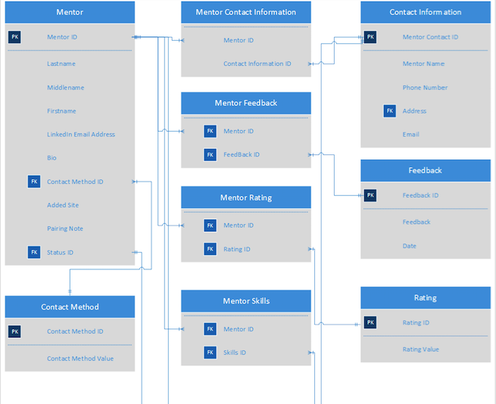

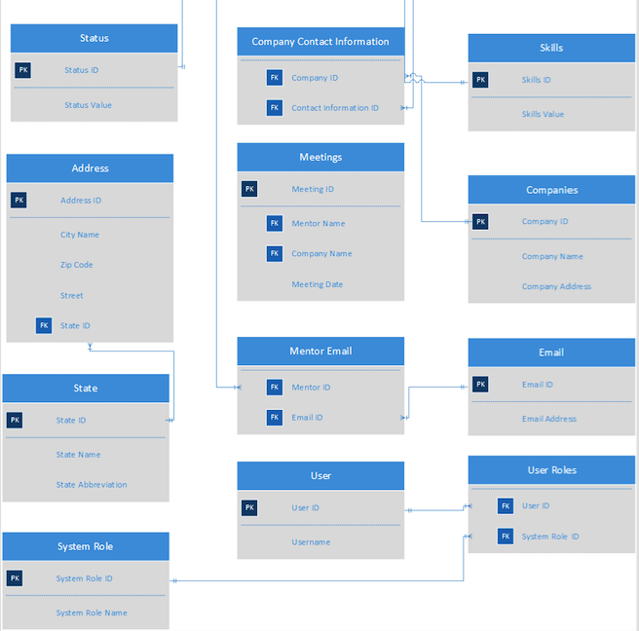

**UI Mockups:**

**User Interactions [Michael Bernabei]:**

**Requirement ID: FR-002**

**Use Case ID: Store a mentor’s LinkedIn profile**

**Use Case Description: Store a mentor’s LinkedIn profile in the database**

**Person Who Implemented: Michael Bernabei**

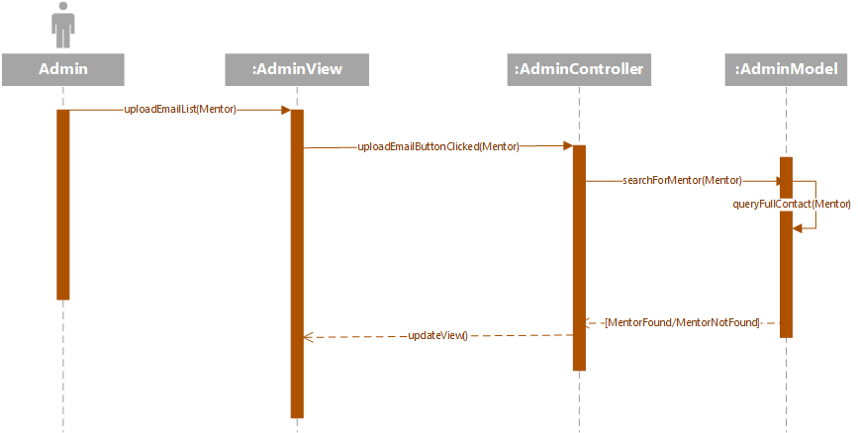

**Class Diagram:**

Class Diagram exists in highest level of repository, it is labeled ClassDiagram.png.