Springboot3 course documentation

Inversion of control (IoC)
The approach of outsourcing the construction and management of objects. It’a a design principle.

Dependency injection (DI)
It’s a specific technique used to implement the IoC. The class does not create its dependencies, but rather receives them from an external source.
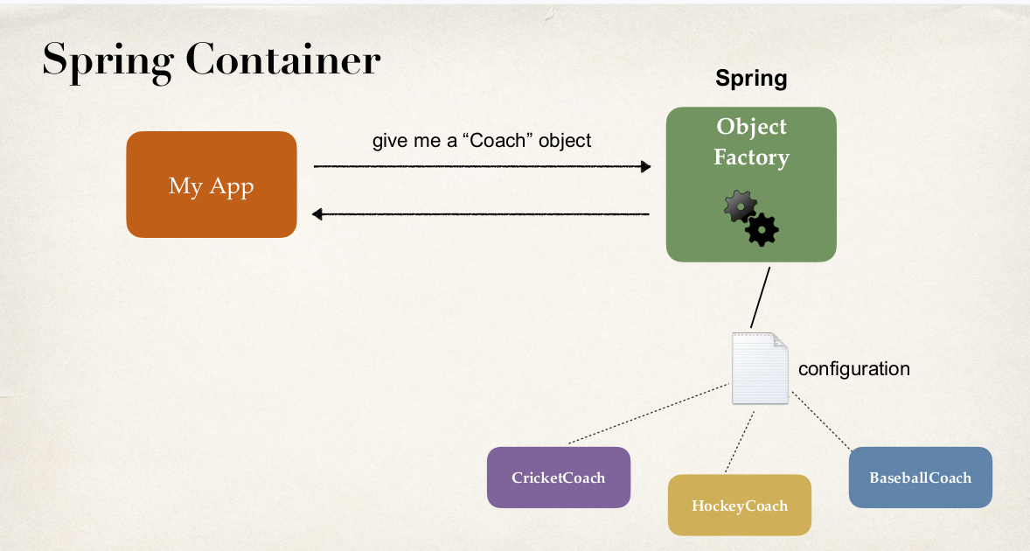

Types of injection
- Constructor injection: recommended. Use it for required dependencies. If there is only one constructor, the @autowired annotation it’s optional.
//Constructor Injection
@Autowired
public DemoController(Coach theCoach, Player thePlayer){
myCoach = theCoach;
myPlayer = thePlayer;
}

- Setter injection: Use it for optional dependencies. If the dependency is not provided, the app can provide default logic.

@Autowired
public void setCoach(Coach theCoach){
myCoach = theCoach;
}

// The setter can get any name
@Autowired
public void initCoach(Coach theCoach){
myCoach = theCoach;
}

@Autowired(required = false)
public void setPlayer(Player thePlayer){
// default logic
if (thePlayer == null) {
logger.error("thePlayer is null, initialization failed.");
return; // No initialice myPlayer if thePlayer is null
}
myPlayer = thePlayer;
}

- Field injection: Not recommended by Spring Team. It makes the code harder to be unit test.
@Autowired
private Coach myCoach;

In this case, myCoach is private and can’t easely be mocked in a unit test.
For testing, we can`t test the class without Spring, you need to initialize Spring for the test:
@RunWith(SpringJUnit4ClassRunner.class)
@ContextConfiguration(classes = {
MyService.class,
MyRepository.class
})
public class MyServiceTest {
@Autowired
private MyService myService;

// ...
}

Spring Autowiring
Used for dependency injection. Spring will look for an annotated class that matches by type (class or interface and will inject it directly.
@Component annotation marks the class as an Spring Bean, that’s it a class that can be managed by Spring. Makes the class available for dependency injection. Works even in private fields. Uses Java Reflection. Sets the values in the class directly.

Spring Scan
Spring will scan all the classes in all the @SpringbootApplication annoted class packege and sub-packages.
How scan packages outside the @SpringbootApplication scope:
@SpringBootApplication(scanBasePackages = {"com.example.demo","com.example.demo2"})

@SpringBootApplication
It’s composed by other annotations:
- @EnableAutoConfiguration: enable Spring boot’s autoconfiguration support.
- @ComponentScan: enable component scanning for the current package and sub-packages.
- @Configuration: able to register extra beans with the @Bean annotation and other configuration classes.

Qualifiers
If there’s more than one candidate to be injected, we have a problem because Spring doesn’t know wich one use. Ie:
@Component
public class CricketCoach implements Coach

@Component
public class FotballCoach implements Coach

@Autowired
public void setCoach(Coach theCoach){
myCoach = theCoach;
}

Description:

Parameter 0 of method setCoach in com.example.demo.DemoController required a single bean, but 2 were found:
- cricketCoach: defined in file [/home/bernabe/IdeaProjects/springboot3course/06-spring-core-qualifiers/target/classes/com/example/demo/CricketCoach.class]
- fotballCoach: defined in file [/home/bernabe/IdeaProjects/springboot3course/06-spring-core-qualifiers/target/classes/com/example/demo/FotballCoach.class]

Action:

Consider marking one of the beans as @Primary, updating the consumer to accept multiple beans, or using @Qualifier to identify the bean that should be consumed

Solution 2: Constructor injection using specific implementation with @Qualifier
@Qualifier("cricketCoach") same name as the class, 1st letter in lowercase.
@Autowired
public void setCoach(@Qualifier("cricketCoach") Coach theCoach){
myCoach = theCoach;
}

Primary
We can delegate the responsability of choosing the Bean using the @Primary bean.
@Component
@Primary
public class FotballCoach implements Coach

Lazy initialization of Spring Beans
By default, all Spring beans are initialized in the project startup. Is possible to make a lazy initialization,
Disabled by default. To be enabled for all the beans:
application.properties:
spring.main.lazy-initialization=true

We can use it at class level for single lazy beans without the property and using the @Lazy annotation at class level:
@Component
@Lazy
public class CricketCoach implements Coach

Bean scopes (lifecycles of a bean)
- How long lives a bean?
- How many instances are created?
- How is the bean shared?

- Defaultt scope: singleton.
  - Spring creates only one instance of the bean.
  - All dependences of the bean uses the same bean.
- Prototype scope
  - creates a new bean instance for every container request.
- Request scope
  - creates a new bean instance for every HTTP request. Web applications.
- Session
  - creates a new bean instance for every web session. Web applications.
- Global-session
  - global http web session. Web applications.

It’s possible to specify the scope of a bean with the @Scope annotation:
@Scope(ConfigurableBeanFactory.SCOPE_PROTOTYPE)

public DemoController(@Autowired Coach theCoach, @Autowired Coach theCoach2) {
logger.info("DemoController init");
this.myCoach = theCoach;
this.myCoach2 = theCoach2;
logger.info("myCoach == myCoach2: " + (myCoach == myCoach2));
}

Output: (different coaches!)
FootballCoach starts
FootballCoach starts
myCoach == myCoach2: false

But if we set the default Singleton scope: (same coach)
@Scope(ConfigurableBeanFactory.SCOPE_SINGLETON)

FootballCoach starts
myCoach == myCoach2: true

Custom Init and destroy methods
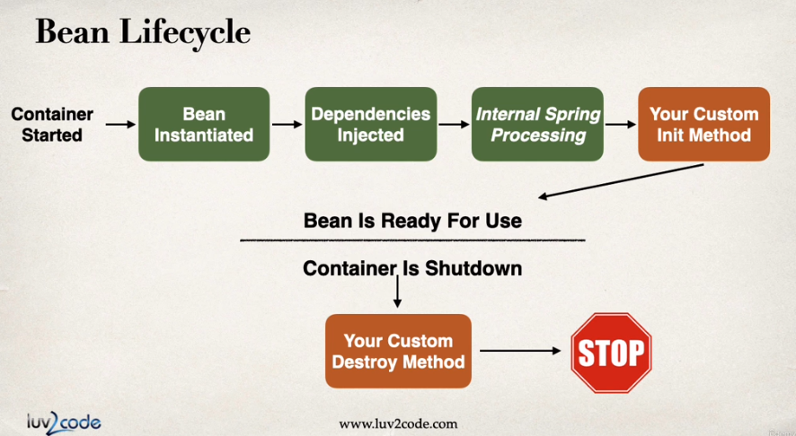
@PostConstruct
public void doStartupStuff(){
System.out.println("Startup works ................");
}
@PreDestroy
public void doCleanupStuff(){
System.out.println("Clean works.......");
}

