**FUNDAMENTALS OF DATABASES – WEEK 3 – ACTIVITY 2**

Supply/perform what is asking in the following statements. Attach or put a screenshot for each number to support your answers.

1. Search for two websites and perform the following CRUD operations:

**FACEBOOK**

* 1. Create - signup using your personal information
  2. Retrieve – search any information to the website
  3. Update – update your personal information
  4. Delete – delete or deactivate your account

1. 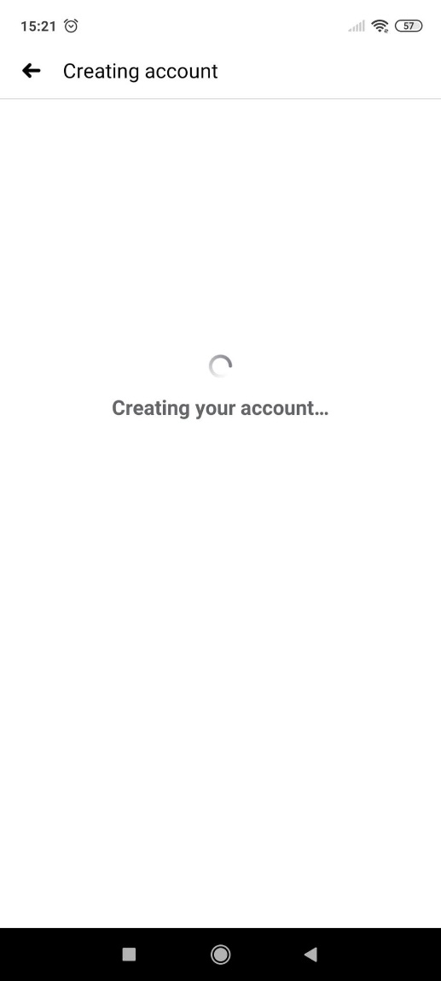**CREATE**

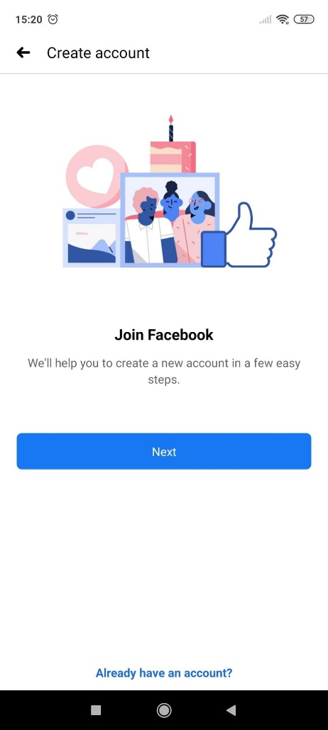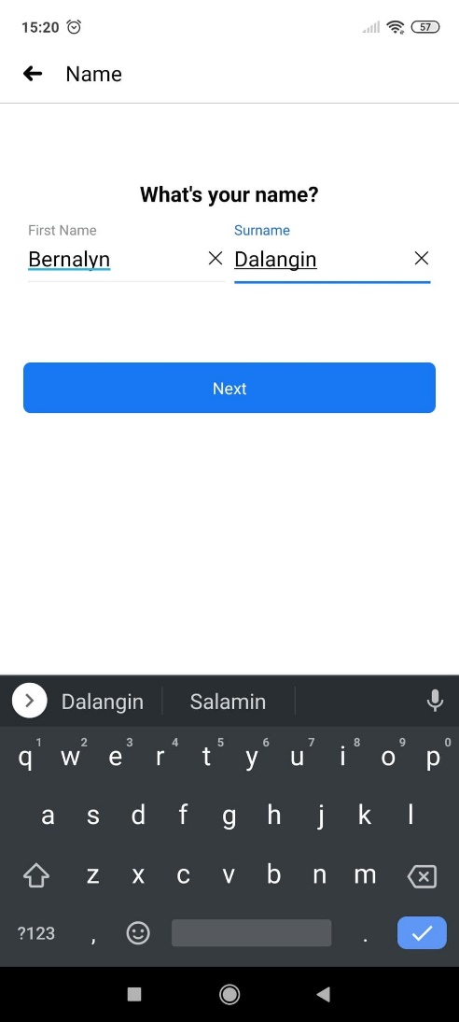

1. 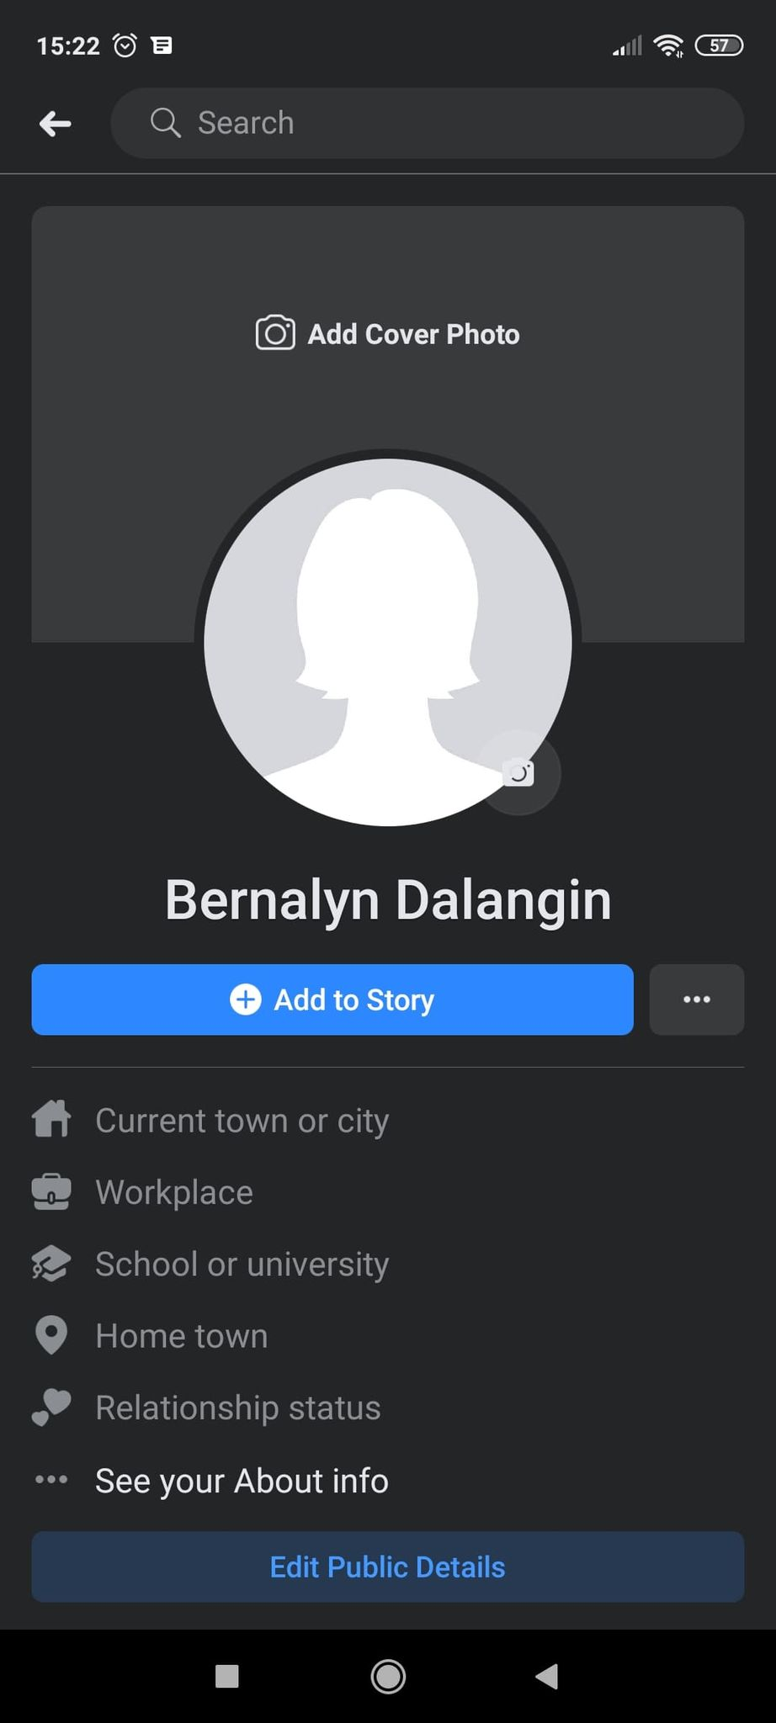**RETRIEVE**
2. 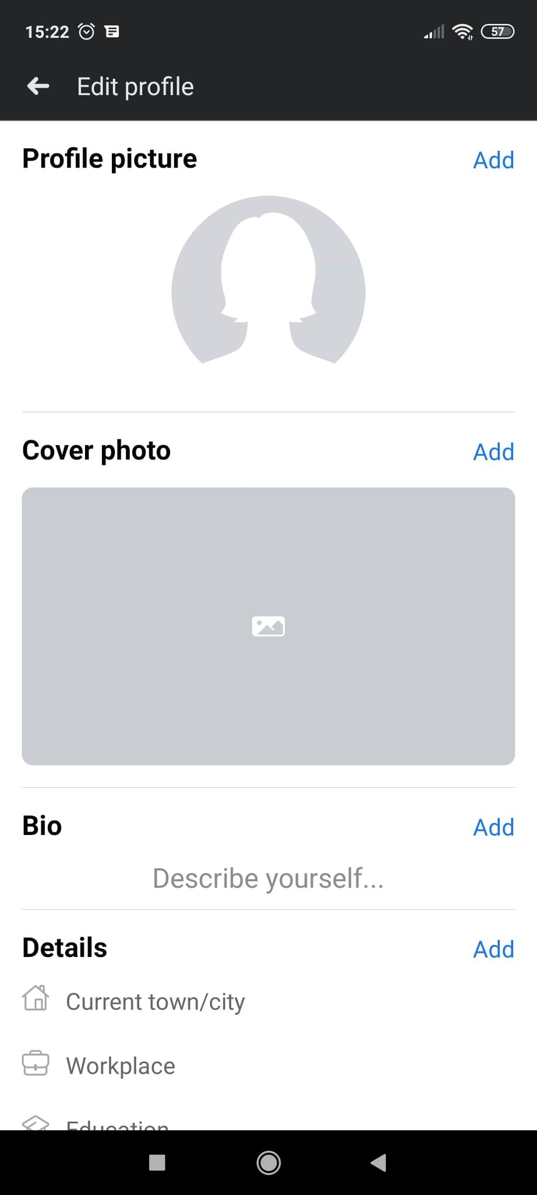**UPDATE**

1. 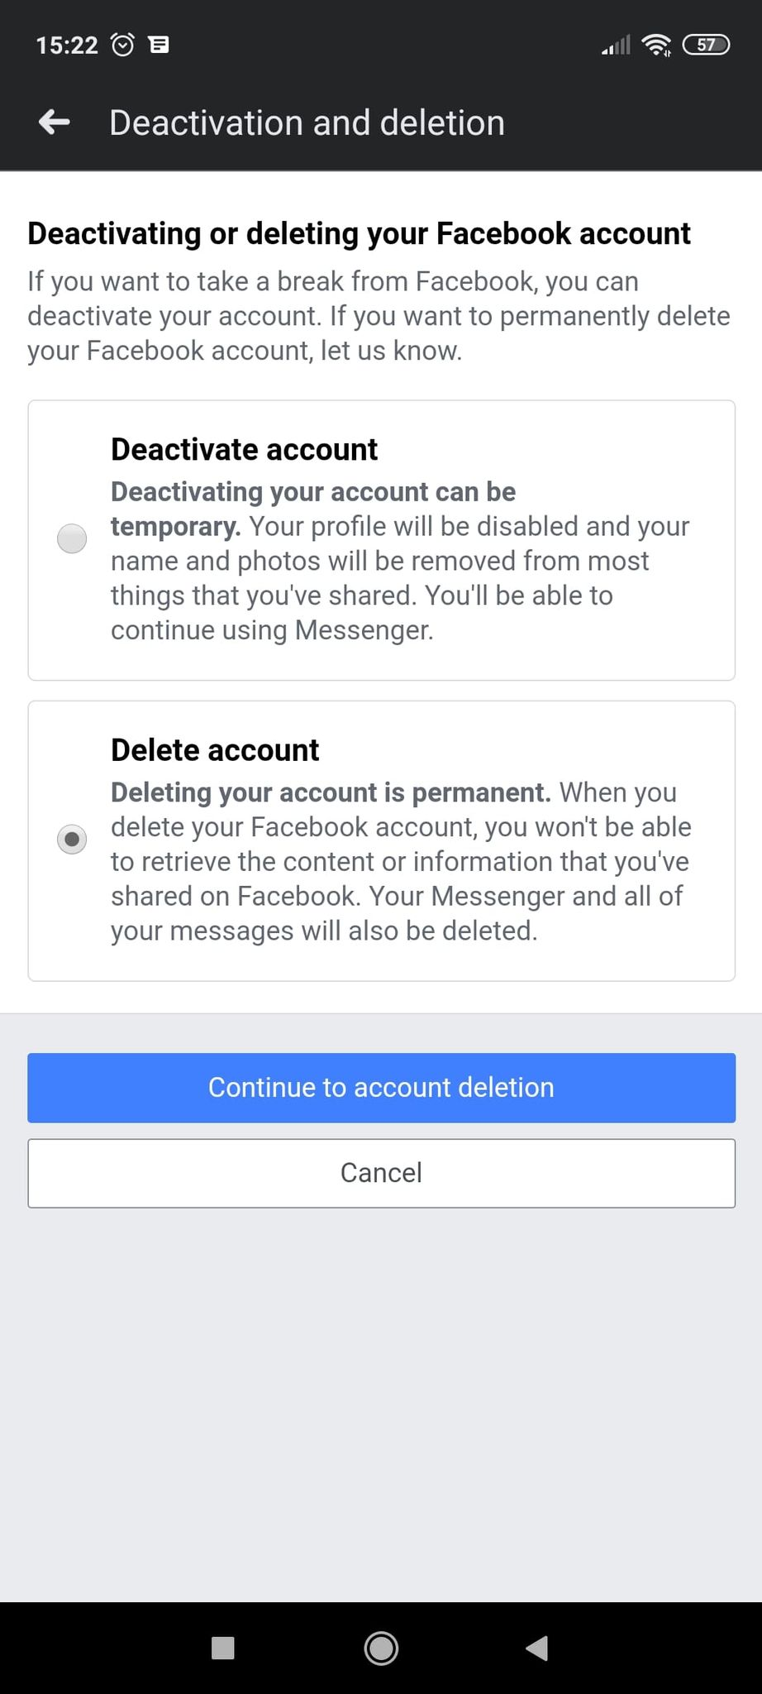**DELETE**