**FUNDAMENTALS OF DATABASES – WEEK 3 – ACTIVITY 1**

Supply/perform what is asking in the following statements. Attach or put a screenshot for each number to support your answers.

1. Search a website or install a free software (for those who have laptop) which can be used as example of different types of interfaces for database or data management in the software/system.
2. Capture or make a screenshot for each types of interface given below and briefly explain its importance or benefits to the users.
   1. Menu-Based Interface
   2. Forms-Based Interface
   3. Graphical User Interface
   4. Natural language Interface
   5. Speech Input and Output
   6. Interfaces for DBA

Answer:



The user can see the navigation bar easier with this interface, with just one click, it can show the different options the user can pick.

1. 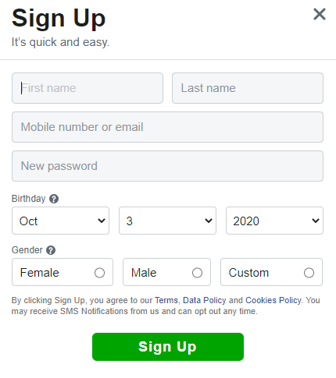

In these forms, the user can create an account for a social media site with ease.

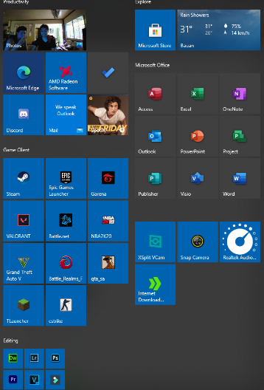

In this type of interface, the user can easily access through this shortcuts what application the user wants to use.

d.

In this feature, this interface easily translate any word you want to another language.

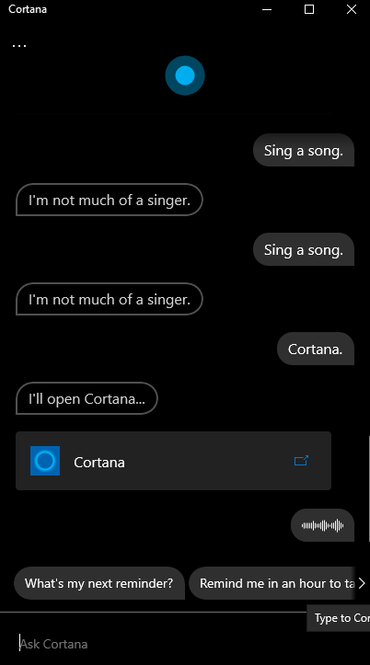e.

In this interface, the user can command an A.I. or maybe just to it with voice input.

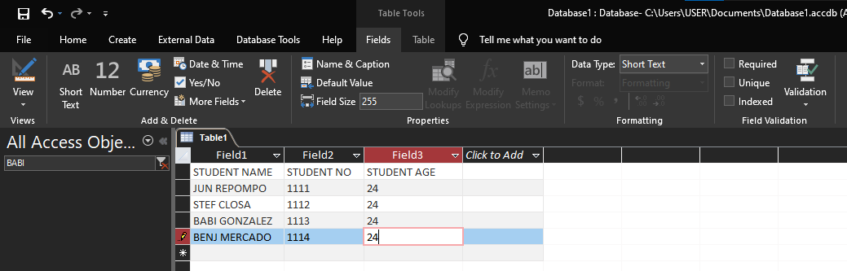f.

In this interface, the user can easily manipulate the data in this database management systems.